

University of Michigan Medical Center
Protocols and Guidelines
For
Adult Perfusion

Editor & Illustrator
Eric Jenkins, CCT, CCP

Associate Editors
Russell Butler, CCP
Kevin Griffith, CCP

Contributors

Jan Aukerman, CCP
Russell Butler, CCP
Kevin Griffith, CCP
Eric Jenkins, CCT, CCP
Greg Kline, CCP
Joe Niman, CCP
Nina Paugh, CCP
Theron Paugh, CCP
Rocco Polito, CCP
David Sturmer, CCP
Chris Yann, RN, CCP

Physician Review

Richard Prager, MD
Michael Deeb, MD
Steven Bolling, MD
Frank Pagani, PhD, MD
Himanshu Patel, MD
Wei Lau, MD

Copyright 1998
Revised 2004
The Regents of the University of Michigan

Table of Contents
Table of Contents i
Tables of Figures 1
Preface 1
Section 1: Equipment Selection 2
Oxygenator Selection Criteria 2
Arterial Filter Selection Criteria 2
Tubing Pack Selection Criteria 3
Vacuum Assisted Venous Drainage (VAVD) Selection Criteria 3
Cell Saver Selection Criteria 4
Hemoconcentrator Selection Criteria 5
Section 2: General Patient Management & Perfusion Technique 6
Extracorporeal Circuit Prime Constituents 6
Basic Management Parameters during CPB 10
Vacuum Assisted Venous Drainage Technique 17
Guidelines for Surgeon’s Preference 20
Ultrafiltration Management and Technique 28
Autotransfusion Protocol 29
Anticoagulation Management 31
Pre-CPB Autologous Whole Blood Collection 32
Section 3: Cardioplegia Protocols 34
General Cardioplegia Protocols 34
Section 4: Drug & Blood Product Administration Protocols 45
Drugs that can be given PRN 45
Drugs that cannot be given PRN 47
Antibiotic Preference 48
Methylprednisolone Usage during Procedures Requiring DHCA or Orthotopic Transplantation 51
Prophylactic Treatment of Possible Protamine Reactions 52
Post Aortic Crossclamp Drug Regimen 53
Pharmacological Treatment for Hyperkalemia 55
Vitamin K Administration 56
Arginine Vasopressin Administration 57
General Guidelines for the Administration of Blood Bank Products 58
Cardiopulmonary Bypass Transfusion Triggers 59
Section 5: Transplant Protocols 60
Heart Transplant 60
Perfusion Management of Sickle Cell Anemia Patient during Orthotopic Heart Transplantation 71
Perfusion and Anticoagulation Management of Heart Transplant Patients with Heparin Induced Thrombocytopenia / Heparin Associated Thrombocytopenia (HIT / HAT) Using Bivalirudin (Angiomax) 80
Orthotopic Liver Transplant Protocols 90
Liver Reperfusion Protocol 118
Lung Transplantation 120
Section 6: Aortic Aneurysm and Dissection Procedures 127
Left Heart Bypass 127
Transverse Aortic Arch Dissection or Aneurysm Repair Requiring Deep Hypothermic Circulatory Arrest (DHCA), Selective Antegrade Cerebral Perfusion (SACP), and/or Retrograde Cerebral Perfusion (RCP) Under Revision 132
Dissection or Aneurysm Repair through a Left Thoracotomy Requiring DHCA, Left Atrial Venting, and Active Venous Drainage (Under Revision) 148
Section 7: Ventricular Assist Protocols & Procedures 159
Abiomed BVS 5000 Set-Up, Prime, and Initiation 159
Recommendations for Abiomed BVS 5000 Operation during Return to the OR for Re-Exploration 164
Bedside Replacement of the Abiomed BVS 5000 165
Abiomed ECMO 168
CPB Management for TCI HeartMate Implantation Procedure 178
TCI HeartMate Implantable Pneumatic (IP) Set-Up and Operation 186
HeartMate Vented Electric (VE) Set-Up and Operation 189
HeartMate Vented Electric (VE) Alarm & Advisory Situations 193
TCI HeartMate VE Trouble Shooting Decision Flow Sheet 195
HeartMate Extended Lead Vented Electric (XVE) Alarm Situations 196
HeartMate VE: Conversion to Pneumatic Console Operation 199
HeartMate VE: Hand Pumping 200
HeartMate Patient Travel Guideline for 4C and TICU 201
Thoratec VAD System Set-Up and Operation 207
Section 8: Special Cardiac Procedures 213
Redo CABG through Left Thoracotomy with or without Left Atrial Venting and Vacuum Assisted Venous Drainage 213
Redo Mitral Valve Repair/Replacement through a Right Thoracotomy with Vacuum Assisted Venous Drainage and Mild Hypothermia 218
CPB with DHCA and Lancaster Cooling Jacket for Pulmonary Thromboendarterectomy 223
Section 9: Non-Cardiac CPB Procedures 230
Fem-Fem CPB with DHCA and Active Venous Drainage for Repair of Giant Intra-Cerebral Aneurysms 230
Resection of Intravascular Renal Carcinoma Requiring Deep Hypothermic Circulatory Arrest (DHCA) 238
Section 10: Perfusion Management of Pathologies Affecting CPB Technique 247
Perfusion Management of Cold Agglutinins 247
Perfusion and Anticoagulation Management of the Heparin Induced Thrombocytopenia/Heparin Associated Thrombocytopenia (HIT/HAT) Patient with Bivalirudin (Angiomax) 254
Perfusion Management of Sickle Cell Anemia Patient 258
Section 11: Emergency Procedures 263
Failed Oxygenator Change Out 263
Open Venous Reservoir Change Out 266
Pump Boot or Centrifugal Pump Head Change Out 269
Cardioplegia Delivery System Change Out 271
Pump Module Failure 273
Water Heater/Cooler Failure 275
Management of Massive Gas Embolism 275
Re-establishment of Bypass Following Initial Termination 278
Appendix A: Reference 280
Essentials and Guidelines for Perfusion Practice of the American Society of Extra-Corporeal Circulation 280
Appendix B: Perfusion Documentation 286
UMMC Policy: Medical Records and Confidentiality 286
Cardiopulmonary Bypass Record & Guidelines for Charting 290
Orthotopic Liver Transplant Veno-Venous Bypass Record & Guidelines for Charting 307
Appendix C: Equipment Specifications 313
PVC Tubing Flow & Volume Specifications 313
Oxygenator Specifications 314
Arterial Line Filter Specifications 315
Hemoconcentrator Specifications 316

Tables of Figures
Figure 1: Basic Adult CPB Circuit Diagram 8
Figure 2: Vacuum Assisted Venous Drainage Diagram 18
Figure 3: Pagani Heart Transplant Circuit 61
Figure 4: Devaney and Patel Heart Transplant Circuit 63
Figure 5: CPB Circuit for Heart Transplant Patient with Sickle Cell Anemia 72
Figure 6: Heart Transplant Patient with HIT/HAT Circuit 81
Figure 7: RMI FEMIIOXXA Cannula Flow Chart 91
Figure 8: Pre-Assembled Y Connector for RIJ Cannula 92
Figure 9: 16 Fr. RIJ Cannula Set-Up 93
Figure 10: 16 Fr. RMI Flush Diagram 93
Figure 11: 16 Fr. RIJ Cannula & Pre-Assembled Y Connection Diagram 94
Figure 12: 16 Fr. RIJ Cannula to Belmont HMS2000 Connection Diagram 95
Figure 13: ¼ x 3/8” Pre-Assembled Connector Diagram 96
Figure 14: 14 Fr. RIJ Cannula Set-Up 97
Figure 15: 14 Fr. RMI Cannula Flush Diagram 98
Figure 16: 14 Fr. RIJ Cannula & Pre-Assembled Y Connection Diagram 99
Figure 17: Portal Vein Cannula Assembly Diagram 101
Figure 18: Piggyback or Standard 3-Way Veno-Venous Bypass Circuit Diagram 102
Figure 19: Niman Prime Technique Phase 1 Diagram 104
Figure 20: Portal Vein Cannula Assembly Diagram 106
Figure 21: Niman Prime Technique Phase 2 Diagram 107
Figure 22: “Piggyback” VV Bypass Circuit with 16 Fr. RIJ Cannula & Belmont HMS2000 Integration Diagram 109
Figure 23: “Piggyback” VV Bypass Circuit w/ 12 or 14 Fr. RIJ Cannula Diagram 110
Figure 24: VV Bypass Circuit with 16 Fr. RIJ Cannula & Belmont HMS2000 Integration Diagram 111
Figure 25: Standard Veno-Venous Circuit with 12 or 14 Fr. RIJ Cannula Diagram 112
Figure 26: 16 Fr. Cannula Disconnection from VV Bypass Circuit Diagram 114
Figure 27: 14 Fr. Cannula Disconnection from VV Bypass Circuit Diagram 115
Figure 28: DeBakey Aortic Aneurysm Type Illustrations 126
Figure 29: Left Heart Bypass Circuit Diagram 129
Figure 30: Aortic Arch Aneurysm Illustration 131
Figure 31: Belmont HMS2000 System Diagram 136
Figure 32: RCP / SACP Extracorporeal Circuit Diagram 140
Figure 33: Descending Aortic Aneurysm Illustration 147
Figure 34: Abiomed Priming Circuit Diagram 159
Figure 35: Pre-Assembled Diamond Diagram 168
Figure 36: Oxygenator & Pre-Assembled Diamond Priming Diagram 169
Figure 37: Oxygenator Insertion into Abiomed Circuit Diagram 171
Figure 38: Abiomed ECMO Circuit Diagram 173
Figure 39: Abiomed ECMO Circuit with Hemoconcentrator for CVVH Diagram 174
Figure 40: Lancaster Cooling Jacket Components 224
Figure 41: Lancaster Cooling Jacket Circuit Diagram 226
Figure 42: Extra-Corporeal Circuit for HIT / HAT Patient Diagram 255
Figure 43: Exsanguination Circuit Diagram 259

Preface
This manual has been developed, overseen, and approved by all appropriate attending physicians. The purpose of Protocols and Guidelines for Adult Perfusion is to improve the continuity and quality of care provided by perfusion services at the University of Michigan Medical Center. To that end, this manual presents the basic information necessary for the safe and effective conduct of adult perfusion as suggested by the Essentials and Guidelines for Perfusion Practice of the American Society of Extracorporeal Technology. Accordingly, the Essentials and Guidelines for Perfusion Practice is included in the Appendices and serves only as basis for the protocols and guidelines which follow. The procedural information contained herein is not intended to replace common sense and good judgment. The appropriate course of action in any situation is dictated by a combination of policy, common sense, and experience. Meaningful communication, however, between the perfusionist, the attending surgeon, and anesthesiologist is essential whenever a serious departure from established protocols and guidelines is undertaken.

Section 1: Equipment Selection
Eric Jenkins, CCT, CCP

Oxygenator Selection Criteria
- The oxygenator selected must be able to deliver per the manufacturer recommended blood flow rate range a minimum blood flow of 2.4 l/min/m2 BSA. It is not recommended to exceed the manufacturer recommended maximum blood flow rate of a selected oxygenator.

Medtronic Affinity Membrane Oxygenator (hollow fiber)
Manufacturer Recommended Blood Flow Range
- 1 - 7 l/min
Selection Criteria per Operative Procedure
- Used on all adult procedures.

Arterial Filter Selection Criteria
- It is not recommended to exceed the manufacturer recommended maximum flow rate of a selected arterial filter.

Medtronic Affinity Arterial Filter (38 micron)
Manufacturer Recommended Maximum Blood Flow Rate
- 7.0 l/min
Selection Criteria per Operative Procedure
- All procedures except the following
- heart and/or lung transplants

Pall LeucoGuard-6 Arterial Filter (40 micron)
Manufacturer Recommended Maximum Blood Flow Rate
- 6.0 l/min
Selection Criteria per Operative Procedure
- Mandatory Usage on all heart and/or lung transplants.
- Mandatory Usage on HeartMate implantations.
- All procedures on patients with unresolved bacterial endocarditis.
Special Note
- All Pall Leuco-Guard 6 arterial filters are to be inserted into the Medtronic Affinity 38 micron arterial filter bypass line. This assures that another arterial filter is available should the Pall Leuco-Guard 6 arterial filter become obstructed.
- It is recommended that the Medtronic Affinity 38 micron arterial filter be primed antegrade. The Pall Leuco-Guard 6 arterial filter is then primed retrograde.

Tubing Pack Selection Criteria

Adult Tubing Pack
- Used on all adult patients.

Vacuum Assisted Venous Drainage (VAVD) Selection Criteria

Equipment
- vacuum regulator (on pump console)
- vacuum source (OR column)
- 1 VAVD pack (Pump Cart, Pump Room, or Core A Store Room)

Bolling
- Set up VAVD on all cases.

Deeb
- Set up VAVD all cases requiring a left thoracotomy and/or femoral venous cannulation.

Pagani
- Set up VAVD on heart transplants and VAD emplacements.
- Consult Dr. Pagani prior to setting up vacuum assisted venous drainage all cases requiring a left thoracotomy and/or femoral venous cannulation.

Patel
- Set up VAVD on heart transplants and VAD emplacements.
- Consult Dr. Pagani prior to setting up vacuum assisted venous drainage all cases requiring a left thoracotomy and/or femoral venous cannulation.

Prager
- Consult Dr. Prager prior to setting up vacuum assisted venous drainage all cases requiring a left thoracotomy and/or femoral venous cannulation.

Cell Saver Selection Criteria
- If there is any doubt regarding the use of a cell saver, consult the surgeon on a case by case basis.

Bolling
- Set up a cell saver on all cases.

Deeb
- On cases not requiring DHCA set up a cardiotomy with suction. Only set up a bowl assembly if the volume scavenged is enough for at least one unit to be processed.

Pagani
- On cases not requiring DHCA set up a cardiotomy with suction. Only set up a bowl assembly if the volume scavenged is enough for at least one unit to be processed.
- On all OPCAB’s, set up a cardiotomy with suction. Only set up a bowl assembly if the volume scavenged is enough for at least one unit to be processed.

Prager
- Does not routinely use a cell saver.
- On re-operations, set up a cardiotomy with suction. Only set up a bowl assembly if the volume scavenged is enough for at least one unit to be processed.
- On all OPCAB’s, set up a cardiotomy with suction. Only set up a bowl assembly if the volume scavenged is enough for at least one unit to be processed.

Patel
- Does not routinely use a cell saver.
- On re-operations, set up a cardiotomy with suction. Only set up a bowl assembly if the volume scavenged is enough for at least one unit to be processed.
- On all OPCAB’s, set up a cardiotomy with suction. Only set up a bowl assembly if the volume scavenged is enough for at least one unit to be processed.

Hemoconcentrator Selection Criteria
- Aside from the surgeon specific selection criteria listed below, the perfusionist may set up a hemoconcentrator at his/her discretion when there is a need to remove excess perfusate volume during CPB.

Equipment
- vacuum source (OR column)
- Bard HC70 Hemoconcentrator (available in pump room
- Bard HC70 Hemoconcentrator Holder (on pump console)
- sterile suction tubing (available in A Core Nursing Supply Racks)
- suction canister and holder

Indications per Surgeon
Bolling
- Set up hemoconcentrator on all patients with significant renal dysfunction or failure.
Deeb
- Set up hemoconcentrator on all requiring DHCA.
- Set up hemoconcentrator on all patients with significant renal dysfunction or failure.
- Consult Dr. Deeb regarding hemoconcentrator set up regarding patients with active sepsis.
Pagani
- Set up hemoconcentrator on all patients with significant renal dysfunction or failure.
Prager
- Set up hemoconcentrator on all patients with significant renal dysfunction or failure.

Section 2: General Patient Management & Perfusion Technique
Eric Jenkins, CCT, CCP

Extracorporeal Circuit Prime Constituents
- For all adult cardiac surgeries requiring CPB, calculate the patient’s estimated Hct on CPB. The following formula may be used for this calculation.

Estimated CPB Hct Calculation

Estimated CPB Hct = (65 x kg x (pt Hct / 100) x 100
(65 x kg) + ml prime)

where: Estimated CPB Hct = estimated Hematocrit on cardiopulmonary bypass
ml prime = prime volume of extracorporeal circuit
kg = patient’s kilogram weight
pt Hct = patient’s hematocrit measured following monitoring lines
insertion by anesthesia

- If the estimated CPB Hct is greater than or equal to 25%, add the following constituents to the extracorporeal circuit in the usual manner. The following constituents are used on all cases unless stated otherwise in a specific protocol. It is the perfusionist’s responsibility to review a specific protocol, if applicable, to determine whether or not different prime constituents are indicated.

Table 1: Standard Extra-Corporeal Circuit Prime Constituents
Constituent | Amount
Normosol R | 1750 ml
Heparin | 10,000 units
NaHCO3 | 50 mEq
Mannitol (Do not administer in presence of severe renal impairment unless authorized by the attending surgeon.) | 12.5 g
Epsilon-amino-caproic acid (Amicar) or aprotinin (Trasylol)* | 10 g or 2.0 x 106 KIU
- Amicar is administered when aprotinin is not given.
- Neither Amicar nor aprotinin is administered on cases where deep hypothermic circulatory arrest is utilized unless specifically requested by the staff surgeon.

- If the estimated CPB Hct is less than 25%, consult the attending surgeon regarding adding PRBC’s to the pump prime. The following formula may be used to calculate how many ml PRBC’s are required for a target CPB Hct.

PRBC Prime Volume for Target CPB Hct Calculation

X ml PRBC’s = (Target Hct/100) x ((65 x kg) + ml prime vol)) – (65 x kg (pt Hct / 100)
0.6

where: X ml PRBC’s = estimated amount of packed red blood cells necessary to attain
the target hematocrit on cardiopulmonary bypass
target Hct = desired Hematocrit on cardiopulmonary bypass
prime vol = prime volume of extracorporeal circuit
kg = patient’s kilogram weight
pt Hct = patient’s hematocrit measured following monitoring lines
insertion by anesthesia

Figure 1: Basic Adult CPB Circuit Diagram
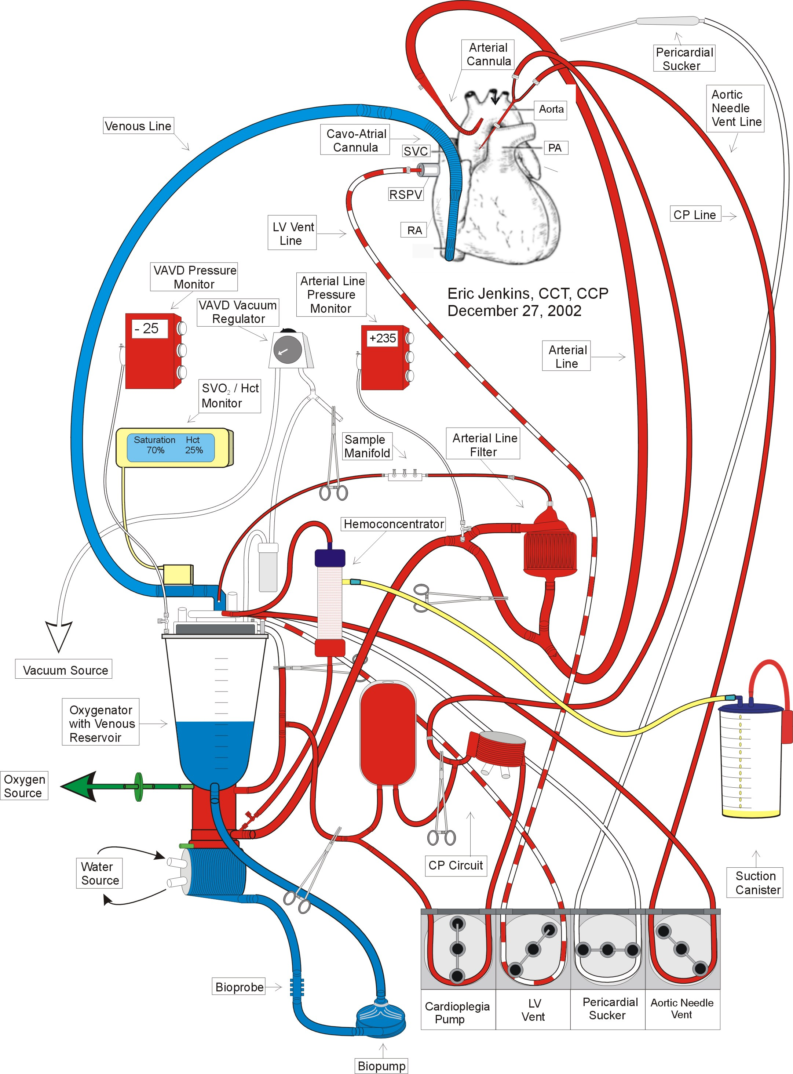

Basic Management Parameters during CPB
- The guiding principle of adequate perfusion is to maintain the normal physiological condition of a given patient during CPB if clinically possible. Whenever clinical conditions occur that upset the normal physiological condition of a patient during CPB, it is the responsibility of the attending surgeon, the staff anesthesiologist, and the perfusionist to use education, experience, and common sense to make appropriate decisions to correct that situation if possible.

Blood Flow Rate
- At this institution, blood flow rate is calculated using a cardiac index of 2.4 l/min/m2. Body surface area (BSA) may be calculated using the following formula:

BSA = (((cm^{0.725} x kg^{0.425}) x 71.84)) / 10,000

- Blood flow rate (> 1.4 l/min/m² < the limits of the extracorporeal circuit) may vary during the course of CPB according to the needs of the procedure and adequate perfusion. However, lower blood flow rates are limited by mean arterial pressure and mixed venous saturation. These limits are discussed below. Whenever the needs of a procedure conflict with adequate perfusion, it is responsibility of the perfusionist to consult the attending surgeon and staff anesthesiologist.

Mean Arterial Pressure Management
- Acceptable MAP ranges are surgeon and disease state specific at this institution.
Routine
- Bolling: 50 - 60-mmHg
- Deeb: ~ 60 mmHg
- Pagani: 70 - 80 mmHg
- Prager: 50 – 60 mmHg
Carotid disease or Recent Carotid Endarterectomy
- Bolling: ~ 75 mmHg
- Deeb: 85 - 90 mmHg
- Pagani: 80 - 100 mmHg
- Prager: 60 – 70 mmHg
Low MAP Treatment Regimen
- When mean arterial pressure falls below the acceptable MAP ranges listed on the preceding page, the following treatment regimen may be used to raise the MAP to an acceptable value.

- Calculate the patient’s systemic vascular resistance (SVR). The equation below may be used to calculate SVR. Normal adult SVR ranges are also listed in the table below:

SVR (Wood units) = (MAP - CVP) / CO

SVR (metric units) = 80(MAP - CVP) / CO

Table 2: Normal Adult SVR Range Table
 | Woods Units  (WU = mmHg.min.L) | Metric Units  (U = dynes.sec.cm⁻⁵)
SVR | 12 - 18 WU | 900 - 1500
(Kaplan JA, Cardiac Anesthesia,W.B. Saunders: Philadelphia, 1993, 59, 63.)

- If the SVR falls within normal range, increase the BFR until the MAP falls within the appropriate MAP Range.
- If the SVR is low, increase BFR and administer phenylephrine (see Section 5)
- If hypotension does not respond to increased blood flow rate and phenylephrine, consult the staff anesthesiologist and attending surgeon regarding further pharmacological intervention.

High MAP Treatment Regimen
- When mean arterial pressures rise above the acceptable MAP ranges listed on the preceding page, the following treatment regimen may be used to lower the MAP to an acceptable value.

- Calculate the patient’s systemic vascular resistance (SVR). The equations above may be used to calculate SVR. Normal adult SVR ranges are also listed in the table above.
- If the SVR is normal, then lower the BFR as long as the mixed venous saturation remains > 65%.
- If the SVR is elevated, increase isofluorane administration. Under most circumstances, isofluorane administration at < 2.0% of the gas flow rate is adequate. Occasionally, brief periods isofluorane administration at > 2.0% < 5% of the gas flow rate are appropriate to treat refractory MAP elevation secondary to inadequate anesthesia. However, extended periods of isofluorane administration at > 2.0% < 5% the gas flow rate are associated with the decoupling of cerebral blood flow autoregulation and should, therefore, be avoided.
- If the elevated MAP does not respond to decreased blood flow rate and isofluorane administration, consult the staff anesthesiologist and attending surgeon regarding further pharmacological intervention.

Central Venous Pressure (CVP)
- < 10 mmHg
- A sudden increase in CVP may be caused by one or a combination of the following causes:
- air lock
- kinked or clamped venous line
- sudden lifting of the heart
- venous line chugging
- venous cannula(e) malposition
- inadequate venous cannula(e)
- pressure transducer malfunction
- monitoring line and/or catheter obstruction
- ongoing drug infusion through monitoring line
- migrating tumor or thrombus
- persistent LSVC
- AV fistula
- PDA
- It is the perfusionist’s responsibility to consult the surgeon in order to diagnose and correct decreased venous return in a timely manner.
- Low BFR should be avoided if possible.

Mean Pulmonary Artery Pressure (MPAP)
- < 10 mmHg
- Generally, a sudden increase of MPAP may occur for the same listed above for increased CVP.
- While weaning from CPB, an elevated MPAP may be caused by one or a combination of the following causes:
- overfilling during weaning
- Avoid overfilling the patient at all times.
- history of obstructive pulmonary vascular disease
- Requires pharmacological intervention by the staff anesthesiologist.
- history of mitral valve disease
- Requires pharmacological intervention by the staff anesthesiologist.
- left ventricular dysfunction
- Requires pharmacological intervention by the staff anesthesiologist.
- Insertion of left ventricular assist device, ie. IABP, Abiomed.

Arterial Blood Gases: Management & Sample Frequency
Sample Frequency
- It is recommended that an arterial blood gas sample (analyzed by a blood gas machine, not the CDI 500) be taken every 30 - 45 minutes. At least two samples should be taken per case if possible.
pH: 7.35 - 7.45 using alpha stat perfusion management technique.
- Respiratory alkalosis may be treated by decreasing the gas flow rate.
- Metabolic alkalosis may be treated by hemoconcentration where excess ultrafiltrate is replaced with unbuffered Normosol R, unbuffered 0.9% NaCl, and/or PRBC’s.
- Respiratory acidosis may be treated by increasing the gas flow rate.
- Metabolic acidosis may be treated with sodium bicarbonate administration and increased blood flow rate.
pCO₂: 35 - 45 mmHg
- Hypocarbia may be treated by decreasing the gas flow rate.
- Hypercarbia may be treated by increasing the gas flow rate. Make certain the patient is adequately anesthetized. Rule out malignant hyperthermia.
pO₂: 100 - 300 mmHg
- Low pO2 may be treated by a combination of increased FiO2 and blood flow rate. Make certain the patient is adequately anesthetized. Rule out malignant hyperthermia.
- High pO2 may be treated by reducing the FiO2.

Venous Oxygen Saturation (vSAT)
vSAT: > 65%
- Low vSAT may be treated with increased FiO₂ and blood flow rate as well as possible PRBC transfusion. Make certain the patient is adequately anesthetized. Rule out malignant hyperthermia.

Hematocrit
- A target Hct > 20% is indicated for CPB initiation. If an asanguineous prime would result in excessive hemodilution (< 20%), the # of PRBC units necessary to achieve the target hematocrit should be added to the prime after the pre-bypass filter is removed. Prior to CPB initiation, the prime can be mixed by opening the oxygenator recirculation line. The resultant Hct on CPB utilizing an asanguineous prime may be calculated using the following formula:

CPB Hct = (((0.065 x kg x (patient Hct / 100)) / ((0.065 x kg) + ml prime))) x 100

- The volume of PRBC’s necessary for a given Hct on CPB may be calculated using the following formula:

? ml PRBC’s = ((Target Hct / 100) x (0.065 x kg) + ml prime)) – ((0.065 x kg x (patient Hct / 100))

- Prior to or during rewarming, it is the perfusionist’s responsibility to ascertain from the surgeon what the end target Hct is. The perfusionist must then add the necessary PRBC units to achieve the end target Hct. The use of diuretics and hemoconcentration should be considered.
- Certain cardiac disease conditions, such as dilated cardiomyopathy, may require a higher Hct on CPB, especially during rewarming and termination. The perfusionist should be prepared to consult the surgeon on such cases.

Serum K⁺
Normal Range:3.5 - 5.5 mEq/l
- Monitor the potassium levels of patients with renal dysfunction frequently.

Hypokalemia
- Hypokalemia may result in cardiac arrhythmias.
- Administer KCl following consultation with the staff anesthesiologist and/or attending surgeon. The following formula may be to calculate the appropriate KCl dose:

?mEq KCl = (4.5 - patient’s K⁺) x (0.065 x kg + prime volume)

Hyperkalemia
- Hyperkalemia may result in cardiac arrhythmias.
- Correct pH and Ca⁺⁺.
- Consider hemoconcentration where excess ultrafiltrate is replaced with 0.9% NaCl.
- If these treatments are ineffective, consider pharmacological treatment of hyperkalemia. See Section 6.

Serum Na⁺
Normal Range: 135 - 145 mEq/l
- Hyponatremia and hypernatremia may result in convulsions and cardiac arrhythmias.

Hyponatremia
- Consider hemoconcentration where excess ultrafiltrate is replaced with 0.9% NaCl.

Hypernatremia
- Cease administration fluids and drugs with a high concentration of Na⁺.

Ionized Serum Ca⁺⁺
Normal Range: 1.10 - 1.32 mmol/l
- Normal Ca⁺⁺ levels are necessary efficient function of smooth and cardiac muscle.

Hypocalcemia
- Administer CaCl₂ following consultation with the staff anesthesiologist and/or attending surgeon. The following formula may be used to calculate the appropriate CaCl dose:

?mg CaCl = 100((1.2 - patient’s Ca⁺⁺) x (0.065 x kg + prime volume))

Serum Glucose
- < 300 mg/dl
- Hypoglycemia and hyperglycemia may result in neurological damage.
- Diabetic patients require frequent monitoring of glucose levels.

Hypoglycemia
- Administer 50% dextrose following consultation with the staff anesthesiologist and/or attending surgeon. The following formula may be used to calculate the appropriate 50 % dextrose dose:

?ml 50% dextrose = 100((100 - patient’s glucose mg/dl) x (0.065 x kg + prime volume))

Hyperglycemia
- Avoid administering fluids containing glucose.
- Consult the staff anesthesiologist regarding insulin administration.
- Consider hemoconcentration where excess ultrafiltrate is replaced with Normosol R or 0.9% NaCl.

Urine Output
- > 1cc/kg/hr
- If the urine output lower than expected, consult the attending surgeon and/or staff anesthesiologist regarding furosemide (Lasix) administration.

Anesthesia
- Administer > 1% isofluorane throughout CPB.

Activated Clotting Time (ACT)
- See “Anticoagulation Management” in Section 4.

Vacuum Assisted Venous Drainage Technique

Vacuum Assisted Venous Drainage Indications
Bolling
- Set up VAVD on all cases.
Deeb
- Set up VAVD all cases requiring a left thoracotomy and/or femoral venous cannulation.
Pagani
- Set up VAVD on heart transplants and VAD emplacements.
- Consult Dr. Pagani prior to setting up vacuum assisted venous drainage all cases requiring a left thoracotomy and/or femoral venous cannulation.
Patel
- Set up VAVD on heart transplants and VAD emplacements.
- Consult Dr. Pagani prior to setting up vacuum assisted venous drainage all cases requiring a left thoracotomy and/or femoral venous cannulation.
Prager
- Consult Dr. Prager prior to setting up vacuum assisted venous drainage all cases requiring a left thoracotomy and/or femoral venous cannulation.

Vacuum Assisted Venous Drainage Equipment & Disposables
- Vacuum Regulator (on pump console)
- Vacuum Source (OR column)
- DLP Pressure Display 60000 monitor
- Medtronic VAVD kit

Vacuum Assisted Venous Drainage Set Up
- Refer to the diagram on the following page.
- Gather disposables.
- Open and connect the sputum bottle to oxygenator vent port using sterile technique.
- Open and connect suction tubing to sputum bottle and the ¼” Y connector attached to vacuum regulator.
- Place a stopcock on a luer port on top venous reservoir using sterile technique.
- Turn on the DLP Pressure Display 60000 monitor. Insert the DLP Pressure Display 60000 disposable transducer into monitor and then attach transducer line to the stopcock on the top of the venous reservoir. Zero the transducer at the venous reservoir.
- Remove cap on pressure relief valve on the top the venous reservoir.
- Turn on vacuum regulator and pre-set to –20 mmHg. Turn off vacuum regulator.

Figure 2: Vacuum Assisted Venous Drainage Diagram
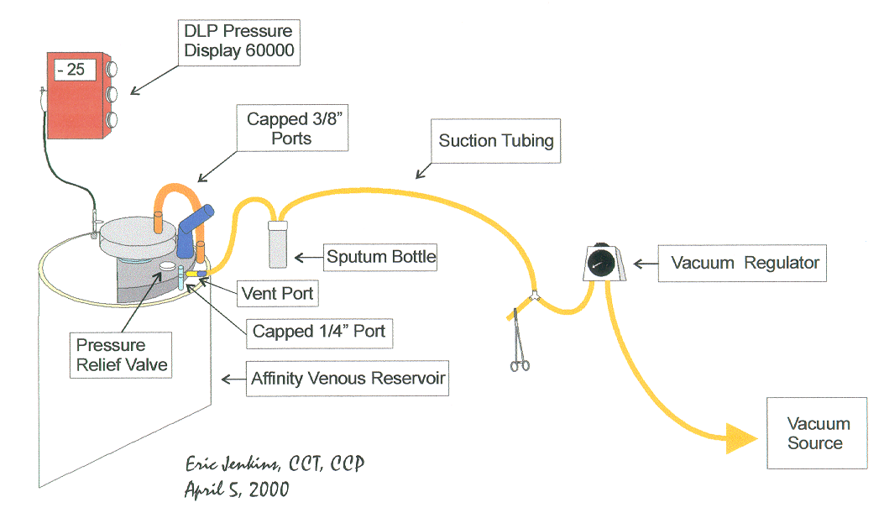

Vacuum Assisted Venous Drainage Initiation
- With the vacuum assist off, initiate CPB in the usual manner.
- Increase the blood flow rate until an equilibrium between blood flow rate and the venous reservoir level is obtained.
- Turn on the vacuum regulator at the pre-set vacuum of – 20 mmHg. Assess the level of the venous reservoir for increased return, and increase the blood flow rate accordingly until adequate perfusion in terms of blood flow rate, venous hemoglobin saturation, and mean arterial pressure are obtained. It may be necessary to increase the vacuum in order to obtain the appropriate blood flow rate; however, do not allow the negative pressure in the venous reservoir to exceed a vacuum greater than – 70 mmHg. It is recommended to use the minimum vacuum assist necessary for adequate perfusion.

Vacuum Assisted Venous Drainage Management
- Negative pressure in the venous reservoir should be monitored continuously and adjusted appropriately for efficient venous return augmentation.
- Do not allow the negative pressure in the venous reservoir to exceed a vacuum greater than – 70 mmHg.
- Whenever the blood flow rate is lowered intermittently, reduce or turn off the vacuum.
- Whenever blood volume is transferred to the patient for vent insertion, for vent removal, or to aspirate air from the aorta, turn off the vacuum.

Vacuum Assisted Venous Drainage Termination
- When blood volume is transferred to the patient to initiate weaning from CPB, terminate vacuum assisted venous drainage.

Guidelines for Surgeon’s Preference

Aprotinin (Trasylol) Usage
- Please consult the surgeon whenever possible regarding aprotinin administration prior to median sternotomy.

Bolling, Deeb, Pagani, and Prager
- Extracorporeal Circuit Loading Dose: 2.0 x 10⁶ KIU or 200 ml @ 10,000 KIU/ml
Bolling and Pagani
- Possible indications:
- patients with coagulopathies
- patients receiving aspirin
- patients on heparin
- aortic root repair
- Ross procedure
- aortic aneurysm
- re-operations
- HeartMate implant
- orthotopic heart transplant
- Will not use aprotinin on patients undergoing a concurrent carotid endarterectomy unless specifically requested by the surgeon.

Deeb
- Possible indications:
- Ross procedures
- Bental without a composite graft procedure.
- For any redo case that does not involve the coronaries, ask Dr. Deeb if he wants to administer aprotinin.
- Consult Dr. Deeb regarding aprotinin administration before any case involving patent coronary stents, CABG’s or concurrent carotid endarterectomy. Generally, no aprotinin is given on these cases.

Patel
- Possible indications:
- aortic root repair
- Ross procedure
- aortic aneurysm
- re-operations
- HeartMate Implant
- orthotopic heart transplant
- endocarditis
- patients in renal failure (confirm administration with Dr. Patel)
- Confirm aprotinin administration with Dr. Patel on any CABG with a concurrent cardiac procedure.

Prager
- Possible indications:
- Re-operations.
- Patients in renal failure (confirm administration with Dr. Prager)

Epsilon-Amino-Caproic Acid (Amicar) Usage
- For all surgeons, any patient not receiving aprotinin should have 10 g epsilon-amino-caproic acid in the pump prime.
- Patients undergoing a concurrent carotid endarterectomy or having pre-existing patent coronary stents are not to receive epsilon-amino-caproic acid unless specifically requested by the surgeon.
- Patients undergoing DHCA are not to receive epsilon-amino-caproic acid unless specifically requested by the surgeon.

Heparin Resistance
Bolling
- If the patient is or has been on heparin and demonstrates heparin resistance, consult Dr. Bolling on whether or not to order a single donor unit of plasma to raise AT3 levels.
Deeb, Pagani, and Patel
- If the patient is or has been on heparin and demonstrates heparin resistance, consult the surgeon on whether or not to order a single donor unit of plasma to raise AT3 levels.
- If the baseline ACT is elevated, let him know. If it is unusually elevated high or low, he may have the circulator order a single donor unit of plasma.

Prager
- If the ACT is < 480s following heparinization, then inform Dr. Prager. The anesthesiologist will administer an additional bolus of heparin. Check another ACT. If the ACT is still< 480s, consult Dr. Prager.
- Dr. Prager will not routinely order plasma for patients on a heparin drip.

Cannulation

Ascending Aorta
Bolling
- 7 - 8 mm Sarns Soft Flow
- For right thoracotomy approach, cannulate with 7 - 8 mm Sarns Soft Flow.

Deeb
- 7 - 8 mm Sarns Soft Flow
Pagani
- 7 - 8 mm Sarns Soft Flow
- For right thoracotomy approach, cannulate with 7 - 8 mm Sarns Soft Flow

Patel
- 7 - 8 mm Sarns Soft Flow
- For right thoracotomy approach, cannulate with 7 - 8 mm Sarns Soft Flow.

Prager
- 7 - 8 mm Sarns Soft Flow

Descending Thoracic Aorta
Bolling
- For full CPB, consult surgeon.
- For LHB, consult surgeon.
Deeb
- For full CPB, 7 – 8 mm Sarns Soft Flow
- For LHB, 16 Fr DLP Wire Wound. Have both Carmeda and non-Carmeda available.
Pagani
- For full CPB, consult surgeon.
- For LHB, consult surgeon.

Patel
- For full CPB, 7 – 8 mm Sarns Soft Flow
- For LHB, 16 Fr DLP Wire Wound. Have both Carmeda and non-Carmeda available.

Prager
- For full CPB, consult surgeon.
- For LHB, consult surgeon.

Femoral Artery
Bolling, Deeb, Pagani, Patel, and Prager
- For LHB, cannulate with surgeon’s choice femoral arterial cannula.
- Have Carmeda coated femoral arterial cannulae available.
Bolling
- For standard CPB, cannulates with non-disposable metal femoral arterial cannula. The nurses keep a set of these. Be sure to verify that the cannula is large enough to allow adequate blood flow.
Deeb, Pagani, Patel, and Prager
- 18 - 24 Fr RMI

Right Atrium
Bolling, Deeb, Pagani, Patel, and Prager
- For < 50 kg, cannulate with DLP Fr.32 X 40 Fr. Two-Stage Wire-Reinforced Venous Return Catheter (elliptical shaped).
- For > 50 kg, cannulate with DLP 36 Fr. X 46 Fr. Wire-Reinforced Veno-atrial Catheter (elliptical shaped).

Left Atrium
Bolling, Deeb, Pagani, Patel, and Prager
- For LHB, cannulate with Medtronic Left Atrial Cannula or Medtronic angled metal tip (Pacifico) venous cannula.
- Have Carmeda coated Medtronic Left Atrial Cannula or Carmeda coated Medtronic angled metal tip (Pacifico) venous cannula available.
- For left atrial venting, cannulate with 24 Fr DLP angled metal tip (Pacifico) venous cannula.

Bicaval
Bolling, Deeb, Pagani, Patel, and Prager
- For mediastinal approach, cannulate the SVC with 24 Fr. DLP angled metal tip (Pacifico) venous cannula and the IVC with 28 Fr. DLP angled metal tip (Pacifico) venous cannula.
Bolling and Patel
- For right thoracotomy approach, Dr. Bolling cannulates the SVC with 24 Fr. DLP angled metal tip (Pacifico) venous cannula and the IVC with a 32 Fr. William Harvey Type 1967SR lighthouse tipped wire-reinforced venous cannula.

Femoral Vein
Bolling, Deeb, Pagani, Patel, and Prager
- Cannulate with a 28 Fr. DLP 96428 Femoral Venous Cannula.
- Have a selection of RMI Fem-Flex II Femoral Venous Cannulae available.

Mean Arterial Pressure (MAP) Management
Routine
- Bolling: 50 - 60 mmHg
- Deeb: ~60 mmHg
- Pagani: 70 – 80 mmHg
- Patel: ~60 mmHg
- Prager: 50 – 60 mmHg
Carotid Disease or Recent Carotid Endarterectomy
- Bolling: ~75 mmHg
- Deeb: 85 - 90 mmHg
- Pagani: 80 - 100 mmHg
- Patel: 85 – 90 mmHg
- Prager: 60 – 70 mmHg
- Do not allow the pressure to drop below 60 mmHg.

Venting
Bolling
- On straight forward CABG’s, Dr. Bolling does not vent the left ventricle.
- On CABG’s with poor ventricular function, Dr. Bolling vents the pulmonary artery with a Ferguson Vent.
- On valves and other open procedures, Dr. Bolling vents the left ventricle with a 20 Fr. DLP 12002 Adult Vent Catheter inserted through the right superior pulmonary vein (RSPV).
Deeb, Patel, and Pagani
- Unless otherwise requested, Drs. Deeb and Pagani vent the left ventricle with a 20 Fr. DLP 12002 Adult Vent Catheter inserted through the right superior pulmonary vein (RSPV).
Prager:
- On CABG’s, Dr. Prager vents through the “Y” connector in the cardioplegia line.
- The vent must be turned off during cardioplegia delivery.
- On valves and other open procedures, Dr. Prager vents the left ventricle with a 20 Fr. DLP 12002 Adult Vent Catheter inserted through the right superior pulmonary vein (RSPV).

Cooling
Bolling
- On all procedures, begin cooling at the initiation of CPB.
- On heart transplant, CABG and valve repair/replacement procedures via a median sternotomy cool the patient to a bladder temperature of 32 - 34ºC by maintaining a perfusate temperature of 32 -34ºC.
- Dr. Bolling may designate another target temperature for cases of short duration or for cases with pathology affected by temperature.
- On cases requiring circulatory arrest, cool the patient to a bladder temperature of 18ºC maintaining 8 - 12ºC temperature gradient between the perfusate and bladder temperatures.
- Do not allow the bladder temperature to fall below the designated target temperature, or rewarming will be unnecessarily prolonged.
Deeb
- On all procedures, do not initiate cooling until the LV vent is in place and functioning.
- On heart transplant, CABG and valve repair/replacement procedures via a median sternotomy cool the patient to a bladder temperature of 30ºC by maintaining a perfusate temperature of 30ºC.
- The surgeon may designate another target temperature for cases of short duration or for cases with pathology affected by temperature.
- On aortic root replacements, cool the patient to a bladder temperature of 25ºC by maintaining a perfusate temperature of 25ºC.
- On ascending aortic aneurysm repairs not requiring circulatory arrest, cool the patient to a bladder temperature of 28ºC by maintaining a perfusate temperature of 28ºC.
- On cases requiring circulatory arrest, cool the patient to a bladder temperature of 18ºC or less maintaining an 8 - 12ºC temperature gradient between the perfusate and bladder temperatures.
- Do not allow the bladder temperature to fall below the designated target temperature, or rewarming will be unnecessarily prolonged.
Pagani
- On all procedures, do not initiate cooling until the LV vent is in place and functioning.
- On heart transplant, CABG, and valve repair/replacement procedures via a median sternotomy, cool the patient to a bladder temperature of 32 - 34ºC by maintaining a perfusate temperature of 32 - 34ºC.
- Dr. Pagani may designate another target temperature for cases of short duration or for cases with pathology affected by temperature.
- On cases requiring circulatory arrest, cool the patient to a bladder temperature of 18ºC maintaining an 8 - 12ºC temperature gradient between the perfusate and bladder temperatures.
- Do not allow the bladder temperature to fall below the designated target temperature, or rewarming will be unnecessarily prolonged.

Patel
- On all procedures, begin cooling at the initiation of CPB by allowing the perfusate temperature to drift. In practice, this technique results in cooling to a bladder temperature range of 32 - 34 ºC.
- Dr. Patel may designate another target temperature for cases of short duration or for cases with pathology affected by temperature.
- On open procedures (valves etc), do not initiate active cooling until the left ventricular vent is in place and functioning.
- On cases requiring circulatory arrest, cool the patient to a bladder temperature of 18ºC maintaining an 8 - 12ºC temperature gradient between the perfusate and bladder temperatures.
- Do not allow the bladder temperature to fall below the designated target temperature, or rewarming will be unnecessarily prolonged.
- The surgeon may designate another target temperature for cases of short duration or for cases with pathology affected by temperature.

Prager
- On all procedures, begin cooling at the initiation of CPB by allowing the perfusate temperature to drift. In practice, this technique results in cooling to a bladder temperature range of 32 - 34 ºC.
- Consult Dr. Prager on a case by case basis in regard to target temperature.
- On open procedures (valves etc), do not initiate active cooling until the left ventricular vent is in place and functioning.
- Dr. Prager may designate another target temperature for cases of short duration or for cases with pathology affected by temperature.
- On cases requiring circulatory arrest, cool the patient to a bladder temperature of 18ºC maintaining an 8 - 12ºC temperature gradient between the perfusate and bladder temperatures.
- Do not allow the bladder temperature to fall below the designated target temperature, or rewarming will be unnecessarily prolonged.

Rewarming

Bolling, Pagani, Patel, and Prager
- Rewarm maintaining an 8-12ºC gradient between the venous blood and the water bath temperatures.
- Do not exceed a perfusate temperature of 38.9 ºC.
- Do not exceed a water bath temperature of 42.0ºC.
- Hemoconcentrate and/or make the necessary PRBC additions for the surgeon’s target Hct.

Deeb
- Rewarm maintaining an 8-12ºC gradient between the venous blood and the water bath temperatures.
- Do not exceed a perfusate temperature of 38.9ºC.
- Do not exceed a water bath temperature of 42.0ºC.
- Hemoconcentrate and/or make the necessary PRBC additions for the surgeon’s target Hct.

Topical Rewarming

Bolling, Deeb, and Prager
- When rewarming is initiated, set the water blanket to ~38 ºC.
Pagani and Patel
- When rewarming is initiated, set the water blanket to ~38 ºC.
- If CPB is conducted at normothermia (HeartMate implantation for example), do not use a water blanket.

Post-crossclamp Pharmacology

Bolling, Deeb, Pagani, Patel, and Prager
- Heart Transplants: Administer 12.5 g mannitol, and 10 mg furosemide (Lasix) before the removal of the crossclamp. Do not administer MgSO₄ or lidocaine (Xylocaine).

Bolling
- Administer 200 mg lidocaine (Xylocaine), 12.5 g mannitol, 3 g MgSO₄, and 10 mg furosemide (Lasix) before the removal of the crossclamp. (Dr. Bolling will tell you when to administer these drugs.) If a patient demonstrates persistent ventricular fibrillation, the administration of an additional 50 -100 mg lidocaine (Xylocaine) is usually requested.

Deeb
- Administer 200 mg lidocaine (Xylocaine), 12.5 g mannitol, 3 g MgSO₄, and 10 mg furosemide (Lasix) before the removal of the crossclamp. Administer these drugs during the delivery of warm reperfusion cardioplegia (Hot Shot).

Pagani
- Administer 3 g MgSO₄, 12.5 g mannitol and 10 mg furosemide (Lasix) during the delivery of warm reperfusion cardioplegia (Hot Shot).

Patel
- Administer 200 mg lidocaine (Xylocaine), 12.5 g mannitol, 3 g MgSO₄, and 10 mg furosemide (Lasix) before the removal of the crossclamp. Administer these drugs during the delivery of warm reperfusion cardioplegia (Hot Shot).

Prager
Dr. Pager does not administer a post-crossclamp drug regimen.

Ultrafiltration Management and Technique

Continuous Zero Balanced Ultrafiltration (Z-BUF)

Indications
- All Deeb and Patel patients undergoing deep hypothermic circulatory arrest (DHCA) cases.
- All Deeb and Patel patients with endocarditis and requiring cardiopulmonary bypass.
- Consult Dr. Deeb or Dr. Patel on a case by case basis whether or not the continuous Z-BUF technique should be applied, particularly on patients expected to have a profound inflammatory response to CPB.

Technique
- Immediately after CPB is established, initiate Z-BUF and continue until the end of the case except during DHCA period.
- Produce a minimum of 9 liters of effluent using the appropriate replacement fluid as suggested below.

0.9% NaCl Solution
- Use 0.9% NaCl solution as a perfusate volume replacement when the serum potassium and/or glucose are elevated.
- Be sure to correct the serum calcium prior to CPB termination.
- Buffer each liter of 0.9% NaCl with 24 mEq NaHCO₃ unless the patient has metabolic alkalosis.

Normosol R Solution
- Use Normosol R solution as a perfusate volume replacement when the serum potassium and/or glucose are not elevated.
- Be sure to correct the serum calcium prior to CPB termination.
- Buffer each liter of Normosol R solution with 24 mEq NaHCO₃ unless the patient has metabolic alkalosis. If using Normosol R pH 7.4, it is not necessary to add 24 mEq NaHCO₃.

Autotransfusion Protocol

Purpose
- To provide a blood salvaging and washing process via an autotransfusion machine for autologous blood transfusion.

Policy
- Autotransfusion machines are utilized on selected adult cardiac cases in both the pediatric and adult practice.
- Non-cardiac cell saving and rapid transfusion duties in non-cardiac related cases are handled by anesthesia techs.
- Overall the perfusion team will maintain responsibility for the safety and function of the autotransfusion machines.

Procedures/Precautions
- Follow the Guidelines for use recommended by the company. See the “Autotransfusion Standard Operating Procedure” manual located in the Main Pump Room for details.
- Use only 0.9% NaCl as the wash solution, and suction flush solution.
- Washed red blood cells must be administered within 4 hours of processing when stored at room temperature and within 24 hours of the start of collection when stored at 6ºC.
- Under no circumstances is processed blood to be reinfused directly into the patient from the holding bag. Use a transfer bag with the date, time, initials, and expiration time noted on an “For Autologous Use Only/Washed Red Blood Cells” sticker that has been stamped with the patient’s registration card.
- Never use a cell saver while using Avetin or other collagen based, hemostasis inducing materials.
- Do not use in the presence of methyl methacrylate. (You will see and smell this utilized mostly in orthopedic cases)
- CPD may be used as an alternative to heparin anticoagulation for the return reservoir. NOTE: Monitor Ca⁺⁺ levels closely because CPD chelates Ca⁺⁺.
- Autotransfusion is contraindicated for use in patients with the following conditions:
- Blood contaminated with gastrointestinal contents or bacterial infections.
- Presence of malignant cells.
- Presence of amniotic fluid, C-section.
- Presence of prostatic fluid.

Equipment
- The Haemonetics Cell Saver 5 autotransfusion machine is used at Main and Mott.
- 3 - 1000 cc bag 0.9% NaCl
- Transfer pack
- 30,000 units of heparin

Documentation
- Every case using a cell saver must have the section of the Cardiopulmonary Bypass Record entitled “Autotransfusion” appropriately filled out. (See Appendices).

Anticoagulation Management

Heparin (pork mucosal or beef lung) Management
- Heparin is used to achieve adequate anticoagulation for safe CPB.
- Heparin loading dose: 300 units/kg
- Heparin maintenance: 10,000 units in prime with maintenance doses of 1,000-10,000 units depending on the ACT. Use 1,000 units/ml vials.

Activated Clotting Time (ACT)
- The (ACT) is used to measure adequate anticoagulation for safe CPB.
- A kaolin activated ACT > or = 480 seconds is considered adequate for the initiation and maintenance of safe CPB.

Heparin Resistance Management
- If the heparin loading dose results in an ACT < 480 seconds, then the anesthesiologist and the surgeon should be consulted, and an additional bolus of heparin should be administered.
- If the resulting ACT is still < 480 seconds, then the surgeon and anesthesiologist should again be consulted on the possible diagnosis of AT3 deficiency. If this diagnosis is reached, then 1-2 single donor unit of plasma should be ordered, and either administered before CPB by the anesthesiologist or added to the pump prime by the perfusionist.
- If the surgeon wishes to initiate CPB prior to the administration of plasma, it is the perfusionist's responsibility to discuss the adequacy of anticoagulation with him and then comply if ordered to proceed

Pre-CPB Autologous Whole Blood Collection

Indication

Deeb
- On all cases, Dr. Deeb requires 1 -2 units of autologous whole collected.

Bolling, Pagani, Patel, & Prager
- Consult with staff surgeon and staff anesthesiologist prior to pre-CPB whole blood collection.

Procedure
- 1 -2 units of the patient’s own whole blood are to be collected prior to heparinization. The perfusionist should spin a patient Hct following pre-CPB autologous whole blood collection and then calculate an estimated patient-machine Hct. If the resultant Hct is less than 25%, consult the attending surgeon regarding adding PRBC’s to the pump prime or at the initiation of CPB.

Estimated CPB Hct Calculation

Estimated CPB Hct = (65 x kg x (pt Hct / 100) x 100
(65 x kg) + ml prime)

where: Estimated CPB Hct = estimated Hematocrit on cardiopulmonary bypass
ml prime = prime volume of extracorporeal circuit
kg = patient’s kilogram weight
pt Hct = patient’s hematocrit measured following autologous
whole blood collection by anesthesia

Collection Technique

Disposables
- (1 -2) 600 cc transfer packs
- (1)500 cc CPD bottle
- (1-2) 60 cc syringes
- (1-2) 3-way stopcocks

Procedure
- Attach a 3-way stopcock to a transfer pack.
- Draw 63 cc CPD into a 60 cc syringe and inject it into the transfer pack. Hand the CPD transfer pack(s) to the anesthesiologist.
- Blood collection should be timed to be completed just prior to heparinization. The collection time for each unit is ~15 minutes.
- Anesthesia personnel must monitor the patient blood pressures and EKG during blood collection and transfuse the patient with crystalloid and colloid solutions appropriately. Blood collection should be terminated if the patient becomes unstable.

Storage and Expiration
- When stored at 37ºC, autologous whole blood expires 8 hours from the start of collection.
- When the collected autologous whole blood approaches expiration before the termination of CPB, it may be stored at 1 - 6 ºC or transfused into the extracorporeal circuit. If the collected autologous whole blood is stored at 1 - 6 ºC within 8 hours of the start of collection, it will expire 24 hours from the start if collection.
(American Association of Blood Banks Standards for Perioperative Autologous Blood Collection and Administration, 1st Edition)

Transfusion Technique
- Collected autologous whole blood is transfused after protamine administration is completed.
- Do not transfuse collected autologous whole blood with the Belmont HMS2000 Rapid Infusion System.

Section 3: Cardioplegia Protocols
Eric Jenkins, CCT, CCP and Chris Yann, R N, CCP

General Cardioplegia Protocols

High K⁺ Arresting Dose: Cold Induction
Description and Set-Up
- Cold induction is the routine cardioplegic technique. The Blanketrol connected to the cardioplegia heat exchanger is set on 4ºC.

Composition
- The constituents listed in the table below produce ~1 liter of cold induction cardioplegia solution.
- The constituents listed below are mixed in the cardioplegia reservoir bag and then cooled by recirculation.

Constituents | Amount
Prime Solution | 150 ml
KCl | 24 mEq
THAM (0.3 mEq/ml) | 50 ml
CPD | 12 ml
Dextrose | 5 g
Perfusate | ~700 ml
Lidocaine | 100 mg (Dr. Pagani only)

Antegrade Delivery Technique
- Antegrade cardioplegia is given via the aortic root to the coronary ostia at approximately 250-350 ml/min at a line pressure of 200-250 mmHg. Typically, antegrade cardioplegia is given at the high end of the flow range to arrest the heart quickly. Upon arrest, the flow rate is usually lowered to enhance cooling. Higher initial root pressures should be generated to facilitate closure of the aortic valve. Upon closure of the aortic valve, flow will be solely down the coronary ostia. It is essential during this period to monitor LV vent return, provided of course a LV vent is in place, because increased return can indicate aortic incompetence. This scenario may necessitate the making and delivery of another induction dose in order to ensure that the myocardium is adequately protected. The perfusionist should consult the surgeon to ascertain the adequacy of the aortic root pressure and confirm aortic valve competence. The total volume of cardioplegia given is dependent on the anatomy, the flow rate, and the myocardial temperature. Please note that sometimes a myocardial temperature probe is not used. Inform the surgeon as to the volume infused and the myocardial temperature at regular intervals. Refer to specific preferences in the Surgeon Preference section.

Retrograde Delivery Technique
- Retrograde cardioplegia is given directly into the coronary sinus via a retrograde catheter. Retrograde cardioplegia is delivered at approximately 200 ml/min and coronary sinus pressures ranging from 28 - 50 mmHg. The CVP tracing is used to track the coronary sinus pressure. Note: Each surgeon may have different ideas as to what he wants the coronary sinus pressure to be. Refer to Surgeon Preference section on the following pages. High coronary sinus pressure can indicate that the catheter is too far advanced, potentially endangering coronary sinus integrity. Low coronary sinus pressures can indicate a dislodged catheter resulting in poor coronary sinus perfusion. Both scenarios require the perfusionist to alert the surgeon, so that he can reposition the catheter.

High K⁺ Arresting Dose: Warm Induction
Description
- Warm induction is used to arrest hearts with severely compromised myocardium. Theoretically, warm induction allows the myocardium to increase cellular stores of energy substrate in preparation for extended crossclamp times.

Equipment and Disposable Set-Up
- Warm induction technique may use either 1 or 2 reservoir bags at the discretion of the case perfusionist.
- Warm induction technique also requires 2 Blanketrols, one set at 39ºC and the other at 4ºC. The cardioplegia heat exchanger is initially connected to the 39ºC Blanketrol.

Composition
- The constituents listed in the table below produce ~1 liter of warm induction cardioplegia solution.
- The constituents listed below are mixed in the cardioplegia reservoir bag and then warmed to 37ºC by recirculation.

Constituents | Amount
Prime Solution | 150 ml
KCl | 24 mEq
THAM (0.3 mEq/ml) | 50 ml
CPD | 12 ml
Dextrose | 5 g
0.46 M Aspartate/Glutamate | 50 ml
Perfusate | ~700 ml
Lidocaine | 100 mg (Dr. Pagani only)

1 Bag Technique
- The asanguineous constituents for cold induction cardioplegia (see above) with the exception of only 12 mEq K⁺ are kept handy in (2) 60 cc syringes for immediate injection into the system following the delivery of warm induction cardioplegia.

2 Bag Technique
- The cold induction cardioplegia bag is filled with the constituents (see above) for cold induction, but with only 12 mEq K⁺.
- The cold induction bag should be clamped out to avoid any mixing with the warm induction bag.
- Once on CPB, the cardioplegia pump is stopped, and the warm induction bag is clamped out of the circuit. The cold induction bag is then opened, filled with blood, and then clamped out of the circuit. The warm induction bag is then opened, filled with blood, and recirculated.

Delivery Technique
- Warm induction is delivered antegrade at rate of 250-350 ml/min and line pressure of 200-250 mmHg until the heart arrests. Usually 500 ml is delivered.
- Warm induction is then delivered retrograde at a rate of 200 ml/min for a coronary sinus pressure of 28 - 40 mmHg until 1 liter is given.
- The water lines are then transferred to the cold heater/cooler.

1 Bag Technique
- Following the delivery of warm induction cardioplegia, the (2) 60 cc syringes containing the constituents for cold induction are quickly injected in to the cardioplegia circuit.
- The cardioplegia reservoir bag is simultaneously filled with perfusate until the bag contains 1 liter of solution.
- Cold cardioplegia is then delivered antegrade and/or retrograde for a total of 1 liter, followed by cold blood until the myocardium is cooled to the surgeon’s satisfaction.

2 Bag Technique
- Following the delivery of warm induction cardioplegia, the warm induction bag is clamped out of the circuit.
- Cold cardioplegia is then delivered antegrade and/or retrograde for a total of 1 liter, followed by cold blood until the myocardium is cooled to the surgeon’s satisfaction.

Maintenance and Subsequent Doses: (Cold Maintenance)
Description
- The purpose of maintenance cardioplegia is to ensure myocardial preservation during extended aortic crossclamp periods. Maintenance cardioplegia achieves this by keeping the myocardial temperature <15ºC; washing out metabolites; and delivering oxygen, energy substrate, and buffer. Accordingly, the perfusionist should alert the surgeon should the myocardial temperature exceed 15ºC. The surgeon should also be informed when 20 minutes have passed since the last dose of cardioplegia was delivered. If cardioplegia is not immediately delivered, the surgeon will usually inform the perfusionist when to remind him thereafter.

Drs. Bolling and Deeb

Composition
- For Drs. Bolling and Deeb, cold maintenance cardioplegia solution is made up in batches where sufficient KCl is added to a measured amount of perfusate transferred from the extracorporeal circuit to produce a [K⁺] of 12 mEq/l perfusate.
- The amount of KCl is calculated by subtracting the current serum K⁺ concentration from12.

Dose
- At the time of delivery, the perfusionist should ask the surgeon how much cold maintenance cardioplegia they want delivered.

Dr. Prager
Composition
- For Dr. Prager, cold maintenance cardioplegia solution is made up of cold perfusate. No KCl is added.

Dose
- At the time of delivery, the perfusionist should ask the surgeon how much cold maintenance cardioplegia he wants delivered.
Dr. Pagani

Composition
- For Dr. Pagani, cold maintenance cardioplegia solution is typically composed in 1 liter batches according to the table below.
- The maintenance cardioplegia solution is mixed in the cardioplegia reservoir bag and cooled by recirculation.

Constituents | Amount
KCl | Sufficient KCl is added to produce a liter of maintenance cardioplegia with a K⁺ concentration of 12 mEq/L. The amount of KCl is calculated by subtracting the current serum K⁺ concentration from12.
CPD | 12 ml
Dextrose | Add 5 g dextrose if the current serum glucose is < 300 g/dl.
Perfusate | ~800 ml
Lidocaine | Add 100 mg lidocaine to the first liter of maintenance cardioplegia solution provided 200 mg lidocaine has not already been administered. Example: Generally, during cases utilizing warm induction cardioplegia, 200 mg lidocaine are delivered following a liter of warm and a liter of cold.

Dose and Delivery Technique
- Cold maintenance cardioplegia is delivered antegrade and/or retrograde. Doses vary from 200 to 500 ml.

Vein Graft
Description
- After completion of each distal vein graft anastomosis, Surgeons will flow down the graft with cardioplegia to ascertain the vein graft flow rate.

Technique
- Vein graft flows should be slow at first to maintain integrity of the vessel anastomosis and facilitate air removal. The flow can then be increased up to a line pressure of 225 mmHg. At this pressure announce the graft flow to the surgeon. Normal vein flows can be expected to be in the range of 100-200 ml/min.
- The amount of maintenance cardioplegia delivered down the vein graft is at the surgeon’s discretion.

Warm Reperfusion (Hot Shot)

Description
- Warm reperfusion is given just prior to the removal of the aortic cross clamp. This option is available to all surgeons and facilitates the recovery of a compromised myocardium by providing Kreb's Cycle substrates (aspartate & glutamate), glycolysis substrate (dextrose), intracellular buffer (THAM), and a calcium chelating agent (CPD).

Composition
- The constituents listed in the table produce ~ 600 ml of warm reperfusion cardioplegia solution.
- The warm reperfusion cardioplegia solution is mixed in the cardioplegia reservoir bag and warmed to 37ºC by recirculation

Constituents | Amount
KCl | Sufficient KCl is added to produce a 600ml of maintenance cardioplegia with a K⁺ concentration of 12 mEq/L. The amount of KCl is calculated by subtracting the current serum K⁺ concentration from12 and multiplying by 0.6.
THAM (0.3 mEq/ml) | 45 ml
CPD | 12 ml
Dextrose | Add 5 g dextrose if the current serum glucose is < 300 g/dl.
0.46 M Aspartate/Glutamate | 40 ml
Perfusate | ~500 ml

Dose
- The usual warm perfusion dose is 600 ml. The warm CP temperature is achieved by switching the cardioplegia heat exchanger hoses from the cold Blanketrol to the warm Blanketrol.

Technique
- Generally, the "Hot Shot" is delivered retrograde at 150 - 200 ml/min at a temperature of 32 - 37ºC.
- Dr. Pagani wants the “Hot Shot” to be followed by a minute of warm perfusate.

Surgeon Specific Cardioplegia Technique Guidelines

General
Bolling, Deeb, Pagani, Patel, and Prager
- All tend to crossclamp quickly. It is a good idea to make up cardioplegia solution immediately after going on CPB.

Delivery Method
Bolling, Deeb, Pagani, Patel, and Prager
- Use antegrade and/or retrograde delivery technique.
Patel
- On most CABG’s, Dr. Patel vents the left ventricle with a RSVP vent. He also vents the aorta through a “Y” in the cardioplegia line. Therefore, the vent must be turned off prior to antegrade cardioplegia delivery.
Prager
- On most CABG’s, Dr. Prager vents the aorta through a “Y” in the cardioplegia line. Therefore, the vent must be turned off prior to antegrade cardioplegia delivery.
Deeb and Patel
- On patients undergoing a left thoracotomy to repair a Type B aneurysm or dissection involving the transverse aortic arch, the heart may be arrested by the injection of 40 -120 mEq KCl in 20 mEq increments into the arterial line proximal to arterial line filter. This technique is used because the aortic root and coronary ostia are inaccessible from this exposure (see DHCA with Retrograde and/or Antegrade Cerebral Perfusion, Left Atrial Venting, and Active Venous Drainage in Section 9).

Coronary Sinus Pressure Management
Bolling, Patel, Prager, and Deeb
- Keep coronary sinus pressures at 28 -35 mmHg during retrograde cardioplegia delivery.
Pagani
- Keep coronary sinus pressures < 40 mmHg during retrograde cardioplegia delivery.
Warm Induction
Bolling, Patel, and Prager
- Rarely use warm induction cardioplegia.
Deeb and Pagani
- Frequently use warm induction on acute coronary dissections from the cath lab or any patient with acute myocardial ischemia.

Warm Reperfusion
Bolling
- Frequently uses warm reperfusion on hearts dilated from mitral valve disease.
Deeb
- Frequently uses warm reperfusion on hearts following long ischemic periods such as aortic arch and aortic root repairs.
Pagani
- Uses warm reperfusion on almost all cases.

Prager and Patel
- Does not usually give warm reperfusion.

Vein Graft Cardioplegia
Bolling, Deeb, and Pagani
- Vein graft cardioplegia should be given very slowly at first (< 50 ml/min). When the surgeon asks to “find the flow,” increase the flow until the cardioplegia line pressure reaches 225 mmHg. Essentially, the surgeon is de-airing the graft, tying down the sutures, and then assessing the graft flow.
Prager and Patel
- Does not give vein graft cardioplegia.

Section 4: Drug & Blood Product Administration Protocols
Chris Yann, RN, CCP and Eric Jenkins, CCT, CCP

Drugs that can be given PRN

phenylephrine (Neo-Synephrine)
- Powerful alpha-1 agonist. Little effect on beta-one receptors of the heart. Increases SVR. Effect dissipates after 20 minutes. Prepared in a drip infusion or syringe for bolus.
- Drip: 10 - 40 mg/100 - 250 ml 0.9% NaCl
- Bolus: 10 mg/49 ml Normosol R (= 200 mcg/cc)
Pagani
- Consult Dr. Pagani regarding administration of arginine vasopressin if after a total dose of 15 mg phenylephrine, the MAP is < 60 mmHg at a blood flow rate of 2.4 l/min/m².

Source
- Arginine vasopressin in 20 units/1ml vials is available at the OR pharmacy.

Preparation
- Mix 40 units arginine vasopressin (2 vials) with 38 ml 0.9% NaCl in a 60 cc syringe This results in a concentration of 1 unit arginine vasopressin per ml of solution.

Administration
- Arginine vasopressin is administered only with a syringe pump. (See Theron Paugh for instruction if you are unfamiliar with this device.)
- Initiate arginine vasopressin at a rate of 5 units/hr, then titrate for effect.
- Do not infuse arginine vasopressin at a rate > 5 units/hr.

Isofluorane (Forane)
- Utilized only on CPB for adjunctive anesthesia and accompanying vasodilation. Reduces MAP, decreases SVR, and decreases oxygen consumption. Administered via an anesthetic vaporizer.
- Vaporizer: 0 - 5.0 %
- It is not recommended to exceed 2.0% for extended periods of time.

Buffers
- Buffers are used to correct patients’ acid-base deficits and give a resulting shift in the carbonic acid cycle to the left.
- NaHCO₃ is the only non-cardioplegia buffer utilized on CPB.
- NaHCO₃ : 0-50 mEq PRN

Drugs that cannot be given PRN

Diuretics
- Diuretics are routinely used on CPB to promote urine production and reduce interstitial edema.

Mannitol, an osmotic diuretic, is used in the prime and given upon the removal of the aortic crossclamp to aid in the scavenging of oxygen radicals during reperfusion.
- Do not administer in the presence of severe renal impairment unless authorized by the attending surgeon.
- Apart from administration prescribed by surgeon's protocol (Sections 4, 6, 9, 11, and 12) mannitol should only be administered following consultation with the surgeon and staff anesthesiologist.

Furosemide (Lasix), a loop diuretic, may be administered to patients demonstrating oliguria during CPB despite mannitol administration.
- Apart from administration prescribed by surgeon's protocol (see Section 6), furosemide should only be administered following consultation with the surgeon and staff anesthesiologist.

Antibiotic Preference

Bolling

ADP Patients Not Receiving Implants
- 1 g Cefazolin (Kefzol)
- Added to pump prime.

All Patients Receiving Implants
- 1 g Vancomycin
- Administered slowly on CPB.

Deeb

ADP Patients Not Receiving Implants and Not Undergoing DHCA
- 1 g Cefazolin (Kefzol)
- Added to pump prime.

All Patients Receiving Implants and Not Undergoing DHCA
- 1 g Vancomycin
- Administered slowly on CPB.

All Patients Undergoing DHCA
- 1 g Vancomycin
- Administered slowly on CPB.
- 1 g Ceftazidime (Ceptaz)
- Added to pump prime.

Pagani

ADP Patients Not Receiving Implants
- 1 g Cefazolin (Kefzol)
- Added to pump prime.

All Patients Receiving Implants
- 1 g Vancomycin
- Administered slowly on CPB over a 1 hour period.

Patel

ADP Patients Not Receiving Implants and Not Undergoing DHCA
- 1 g Cefazolin (Kefzol)
- Added to pump prime.

All Patients Receiving Implants and Not Undergoing DHCA
- 1 g Vancomycin
- Administered slowly on CPB.

All Patients Undergoing DHCA
- 1 g Vancomycin
- Administered slowly on CPB.
- 1 g Ceftazidime (Ceptaz)
- Added to pump prime.

Prager

All Patients without a Documented Anaphylactic Allergy to Penicillin or Cephalosporins
- 1 g Cefazolin (Kefzol)
- Added to pump prime.

All Patients with a Documented Anaphylactic Allergy to Penicillin or Cephalosporins
- Consult Dr. Prager prior to Vancomycin administration.
- If Vancomycin is designated, administer 1 g slowly on CPB.

All Transplants Patients
- 1 g Vancomycin
- Administered slowly over a 1 hour period on CPB.
- For all other surgeons, administered slowly on CPB.
- 1.5 g Cefuroxime
- Added to the prime.
- Available in the key code room of the OR pharmacy.

All HeartMate Recipients
- 1 g Vancomycin
- Administered slowly over a 1 hour period on CPB.
- 1.5 g Cefuroxime
- Added to the prime.
- Available in the key code room of the OR pharmacy.

Note: If the patient has a history of penicillin, vancomycin, cephalosporin, and/or cefuroxime allergy, consult the surgeon and/or staff anesthesiologist before antibiotic administration.

Methylprednisolone Usage during Procedures Requiring DHCA or Orthotopic Transplantation

DHCA
- 1 g methylprednisolone just prior to the initiation of DHCA.

Heart Transplantation
- 1g methylprednisolone IV by anesthesia personnel at the time of heparinization.
- It is the perfusionist’s responsibility to make sure that the patient is given methylprednisolone at the proper time.

Lung Transplantation (1 or 2)

Single
- 1 g methylprednisolone just prior to reperfusing the donor lung.
Double
- 500 mg methylprednisolone just prior to reperfusing the first donor lung, then another 500 mg methylprednisolone just prior to reperfusing the second donor lung.
- It is the perfusionist’s responsibility to make sure that the patient is given methylprednisolone at the proper time whether the patient goes on CPB or not. This entails that the perfusionist informs the anesthesiologist of the appropriate protocol if CPB is avoided.

Prophylactic Treatment of Possible Protamine Reactions

Selection Criteria
- All diabetics who have received insulin
- Patients with allergies to fish or shellfish
- Patients s/p vasectomy
- All HeartMate patients

Treatment Regime

Drug | Dose
diphenhydramine (Benadryl) | 50 mg
hydrocortisone (Solu-Cortef) | 100 mg
ranitidine (Zantac) | 50 mg

- If the patient has already received a dose of steroids during the course of the case, then do not administer hydrocortisone.

Treatment Rationale
- These drugs are given to avoid a possible protamine reaction and aid in a reduction of side effects. They are to be given approximately 10 minutes before the termination of CPB. Always discuss the usage of this regime with anesthesia and the surgeon.

Post Aortic Crossclamp Drug Regimen

Bolling
Drug Regimen
Drug | Dose
lidocaine | 200 mg
mannitol | 12.5 g
furosemide | 10 mg
MgSO₄ | 3 g

Delivery Time
- Dr. Bolling will tell you when to administer these drugs.

Deeb
Drug Regimen
Drug | Dose
lidocaine | 200 mg
mannitol | 12.5 g
furosemide | 10 mg
MgSO₄ | 3 g

Delivery Time
- Administer the regimen just as the crossclamp is being released because Dr. Deeb will not usually tell you when to administer these drugs.

Pagani
Drug Regimen
Drug | Dose
mannitol | 12.5 g
furosemide | 10 mg
MgSO₄ | 3 g
Delivery Time
- Administer the regimen during delivery of warm reperfusion cardioplegia.

Patel
Drug Regimen
Drug | Dose
lidocaine | 200 mg
mannitol | 12.5 g
furosemide | 10 mg
MgSO₄ | 3 g

Delivery Time
- Administer the regimen just as the crossclamp is being released because Dr. Patel will not usually tell you when to administer these drugs.

Prager
- Dr. Prager does not administer a post-aortic crossclamp drug regimen.

Heart Transplant Patients
Drug Regimen
Drug | Dose
mannitol | 12.5 g
furosemide | 10 mg

Delivery Time
- Administer the regimen according to the protocol of the attending staff surgeon.

Pharmacological Treatment for Hyperkalemia

Overview and Precautions
- An abnormally high serum potassium level during bypass (approximately > 5.9 mEq/l) can impair cardiac function. Accordingly, it may be necessary to lower the serum potassium level using the following regimen.
- Consult the attending staff anesthesiologist and staff surgeon before the administration of any part of the following regimen.

Treatment Regimen
- Assess patient urine output. If urine output is poor, consult the attending staff anesthesiologist and staff surgeon regarding the administration of 10 - 40 mg furosemide (Lasix).
- Assess patient pH. If the pH is not excessively alkalotic, administer 50 mEq NaHCO₃.
- Assess patient serum ionized Ca⁺⁺. If the serum ionized level less than 1.2 mmol/L, then administer 500 mg CaCl₂.
- Assess patient serum glucose.
- If the serum glucose is less than 280 mg/dl, then administer 12.5 - 25 ml 50% Dextrose and 10 units Regular Humulin Insulin.
- If the serum glucose is greater than 280 mg/dl, then administer 10 units Regular Humulin Insulin.

Vitamin K Administration
Bolling, Deeb, & Pagani
- HeartMate implantation, VAD placement, and heart transplantation
- Anesthesia should administer 1 mg vitamin K prior to the initiation of CPB.
- It is the perfusionist’s responsibility to make sure that this dose of vitamin k is administered.
- The perfusionist should add 1 mg vitamin K to the prime of the extracorporeal circuit.
- Consult the surgeon concerning vitamin K administration to any patient currently on Coumadin.

Prager
- Consult Dr. Prager prior to the administration vitamin K.

Arginine Vasopressin Administration
For Pagani only
- Consult Dr. Pagani regarding administration of arginine vasopressin if after a total dose of 15 mg phenylephrine, the MAP is < 60 mmHg at a blood flow rate of 2.4 l/min/m².

Source
- Arginine vasopressin in 20 units/1ml vials is available at the OR pharmacy.

Preparation
- Mix 40 units arginine vasopressin (2 vials) with 38 ml 0.9% NaCl in a 60 cc syringe. This results in a concentration of 1 unit arginine vasopressin per ml of solution.

Administration
- Arginine vasopressin is administered only with a syringe pump.
- Initiate arginine vasopressin at a rate of 5 units/hr, then titrate for effect.
- Do not infuse arginine vasopressin at a rate > 5 units/hr.

General Guidelines for the Administration of Blood Bank Products
- According to UMMC/blood bank policy, a patient’s registration card must be checked with the arm band on the patient to verify the correctness of the registration card. Therefore, PRBC units cannot be checked or added to the extracorporeal circuit prime until the patient has entered the operating room.
- All blood products are to be appropriately checked by the perfusionist and another qualified medical professional prior to administration.
- PRBC units are to be given in the following order of preference:
- Autologous
- Donor Directed Non-Blood Relative
- Donor Directed Blood Relative
- Homologous
- All directed donor units should be checked to ensure that they are irradiated.
- Do not add blood products to the extra-corporeal circuit until the pre-bypass filter has been removed.
- All whole blood, packed red blood cells, and autotransfusion blood products are to be administered into the circuit through a blood filter only.
- Consult the staff surgeon (page if necessary) before every procedure regarding a plan for pre-CPB autologous whole blood sequestration and/or blood product usage.
- Normally, hematocrits in the range of > 25% are acceptable for the termination of CPB.
- For patients with LVEF < 20%, you will need to achieve hematocrit > 30% prior to termination.
- Watch for significant elevations in K⁺ when giving banked blood.

Cardiopulmonary Bypass Transfusion Triggers

Exceptions
- VAD’s, cardiac transplants, DHCA, Jehovah’s witnesses

Pre CPB
- Any time you have a predicted hematocrit less than 23% consult surgeon regarding blood prime.

On CPB
- All patients < than 23% - transfuse Target – 25%
- *High risk patients 23-25% transfuse Target – 28-30%
- 25-30% notify surgeon Target – determined by surgeon

*Potential high risk factors for transfusion
- Coagulation abnormalities
- History of chronic obstructive pulmonary disease/pulmonary hypertension
- Preoperative creatinine >2 mg/dl
- Preoperative dialysis
- Peripheral vascular disease
- Carotid/cerebral vascular disease
- Emergent/resuscitative status
- Left ventricular ejection fraction < 40%
- History of transient ischemic attack/Cerebrovascular accident
- Age greater than 80 years
- Redo
- Congestive heart failure
- Hepatic dysfunction
- IIb, IIIa therapy
- Clopidogrel therapy

Section 5: Transplant Protocols
Eric Jenkins, CCT, CCP; Russell, Butler, CCP; Rocco Polito, CCP; Joseph Niman, CCP; Wei Lau, MD; Francis Pagani, PhD, MD

Heart Transplant

Equipment Selection
- The standard extracorporeal circuit is used with the exception that a Leukoguard-6 arterial filter is inserted into the Medtronic Affinity 38 micron arterial filter bypass line. In this way, another arterial filter is available should the Leukoguard-6 arterial filter become obstructed.
- It is recommended that the Medtronic Affinity 38 micron arterial filter be primed antegrade. The Leukoguard-6 arterial filter is then primed retrograde.
Figure 3: Pagani Heart Transplant Circuit
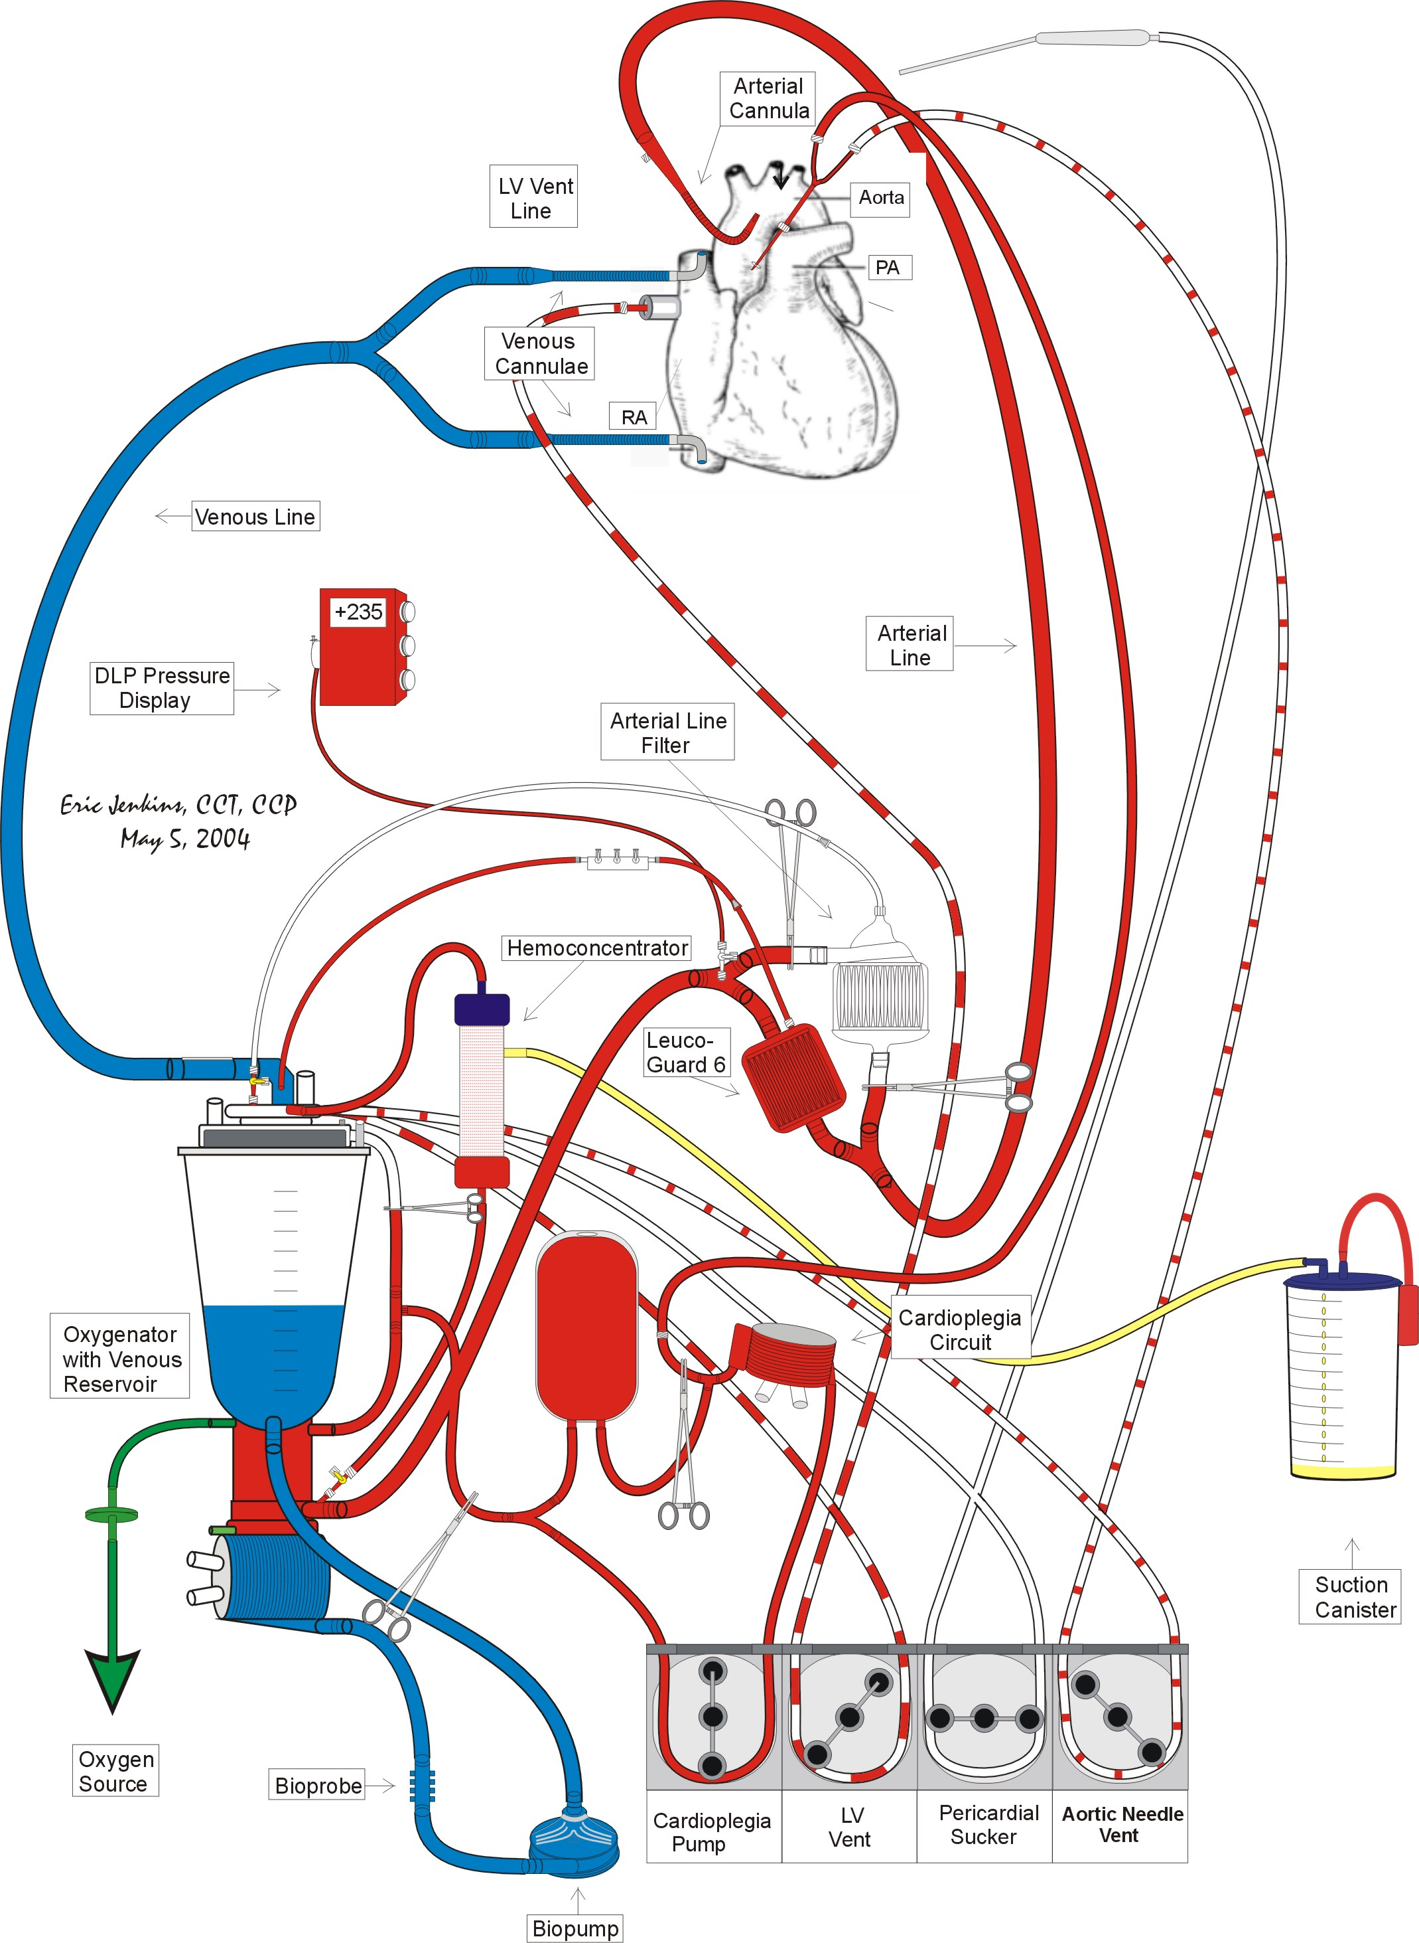

Circuit Modification for Dr. Devaney and Dr. Patel
- Dr. Devaney requests that the perfusionist add another sucker to the standard adult circuit at the Main Hospital. Unlike Dr. Pagani, Dr. Devaney will release the aortic crossclamp before all anastomoses are completed. The additional sucker is necessary for surgical field clearance during right heart anastomoses.

Supplies
- (2) 6” x ¼” tubing
- (1) ¼” connector

Procedure
- Hand up a roll of ¼” tubing to the scrub nurse using sterile technique.
- Double up the #1 and #2 suckers in the far right pumphead.
- Place the vent in the usual #1 sucker position.
- Take the other roll of ¼” tubing and place it in the usual vent position.
- Insert the ¼” connector into the inflow side of the tubing. Make sure the connector is capped.
- When the lines are handed up to the table, have the scrub nurse hand down one end of the other roll of ¼” tubing. Connect it to the ¼” connector.
- Use the diagram on the following page as a guide.
Figure 4: Devaney and Patel Heart Transplant Circuit
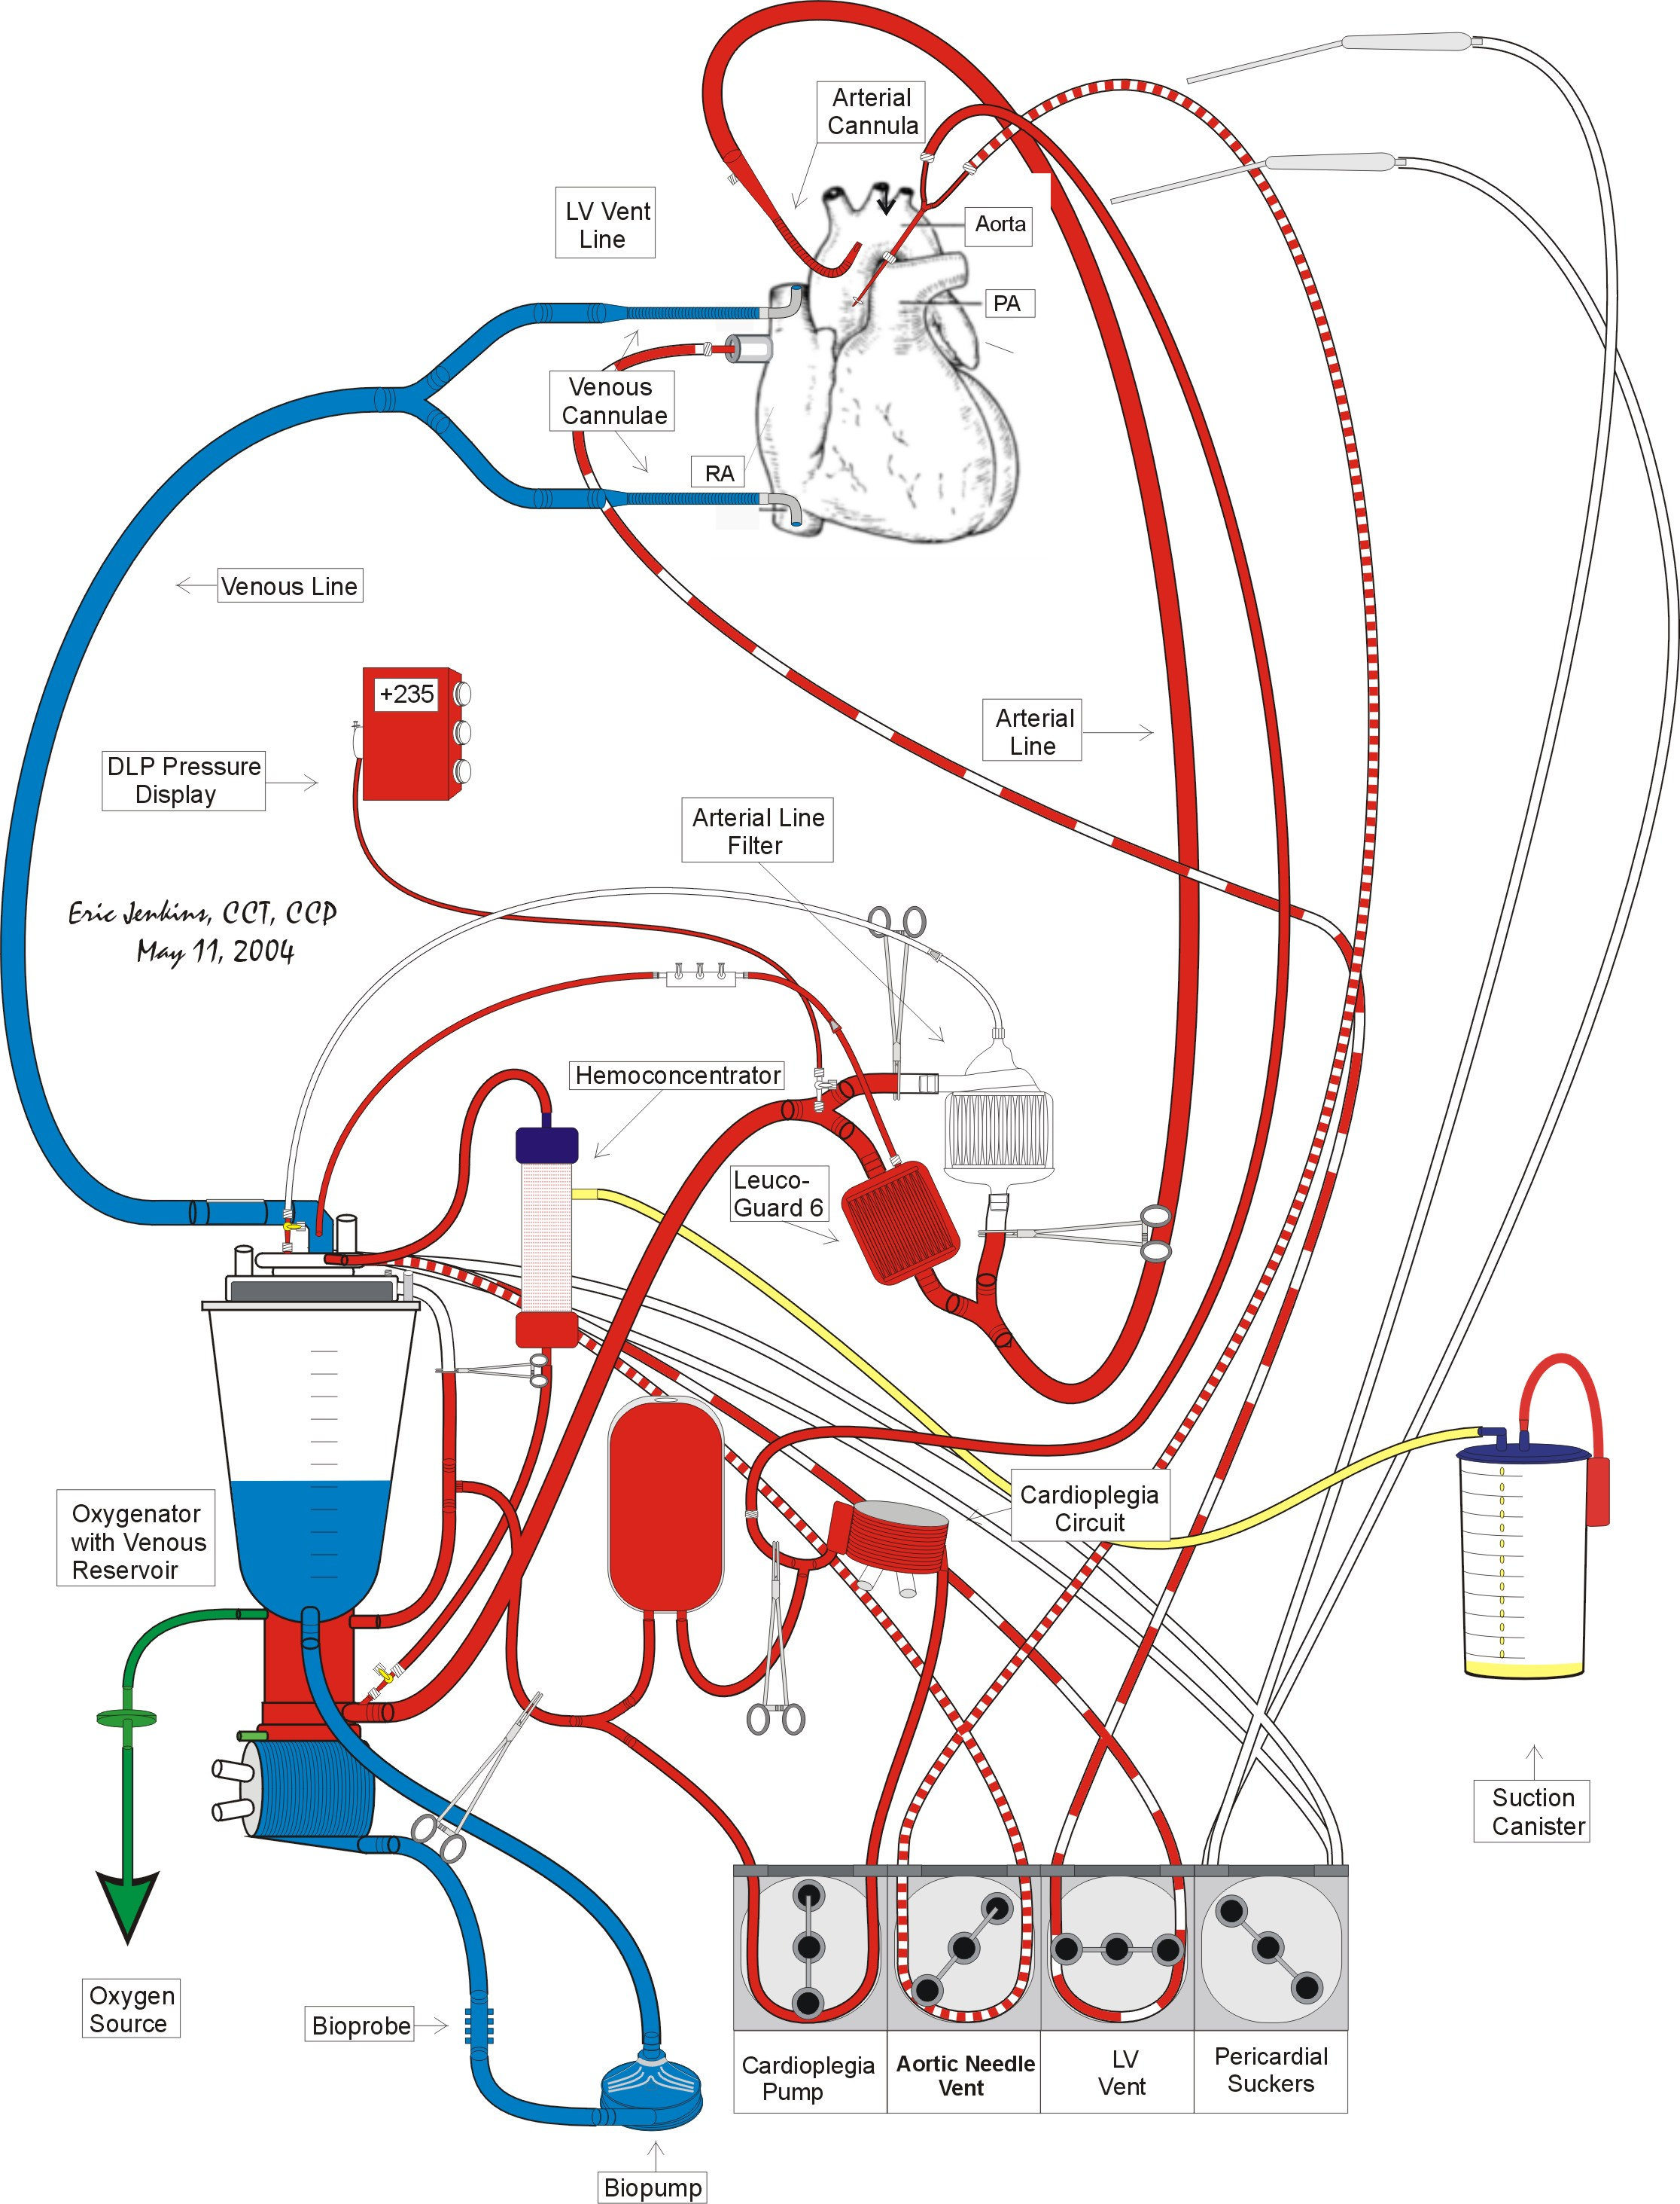

Prime Constituents & Priming Technique
- Consult staff surgeon regarding priming with additional plasma and packed red blood cells.

Prime Technique & Initial Constituents
- After flushing with CO₂, prime and de-air the extra-corporeal circuit with 2000 ml Normosol R.

Additional Constituents & Ultrafiltration
- Have the scrub nurse replace the pre-bypass filter with a 3/8 x 1/2” connector.
- Add the following constituents
- (4) units plasma (single donor or fresh frozen)
- Sufficient leukocyte depleted packed red cells (LDPRC) for prime Hct of 30%. The following equation may be used to calculate the amount LDPRC:

PRBC Prime Volume for Target CPB Hct Calculation

X ml PRBC’s = (Target Hct/100) x ((65 x kg) + ml prime vol)) – (65 x kg (pt Hct / 100)
0.6

where: X ml PRBC’s = estimated amount of packed red blood cells necessary to attain the target hematocrit on cardiopulmonary bypass
Target Hct = desired Hematocrit on cardiopulmonary bypass
prime vol = prime volume of extra-corporeal circuit
kg = patient’s kilogram weight
pt Hct = patient’s hematocrit measured following monitoring lines
insertion by anesthesia
- Using the hemoconcentrator, remove enough ultrafiltrate until the venous reservoir is almost empty-- ~ 100 ml.

Final Constituents
- Add the following constituents:
- ? units leukocyte depleted red blood cells
- 4 units plasma (single donor or fresh frozen)
- 50 mEq NaHCO₃
- 12.5 g mannitol (Do not administer in presence of severe renal impairment unless authorized by the attending surgeon.)
- 10,000 units heparin (pork mucosal)
- 2.0 x 10⁶ KIU aprotinin (Trasylol) (Do not administer unless test dose is negative.)
- 10 g Amicar
- 1 mg vitamin K
- 1.5 g Cefuroxime
- 1 g Vancomycin
- For Dr. Pagani, titrated on CPB over a 1 hour period.
- For all other surgeons, titrated on CPB.

Steroid Administration
- 1 g methylprednisolone (Solu-Medrol) IV by anesthesia personnel at the time of heparinization.
- It is the perfusionist’s responsibility to make sure that the patient is given methylprednisolone (Solu-Medrol) at the proper time.

Aprotinin Administration Guidelines
- The following guidelines are applicable only if aprotinin is administered.
- The aprotinin test dose is to be administered just prior to heparin administration in order to avoid the possibility of an anaphylactic reaction at a point in the case where CPB is difficult to initiate.
- Aprotinin is not added to the pump prime until the test dose has proven negative.
- Be sure to recirculate the prime once aprotinin has been added because a large bolus of concentrated aprotinin may be thrombogenic.

Vitamin K Administration
- Anesthesia should administer 1 mg vitamin K when the patient enters the OR and 1 mg vitamin K every 30 minutes thereafter until the initiation of CPB.
- It is the perfusionist’s responsibility to make sure that this dose of vitamin K is administered.
- The perfusionist should add 1 mg vitamin K to the prime of the extracorporeal circuit.

Antibiotic Regimen
- 1 g Vancomycin
- For Dr. Pagani, titrated on CPB over a 1 hour period.
- For all other surgeons, titrated on CPB.
- 1.5 g Cefuroxime
- Added to pump prime.
- Available in the key code room of the OR pharmacy.

Note: In case of allergy to either Cefuroxime or Vancomycin, consult the attending surgeon and/or anesthesiologist.

MAP Management and Arginine Vasopressin Administration
- Maintain a MAP range of 80 - 100 mmHg.
- Consult Dr. Pagani regarding administration of arginine vasopressin if after a total dose of 15 mg phenylephrine, the MAP is < 60 mmHg at a blood flow rate of 2.4 l/min/m².
Source
- Arginine vasopressin in 20 units/1ml vials is available at the OR pharmacy.
Preparation
- Mix 40 units arginine vasopressin (2 vials) with 38 ml 0.9% NaCl in a 60 cc syringe. This results in a concentration of 1 unit arginine vasopressin per ml of solution.
Administration
- Arginine vasopressin is administered only with a syringe pump.
- Initiate arginine vasopressin at a rate of 5 units/hr, then titrate for effect.
- Do not infuse arginine vasopressin at a rate > 5 units/hr.

Cooling
- Patient is cooled according to the surgeon’s directions on a per case basis.

Cardioplegia
- The cardioplegia solution must not contain any lidocaine.
- Add 2.5 mg nitroglycerine for every 300ml of the first dose of cardioplegia. The first dose is usually ~600 ml.
- At the surgeon’s discretion, cold maintenance cardioplegia is delivered antegrade to the donor heart.

Initial Cardioplegia Dose Constituents
*Please note that these constituent amounts are based on a total cardioplegia volume of 750 ml. This allows for approximately 600 ml in the cardioplegia reservoir or the usually initial dose.
Constituents | Amount
Prime Solution | 150 ml
KCl | 9 mEq (4.5 cc)
THAM (0.3 mEq/ml) | 38 ml
CPD | 9 ml
Dextrose | 3.75 g (7.5 cc)
Nitroglycerine | 6.25 mg
Perfusate | ~450 ml

Maintenance Cardioplegia
Composition
- For Dr. Pagani, cold maintenance cardioplegia solution is typically composed in 1 liter batches according to the table below.
- The maintenance cardioplegia solution is mixed in the cardioplegia reservoir bag and cooled by recirculation.

Constituents | Amount
KCl | Sufficient KCl is added to produce a liter of maintenance cardioplegia with a K⁺ concentration of 12 mEq/L. The amount of KCl is calculated by subtracting the current serum K⁺ concentration from12.
CPD | 12 ml
Dextrose | Add 5 g dextrose if the current serum glucose is < 300 g/dl.
Perfusate | ~800 ml

Dose and Delivery Technique
- Maintenance cardioplegia for orthotopic heart transplants is usually delivered antegrade. 500 ml doses are usually delivered after each anastomosis completion. Please note that after the aortic and left atrial anastomoses are completed Dr. Devaney removes the aortic crossclamp. Dr. Pagani does not release the aortic crossclamp until all anastomosis are completed.

Warm Reperfusion (Hot Shot)
Description
- Warm reperfusion is given just prior to the removal of the aortic cross clamp. This option is available to all surgeons and facilitates the recovery of a compromised myocardium by providing Kreb's Cycle substrates (aspartate & glutamate), glycolysis substrate (dextrose), intracellular buffer (THAM), and a calcium chelating agent (CPD).

Composition
- The constituents listed in the table below produce ~ 600 ml of warm reperfusion cardioplegia solution.
- The warm reperfusion cardioplegia solution is mixed in the cardioplegia reservoir bag and warmed to 37ºC by recirculation.

Constituents | Amount
KCl | Sufficient KCl is added to produce a 600ml of maintenance cardioplegia with a K⁺ concentration of 12 mEq/L. The amount of KCl is calculated by subtracting the current serum K⁺ concentration from12 and multiplying by 0.6.
THAM (0.3 mEq/ml) | 45 ml
CPD | 12 ml
Dextrose | Add 5 g dextrose if the current serum glucose is < 300 g/dl.
0.46 M Aspartate/Glutamate | 40 ml
Perfusate | ~500 ml

Dose
- The usual warm perfusion dose is 600 ml. The warm CP temperature is achieved by switching the cardioplegia heat exchanger hoses from the cold Blanketrol to the warm Blanketrol.

Technique
- Generally, the "Hot Shot" is delivered antegrade at 150 - 200 ml/min at a temperature of 32 - 37ºC.
- Dr. Pagani wants the “Hot Shot” to be followed by a minute of warm perfusate.

Prophylactic Treatment of Possible Protamine Reactions

Treatment Regimen

Drug | Dose
diphenhydramine (Benadryl) | 50 mg
hydrocortisone (Solu-Cortef) | 100 mg
ranitidine (Zantac) | 50 mg

- If the patient has already received a dose of steroids during the course of the case, then do not administer hydrocortisone.

Treatment Rationale
- These drugs are given to avoid a possible protamine reaction and aid in a reduction of side effects. They are to be given approximately 10 minutes before the termination of CPB. Always discuss the usage of this regime with anesthesia and the surgeon.

Post Aortic Crossclamp Pharmacology
- Drug Regimen
- 12.5 g mannitol
- 10 mg furosemide
- No lidocaine
- No MgSO₄

Blood Usage
- Expect Dr. Pagani to require a hematocrit > 35% or greater coming off bypass.
- Notify the surgeon prior to administering blood products.
- All blood products should be irradiated, CMV negative, and administered through a leukocyte filter.

Termination Drug Regimen
- Expect to load the patient with Milranone, Dobutamine, and/or Isuprel.
- Expect the use of nitric oxide by anesthesia for treatment of high PA pressures and prevention of RV failure.

Termination of CPB
- Prior to CPB termination, the perfusionist should manage the patient in order to obtain the following physiological values:
- Hct: > 35%
- pH: 7.45 – 7.5
- pCO₂ ~ 30 mmHg
- CaCl₂ ~ 1.5 mmol/l

Perfusion Management of Sickle Cell Anemia Patient during Orthotopic Heart Transplantation

Pathophysiology
- Sickle cell hemoglobinopathy is a single gene recessive abnormality that may be present in a heterozygous form, sickle cell trait, or in a homozygous recessive form, sickle cell disease. Recessive gene expression results in the substitution of a percentage of normal hemoglobin A with abnormal hemoglobin S.
- The hemoglobin of patients with sickle cell trait (heterozygous) is usually 20 - 45% hemoglobin S. These patients have few clinical problems. Sickle cell crises result only from severe provocation.
- The hemoglobin of patients with sickle cell disease (homozygous) is usually 80 - 98% hemoglobin S. Clinically, sickle cell disease manifests as a sickle cell crisis where the hemoglobin S within erythrocytes dimerizes. This dimerization causes the cell to become sickle shaped. The distortion of erythrocytes increases their fragility resulting in a severe hemolytic anemia. The aggregation of sickled red cells increases blood viscosity resulting in vaso-occlusive phenomena. The sickled cells also disrupt the capillary endothelium resulting in the release of collagen into the capillary bed. Collagen activates the intrinsic pathway of the coagulation cascade that in turn promotes platelet activation and aggregation on damaged endothelial surfaces resulting in further vaso-occlusive phenomena.
- A variety of conditions can induce a sickle cell crisis.
- hypoxia (Hb O₂ saturation < 85%)
- acidosis
- low flow states
- hypovolemia
- hypotension
- dehydration
- hypothermia
- infection
- increased concentration of 2.3-diphosphoglyceric acid

Management Strategy Overview
- Reduce the level of hemoglobin to approximately 5% prior to the operation.
- partial exchange transfusion during preoperative period
- complete exchange transfusion just prior to CPB initiation
- Minimize sickling by avoiding predisposing conditions.

Extracorporeal Circuit Components
- Medtronic Affinity Membrane Oxygenator with CVR
- Adult Tubing Pack
- Medtronic Myotherm Cardioplegia System
- Medtronic Affinity Arterial Line Filter (38 micron)
- Pall Leukoguard-6 Arterial Line Filter
- Cardiotomy Reservoir
- ½” x 6’ PVC tubing
- 3/8” x 6’ PVC tubing
- (1) 6’ x ¼” PVC tubing
- (1) ½” Y connector
- (1) ¼” connector with luer lock adapter
- (1) ¼” perfusion adapters
- (2 - 3) 3 liter suction canisters

Circuit Modification
- Use the diagram on the following page as guide to complete the modifications listed below.
- The Pall Leukoguard-6 arterial line filter is inserted into the Medtronic Affinity 38 micron arterial filter bypass line. In this way, another arterial line filter is available should the Leukoguard-6 arterial filter become obstructed.
- It is recommended that the Medtronic Affinity 38 micron arterial line filter be primed antegrade. The Pall Leukoguard-6 arterial line filter is then primed retrograde.
- A 6” length of the venous line is cut. Insert a ½” Y connector and attach the 6” length of ½” tubing. The modified venous line is attached to the CDI cuvette and then attached to the venous port of the oxygenator in the usual manner.
- Cut a 2’ length of ½” tubing and attach it to the free arm of the ½” Y connector. Clamp and cap the free arm of the venous line.
Figure 5: CPB Circuit for Heart Transplant Patient with Sickle Cell Anemia
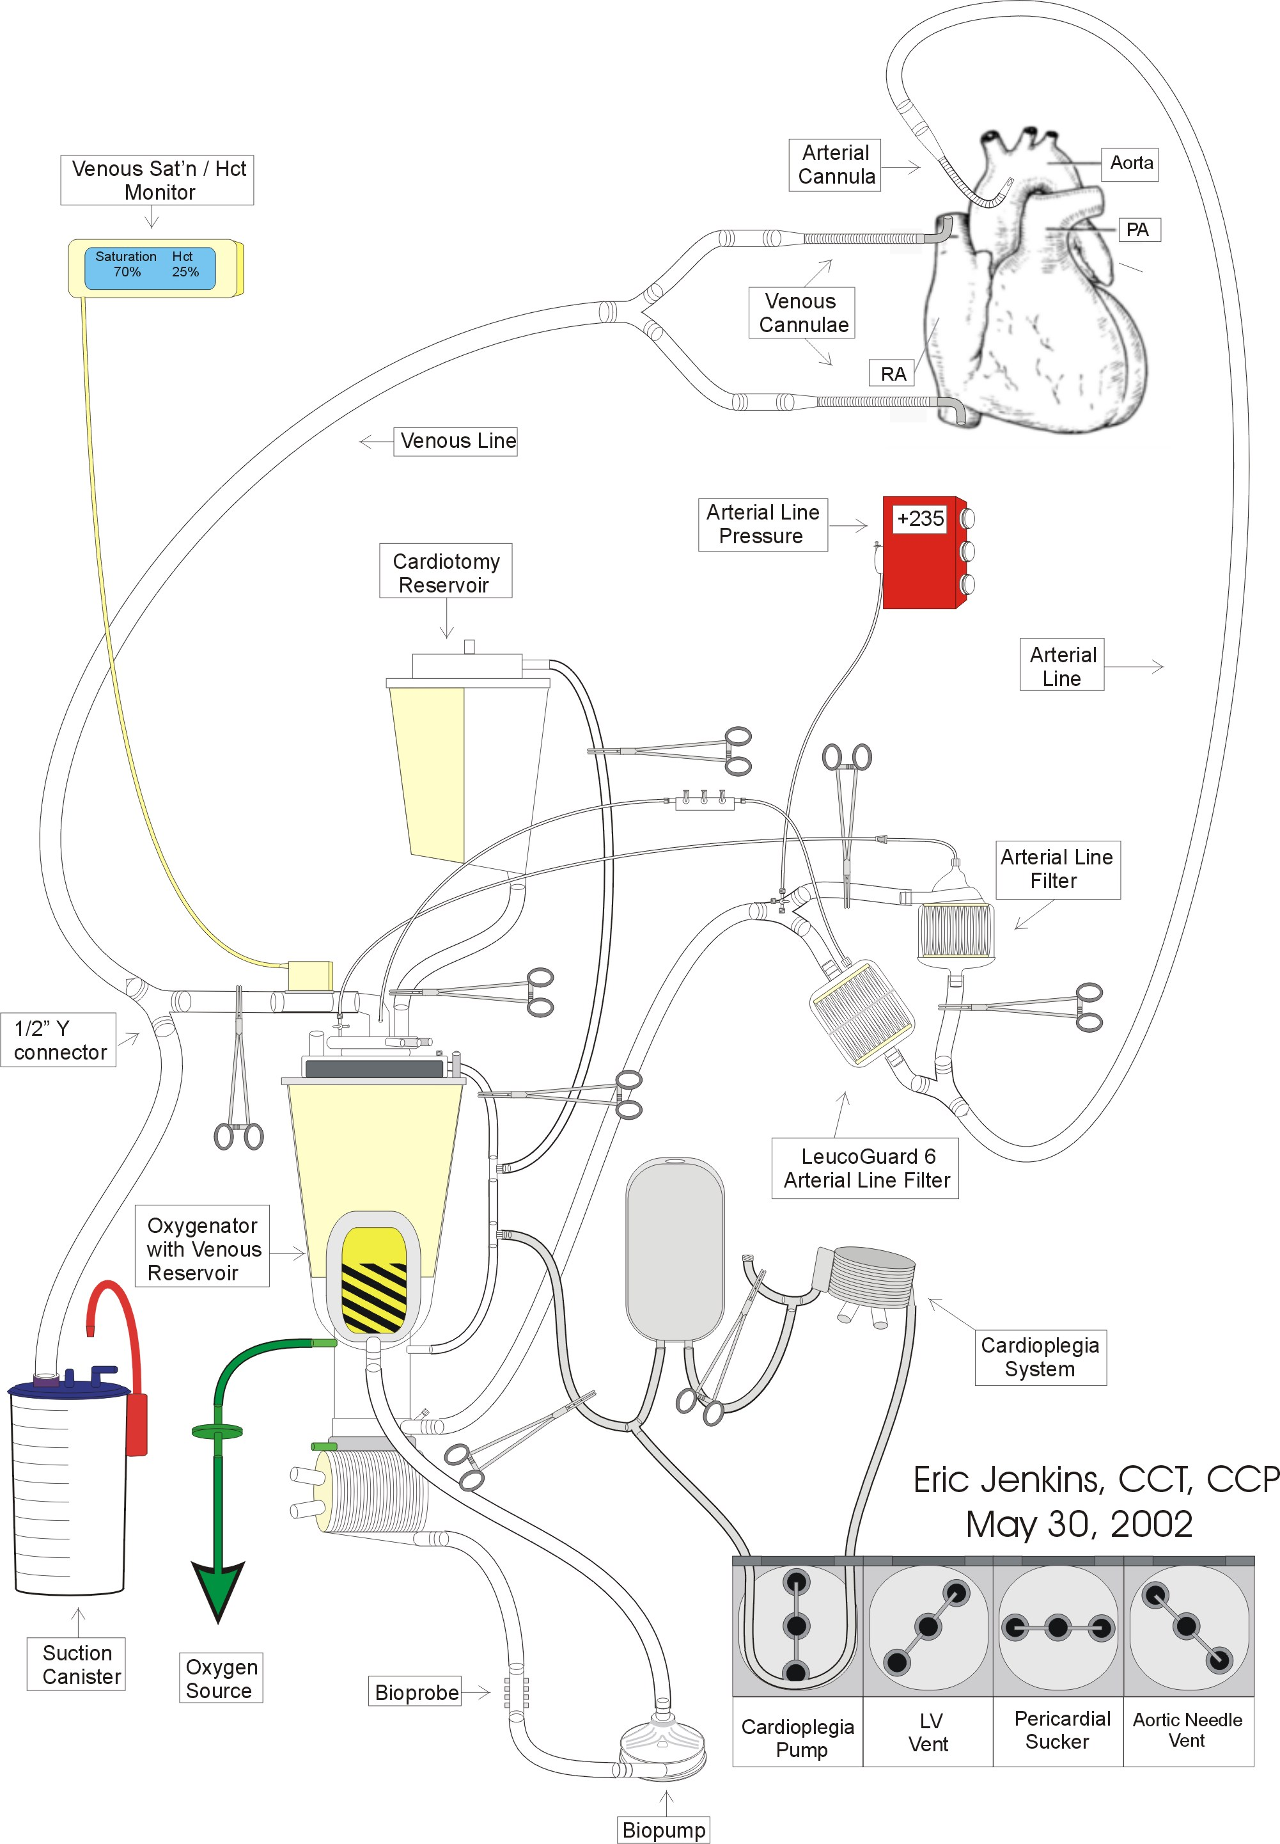

Circuit Modification for Dr. Devaney
- Dr. Devaney requests that the perfusionist add another sucker to the standard adult circuit at the Main Hospital. Unlike Dr. Pagani, Dr. Devaney will release the aortic crossclamp before all anastomoses are completed. The additional sucker is necessary for surgical field clearance during right heart anastomoses.

Supplies
- (2) 6” x ¼” tubing
- (1) ¼” connector

Procedure
- Hand up a roll of ¼” tubing to the scrub nurse using sterile technique.
- Double up the #1 and #2 suckers in the far right pumphead.
- Place the vent in the usual #1 sucker position.
- Take the other roll of ¼” tubing and place it in the usual vent position.
- Insert the ¼” connector into the inflow side of the tubing. Make the connector is capped.
- When the lines are handed up to the table, have the scrub nurse hand down one end of the other roll of ¼” tubing. Connect it to the ¼” connector.

Hemoconcentrator Usage
- Hemoconcentrator usage during CPB is not recommended for a patient with sickle cell anemia because deoxygenation during transit of the device could induce sickling. If excess volume requires attention, the excess volume may be drawn off using transfer packs and then processed by the cell saver.
- For treatment of hyperkalemia, see “Pharmacological Treatment of Hyperkalemia” in Section 6.
- Only use a hemoconcentrator following consultation with the surgeon.

Extracorporeal Circuit Prime Technique
- Please note that the target prime volume for most patients is ~7 liters. Approximately, 3 liters should be stored in the cardiotomy reservoir.
- After flushing with CO₂, prime and de-air the extracorporeal circuit with 2500 ml Normosol R at 40ºC.
- Hand the lines up to the field. Have the scrub nurse replace the pre-bypass filter with a 3/8 x 1/2” connector.
- Add the following constituents:
- 500 ml Hespan
- 50 g Mannitol
- 150 mEq NaHCO₃
- 42,000 units heparin
- 2.0 x 10⁶ KIU aprotinin (See note below.)
- 8 units PRBC
- 5 units FFP
- 1.5 mg fentanyl
- 1000 mg CaCl₂
- Do not add CaCl₂ until all the constituents have been thoroughly mixed with the heparin.
- 10 mg pancuronium
- 5 mg midazolam
- 10 g Amicar
- Consult Dr. Pagani prior to Amicar administration.
- 1 mg vitamin K (See note below.)
- 1.5 g Cefuroxime
- 1 g vancomycin
- Titrated on CPB over a 1 hour period.
- 100 μg norepinephrine
- Recirculate the prime at 38ºC.
- Take a sample of the prime for hematocrit, blood gas, and electrolyte analysis. Correct to normal values if necessary. The Hct should be approximately 30 - 35%.

Steroid Administration
- 1 g methylprednisolone (Solu-Medrol) IV by anesthesia personnel at the time of heparinization.
- It is the perfusionist’s responsibility to make sure that the patient is given methylprednisolone (Solu-Medrol) at the proper time.

Aprotinin Administration Guidelines
- The following guidelines are applicable only if aprotinin is administered.
- The aprotinin test dose is to be administered just prior to heparin administration in order to avoid the possibility of an anaphylactic reaction at a point in the case where CPB is difficult to initiate.
- Aprotinin is not added to the pump prime until the test dose has proven to be negative.
- Be sure to recirculate the prime once aprotinin has been added because a large bolus of concentrated aprotinin may be thrombogenic.

Vitamin K Administration
- Anesthesia should administer 1 mg vitamin K when the patient enters the OR and 1 mg vitamin K every 30 minutes thereafter until the initiation of CPB.
- It is the perfusionist’s responsibility to make sure that this dose of vitamin K is administered.
- The perfusionist should add 1 mg vitamin K to the prime of the extracorporeal circuit.

Antibiotic Regimen
- 1 g Vancomycin
- Titrated on CPB over a 1 hour period.
- 1.5 g Cefuroxime
- Added to pump prime.
- Available in the key code room of the OR pharmacy.

Note: In case of allergy to either Cefuroxime or Vancomycin, consult the attending surgeon and/or anesthesiologist.

CPB Initiation and Complete Exchange Transfusion Technique
- The patient is heparinized with at least 300 units/kg for a resultant ACT of > 480 seconds.
- The patient is then cannulated.
- Both arms of the venous line are clamped distal to the ½” Y connector
- The free arm of the venous line is placed in a 3 liter suction canister. A second 3 liter suction canister should be within easy reach.
- On the surgeon’s command, the perfusionist removes the clamp on the free arm of the venous line allowing the patient to exsanguinate the equivalent of their calculated blood volume (0.65 x kilogram weight, ~ 4 liters).
- The patient is then rapidly transfused from the extracorporeal circuit to maintain adequate blood pressures. Simultaneously, an additional 2 liters is allowed to drain into the suction canisters.
- When the complete exchange transfusion is complete, the free arm of the venous line is clamped and capped.
- Full CPB is then initiated in the usual manner.

Perfusion Parameters Management
- The following perfusion parameters are to be followed in order to avoid conditions that could induce sickle cell crisis;
- Blood Flow Rate: > 3.0 l/min
- vSAT: > 85%
- pH: > 7.4
- PaCO₂: < 35 mmHg
- PaO₂: > 300 mmHg
- Hct: > 30%
- HCO₃⁻: > 24 mEq
- BE: > 0.0

MAP Management and Arginine Vasopressin Administration
- Maintain a MAP range of 65 - 80 mmHg.
- Consult Dr. Pagani regarding administration of arginine vasopressin if after a total dose of 15 mg phenylephrine, the MAP is < 60 mmHg at a blood flow rate of 2.4 l/min/m².
Source
- Arginine vasopressin in 20 units/1ml vials is available at the OR pharmacy.
Preparation
- Mix 40 units arginine vasopressin (2 vials) with 38 ml 0.9% NaCl in a 60 cc syringe. This results in a concentration of 1 unit arginine vasopressin per ml of solution.
Administration
- Arginine vasopressin is administered only with a syringe pump.
- Initiate arginine vasopressin at a rate of 5 units/hr, then titrate for effect.
- Do not infuse arginine vasopressin at a rate > 5 units/hr.

Cardioplegia Composition and Technique
- Myocardial preservation is induced and maintained with crystalloid cardioplegia.

Composition

Constituents | Amount
Normosol R | 1000 ml
KCl | 12 ml (2 mEq/ml)
NaHCO₃ | 24 ml (2 mEq/ml)
CPD | 12 ml
50% Dextrose | 10 ml
THAM | 50 ml (0.3 mEq/ml)

Maintenance Cardioplegia
Composition
- For Dr. Pagani, cold maintenance cardioplegia solution is typically composed in 1 liter batches according to the table below.
- The maintenance cardioplegia solution is mixed in the cardioplegia reservoir bag and cooled by recirculation.

Constituents | Amount
Normosol R | 1000 ml
KCl | 6ml (2 mEq/ml)
NaHCO₃ | 24 ml (2 mEq/ml)
CPD | 12 ml
50% Dextrose | 10 ml
THAM | 50 ml (0.3 mEq/ml)

Dose and Delivery Technique
- Maintenance cardioplegia for orthotopic heart transplants is usually delivered antegrade. 500 ml doses are usually delivered after each anastomosis completion. Please note that after the aortic and left atrial anastomoses are completed Dr. Devaney removes the aortic crossclamp. Dr. Pagani does not release the aortic crossclamp until all anastomosis are completed.

Post Aortic Crossclamp Pharmacology
- Drug Regimen
- 12.5 g mannitol
- 10 mg furosemide
- No lidocaine
- No MgSO₄

Blood Usage
- Expect Dr. Pagani to require a hematocrit > 35% or greater coming off bypass.
- Notify the surgeon prior to administering blood products.
- All blood products should be irradiated, CMV negative, and administered through a leukocyte filter.

Prophylactic Treatment of Possible Protamine Reactions

Treatment Regimen

Drug | Dose
diphenhydramine (Benadryl) | 50 mg
hydrocortisone (Solu-Cortef) | 100 mg
ranitidine (Zantac) | 50 mg

- If the patient has already received a dose of steroids during the course of the case, then do not administer hydrocortisone.

Treatment Rationale
- These drugs are given to avoid a possible protamine reaction and aid in a reduction of side effects. They are to be given approximately 10 minutes before the termination of CPB. Always discuss the usage of this regime with anesthesia and the surgeon.

Termination Drug Regimen
- Expect to load the patient with Milranone, Dobutamine, and/or Isuprel.
- Expect the use of nitric oxide by anesthesia for treatment of high PA pressures and prevention of RV failure.

Termination of CPB
- Prior to CPB termination, the perfusionist should manage the patient in order to obtain the following physiological values:
- Hct: 30 – 35%
- pH: 7.45 – 7.5
- pCO₂ ~ 30 mmHg
- CaCl₂ ~ 1.5 mmol/l

Perfusion and Anticoagulation Management of Heart Transplant Patients with Heparin Induced Thrombocytopenia / Heparin Associated Thrombocytopenia (HIT / HAT) Using Bivalirudin (Angiomax)

Overview
- Heparin induced thrombocytopenia can be a life threatening complication of long-term heparin therapy. An alternative to heparin must be used in these patients in order to perform cardiopulmonary bypass safely. Bivalirudin is one such alternative anticoagulation therapy.
- Bivalirudin is a direct thrombin inhibitor that has no neutralizing agent. Despite its reported fast renal elimination, quick hemostasis following cardiopulmonary bypass should not be expected.
- Maintain a venous reservoir level below the filter sock whenever possible to avoid providing a matrix for thrombus formation.
- Do not use pericardial suckers until CPB has been safely initiated.

Anticoagulation Management

Pre-CPB

Loading
- Bivalirudin bolus to prime: 50 mg bivalirudin (Angiomax)
- Loading dose to patient: 2.25 mg/kg IV bivalirudin (Angiomax) to patient
- Start constant infusion at 1.25 mg/kg/hr bivalirudin (Angiomax)
- Wait 5 minutes before checking ACT.
- Do not initiate CPB until ACT is > 550 seconds and a minimum of 20 mins has elapsed from the time that the initial loading dose was administered.
- If initial ACT is < 550 seconds, re-bolus patient with 1.125 mg/kg bivalirudin (Angiomax).
- Repeat ACT after 5 minutes. Repeat step #6 as necessary following consultation with the staff surgeon and staff anesthesiologist.

During CPB
- Just prior to CPB initiation, transfer the bivalirudin (Angiomax) bivalirudin constant infusion to the heart and lung machine. The bivalirudin (Angiomax) constant infusion is inserted into the venous blood temp probe site.
- Measure an ACT a minimum of every 10 – 15 mins using Hemochron Jr. II.
- If the ACT falls below 480 seconds, re-bolus with 0.25 mg/kg and increase constant infusion rate by 0.5 mg/kg/hr.
- If the ACT is over 600 seconds, lower constant infusion rate by 0.5 mg/kg/hr.

Preparation for CPB Termination
- Discontinue bivalirudin (Angiomax) infusion 30 minutes prior to CPB termination. Consult the staff surgeon and staff anesthesiologist regarding the exact timing of infusion termination.
- Discontinue pericardial sucker usage 15 – 30 mins prior to CPB following consultation with the staff surgeon.
- Ultrafiltrate to lower bivalirudin (Angiomax) concentration. Consult staff surgeon and anesthesia regarding target ACT for CPB termination.

Post-CPB
- Vigorous diuresis.

Extracorporeal Circuit Components
- Do not use Carmeda or Trillium coated components.
- Medtronic Affinity membrane oxygenator with integrated cardiotomy/venous reservoir
- Uncoated Medtronic Affinity membrane oxygenator with integrated cardiotomy/venous reservoir is stored on the wire racks in the Core A storage area.
- Medtronic Affinity arterial filter (38 micron)
- Main Adult tubing pack
- Myotherm cardioplegia system
- Minntech HPH 1000TS hemoconcentrator
- (1) high flow stopcock

Circuit Modification
- Insert a Medtronic Affinity arterial filter (38 micron) into the ALF bypass line.
- After priming both filters, isolate the ALF inserted into the ALF bypass line with tubing clamps. If the ALF exposed to the perfusate becomes obstructed during CPB, remove the tubing clamps isolating the spare ALF and then isolate the obstructed ALF.
Figure 6: Heart Transplant Patient with HIT/HAT Circuit
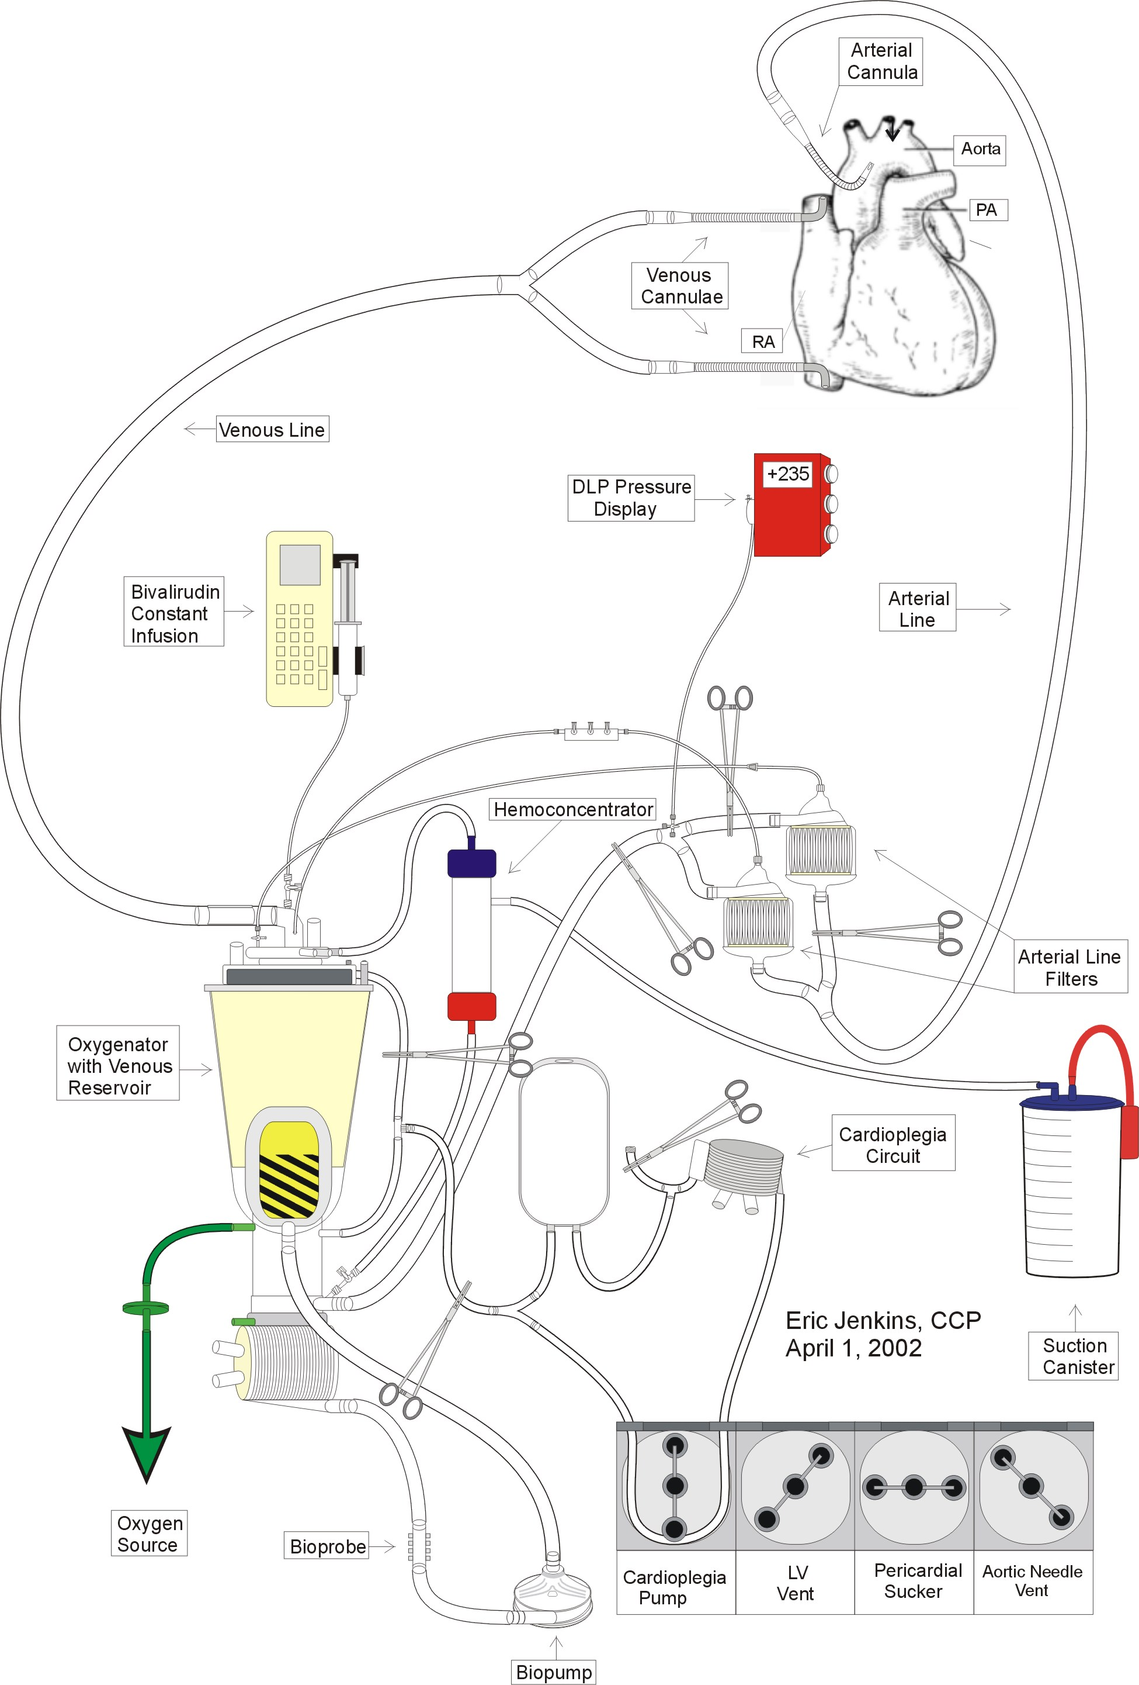

Circuit Modification for Dr. Devaney
- Dr. Devaney requests that the perfusionist add another sucker to the standard adult circuit at the Main Hospital. Unlike Dr. Pagani, Dr. Devaney will release the aortic crossclamp before all anastomoses are completed. The additional sucker is necessary for surgical field clearance during right heart anastomoses.

Supplies
- (2) 6” x ¼” tubing
- (1) ¼” connector

Procedure
- Hand up a roll of ¼” tubing to the scrub nurse using sterile technique.
- Double up the #1 and #2 suckers in the far right pumphead.
- Place the vent in the usual #1 sucker position.
- Take the other roll of ¼” tubing and place it in the usual vent position.
- Insert the ¼” connector into the inflow side of the tubing. Make the connector is capped.
- When the lines are handed up to the table, have the scrub nurse hand down one end of the other roll of ¼” tubing. Connect it to the ¼” connector.

Cell Saver
- No cell saver is used.

Prime Constituents & Priming Technique
- Consult staff surgeon regarding priming with additional plasma and packed red blood cells.

Prime Technique & Initial Constituents
- After flushing with CO₂, prime and de-air the extracorporeal circuit with 2000 ml Normosol R.

Additional Constituents & Ultrafiltration
- Hand the lines up to the field. Have the scrub nurse replace the pre-bypass filter with a 3/8 x 1/2” connector.
- Add the following constituents
- (4) units plasma (single donor or fresh frozen)
- Sufficient leukocyte depleted packed red cells (LDPRC) for prime Hct of 30%. The following equation may be used to calculate the amount LDPRC.

PRBC Prime Volume for Target CPB Hct Calculation

X ml PRBC’s = (Target Hct/100) x ((65 x kg) + ml prime vol)) – (65 x kg (pt Hct / 100)
0.6

where: X ml PRBC’s = estimated amount of packed red blood cells necessary to
attain the target hematocrit on cardiopulmonary bypass
Target Hct = desired Hematocrit on cardiopulmonary bypass
prime vol = prime volume of extracorporeal circuit
kg = patient’s kilogram weight
pt Hct = patient’s hematocrit measured following monitoring lines
insertion by anesthesia

- Using the hemoconcentrator, remove enough ultrafiltrate until the venous reservoir is almost empty-- ~ 100 ml.

Final Constituents
- Add the following constituents:
- ? units leukocyte depleted red blood cells
- 4 units plasma (single donor or fresh frozen)
- 50 mEq NaHCO₃
- 12.5 g mannitol (Do not administer in presence of severe renal impairment unless authorized by the attending surgeon.)
- 50 mg bivalirudin (Angiomax)
- 2.0 x 10⁶ KIU aprotinin (Trasylol) (Do not administer unless test dose is negative.)
- 10 g Amicar
- 1 mg vitamin K
- 1.5 g Cefuroxime
- 1 g Vancomycin
- For Dr. Pagani, titrated on CPB over a 1 hour period.
- For all other surgeons, titrated on CPB.

Note: Consult surgeon regarding Amicar and/or aprotinin administration.

Steroid Administration
- 1 g methylprednisolone (Solu-Medrol) IV by anesthesia personnel at the time of heparinization.
- It is the perfusionist’s responsibility to make sure that the patient is given methylprednisolone (Solu-Medrol) at the proper time.

Aprotinin Administration Guidelines
- The following guidelines are applicable only if aprotinin is administered.
- The aprotinin test dose is to be administered just prior to heparin administration in order to avoid the possibility of an anaphylactic reaction at a point in the case where CPB is difficult to initiate.
- Aprotinin is not added to the pump prime until the test dose has proven negative.
- Be sure to recirculate the prime once aprotinin has been added because a large bolus of concentrated aprotinin may be thrombogenic.

Vitamin K Administration
- Anesthesia should administer 1 mg vitamin K when the patient enters the OR and 1 mg vitamin K every 30 minutes thereafter until the initiation of CPB.
- It is the perfusionist’s responsibility to make sure that this dose of vitamin K is administered.
- The perfusionist should add 1 mg vitamin K to the prime of the extracorporeal circuit.

Antibiotic Regimen
- 1 g Vancomycin
- For Dr. Pagani, titrated on CPB over a 1 hour period.
- For all other surgeons, titrated on CPB.
- 1.5 g Cefuroxime
- Added to pump prime.
- Available in the key code room of the OR pharmacy.

Note: In case of allergy to either Cefuroxime or Vancomycin, consult the attending surgeon and/or anesthesiologist.

MAP Management and Arginine Vasopressin Administration
- Maintain a MAP range of 80 - 100 mmHg.
- Consult Dr. Pagani regarding administration of arginine vasopressin if after a total dose of 15 mg phenylephrine, the MAP is < 60 mmHg at a blood flow rate of 2.4 l/min/m².
Source
- Arginine vasopressin in 20 units/1ml vials is available at the OR pharmacy.
Preparation
- Mix 40 units arginine vasopressin (2 vials) with 38 ml 0.9% NaCl in a 60 cc syringe. This results in a concentration of 1 unit arginine vasopressin per ml of solution.
Administration
- Arginine vasopressin is administered only with a syringe pump.
- Initiate arginine vasopressin at a rate of 5 units/hr, then titrate for effect.
- Do not infuse arginine vasopressin at a rate > 5 units/hr.

Cooling
- Patient is cooled according to the surgeon’s directions on a per case basis.

Cardioplegia
- The cardioplegia solution must not contain any lidocaine.
- Add 2.5 mg nitroglycerine for every 300ml of the first dose of cardioplegia. The first dose is usually ~600 ml.
- At the surgeon’s discretion, cold maintenance cardioplegia is delivered antegrade to the donor heart.

Initial Cardioplegia Dose Constituents
*Please note that these constituents amounts are based on a total cardioplegia volume of 750 ml. This allows for approximately 600 ml in the cardioplegia reservoir or the usual initial dose.

Constituents | Amount
Prime Solution | 150 ml
KCl | 9 mEq (4.5 cc)
THAM (0.3 mEq/ml) | 38 ml
CPD | 9 ml
Dextrose | 3.75 g (7.5 cc)
Nitroglycerine | 6.25 mg
Perfusate | ~450 ml

Maintenance Cardioplegia
Composition
- For Dr. Pagani, cold maintenance cardioplegia solution is typically composed in 1 liter batches according to the table below.
- The maintenance cardioplegia solution is mixed in the cardioplegia reservoir bag and cooled by recirculation.

Constituents | Amount
KCl | Sufficient KCl is added to produce a liter of maintenance cardioplegia with a K⁺ concentration of 12 mEq/L. The amount of KCl is calculated by subtracting the current serum K⁺ concentration from12.
CPD | 12 ml
Dextrose | Add 5 g dextrose if the current serum glucose is < 300 g/dl.
Perfusate | ~800 ml

Dose and Delivery Technique
- Maintenance cardioplegia for orthotopic heart transplants is usually delivered antegrade. 500 ml doses are usually delivered after each anastomosis completion. Please note that after the aortic and left atrial anastomoses are completed Dr. Devaney removes the aortic crossclamp. Dr. Pagani does not release the aortic crossclamp until all anastomosis are completed.

Warm Reperfusion (Hot Shot)
Description
- Warm reperfusion is given just prior to the removal of the aortic cross clamp. This option is available to all surgeons and facilitates the recovery of a compromised myocardium by providing Kreb's Cycle substrates (aspartate & glutamate), glycolysis substrate (dextrose), intracellular buffer (THAM), and a calcium chelating agent (CPD).

Composition
- The constituents listed in the table produce ~ 600 ml of warm reperfusion cardioplegia solution.
- The warm reperfusion cardioplegia solution is mixed in the cardioplegia reservoir bag and warmed to 37ºC by recirculation

Constituents | Amount
KCl | Sufficient KCl is added to produce a 600ml of maintenance cardioplegia with a K⁺ concentration of 12 mEq/l. The amount of KCl is calculated by subtracting the current serum K⁺ concentration from12 and multiplying by 0.6.
THAM (0.3 mEq/ml) | 45 ml
CPD | 12 ml
Dextrose | Add 5 g dextrose if the current serum glucose is < 300 g/dl.
0.46 M Aspartate/Glutamate | 40 ml
Perfusate | ~500 ml

Dose
- The usual warm perfusion dose is 600 ml. The warm CP temperature is achieved by switching the cardioplegia heat exchanger hoses from the cold Blanketrol to the warm Blanketrol.

Technique
- Generally, the "Hot Shot" is delivered antegrade at 150 - 200 ml/min at a temperature of 32 - 37ºC.
- Dr. Pagani wants the “Hot Shot” to be followed by a minute of warm perfusate.

Post Aortic Crossclamp Pharmacology
- Drug Regimen
- 12.5 g mannitol
- 10 mg furosemide
- No lidocaine
- No MgSO₄

Blood Usage
- Expect Dr. Pagani to require a hematocrit > 35% or greater coming off bypass.
- Notify the surgeon prior to administering blood products.
- All blood products should be irradiated, CMV negative, and administered through a leukocyte filter.

Prophylactic Treatment of Possible Protamine Reactions

Treatment Regimen

Drug | Dose
diphenhydramine (Benadryl) | 50 mg
hydrocortisone (Solu-Cortef) | 100 mg
ranitidine (Zantac) | 50 mg

- If the patient has already received a dose of steroids during the course of the case, then do not administer hydrocortisone.

Treatment Rationale
- These drugs are given to avoid a possible protamine reaction and aid in a reduction of side effects. They are to be given approximately 10 minutes before the termination of CPB. Always discuss the usage of this regime with anesthesia and the surgeon.

Termination Drug Regimen
- Expect to load the patient with Milranone, Dobutamine, and/or Isuprel.
- Expect the use of nitric oxide by anesthesia for treatment of high PA pressures and prevention of RV failure.

Termination of CPB
- Prior to CPB termination, the perfusionist should manage the patient in order to obtain the following physiological values:
- Hct: > 35%
- pH: 7.45 – 7.5
- pCO₂ ~ 30 mmHg
- CaCl₂ ~ 1.5 mmol/l

Orthotopic Liver Transplant Protocols

Overview
- When a side-biter vascular clamp cannot be placed on the inferior vena cava (IVC), veno-venous bypass is used to facilitate the removal of a diseased liver and the implantation of a donor liver by shunting blood from the portal vein and/or saphenous vein to the right internal jugular (RIJ) vein.
- Liver bypass can minimize operative blood loss and mesenteric edema.
- The liver bypass circuit may provide a conduit for the rapid infusion system (Belmont HMS2000). A 16 Fr. RMI cannula in the RIJ is recommended. The RIS is operated by and the responsibility of anesthesia personnel.
- When the cadaver liver is removed from cold storage, it is continuously reperfused through the portal vein with a cold solution of Lactated Ringer’s and 25% human albumin to maintain tissue preservation during implantation.

Perfusionist Responsibilities
- The perfusionist will be present to assist the anesthesiologist, who conducts the actual insertion of the percutaneous 12, 14, or 16 Fr RMI cannula (Consult the anesthesiologist prior to opening any cannulae.) into the right internal jugular vein. This will necessitate the perfusionist's presence at or before the time of insertion of the lines.
- The perfusionist is responsible for the set-up and conduct of veno-venous bypass. The veno-venous bypass circuit is not constructed until the staff surgeon determines whether or not the procedure can be performed without liver bypass. Two different methods may be used to construct and prime the veno-venous bypass circuit:
- The immersion method requires the perfusionist to prepare a sterile field and to scrub gown and glove.
- The Niman method requires the perfusionist to construct a sterile circuit which is primed using an IV administration set. This method does not require a sterile field or for the perfusionist to scrub, gown, and glove.
- See Surgeon Preference Table below.
- The perfusionist is responsible for the set-up and conduct of donor liver reperfusion.

Recommendations
- In the past, all flush solutions contained 2 units/cc heparin. This practice was discontinued in order to avoid exacerbating an existing coagulapathy secondary to liver dysfunction. However, some liver transplant patients are not coagulopathic. If these patients are not expected to be connected to the RIS system for an extended period time, then the perfusionist should consult the attending anesthesiologist and surgeon concerning the use of heparin in the flushing solution and/or the initiation of a heparin drip through the cannula. The heparin can always be reversed with protamine once morbid thrombogenesis is not an issue.

Pre-Operative Line Insertion

RIJ Cannula Selection Criteria
- Determine the flow rate range for the patient using 30 – 50 ml/kg/min.
- Consult the staff anesthesiologist prior to lining the patient regarding whether or not he plans to integrate the RIS system with the veno-venous bypass circuit.
- Veno-venous bypass circuit with RIS system integration
- Using cannula flow chart on the following page, determine the appropriate cannula size to accommodate the patient’s flow rate range.
- If flows greater than 3000 ml/min are calculated at the minimum rate of 30 ml/kg/min and the RIS system is integrated with the veno-venous bypass circuit, then the placement of a 16 Fr. RMI cannula in the RIJ is recommended.
- Placement of a 12 or 14 Fr. RMI cannula under these circumstances may cause the RIS system not to function because of high pressure when the VVB flow rate is > 3.0 l/min and the RIS flow rate is > 500 ml/min.
- Veno-venous bypass circuit with RIS system integration
- Using cannula flow chart on the following page, determine the appropriate cannula size to accommodate the patient’s flow rate range.

Figure 7: RMI FEMIIOXXA Cannula Flow Chart
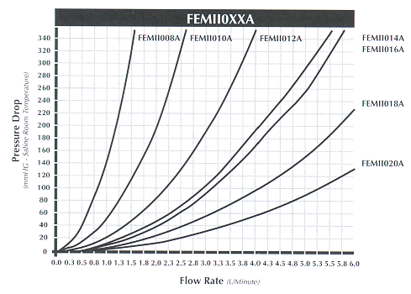

Research Medical, Inc. Product Catalog, January 1, 2000

Right Internal Jugular Vein Line Insertion with 16 Fr. RMI Cannula

Equipment
- (1) metal rolling table
- (1) sterile tubing clamp (obtained from the scrub nurse after gowning and gloving)

Sterile Supplies
- (1) plastic table cover
- gloves
- gown
- towels (4 – pack)
- (4 - 6) 4x4 sponges
- kidney basin set
- 1000 ml bottle of 0.9% NaCl
- (1) 16 Fr RMI cannula
- (1) silastic rubber suture ring
- (5) 60 cc catheter syringes
- (1) 60 cc luer-lock syringes
- (1) pre-assembled Y connector (See diagram.)
Figure 8: Pre-Assembled Y Connector for RIJ Cannula
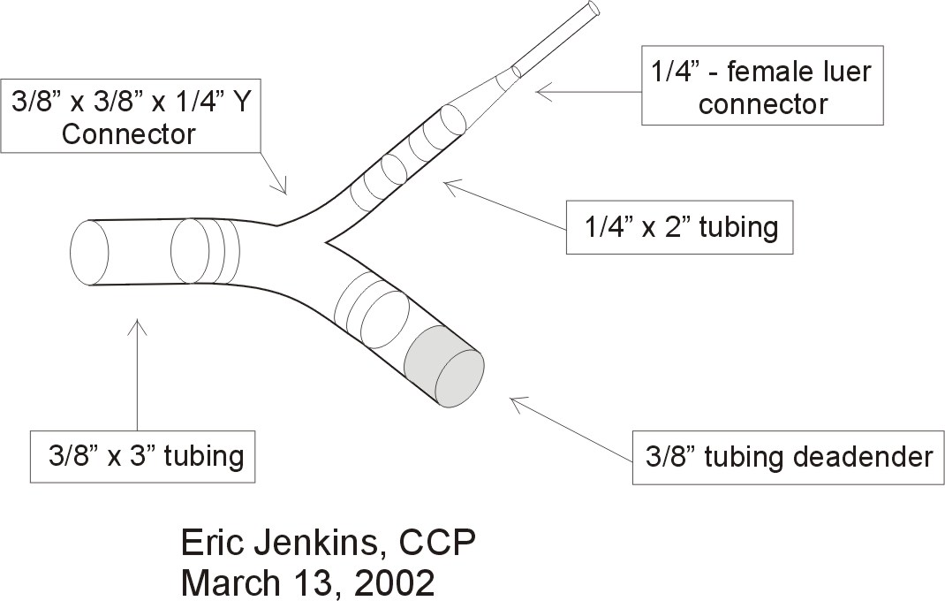
- (1) cannula insertion kit
- (1) syringe pump tubing set
- (1) large bore 4-way stopcock
- (1) sterile deadender

Setup
- Prepare sterile table.
- Place all supplies on the table using sterile technique.
- Pour ~500 ml 0.9% NaCl into the kidney basin.
- Scrub, gown, and glove.
- Load all of the 60 cc syringes with 0.9% NaCl from the kidney basin.
- Take a 60 cc Luer-Lock syringe and attach it to the syringe pump tubing set. Attach a high flow 3-way stopcock to the end of the syringe pump tubing set. Flush the syringe pump tubing and stopcock. Set this syringe and (2) 60 cc catheter syringes aside for use during the RIJ catheter insertion. Save another (2) catheter syringes for use when the patient is disconnected from the veno-venous bypass circuit.
- Hand the kidney basin with the remaining 0.9% NaCl and (1) 60 cc catheter syringes filled with 0.9% NaCl to the scrub nurse for future use.
- Attach the sterile deadender to the female luer connector of the pre-assembled Y connector.
- Insert the distal end of the RIJ cannula through the silastic rubber suture ring. Push the suture ring until it is 12 cm from the tip of the cannula. Use the ruler on the handle of the disposable scalpel handle. See diagram below.

Figure 9: 16 Fr. RIJ Cannula Set-Up
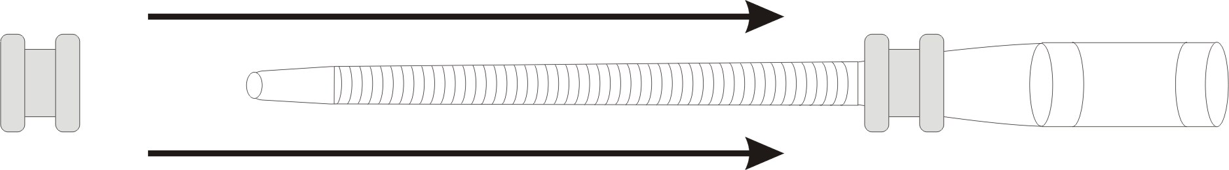

- You are now ready to assist the anesthesiologist.

Right Internal Jugular or Left Subclavian Cannulation
- The anesthesiologist will execute a percutaneous entry into the right internal jugular (RIJ) vein or left subclavian (LS) vein. A progressive series of dilator insertions over a J-wire will be used to allow insertion of the 16 Fr cannula. Remain gowned and gloved, and be prepared to assist the anesthesiologist during this procedure.
- Have the sterile tubing clamp, the custom cannula adapter, 2 catheter syringes filled with 0.9% saline solution, and the syringe pump tubing assembly ready. As soon as the wire and internal dilator-stylet are removed, clamp the posterior portion of the cannula. Take care not to clamp the wire reinforced section of the cannula.

Figure 10: 16 Fr. RMI Flush Diagram
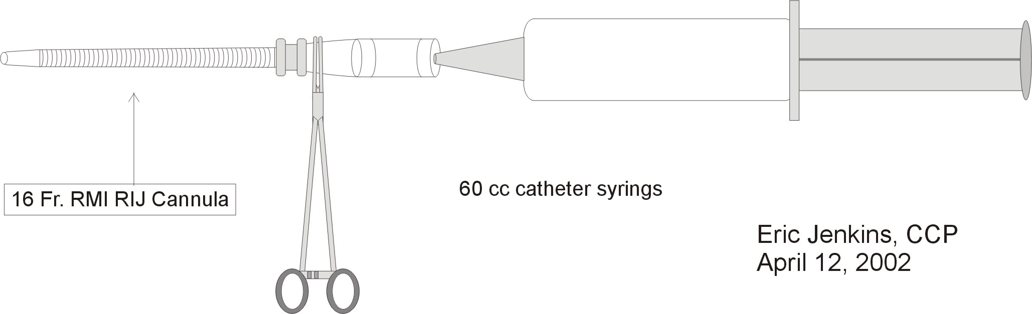

- Take a catheter syringe and slowly fill the posterior end of the cannula with 0.9% saline taking care to eliminate all air. When the cannula proximal to the tubing clamp is filled, insert the catheter syringe firmly making a tight seal. Check to make sure no air is present. Remove the tubing clamp and flush the cannula. Replace the tubing clamp and then repeat the above procedure with the second catheter syringe saving ~20 cc of 0.9% saline solution.
- Clamp the cannula again, and remove the catheter syringe.
- Attach stopcock of the syringe pump assembly to the luer connector of the RIJ cannula.
- Take the pre-assembled Y connector and fill it with 0.9% saline from the catheter syringe.
- Make a fluid connection between the pre-assembled Y connector and the cannula by having the anesthesiologist slowly inject 0.9% saline from the syringe pump assembly. See diagram on the following page.
- When the connection is complete, insert the syringe into a syringe pump and set the infusion rate at 10 cc/hr.

Figure 11: 16 Fr. RIJ Cannula & Pre-Assembled Y Connection Diagram

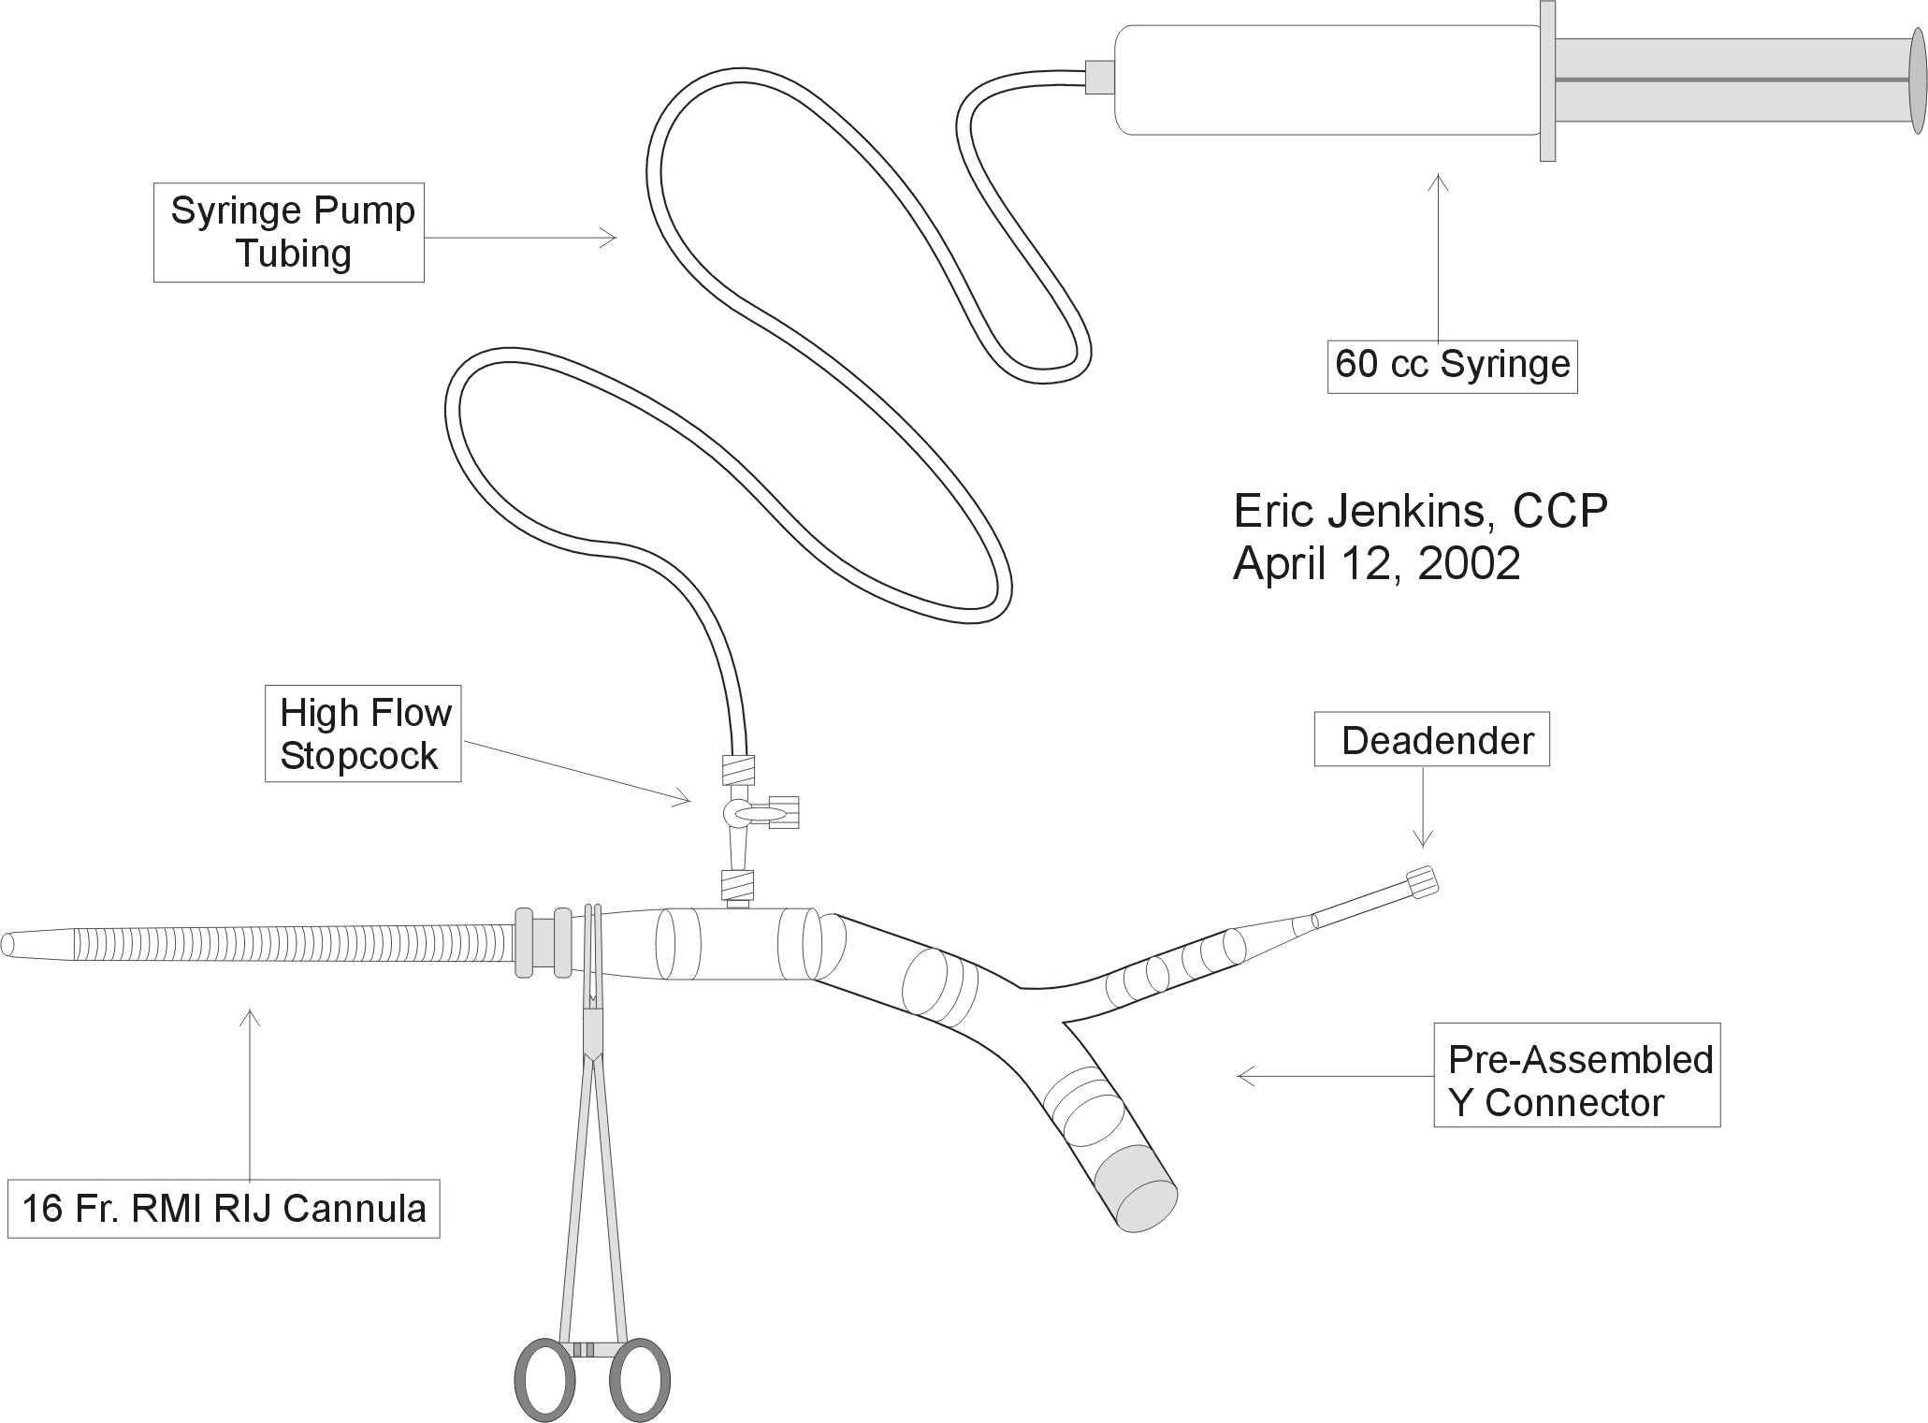

16 Fr. RIJ Cannula to Belmont HMS2000 Connection Procedure
- Stop Belmont HMS2000 recirculation.
- Clamp the 16 Fr. RIJ cannula distal to the luered sideport.
- Remove the deadender from ¼” arm of the pre-assembled Y connector and from Belmont HMS2000 infusion line.
- Take the Belmont HMS2000 infusion line and the pre-assembled y connector and make an air free connection. Having the Belmont HMS2000 infuse very slowly can facilitate this connection. See diagram below. The tubing clamp is then removed.

Figure 12: 16 Fr. RIJ Cannula to Belmont HMS2000 Connection Diagram
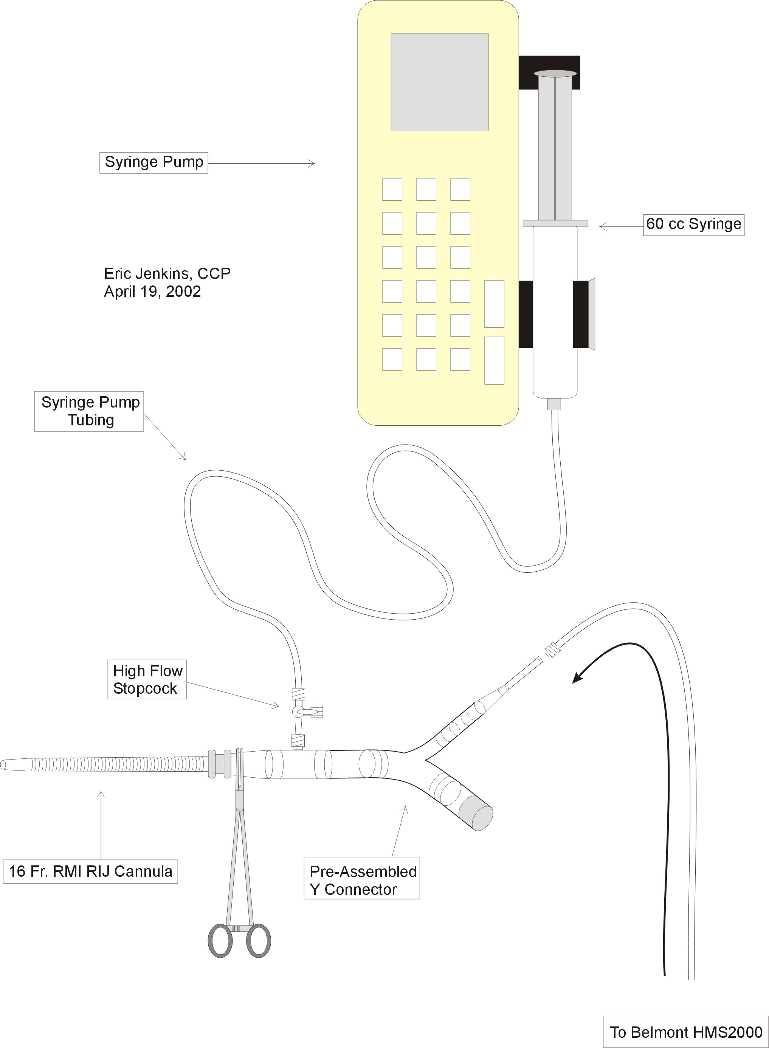
- The anesthesiologist should then set the Belmont HMS2000 to infuse at a rate not lower than 100 ml/hr in order to keep the cannula free of clot.
- Once all the lines are in place, the patient is x-rayed to check the position of the cannula and various catheters.

Right Internal Jugular Vein Line Insertion with 14 Fr. RMI Cannula

Equipment
- (1) metal rolling table
- (1) sterile tubing clamp (obtained from the scrub nurse after gowning and gloving)

Sterile Supplies
- (1) plastic table cover
- gloves
- gown
- towels (4 – pack)
- (4 - 6) 4x4 sponges
- kidney basin set
- 1000 ml bottle of 0.9% NaCl
- (1) 14 Fr RMI cannula
- (1) silastic rubber suture ring
- (1) 60 cc catheter syringes
- (3) 60 cc luer-lock syringes
- (1) pre-assembled connector (See diagram.)

Figure 13: ¼ x 3/8” Pre-Assembled Connector Diagram

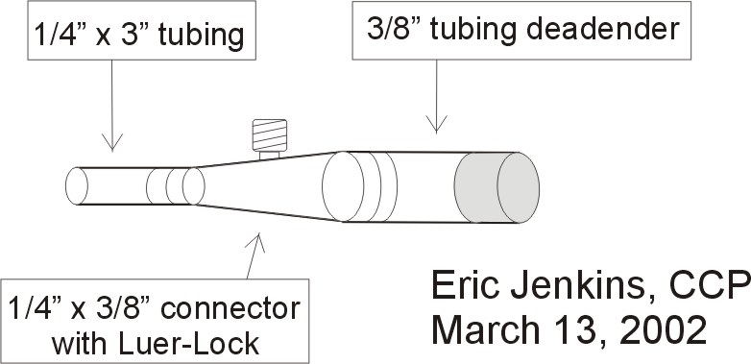

- (1) cannula insertion kit
- (1) syringe pump tubing set
- (1) large bore 4-way stopcock
- (1) cannula adapter

Setup
- Prepare sterile table.
- Place all supplies on the table using sterile technique.
- Pour ~500 ml 0.9% NaCl into the kidney basin.
- Scrub, gown, and glove.
- Load all of the 60 cc syringes with 0.9% NaCl from the kidney basin.
- Take a 60 cc Luer-Lock syringe and attach it to the syringe pump tubing set. Attach a high flow 3-way stopcock to the end of the syringe pump tubing set. Flush the syringe pump tubing and stopcock. Attach the cannula adapter to one of the 60 cc syringes. Set this syringe and the syringe pump aside for use during the RIJ cannula insertion. Save another 60 cc syringe for use when the patient is disconnected from the veno-venous bypass circuit.
- Hand the kidney basin with the remaining 0.9% NaCl and (1) 60 cc catheter syringes filled with 0.9% NaCl to the scrub nurse for future use.
- Insert the distal end of the RIJ cannula through the silastic rubber suture ring. Push the suture ring until it is 12 cm from the tip of the cannula. Use the ruler on the handle of the disposable scalpel handle. See diagram below.

Figure 14: 14 Fr. RIJ Cannula Set-Up

- You are now ready to assist the anesthesiologist.

Right Internal Jugular or Left Subclavian Cannulation
- The anesthesiologist will execute a percutaneous entry into the right internal jugular (RIJ) vein or left subclavian (LS) vein. A progressive series of dilator insertions over a J-wire will be used to allow insertion of the 14 Fr cannula. Remain gowned and gloved, and be prepared to assist the anesthesiologist during this procedure.
- Have the sterile tubing clamp, the pre-assembled connector, the 60 cc syringe with the cannula adapter, and the syringe pump tubing assembly ready. As soon as the wire and internal dilator-stylet are removed, clamp the posterior portion of the cannula. Take care not to clamp the wire reinforced section of the cannula.
Figure 15: 14 Fr. RMI Cannula Flush Diagram
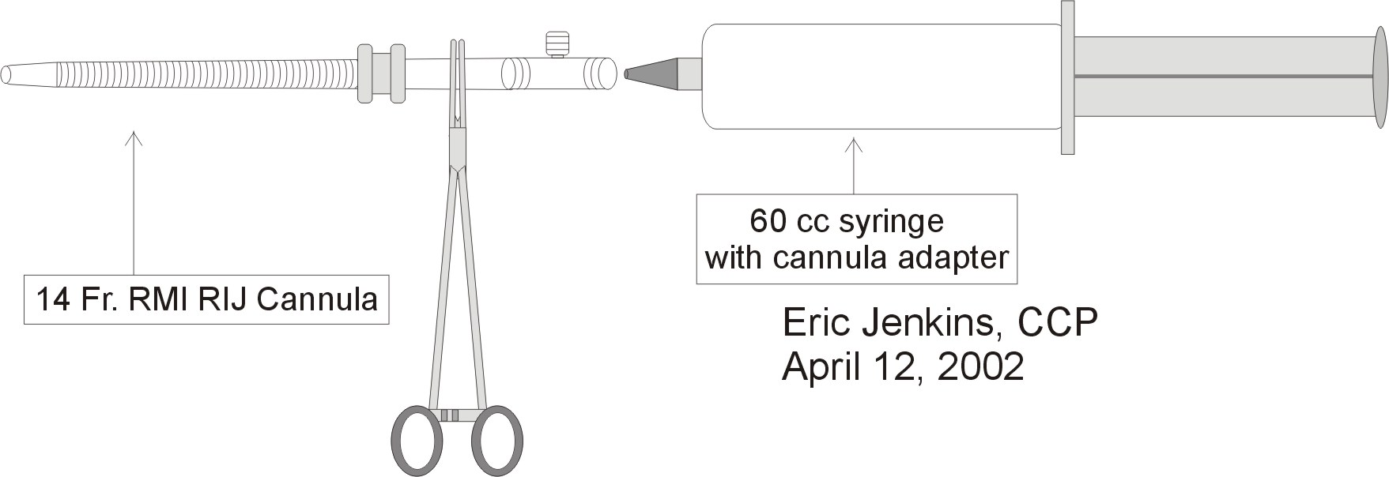
- Take the 60 cc syringe with the cannula adapter and slowly fill the posterior end of the cannula with 0.9% saline taking care to eliminate all air. When the cannula proximal to the tubing clamp is filled, insert the syringe firmly making a tight seal. Check to make sure no air is present. Remove the tubing clamp and flush the cannula. Replace the tubing clamp.
- Attach stopcock of the syringe pump assembly to the luer connector of the RIJ cannula.
- Take the pre-assembled connector and fill it with 0.9% saline from the syringe pump syringe.
- Make a fluid connection between the pre-assembled connector and the cannula by having the anesthesiologist slowly inject 0.9% saline from the syringe pump assembly. See diagram on the following page.
- When the connection is complete, insert the syringe into a syringe pump and set the infusion rate at 10 cc/hr.
Figure 16: 14 Fr. RIJ Cannula & Pre-Assembled Y Connection Diagram

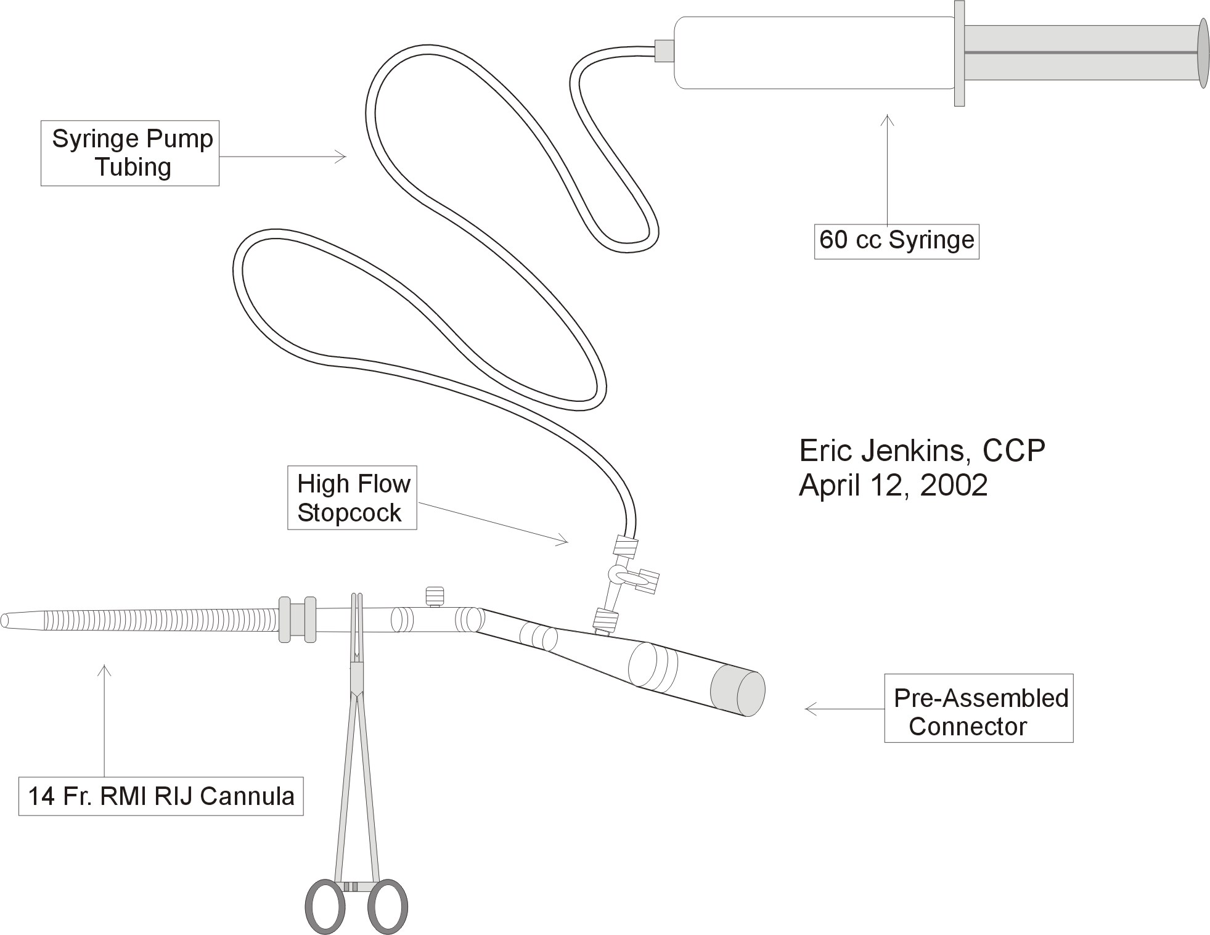

Surgeon Circuit Preference Chart
- The following chart only provides general guidelines with respect to the timing of circuit construction and priming, circuit specifications, and prime method. It is the perfusionist’s responsibility to consult the surgeon in a timely manner regarding any circuit preferences specific to the case.

Surgeon | Timing | Circuit | Prime Method
Arenas | Consult | Consult | Submersion or Niman
Campbell | Consult | Consult | Submersion or Niman
McGee | Consult | Consult | Submersion or Niman
Punch | Consult | Consult | Niman
Song | Consult | Consult | Submersion or Niman

Veno-Venous Bypass Set-Up

Standard 3-Way & Piggyback Veno-Venous Bypass Set-Up Using Submersion Prime Method
- This set-up method may be used for all surgeons. It is not, however, recommended for Dr. Punch.

Equipment
- Biopump console with metal rolling stand
- Liver Transplant Supply Cart
- Biopump Remote Tether
- DLP Pressure Display 60000 monitor
- metal rolling table
- IV pole
- extension chord
- (3) sterile tubing clamps ( obtained from the scrub nurse after gowning and gloving)

Sterile Supplies
- (1) plastic table cover
- gloves
- gown
- towels (4 – pack)
- (1) disposable scalpel
- (2) 8’ x 3/8” PVC tubing (use (3) 6’ rolls if necessary)
- (1) BP-80 Biopump
- (1) 28 Fr. Medtronic wire reinforced venous cannula (not metal tipped)
- (2) Sorenson Extension Sets
- (2) 3/8 x 3/8” connector with Luer-Lock
- (1) 3/8” Y connector (For 3-way standard VV bypass circuit only.)
- (1) Biomedicus DP-38 flow probe
- (1)DLP Pressure Display 60000 disposable transducer
- (1) 3-way stopcock
- (1) large sterile basin (obtained from circulating RN or the Core)
- (5) 1000 ml warm 0.9% NaCl solution (located in Core warmer)
- (1) 16 Fr RMI cannula (Open only if saphenous cannulation is planned.)

Circuit Setup
- Prepare sterile table.
- Place all sterile on the sterile table except the 16 Fr RMI cannula and (1) Sorenson Extension Set.
- Pour (5) L warm 0.9% NaCl solution into basin (optional).
- Scrub, gown, and glove.
- Construct the Portal Vein Cannula Assembly using the “Portal Vein Cannula Assembly Diagram” below as a guide.

Figure 17: Portal Vein Cannula Assembly Diagram
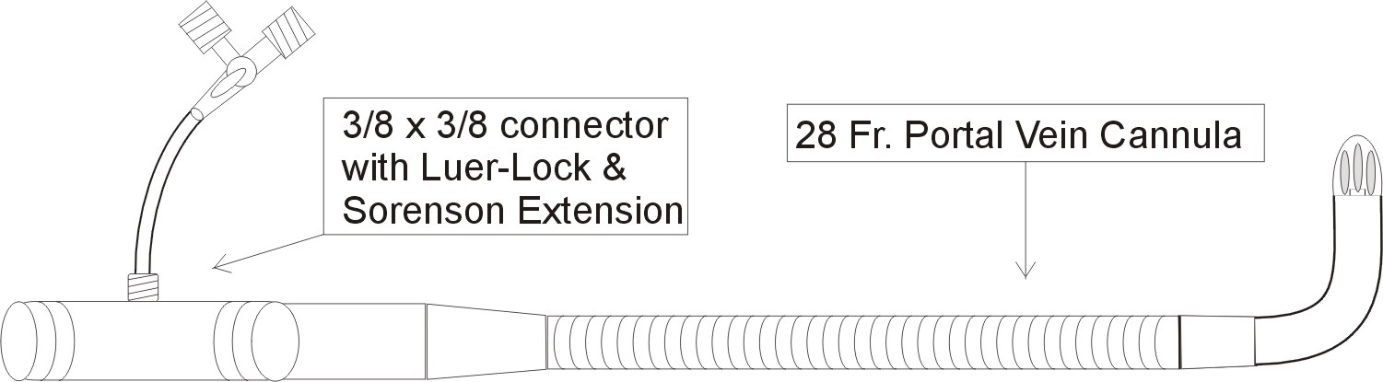

- Construct and prime by submersion the basic veno-venous bypass circuit using the “Veno-Venous Bypass Circuit Diagram” below as a guide.
- Construct a “Y” tubing assembly using one of the following diagrams the “Standard 3-Way Veno-Venous Bypass Circuit Diagram” below as a guide. If appropriate, the “Y” tubing assembly may be primed by submersion and connected to the basic veno-venous bypass circuit.

Figure 18: Piggyback or Standard 3-Way Veno-Venous Bypass Circuit Diagram

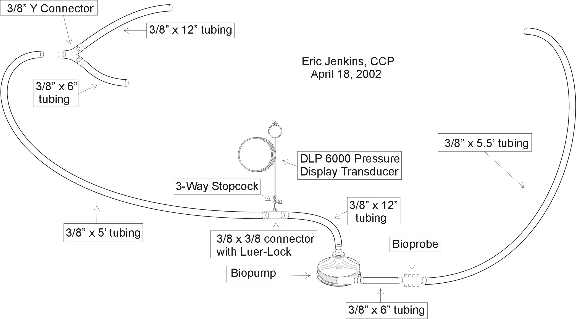

- Upon completion, place the portal vein cannula assembly, the veno-venous bypass circuit, and “Y” tubing assembly on the scrub nurse’s back table.

Standard 3-Way& Piggyback Veno-Venous Bypass Set-Up Using Niman Prime Method
- This set-up method may be used for all surgeons

Niman Prime Technique Phase 1

Equipment
- Biopump console with metal rolling stand
- Liver Transplant Supply Cart
- Biopump Remote Tether
- DLP Pressure Display 60000 monitor
- IV pole
- extension chord
- (2) tubing clamps

Sterile Supplies for Perfusion
- (1)disposable scalpel
- (1) 8’ x 3/8” PVC tubing (use 6’ rolls if necessary)
- (1) BP-80 Biopump
- (1) Biomedicus DP-38 flow probe
- (1) DLP Pressure Display 60000 disposable transducer
- (1) 3-way high flow stopcock
- (1) 10 or 20 cc syringe
- (1) liter Normosol R
- (1) Macro IV administration set
- (1) 3/8” tubing deadender
- (1) 3/8 x 3/8” connector with luer lock
- (1) deadender

Distal Circuit Construction & Assembly
- Using the “Niman Prime Technique Phase 1 Diagram” on the following page as a guide, follow the suggested instructions below to construct and assemble the portion of the veno-venous bypass circuit.
- Attach the Biopump Remote Tether and DLP Pressure Display 60000 monitor to an IV pole.
- Open a B-80 Biopump and place it in the holding receptacle of the Biopump Remote Tether with outlet port pointed upward.
- Using sterile technique, take the scalpel and cut a 6” and 12” length of tubing from a roll of 3/8” x 8” tubing.
- Insert the 3/8 x 3/8” connector with luer lock into the 3/8” tubing deadender.
- Insert the other end of the 3/8 x 3/8” connector with luer lock into the 12” length of 3/8” tubing.
- Attach this assembly to the inflow port of the BP-80 Biopump.
Figure 19: Niman Prime Technique Phase 1 Diagram
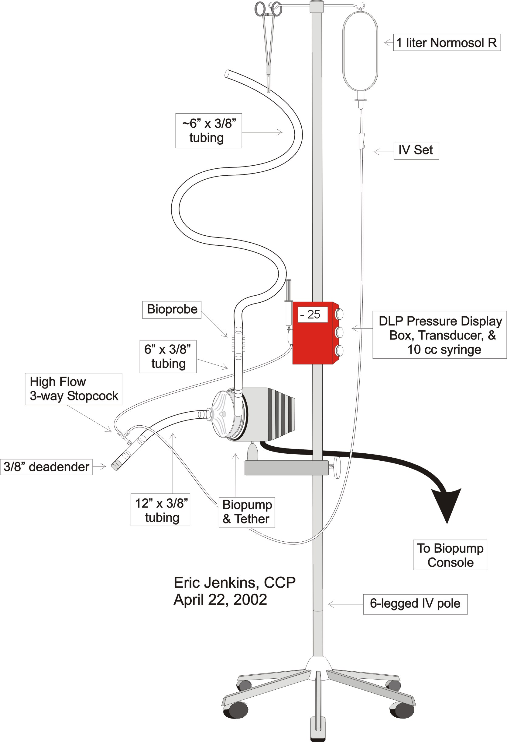
- Insert the Biomedicus DP-38 flow probe into the 6” length of 3/8” tubing.
- Attach this assembly to the outlet port of the BP-80 Biopump.
- Insert the remaining length of 3/8” tubing to the other end of the Biomedicus DP-38 flow probe.
- Partially occlude the free end of the long length of the 3/8” tubing with a tubing clamp and hang it from the IV pole.
- Insert the DLP Pressure Display 60000 disposable transducer into the DLP Pressure Display 60000 monitor.
- Attach a 3-way high flow stopcock to the luer-lock of the 3/8 x 3/8” connector. Turn the handle of the stopcock so that all 3-ways are closed.
- Connect the DLP Pressure Display 60000 disposable transducer to vertical port of the 3-way high flow stopcock.
- Attach a 10 or 20 cc syringe to the DLP Pressure Display 60000 disposable transducer.
- Hang and spike a 1 liter bag of Normosol R with the macro IV administration set.
- De-air the macro IV administration set and insert the free end into the sideport of the 3-way high flow stopcock.

Distal Circuit Prime Technique
- Turn the handle of the 3-way high flow stopcock so that the macro IV administration set is open only to the DLP Pressure Display 60000 disposable transducer.
- Open the Claire clamp of the macro IV administration set and prime the DLP Pressure Display 60000 disposable transducer using the 10 or 20 cc syringe.
- When the DLP Pressure Display 60000 disposable transducer is air free, close the Claire clamp and turn the handle of the 3-way high flow stopcock so that the macro IV administration set is open only to the distal veno-venous bypass circuit.
- Remove the syringe from prime the DLP Pressure Display 60000 disposable transducer, and zero the transducer. Place a sterile deadender on the DLP Pressure Display 60000 disposable transducer.
- Open the Claire clamp of the macro IV administration set. Prime the distal veno-venous bypass circuit. When the circuit is primed, close the Claire clamp of the macro IV administration.
- When the entire circuit is air free, place a tubing clamp close to the free end of the distal veno-venous bypass circuit. Be sure the free end of the tubing is capped.

Niman Prime Technique Phase 2

Sterile Supplies for Nursing
- (1) 8’ x 3/8” PVC tubing (use 6’ rolls if necessary)
- (1) 3/8” Y connector (For 3-way standard VV bypass circuit only.)
- (2) Sorenson Extension Sets
- (1) 28 Fr. Medtronic wire reinforced venous cannula (not metal tipped)
- (1) 16 Fr RMI cannula (Open only if saphenous cannulation is planned.)
- (1) cannula insertion kit Open only if saphenous cannulation is planned.)
- (2) 60 cc catheter syringes

Proximal Circuit Construction & Assembly
- Using sterile technique, pass up the supplies listed above to the scrub nurse.
- Have the scrub nurse fill the 60 cc catheter syringes with 0.9% NaCl solution. These should be set aside until the portal and/or saphenous cannulae require flushing.
- Using the “Portal Vein Cannula Assembly Diagram”, have the scrub nurse assemble the portal vein cannula. This, too, should be set aside until the portal vein is cannulated.

Figure 20: Portal Vein Cannula Assembly Diagram

- Using the “Niman Prime Technique Phase 2 Diagram” on the following page, have the scrub nurse construct the tubing “Y”. Do not have the scrub connect the tubing “Y” to remaining length of 3/8” tubing until it is definite that the surgeon plans to “piggyback” the donor liver.
Figure 21: Niman Prime Technique Phase 2 Diagram
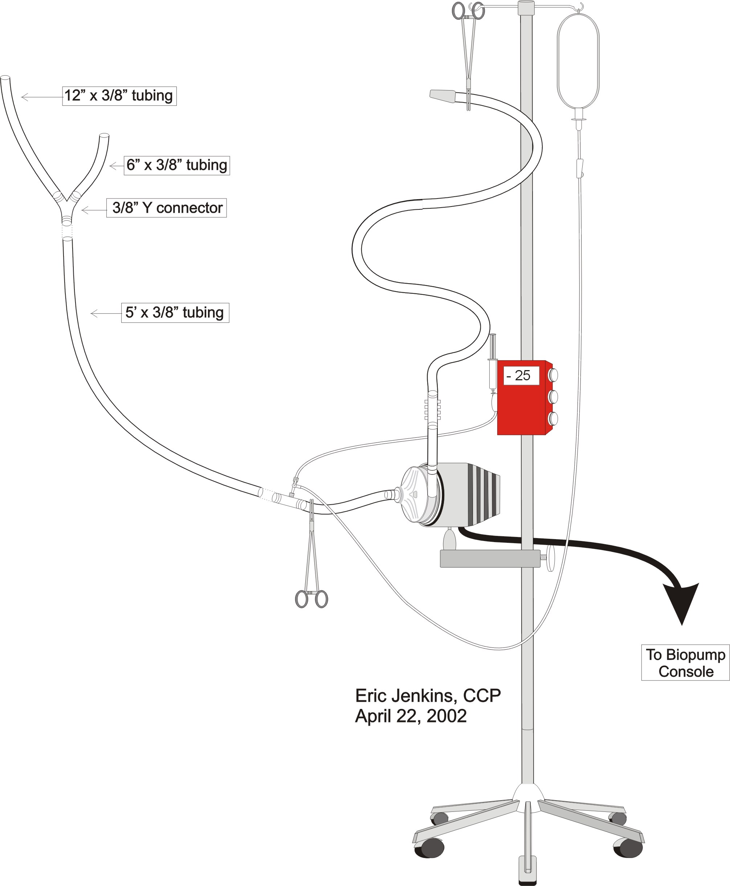

Proximal Circuit Prime Technique
- Use the “Niman Prime Technique Phase 2 Diagram” on the previous page as a guide during priming.
- Place a tubing clamp between the 3/8 x 3/8” connector and the BP-80 Biopump.
- If saphenous vein is going to be cannulated, have the scrub nurse or surgeon connect the tubing “Y” to one end of the ~5’ length of 3/8” tubing.
- Holding the tubing up, remove the 3/8” tubing deadender from the 3/8 x 3/8” connector.
- Have the scrub nurse or surgeon pass off the ~5’ length of 3/8” tubing.
- Connect the ~5’ length of 3/8” tubing to from the 3/8 x 3/8” connector.
- Open the Claire clamp of the macro IV administration set and prime the ~5’ length of 3/8” tubing.
- Close the Claire clamp of the macro IV administration set. When the proximal circuit is air free, have the surgeon or scrub nurse clamp the proximal end(s) of the veno-venous bypass circuit.

Veno-Venous Bypass Cannulation Technique & Circuit Configuration

“Piggyback” Veno-Venous Cannulation & Circuit Configuration
- Prior to cannulation, the surgeon will determine whether or not he can perform a “piggyback” liver transplant. If a “piggyback” liver transplant technique is chosen, then the “Y” tubing assembly and a 16 Fr RMI cannula for saphenous vein cannulation will not be used. See the two following diagrams.

Figure 22: “Piggyback” VV Bypass Circuit with 16 Fr. RIJ Cannula & Belmont HMS2000 Integration Diagram
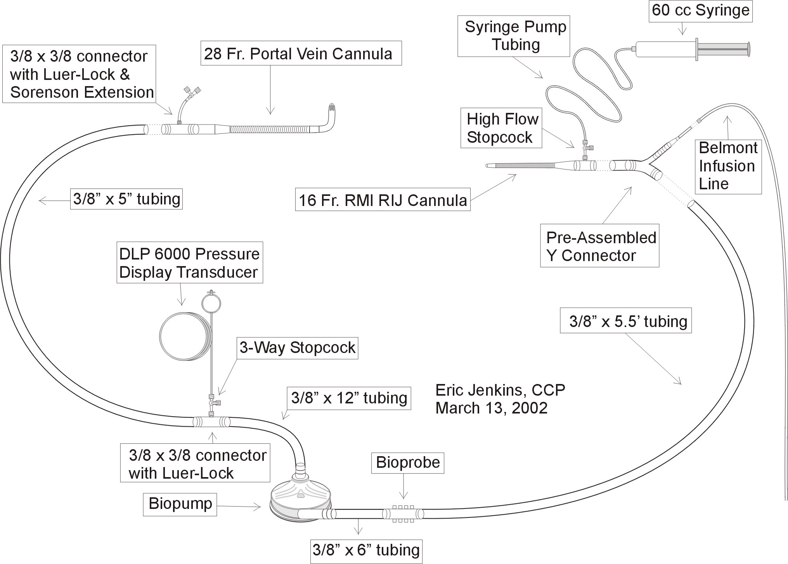
Figure 23: “Piggyback” VV Bypass Circuit w/ 12 or 14 Fr. RIJ Cannula Diagram
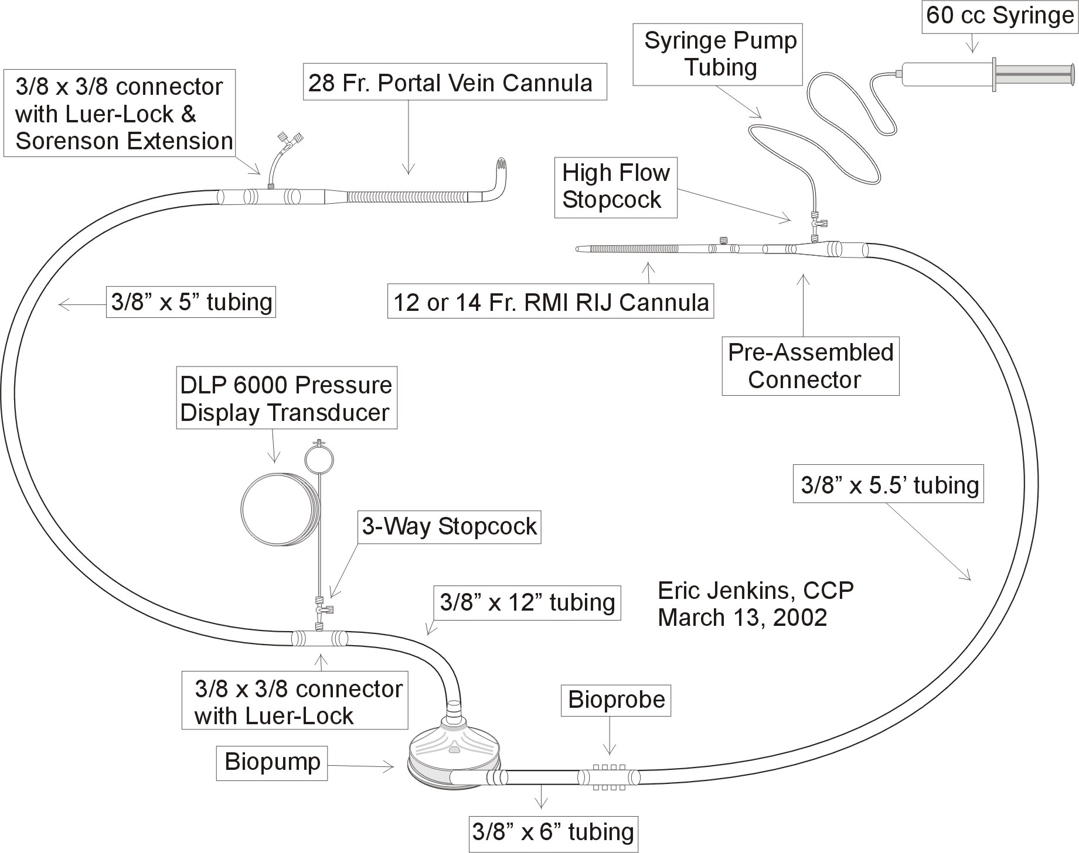
- Regardless of the priming technique used, the piggyback veno-venous bypass circuit should be configured according to the appropriate preceding diagrams.
- If the submersion technique is used, the Biopump and the circuit outflow arm are handed off to the perfusionist by the surgeon. Please note that some surgeons may hand off the circuit outflow arm over the ether screen to anesthesia.
- The Biopump is placed in the tethered holder, and the Bioprobe is placed in the Bioprobe transducer.
- Clamp both inlet and the outlet of the Biopump. Zero and balance the Bioprobe.
- Insert the DLP Pressure Display 60000 transducer into the DLP Pressure Display 60000 monitor. Zero the DLP Pressure Display 60000 transducer.
- If the Niman technique is used, the surgeon or scrub nurse hands off the inflow arm of the circuit. The perfusionist attaches and then primes the inflow arm as described earlier.
- Once the surgeon has finished orienting and securing the circuit, he will cannulate the portal vein and then make an air free fluid connection between the portal cannula and the veno-venous bypass circuit.
- During portal cannulation, the perfusionist clamps the RIJ or LS cannula and removes the 3/8" deadender. An air free fluid connection is then made between the RIJ or LS cannula and the outflow of the veno-venous bypass circuit. The circuit should not be allowed to remain static for very long in order to avoid thrombus formation.

Standard Veno-Venous Cannulation & Circuit Configuration
- If a “piggyback” liver transplant technique is not possible, then the surgeon will request the perfusionist to hand up a 16 Fr RMI cannula, 3/8” connector with a luered sideport and a 6” Monitoring Extension Set. See following two diagrams.
- Make sure the 6” Monitoring Extension Set is attached to the sideport of the 16 Fr RMI cannula.
- The surgeon will hand off the veno-venous bypass circuit to the perfusionist.

Figure 24: VV Bypass Circuit with 16 Fr. RIJ Cannula & Belmont HMS2000 Integration Diagram
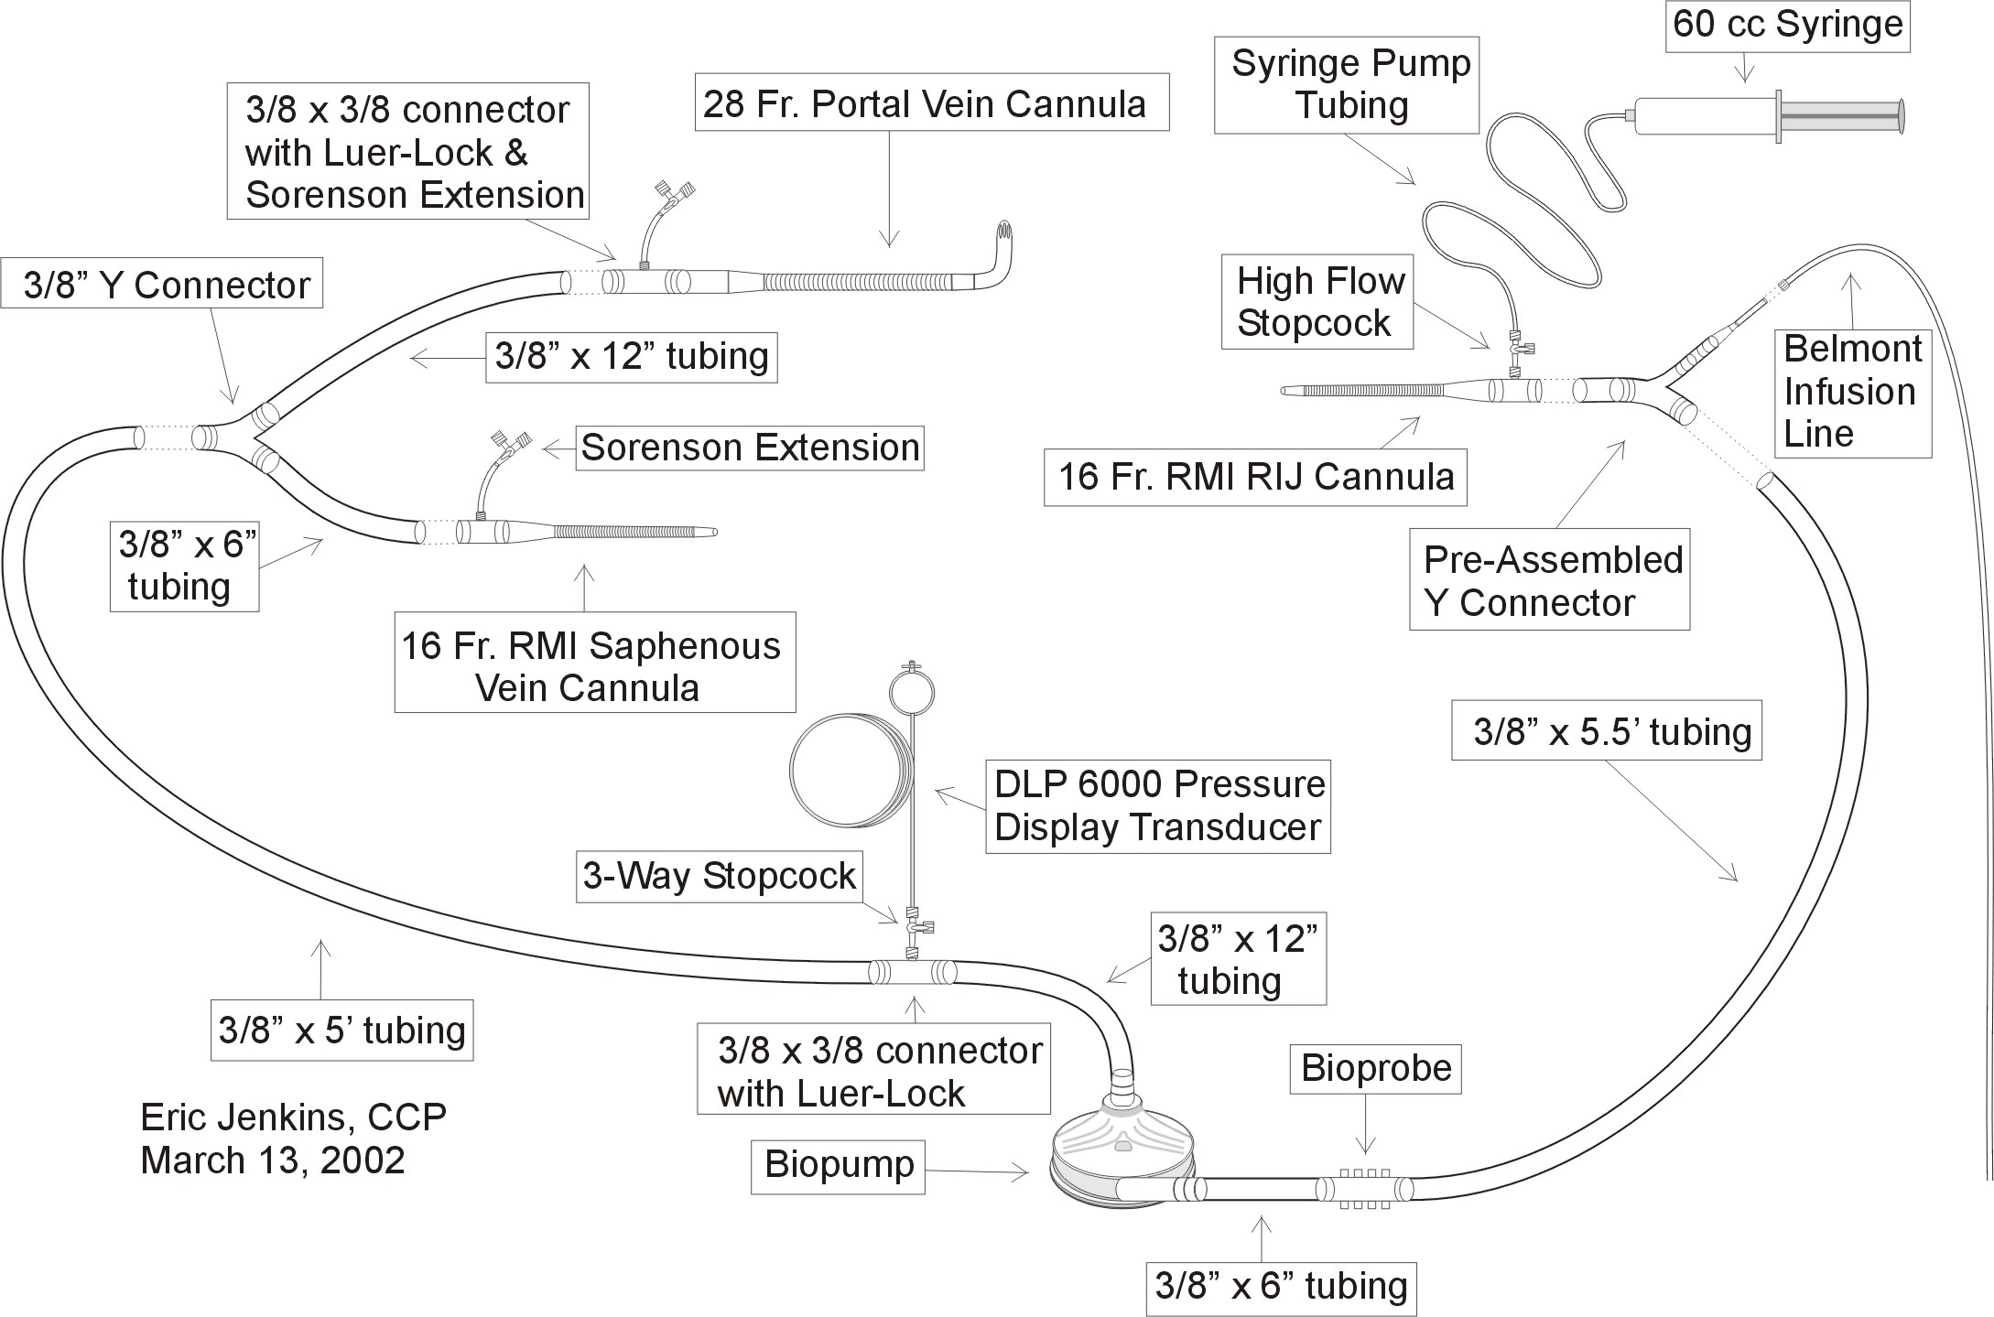
Figure 25: Standard Veno-Venous Circuit with 12 or 14 Fr. RIJ Cannula Diagram
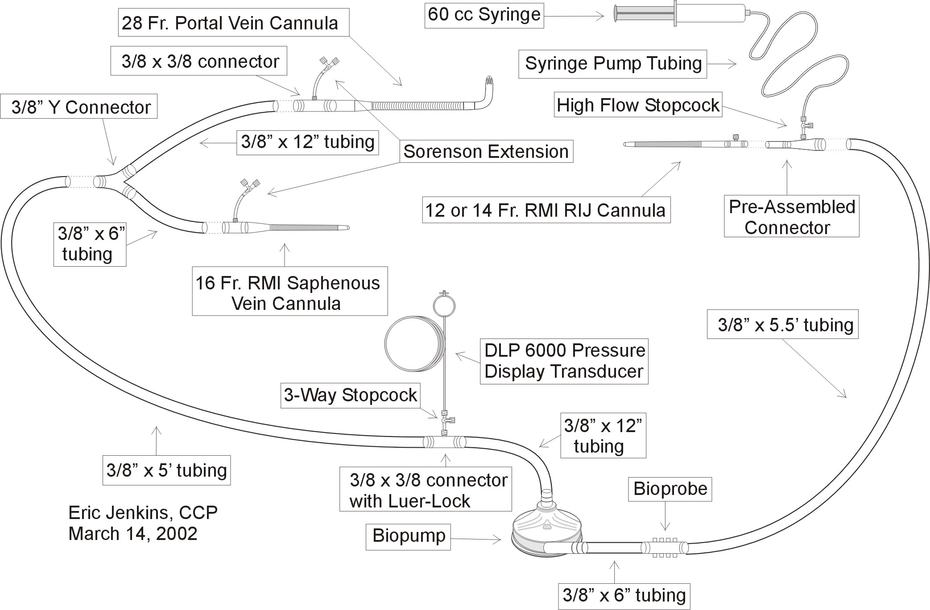

- Regardless of the priming technique used, the standard veno-venous bypass circuit should be configured according to the appropriate preceding diagrams.
- If the submersion technique is used, the Biopump and the circuit outflow arm are handed off to the perfusionist by the surgeon. Please note that some surgeons may hand off the circuit outflow arm over the ether screen to anesthesia.
- The Biopump is placed in the tethered holder, and the Bioprobe is placed in the Bioprobe transducer.
- Clamp both inlet and the outlet of the Biopump. Zero and balance the Bioprobe.
- Insert the DLP Pressure Display 60000 transducer into the DLP Pressure Display 60000 monitor. Zero the DLP Pressure Display 60000 transducer.
- If the Niman technique is used, the surgeon or scrub nurse hands off the inflow arm of the circuit. The perfusionist attaches and then primes the inflow arm as described earlier.
- Once the surgeon has finished orienting and securing the circuit, he will cannulate the portal vein and then make an air free fluid connection between the portal cannula and the veno-venous bypass circuit.
- During portal cannulation, the perfusionist clamps the RIJ or LS cannula and removes the 3/8" deadender. An air free fluid connection is then made between the RIJ or LS cannula and the outflow of the veno-venous bypass circuit. The circuit should not be allowed to remain static for very long in order to avoid thrombus formation.

Veno- Venous Bypass Management

Standard Veno-Venous Bypass Initiation
- Veno-venous bypass is initiated when the surgeon cannulates the femoral vein. Unclamping the inflow first and then the outflow accomplish initiation. Target flow rates should be > 1 l/min to avoid thrombogenesis.
- Do not exceed – 70 mmHg on the inflow line.
- If the flow rate is < 1 l/min at –70 mmHg, inform the surgeon immediately. Usually, the surgeon will have the perfusionist briefly terminate veno-venous bypass while he/she adjusts the cannula position.
- When the surgeon is ready to cannulate the portal vein, veno-venous bypass is terminated briefly. Clamping the outflow first and then the inflow accomplish termination.
- Upon resumption of veno-venous bypass, the flow rate should be greater than femoral bypass. Target flow rates should range from 30 to 50 ml/kg/min. Frequently, the surgeon will test the portal cannulation by leaving the femoral clamped.
- If the flow rate is less than expected at –70 mmHg, inform the surgeon immediately. Usually, the surgeon will have the perfusionist briefly terminate veno-venous bypass while he/she adjusts the cannula position.
- When the surgeon is ready to make the portal vein anastomosis, portal bypass will be terminated. Target flows will again be > 1 l/min to avoid thrombogenesis.

“Piggyback” Veno-Venous Bypass Initiation
- Veno-venous bypass is initiated when the surgeon cannulates the portal vein. Target flow rates should range from 30 - 50 ml/kg/min. Target flow rates should be > 1 L/min to avoid thrombogenesis.
- Do not exceed – 70 mmHg on the inflow line.
- If the flow rate is less than expected at –70 mmHg, inform the surgeon immediately. Usually, the surgeon will have the perfusionist briefly terminate veno-venous bypass while he/she adjusts the cannula position.

Veno-Venous Bypass Termination
- On the surgeon’s command, terminate veno-venous bypass.
- The surgeon will clamp the saphenous vein cannula and disconnect it from the bypass circuit. Note clamping the portal vein cannula and disconnecting it from the bypass circuit terminates “piggyback” veno-venous bypass.
- Simultaneously, have the anesthesiologist discontinue Belmont HMS2000 infusion if applicable.
- Clamp the outflow arm of the veno-venous bypass circuit just proximal to pre-assembled Y or straight connector.
- Clamp the RIJ or LS cannula.
- Disconnect the cannula assembly from the bypass circuit. See diagrams below.

Figure 26: 16 Fr. Cannula Disconnection from VV Bypass Circuit Diagram

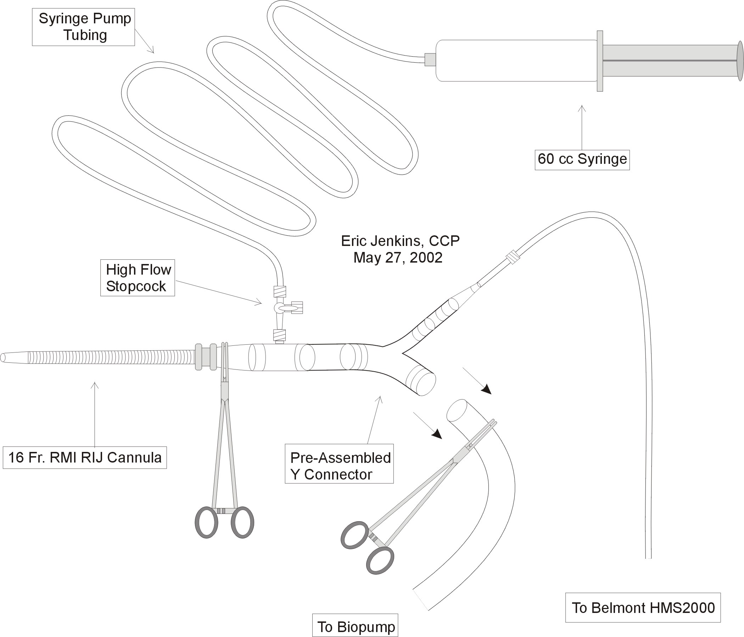
Figure 27: 14 Fr. Cannula Disconnection from VV Bypass Circuit Diagram
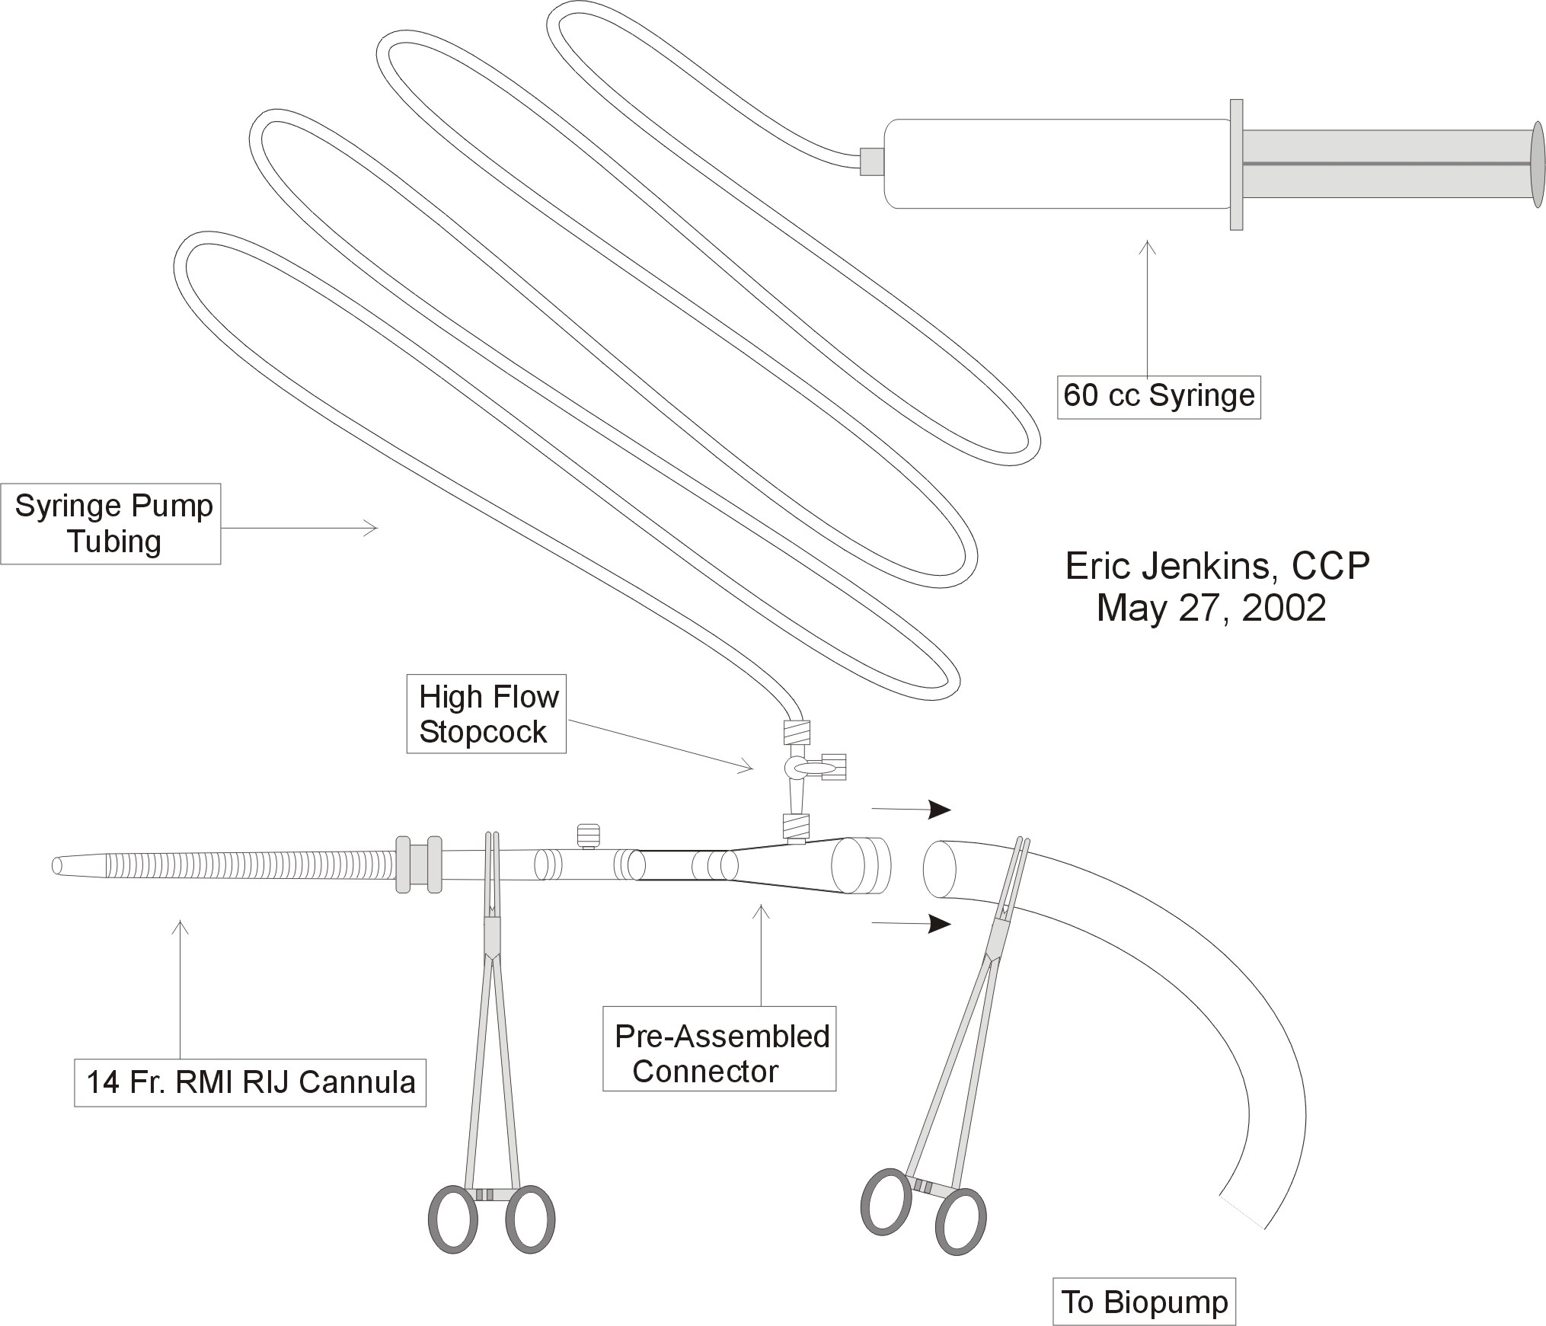
- Take a catheter syringe (16 Fr. cannula) or 60 cc syringe with cannula adapter (12 or 14 Fr. cannula) and slowly fill the posterior end of the cannula with 0.9% NaCl taking care to eliminate all air. When the cannula proximal to the tubing clamp is filled, insert the catheter syringe firmly making a tight seal. Check to make sure no air is present. Remove the tubing clamp and flush the cannula. Replace the tubing clamp and then repeat the above procedure with the second catheter syringe saving approximately 20 - 30 cc of saline.
- Clamp the cannula again, and remove the catheter syringe. Take a 3/8" deadender and fill it with 0.9% NaCl from the catheter syringe. Make a fluid connection between the 3/8" deadender and the cannula using the syringe pump syringe.
- Set the syringe pump infusion rate at 10 cc/hr.
- On cases where the Belmont HMS2000 is integrated into the RIJ cannula, set the Belmont HMS2000 infusion rate should then be set at not less than 100 ml/hr. The Belmont HMS2000 system may be used for the rest of the case.
- Before discarding the bypass circuit, have the surgeon scavenge the remaining perfusate to the cell saver if possible.

Belmont HMS2000 Disconnection Procedure
- The Belmont HMS2000 disconnection procedure only applies to patients’ who have the Belmont HMS2000 system integrated into the RIJ or LS cannula.
- Anesthesia personnel may perform this procedure.
- When the patient is ready to be transported to the SICU, stop the Belmont HMS2000 transfusion.
- Clamp the 16 Fr. RIJ or LS cannula.
- Clamp the 3/8” tubing just distal to the 16 Fr. RIJ or LS cannula.
- Disconnect the pre-assembled Y connector from the RIJ or LS cannula.
- Take a catheter syringe (16 Fr. cannula) or 60 cc syringe with cannula adapter (12 or 14 Fr. cannula) and slowly fill the posterior end of the cannula with 0.9% NaCl taking care to eliminate all air. When the cannula proximal to the tubing clamp is filled, insert the catheter syringe firmly making a tight seal. Check to make sure no air is present. Remove the tubing clamp and flush the cannula. Replace the tubing clamp and then repeat the above procedure with the second catheter syringe saving approximately 20 - 30 cc of saline.
- Clamp the cannula again, and remove the catheter syringe. Take a 3/8" deadender and fill it with 0.9% NaCl from the catheter syringe. Make a fluid connection between the 3/8" deadender and the cannula using the syringe pump syringe.
- Set the syringe pump infusion rate at 10 cc/hr.
- The RIJ or LS cannula will be removed later in the SICU.

Liver Reperfusion Protocol
- Do not set up liver reperfusion for Dr. Arenas without consultation.

General
- This policy is designed to aid the staff in the proper techniques of cadaver liver reperfusion. Any deviations from policy should come at the direction of the liver transplant surgeon. Any alterations or deviations from this policy should be immediately reported to the liver transplant surgeon.

Circuit Set-Up

Supplies
- All the supplies listed below are stocked in the transplant supply room next to room 15 at the Main Hospital.

- chilled 1000 ml lactated Ringer’s solution
- 3 12.5 g vials albumin
- 1 Y-Type blood set
- 1 blood warming coil

Procedure
- Connect the distal male end of the Y-Type blood set to the female end of the warming coil.
- Spike a chilled 1000mL lactated Ringer’s solution bag from the solution refrigerator and prime the circuit making certain that it is air free.
- Inject the 1000 ml lactated Ringer’s solution bag with 37.5 g albumin.
- Place the primed circuit and reperfusion solution in the solution refrigerator until the cadaver liver is taken out of ice.

Cooling Bucket & Temperature Monitor Set-Up

Equipment & Supplies
- An IV pole with all the appropriate equipment (listed below) assembled and attached is usually located in the transplant supply room next to room 15 at the Main Hospital. Otherwise, it may be necessary to gather and assemble the equipment. This should be done sometime after line insertion.
- (1) IV pole
- (1) insulated cooling bucket
- (1) Shiley J-Type cooling bucket holder
- (1) bottle isopropyl alcohol
- non-sterile ice

Procedure
- Just prior to when the cadaver liver is taken out of ice, obtain the prepared IV pole and fill the cooling bucket with non-sterile ice. It may be necessary to ask the circulator to perform this task if veno-venous bypass circuit cannot be left momentarily unattended.
- Pour a 50% mixture of isopropyl alcohol and water into the cooling bucket.
- Hang the primed circuit and reperfusion solution from the IV pole.

Reperfusion
- Position the IV pole next to the Biomedicus console.
- Using sterile technique, accept the extension tubing from the surgeon.
- Connect the reperfusion line to the extension tubing. Flush the extension line to remove all air. Increase the flow rate once the extension line is connected to the liver perfusion cannula. Inform the surgeons about the reperfusion flow rate and make adjustments if the line is not running.
- Place the Blood Warming Coil into the cooling bucket. Run the line wide open and adjust flow rate by manipulating the height of the IV pole. Increases and decreases in flow rate produce corresponding changes in the temperature. Avoid prolonged stoppage or low flow because the solution to freeze blocking the tubing.
- Termination of liver reperfusion is indicated by the surgeon and occurs just prior to the start of the portal vein anastomosis. Dispose of the reperfusion circuit. Clean and stow the equipment.

Lung Transplantation

Recommendations
- When a lung transplant is posted, the perfusionist will contact the attending surgeon to obtain the following information.
- Is the procedure a single or a bilateral lung transplant?
- If only one lung is being transplanted, which one?
- What surgical exposure will be utilized?
- What extracorporeal support options does the surgeon require?
- a perfusionist on standby
- a conventional pump set-up without cardioplegia for a right lung or bilateral lung transplant
- a vacuum assisted venous drainage pump set-up without cardioplegia for a left lung transplant via a left thoracotomy

Perfusionist Responsibilities

Steroid Administration
- The perfusionist is responsible for steroid administration.

Pneumoplegia
- The perfusionist is responsible for the delivery of pneumoplegia.

CPB
- The perfusionist is responsible for the assembly and operation of the appropriate extracorporeal circuit.

Steroid Administration for Single/Double Lung Transplantation
- It is the perfusionist's responsibility to make sure that the patient is given methylprednisolone (Solu-Medrol) at the proper time whether patient goes on CPB or not. This entails that the perfusionist informs the anesthesiologist of the appropriate protocol if CPB is avoided.
- Single:
- 1 g Solu-Medrol immediately prior to reperfusing the lung.
- Double:
- 500 mg Solu-Medrol just prior to reperfusing one lung.
- 500 mg Solu-Medrol just prior to reperfusing the second lung.

Intra-operative Pneumoplegia Delivery for Single/Double Lung Transplantation

Equipment
- IV pole
- Ice bucket

Supplies
- TURP administration set
- Pall Blood Transfusion Filter
- Viaspan solution
- 40 units regular insulin

Pre-Administration Instructions
- Obtain TURP administration set, Viaspan, and regular insulin from organ procurement supplies in the room between OR’s 14 and 15.
- Ice down 1 liter Viaspan solution when the harvest transplant team leaves for the donor hospital.
- 40 units regular insulin is added to the Viaspan solution ONLY when the donor team has returned from the donor hospital. Mix solution thoroughly.

Administration Instructions
- Hand the TURP administration set sterilely to the sterile field.
- When scrub nurse passes off TURP administration set, attach the Pall Blood Transfusion Filter, and spike the modified Viaspan solution.
- Hang on I.V. pole and gravity prime the line to the field.
- Wait for instructions to begin pneumoplegia delivery.
- Guidelines for pneumoplegia delivery

Single Lung Transplantation
- The first pneumoplegia dose is generally given when the lung comes out of cold storage. Generally 500 - 1000 mL is given at this time.
- A second pneumoplegia dose may be given just prior to reperfusion of the donor lung. Usually 500 mL is also delivered at this point.

Double Lung Transplantation
- The only difference with a double lung transplant is that the patient's position (Rt./Lt. thoracotomy) is changed, then after redraping and prepping the second lung is done in the same fashion as the first.
- Pneumoplegia delivery is done in the same manner as described above.

CPB Standby for Single/Double Lung Transplantation
- The perfusionist on standby is still responsible for steroid administration and pneumoplegia delivery as described above.
- If the surgeon requests the perfusionist to be on standby for CPB, the perfusionist must inquire as to whether or not the surgeon wants an extracorporeal circuit assembled and primed.
Even if the surgeon requests the perfusionist to standby without an extracorporeal circuit assembled, the perfusionist is still responsible to be immediately available should an extracorporeal circuit be emergently requested.
- For most lung transplant recipients, an extracorporeal circuit will not be set up until the surgeon has determined whether or not the patient will tolerate one lung ventilation. At this point the surgeon will make the decision whether or not the patient will require cardiopulmonary bypass (CPB).
- If the surgeon requests the perfusionist to standby with an extracorporeal circuit assembled, the perfusionist must obtain the following information from the surgeon. For patients with primary pulmonary hypertension, the surgeon will most likely require a pump set-up.
- Will active venous drainage be required?
- Generally, vacuum assisted venous drainage is required for a left lung transplantation through a left thoracotomy.

Extracorporeal Circuit Assembly and CPB for Right Lung or Bilateral Lung Transplantation
If the surgeon requests a pump set-up, the perfusionist will assemble and prime a conventional extracorporeal circuit with the following differences in the pump room.
- No cardioplegia delivery system is required.
- Insert a Pall Leuko-Guard 6 arterial filter into the Medtronic Affinity 38 micron arterial filter bypass line.
- The circuit is to be primed with crystalloid only:
- 1750 ml Normosol R
- If the surgeon decides to go on CPB, then the perfusionist will either pull the standby pump into the operating room or build and prime a circuit in the operating room.
- All the additional designated prime constituents should be added once the pump is moved into the operating room:
- 50 mEq NaHCO₃
- 12.5 g Mannitol
- 10,000 units heparin
- 1.0 - 2.0 x 10⁶ KIU aprotinin (Trasylol) or 10 g epsilon-aminocaproic acid (Amicar)
- antibiotic per protocol (See Antibiotic Preference in Section 6.)
- CPB is conducted at normothermia according to the following parameters:
- Blood flow rate: 2.4 L/min/m²
- MAP: 50 – 70 mmHg
- vSAT: > 65%
- arterial line pressure: < 300 mmHg

Extracorporeal Circuit with Vacuum Assisted Venous Drainage for Left Lung Transplantation through a Left Thoracotomy
- If the surgeon requests an extracorporeal circuit with vacuum assisted venous drainage, then the perfusionist will add a vacuum assisted venous drainage set-up into the conventional extracorporeal circuit. For the specific requirements of vacuum assisted venous drainage, see the section on Vacuum Assisted Venous Drainage Technique below. The circuit is assembled in the pump room with the differences listed immediately below.
- No cardioplegia delivery system is required.
- Insert a Pall Leuko-Guard 6 arterial filter into the Medtronic Affinity 38 micron arterial filter bypass line.
- The circuit is to be primed with crystalloid only.
- 1250 ml Normosol R
- 500 ml 6% hetastarch in 0.9% saline injection (Hespan)
- If the surgeon decides to go on CPB, then the perfusionist will either pull the standby pump into the operating room or build and prime a circuit in the operating room.
- All the additional designated prime constituents should be added once the pump is moved into the operating room.
- 50 mEq NaHCO₃
- 12.5 g Mannitol
- 10,000 units heparin
- 1.0 - 2.0 x 10⁶ KIU aprotinin (Trasylol) or 10 g epsilon-aminocaproic acid (Amicar)
- antibiotic per protocol (See Antibiotic Preference in Section 6.)
- CPB is conducted at normothermia according to the following parameters:
- Blood flow rate: 2.4 L/min/m²
- MAP: 50 – 70 mmHg
- vSAT: > 65%
- arterial line pressure: < 300 mmHg

Vacuum Assisted Drainage Technique

Vacuum Assisted Venous Drainage Equipment & Disposables
- Vacuum Regulator (on pump console)
- Vacuum Source (OR column)
- DLP Pressure Display 60000 monitor
- Medtronic VAVD kit

Vacuum Assisted Venous Drainage Set Up
- Refer to the diagram on the following page.
- Gather disposables.
- Open and connect the sputum bottle to oxygenator vent port using sterile technique.
- Open and connect suction tubing to sputum bottle and the ¼” Y connector attached to vacuum regulator.
- Place a stopcock on a luer port on top venous reservoir using sterile technique.
- Turn on the DLP Pressure Display 60000 monitor. Insert the DLP Pressure Display 60000 disposable transducer into monitor and then attach transducer line to the stopcock on the top of the venous reservoir. Zero the transducer at the venous reservoir.
- Remove cap on pressure relief valve on the top the venous reservoir.
- Turn on vacuum regulator and pre-set to –20 mmHg. Turn off vacuum regulator.

Vacuum Assisted Venous Drainage Diagram

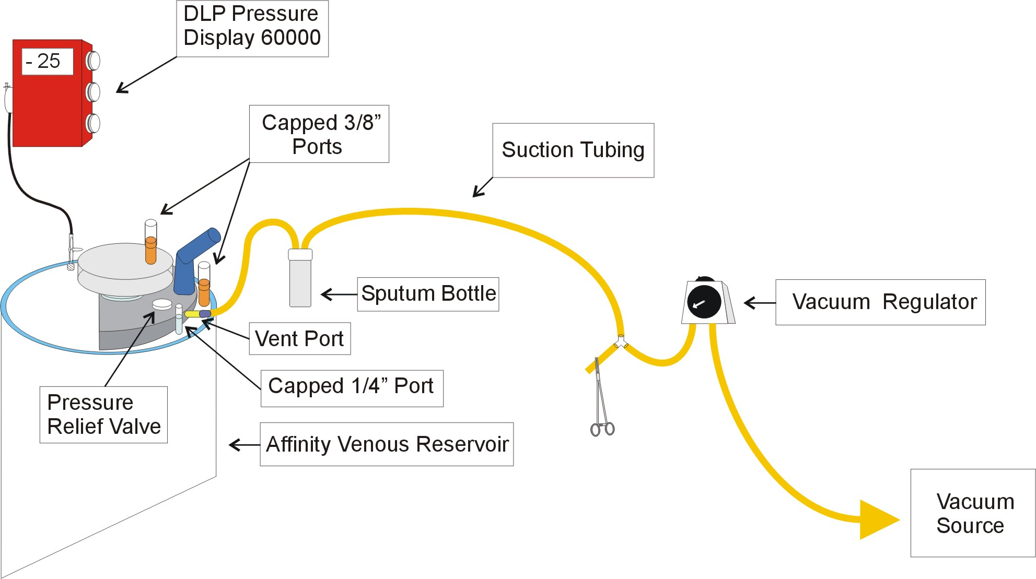

Procedure

Cannulation
- femoral artery
- Edwards Fem-Flex femoral arterial cannula
- metal femoral artery cannula (these are kept by nursing)
- Biomedicus arterial cannula (available from ECMO)
- femoral vein
- 28 Fr. DLP 96428 Femoral Venous Cannula
- 18 - 28 Fr RMI Femoral Venous Cannula (available at Mott)
- Biomedicus venous cannula (available from ECMO)
- left atrium (vent)
- 24 Fr. DLP angled metal tip (Pacifico) venous cannula
- The left atrial vent is connected to the venous line by a Y connector.

Initiation of CPB and Vacuum Assisted Venous Drainage
- The femoral artery and vein are cannulated under direct vision and then connected to the heart and lung machine in the usual manner.
- Upon verification that the arterial line is patent, initiate CPB in the usual manner with the vacuum assist off.
- Establish the maximum blood flow rate based on gravity venous drainage.
- Turn on the vacuum regulator at the pre-set vacuum of – 20 mmHg.
- Assess the level of the venous reservoir for increased return, and increase the blood flow rate accordingly until adequate perfusion in terms of blood flow rate, venous hemoglobin saturation, and mean arterial pressure are obtained.
- It may be necessary to increase the vacuum in order to obtain the appropriate blood flow rate; however, do not allow the negative pressure in the venous reservoir to exceed a vacuum greater than – 70 mmHg. It is recommended to use the minimum vacuum assist necessary for adequate perfusion.
- If the target blood flow rate is not achieved, have venous cannula position checked.

Maintenance of Vacuum Assisted Venous Drainage and CPB
- Negative pressure in the venous reservoir should be monitored continuously and adjusted appropriately for efficient venous return augmentation.
- Do not allow the negative pressure in the venous reservoir to exceed a vacuum greater than – 70 mmHg.
- Whenever the blood flow rate is lowered intermittently, reduce or turn off the vacuum.
- Whenever blood volume is transferred to the patient for vent insertion, for vent removal, or to aspirate air from the aorta, turn off the vacuum.

Termination of Vacuum Assisted Venous Drainage and CPB
- When blood volume is transferred to the patient to initiate weaning from CPB, terminate vacuum assisted venous drainage.
- Terminate CPB in the usual manner.

Section 6: Aortic Aneurysm and Dissection Procedures
Eric Jenkins, CCT, CCP; Jan Aukerman, CCP; and Michael Deeb, MD

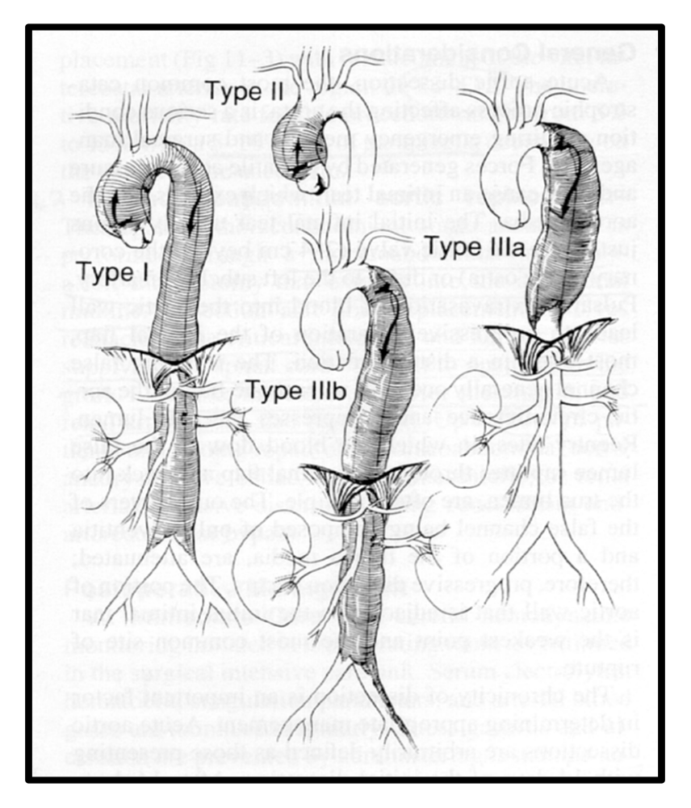
Figure 28: DeBakey Aortic Aneurysm Type Illustrations

Left Heart Bypass

Recommendations
- Prior to set-up, consult the attending surgeon as to what perfusion options he wants to have available, i.e. left heart bypass (LHB), DHCA with RCP, DHCA with vacuum assisted venous drainage, etc.
- If the attending surgeon requests LHB, ascertain as to whether or not the circuit should be Carmeda coated.

Indication
- Generally, left heart bypass is utilized on traumatic aortic transections and descending aortic aneurysms that do not extend to the diaphragm or involve the aortic arch.

Description
- Left atrial to femoral artery or descending thoracic aorta bypass using a Biopump circuit.

Overview
- Application: LHB provides perfusion distal to a clamped-out thoracic aortic aneurysm or transection.
- Anticoagulation: This technique is fairly simple with a major advantage of no or minimal heparinization. Occasionally, 3000 - 5000 units of Heparin are given at the surgeon’s discretion. If a Carmeda circuit is utilized, the procedure, theoretically, can be done without heparinization. In either case, ACT's are not routinely monitored.
- Volume Management: With this technique, the patient is the reservoir. Therefore, the ability of the anesthesiologist to maintain patient volume load is of critical importance. Adequate venous access to allow large amounts of volume to be transfused is necessary. The anesthesiologist and the perfusionist must communicate with respect to pressure, blood flow, and pressure management.
- Oxygenation: The left heart bypass circuit does not incorporate an oxygenator; therefore, the anesthesiologist is responsible for oxygenation by ventilating the patient adequately. For this procedure, a dual lumen endotracheal tube is utilized to selectively ventilate one lung, while the other is collapsed during exposure and repair.

Required Arterial Monitoring Lines
- Femoral - MUST be used to monitor perfusion pressure distal to the clamped aorta.
- Right Radial - MUST be used to monitor perfusion pressure proximal to the clamped aorta.

Cannulation

Non-Carmeda
Left Atrium: Usually a Medtronic DLP angled metal tip (Pacifico)
- Sizes: 24 Fr, 28 Fr
- Location: Rooms 6 & 7 and Core A
Femoral Artery: Usually a DLP wire reinforced arterial cannula.
- Sizes: 14 Fr, 16 Fr
- Location: Perfusion supplies wire racks in Core A supply room
Descending Thoracic Aorta: Usually a Medtronic DLP wire reinforced
- Size: 16 Fr
- Location: Perfusion supplies wire racks in Core A supply room and Mott Pump Room

Carmeda
- Carmeda coated cannulae are available. Please make sure the coated cannulae are used appropriately.
Left Atrium: Usually a Medtronic right angle wire reinforced with a lighthouse tip).
- Sizes: 24 Fr, 28 Fr
- Location: Perfusion supplies wire racks in Core A supply room
Femoral Artery: Usually a DLP wire reinforced arterial cannula.
- Sizes: 14 Fr, 16 Fr
- Location: Perfusion supplies wire racks in Core A supply room
Descending Thoracic Aorta: Usually a Medtronic DLP wire reinforced
- Size: 14 Fr.,16 Fr
- Location: Perfusion supplies wire racks in Core A supply room.

Target Parameters
Distal Perfusion
- Maintain a minimum flow of 30 ml/kg at a minimal mean arterial pressure of 60 mmHg.
- Frequently, half of the pre-clamp cardiac output, as measured by the Swann-Ganz catheter, is an accurate target for adequate distal perfusion provided that target exceeds 30 ml/kg.
Proximal Perfusion
- After placement of the aortic clamps, adjust pump flow to manage preload of the left ventricle and keep proximal pressure at 110-120 mmHg systolic.

Equipment
- Please note that if the attending surgeon requests a Carmeda coated circuit, all the disposables listed below should be Carmeda coated.
- (1) Biomedicus console
- (1) Biopump (BP-80)
- Carmeda coated Bioprobe
- (2) 6’ x 3/8" PVC tubing
- (1) 6’ x ¼” PVC tubing
- (1) 3/8 - 3/8" connector (no luer lock)
- (1) ¼ - ¼” connector (no luer lock)
- (1) sterile blade
- (1) large sterile basin (obtained from circulating RN or the Core)
- (2) sterile tubing clamps
- (5) liters of warm normal saline solution (located in the sterile core warmer)
- Sterile gown, gloves, table cover.
- Small tables for sterile assembly and placement of the Biomedicus console during the procedure.
- Sterile towels
- Cannulae (per surgeon's request)

Setup
- In the OR room, cover a table with a sterile drape to create a sterile field on which the perfusionist can assemble the circuit. Place all the sterile, disposable supplies on the sterile field. Pour the priming solution into the basin and discard the bottles. Scrub, gown, and glove.
- Construct and prime by submersion the Left Heart Bypass Circuit using the “Left Heart Bypass Circuit Diagram” below as a guide.

Figure 29: Left Heart Bypass Circuit Diagram
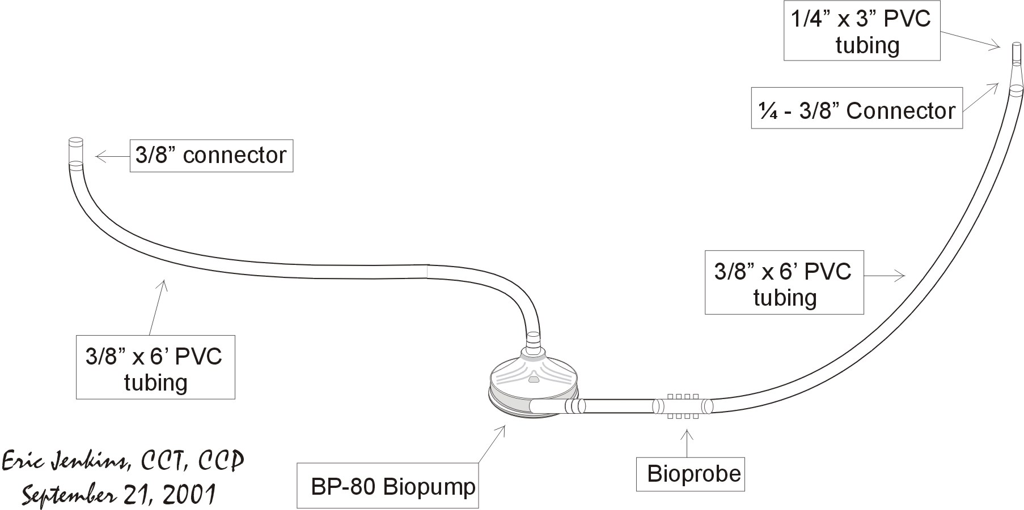

Initiation & Termination
- When the aortic lesion and cannulation sites are exposed, the BP-80 will be handed off the field to the perfusionist for attachment to the pump console.
- Balance and zero the Bioprobe.
- Initiation of left heart bypass is made at the surgeons request and accomplished by unclamping the inlet and then outlet.
- Flows are adjusted according to the aforementioned parameters.
- Termination of left heart bypass is made at the surgeons request, and accomplished by clamping the outlet and then the inlet to the Biopump.

Transverse Aortic Arch Dissection or Aneurysm Repair Requiring Deep Hypothermic Circulatory Arrest (DHCA), Selective Antegrade Cerebral Perfusion (SACP), and/or Retrograde Cerebral Perfusion (RCP) Under Revision

Overview
- Please note that this protocol describes the most probable case scenario. There can and will be variations in perfusion technique dictated by the specific presentation of the dissection or aneurysm. Consequently, it is the perfusionist’s responsibility to confer with the staff surgeon regarding perfusion strategy on a case by case basis.
- Repair of a DeBakey Type 1 dissection or aneurysm (see illustration below) involving the transverse aortic arch that is exposed through a median sternotomy and requires DHCA generally necessitates DHCA.
Figure 30: Aortic Arch Aneurysm Illustration
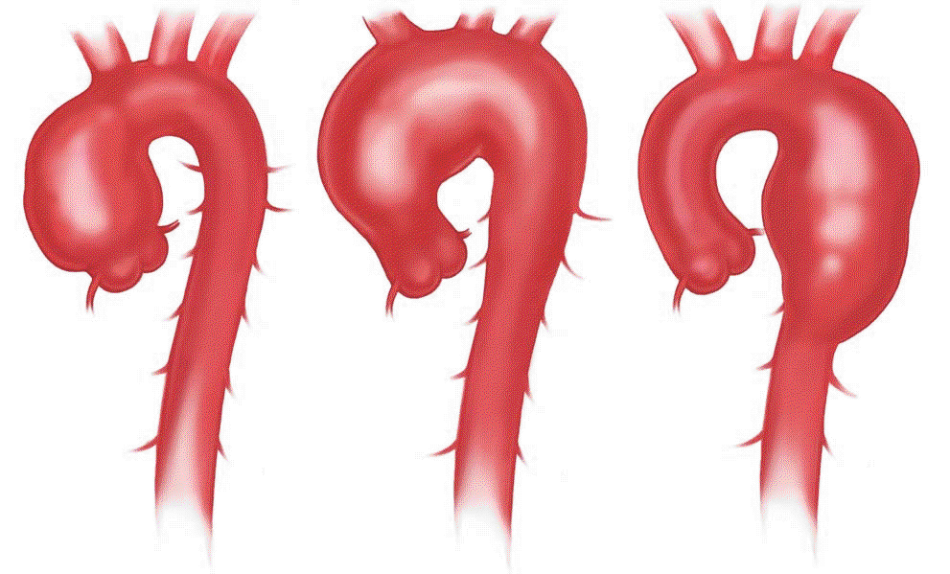

- DHCA times greater than 30 minutes are associated with an exponential increase in neurological morbidity. To prolong the safe period of DHCA, ACP is used to provide oxygen and nutrients to the brain.
- Entry of gaseous and particulate emboli into the cephalic vasculature during the procedure in another source of associated neurological morbidity. Selective use of RCP may prevent this type of injury.

Pre-CPB Case Set-Up

Pressure Monitoring Technique
- Anesthesia should set up four transducers with Male to Male connectors on the pulmonary artery, and central venous pressure transducers. The perfusionist should confer with anesthesia personnel regarding monitoring requirements.
- The monitors should be configured to display four pressures simultaneously.
- It is the perfusionist's responsibility to make sure that all monitoring devices are in place.

Left Radial Artery
- Monitoring arterial pressure via the left radial artery is recommended because it allows the systemic pressure to be monitored when CPB is reestablished following DHCA. The left radial artery pressure is transduced on the left radial artery transducer.

Pulmonary Artery
- Pulmonary artery pressure is measured through the Swann-Ganz catheter and transduced on the PA transducer.

Inominate Artery
- Inominate artery pressure (IAP) is measured directly through a retrograde cardioplegia cannula placed in the vessel and transduced on the PA transducer. The PA transducer should be re-labeled on the monitor as ICP to avoid confusion.

Coronary Sinus Pressure
- Coronary sinus pressure measured from the retrograde cardioplegia cannula and transduced on the CVP transducer.

Retrograde Cerebral Perfusion Pressure/ Superior Vena Cava Pressure
- The retrograde cerebral pressure is measured through the side port of the cordis, transduced on the fourth transducer, and labeled on the monitor appropriately.

Central Venous Pressure
- The central venous pressure is measured through the Swann-Ganz catheter and transduced on the CVP transducer.

Left Femoral Artery
- In the event that the left radial artery pressure line fails secondary to DHCA, monitoring arterial pressure via the left femoral artery is recommended. The left femoral artery pressure should be transduced on the radial artery transducer.

Temperature Monitoring Technique

Nasopharyngeal
- Nasopharyngeal temperature is displayed on the overhead monitor.

Bladder
- Nasopharyngeal temperature is displayed on the overhead monitor.

Perfusate
- Perfusate temperature is displayed on the Sarns 8000 arterial module of the heart and lung machine.

Myocardial
- Perfusate temperature is displayed on the Sarns 8000 cardioplegia module of the heart and lung machine.

Cardioplegia
- Perfusate temperature is displayed on the Sarns 8000 cardioplegia module of the heart and lung machine.

- Options
- Venous blood temperature may be measured to facilitate monitoring of the perfusate temperature gradient during rewarming.
- A portable tympanic temperature probe is available in Recovery if an alternate method of cerebral temperature monitoring is necessary.

Cell Saver Technique

Primary Sternotomy

Deeb
- No cell saver is set up.

Bolling, Pagani, Prager, Patel
- Consult the surgeon regarding cell saver technique. If the surgeon requests a cell saver, use the following guidelines.
- Set up a cardiotomy and aspiration line. Only set-up a wash set if enough volume is scavenged during CPB to wash a full bowl of red blood cells.
- All washed red blood cells may be returned to the pump during CPB, but not post-CPB. The hemoconcentrator already set up for these cases will be used to handle any excess volume during CPB.

Redo Sternotomy

Deeb
- No cell saver is set up.

Bolling, Pagani, Prager, Patel
- Consult the surgeon regarding cell saver technique. If the surgeon requests a cell saver, follow the following guidelines.
- Set up a cardiotomy and aspiration line. Only set-up a wash set if enough volume is scavenged during CPB to wash a full bowl of red blood cells.
- All washed red blood cells may be returned to the pump during CPB, but not post-CPB. The hemoconcentrator already set up for these cases will be used to handle any excess volume during CPB.

Belmont HMS2000 Set-Up & Operation
- The following protocol is adapted from Belmont Instrument Corporation Fluid Management System FMS2000 Operator/Service Manual.
- Set up the Belmont HMS2000 at the beginning of the case.

Belmont HMS2000 Set-Up
- Obtain a Belmont HMS2000 mounted on an IV pole. These may be located outside the rooms 6 or 7 or in the anesthesia workroom.
- Plug the unit in and switch circuit breaker to the “on” position. After self-diagnostic tests, press the service button in the lower right hand corner of the display screen. Increase the “pressure limit” to 300 mmHg by pressing the PRESS LIMIT soft key.
- Press the EXIT SERVICE soft key, and the unit should then display the following message: “*****MISSING DISPOSABLE*****OPEN DOOR TO SILENCE ALARM. INSTALL THE DISPOSABLE. CLOSE THE DOOR.”
- Obtain the disposable set with cardiotomy reservoir. This is located in the anesthesia storeroom in B Core.
- Using the diagram on the following page and the instructions below as a guide, install the Belmont HMS2000 disposable.
- Remove the disposable set from the tray and lay the reservoir chamber over the top of the machine. With the red tinted tubing on top, insert the heat exchanger into the well.
- Push the interlock block into the slot above the pump and firmly position the tubing into the fluid out detector.
- Guide the curved piece of pump tubing over the pump head and position the pump tubing into the groove to the right.
- Place the pressure chamber into the pressure chamber slot. Firmly insert the wider infuse line into the air detector and to the left of the valve wand.
- Close the door. Make certain the tubing is not crimped or caught in the door. Press NEXT. The prime screen will display when the door is closed and the disposable set is installed.

Belmont HMS2000 Cardiotomy Reservoir Setup
- Using aseptic technique, disconnect the standard fluid supply from the universal disposable from the luer lock connectors.
- Disconnect the larger pump tubing by pressing in the luer lock tab and pulling out the connector.
- Disconnect the thinner recirculation line by unscrewing the connector.
- Assemble the cardiotomy reservoir using aseptic technique by first attaching the 2 quick prime lines onto the top of the reservoir. The larger double spiked quick prime line attaches in the center. The thinner quick prime line attaches next to it.
- Assemble the 2 connection leads by attaching them into the connectors at the bottom of the cardiotomy reservoir.
- Connect the cardiotomy reservoir to the universal disposable.
- Attach the cardiotomy reservoir holder on the IV pole and place the reservoir into the holder.
- Make certain the 2 connections leads underneath the cardiotomy reservoir are not stretched or kinked. Stretched or kinked connection leads can cause flow restrictions and frequent “Fluid Out” alarms.
Figure 31: Belmont HMS2000 System Diagram
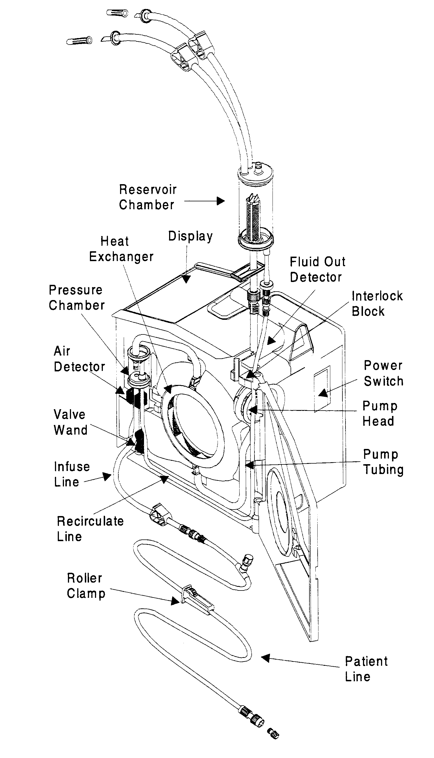

Belmont HMS2000 Prime Procedure
- Take and drop 500 ml Normosol R into the cardiotomy.
- Press the PRIME soft key in the lower right hand corner of the display screen.
- When the autoprime is completed, press PT. LINE PRIME soft key to prime patient line. Continue to prime until the patient line is air free.
- Hand device over to anesthesia.

Pre-CPB Autologous Whole Blood Collection
- 1 -2 units of the patient’s own whole blood are to be collected prior to heparinization. This is done as long as the resultant hematocrit falls within a calculated 18 - 22% resultant hematocrit on CPB. The perfusionist should spin a patient Hct following pre-CPB autologous whole blood collection and then calculate an estimated patient-machine Hct. If the resultant Hct is less than 25%, consult the attending surgeon regarding adding PRBC’s to the pump prime or at the initiation of CPB.

Estimated CPB Hct Calculation

Estimated CPB Hct = (65 x kg x (pt Hct / 100) x 100
(65 x kg) + ml prime)

where: Estimated CPB Hct = estimated Hematocrit on cardiopulmonary bypass
ml prime = prime volume of extracorporeal circuit
kg = patient’s kilogram weight
pt Hct = patient’s hematocrit measured following autologous
whole blood collection by anesthesia

Collection Procedure

Disposables
- (1 -2) 600 cc transfer packs
- (1)500 cc CPD bottle
- (1-2) 60 cc syringes
- (1-2) 3-way stopcocks

Procedure
- Attach a 3-way stopcock to a transfer pack.
- Draw 63 cc CPD into a 60 cc syringe and inject it into the transfer pack. Hand the CPD transfer pack(s) to the anesthesiologist.
- Blood collection should be timed to be completed just prior to heparinization. The collection time for each unit is ~15 minutes.
- Anesthesia personnel must monitor the patient blood pressures and EKG during blood collection and transfuse the patient with crystalloid and colloid solutions appropriately. Blood collection should be terminated if the patient becomes unstable.

Storage and Expiration
- When stored at 37ºC, autologous whole blood expires 8 hours from the start of collection.
- When the collected autologous whole blood approaches expiration before the termination of CPB, it may be stored at 1 - 6 ºC or transfused into the extracorporeal circuit. If the collected autologous whole blood is stored at 1 - 6 ºC within 8 hours of the start of collection, it will expire 24 hours from the start if collection.
(American Association of Blood Banks Standards for Perioperative Autologous Blood Collection and Administration, 1st Edition)

Transfusion Technique
- Collected autologous whole blood is transfused after protamine administration is completed.
- Do not transfuse collected autologous whole blood with the Belmont HMS2000 Rapid Infusion System.

Extracorporeal Circuit Set-Up

Additional Equipment
- Minntech HPH 1000 Hemoconcentrator
- Capiox infant arterial line filter holder
- DLP Pressure Display 60000

Extracorporeal Circuit Components

Standard Extracorporeal Circuit Components
- surgeon's preference 2-stage venous cannula or bicaval cannulae (nursing)
- Medtronic Affinity Membrane Oxygenator
- Medtronic Adult Tubing Pack

Non-Standard Extracorporeal Circuit Components
- surgeon's preference femoral arterial cannula (nursing)
- Minntech HPH 1000 hemoconcentrator
- suction tubing

Antegrade Cerebral Perfusion Components
- Capiox infant arterial line filter
- One way valve purge line with stopcock
- (2) 6’ rolls of ¼” PVC tubing
- (2) ¼” Y connector (nursing)
- ¼” straight connector
- ¼” straight connector with luer lock connector
- (2 - 3)13 Fr. retrograde cardioplegia cannulae (nursing)
- (4) ¼” perfusion adapters (3 for nursing)
- DLP Pressure Display 60000 transducer

Retrograde Cerebral Perfusion Components
- (1) 6” roll of 3/8” PVC tubing
- (1) 3/8” Y connector
- (2) 3/8" straight connectors
- 24 Fr DLP venous cannula or surgeon's preference

Circuit Modification
- Modify the basic adult extra-corporal circuit according to the diagram of the following page.
- Some perfusionists may prefer to use an additional Sarns 8000 roller pump module instead of doubling up the #1 and #2 suckers.
- The arterial Y, possibly the venous Y, and the SACP double Y set-ups are constructed by the surgeon or scrub nurse prior to CPB initiation. The perfusionist should inspect these circuit attachments.
- The arterial Y and possibly the venous Y set-up is attached and primed after the A-V loop is divided.
- The SACP triple Y set-up is attached and primed during CPB just prior to DHCA.
Figure 32: RCP / SACP Extracorporeal Circuit Diagram
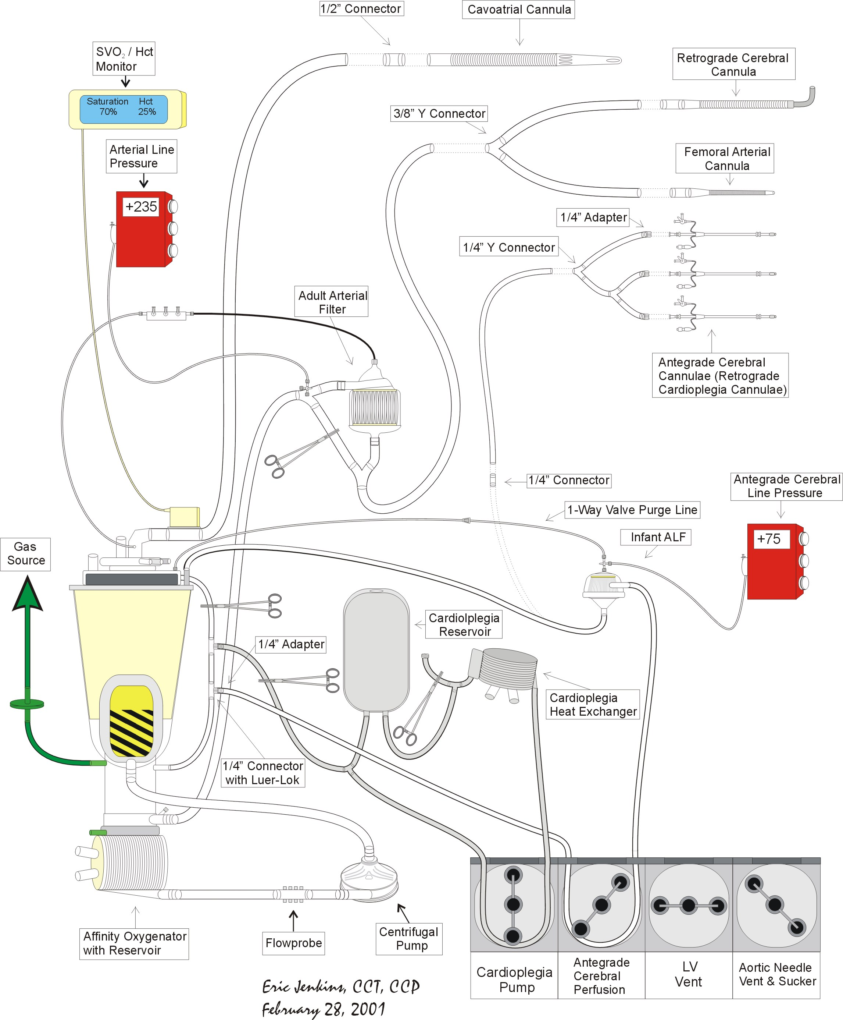

Prime Constituents
- 1750 ml Normosol R
- 50 g albumin
- 50 mEq NaHCO₃
- 12.5 g mannitol
- 10,000 units heparin
- 2.0 x 10⁶ KIU aprotinin (added after negative test dose)
- 1 g cetazidime (Ceptaz)
- 1 g vancomycin (titrated during CPB)

CPB Procedure and Technique
- The following describes the most likely sequence of events when circulatory arrest is required. Circulatory arrest is generally required when replacement of the partial or complete transverse aortic arch is necessary.

Anticoagulation
- 300 – 400 units Heparin per kg is administered by the anesthesiologist at the surgeon’s request.
- 3 – 4 minutes following heparin administration, a kaolin ACT is measured.
- Pericardial suckers may be safely turned on when the kaolin ACT reaches 300 seconds.
- When the kaolin ACT reaches 400 seconds, CPB may be initiated safely.
- During CPB, a kaolin ACT > 480 seconds is to be maintained.

Cannulation
- Approximately 2 minutes after heparin administration, the surgeon performs the following cannulations.

Arterial
- Distal ascending aortic arch cannulation is used when an aneurysm is present. A Terumo Softflow arterial cannula is usually the cannula of choice. The cannula is then connected to an arm of the bifurcated arterial line.
- Femoral arterial cannulation is most likely when a dissection is present. A Fem-flex femoral arterial cannula is usually the cannula of choice. The cannula is then connected to an arm of the bifurcated arterial line.

Venous
- Whether cavo-atrial or bicaval cannulation is used is determined on a case by case basis.
Cavo – Atrial
- A two stage Terumo venous cannula is placed in the right atrium through the right atrial appendage. The cannula is then connected directly to the venous line.
Bicaval
- The SVC is cannulated with an angled 24 Fr. DLP venous cannula. The cannula is then connected to an arm of the bifurcated venous line.
- After CPB is initiated and adequate venous return from the SVC is confirmed, the IVC is cannulated with an angled 28 Fr. DLP venous cannula. The cannula is then connected to the other arm of the bifurcated venous line.

Superior Vena Cava
- When cavo-atrial cannulation is utilized, the SVC is cannulated with an angled 24 Fr. DLP venous cannula prior to CPB initiation. The SVC cannula is then connected to the bifurcated arterial line.

Coronary Sinus
- Prior to CPB initiation, the coronary sinus is cannulated with a 15 Fr. retrograde cardioplegia cannula. The cannula is then connected to the cardioplegia line.

CPB Initiation LV Vent Placement
- When the cannulations listed above are completed and the ACT is greater than 400 seconds, CPB is initiated at 37ºC.
- When a blood flow rate of 2.4 l/min/m² and adequate venous drainage are confirmed, blood volume is transferred to the patient from the venous reservoir. With the heart ejecting, a vent is inserted through right superior pulmonary vein into the left ventricle. With the vent pump on, the vent is connected to the left ventricular vent line. Blood volume is then transferred back to the venous reservoir.

Cooling
- Cooling for circulatory arrest is started immediately after placement of the left ventricular vent.
- The patient is cooled to a bladder temperature of 18 ºC maintaining an 8 – 12ºC gradient between the bladder and perfusate temperatures.
- The perfusate temperature should not fall below 13 ºC.
- The Hct during cooling should be 20 – 25%.
- The patient’s head is packed in ice by the anesthesiologist.
- During cooling, the surgeon will begin to repair and/or replace the aortic valve and aortic root if appropriate.

Cardioplegia
- Just prior to cross clamping the aorta, the heart is fibrillated with an electric fibrillator.
- The blood flow rate is lowered at the surgeon’s request. When the aortic is securely cross clamped, the blood flow rate is increased to full, and cardioplegia is delivered retrograde via the coronary sinus. 1250 – 2000 ml of cardioplegia solution are delivered at a flow rate of ~ 200 cc/min to arrest and cool the heart. The coronary sinus pressure should not exceed 40 mmHg.
- The aortic valve is removed and the aortic valve annulus debrided. Another dose of cardioplegia will be given at this point to flush out the coronary ostia with the left ventricular vent turned off.
- A dose of 500 cc will be given at this time and every 20 minutes throughout the cross clamp period. The surgeon should be alerted if the myocardial temperature exceeds 12ºC or if any electromechanical activity is detected.

Pre-DHCA Drug Regimen
- Once the patient is cooled to a bladder temperature of 18ºC, the patient is placed in Trendelenberg. At the surgeon’s request, the pre-DHCA drug regimen listed below is administered and allowed to circulate. Dr. Deeb refers to these drugs collectively as the “tols.”

1 g thiopental
25 g mannitol
5,000 - 10,000 units heparin
1 gram methylprednisolone (Solu-Medrol)

- The surgeon snares down on the SVC cannula (isolating it) and retrograde cerebral blood flow is initiated at a flow rate of 500-800ml’s/minute and a pressure measured from the cordis not to exceed 35mmHg. Retrograde cerebral perfusion is usually maintained for approximately 3 to 7 minutes while the surgeon evaluates and cannulates the head vessels with DLP cardioplegia balloon tipped cannulae.
- The separate antegrade cerebral tubing is handed down from the field and flushed/de-aired to the cardioplegia cannulae. After antegrade cerebral perfusion is established at flows of approximately 750 – 1000 ml/min. (approximately 15 to 20% of the cardiac output) with a pressure of 80 mmHg, retrograde cerebral perfusion is terminated. Pressure is monitored directly from the cardioplegia cannula placed in the innominate artery and again the mean (IAP) pressure maintained at 80 mmHg (as normally seen in the aorta during CPB).
- The Hemashield Gold graft is anastomosed first to the distal aorta.
(INSERT DIAGRAM 1)

- The subclavian artery is then anastomosed. Once this is accomplished, the cross clamp is applied between the subclavian artery and the second head vessel.
(INSERT DIAGRAM 2)

- Blood flow is re-established through the side arm of the Hemashield Gold arch graft using a DLP 8mm. cannula.
- The femoral cannula, if present, is used momentarily for de-airing purposes and then clamped. Thus, CPB is now provided via the antegrade cerebral circuit as well as down the descending aorta. When the second head vessel is anastomosed and de-aired, the aortic cross clamp is moved over between the first and second aortic head vessel on the graft, and antegrade cerebral flow may now be reduced to approximately 500 cc/minute at the surgeon’s direction.

- (INSERT DIAGRAM 3)

- Remember the patient’s blood pressure is still being monitored from the IAP cannula and the radial artery. A flow of 500 cc./minute through the antegrade circuit at this time is adequate since cerebral flow is also being provided from the other two head vessels.
- Rewarming to 28C is usually initiated by the surgeon at this time, before the last head vessel is anastomosed. Antegrade cerebral perfusion is terminated when the final head vessel is anastomosed and the entire graft is open for perfusion. Rarely the surgeon may go briefly back to the retrograde cerebral perfusion flow, but this is extremely uncommon.

(INSERT DIAGRAM 4)

- As soon as the circulatory arrest event is over, the patient should be taken out of Trendelenberg. Unnecessarily prolonged head down positioning may lead to venous pooling in the patient’s head.
- As needed other cardiac procedures can then be completed at 28C and full rewarm is initiated upon the surgeon’s order.

Rewarming Technique
- Rewarm maintaining an 8-12ºC gradient between the venous blood and the water bath temperatures.
- Do not exceed a perfusate temperature of 38.9 ºC.
- Hemoconcentrate and make the necessary PRBC additions for the surgeon’s target Hct.

Note: The heater coolers at the Main hospital are very old and do not change temperature efficiently. A 10 -12 C gradient is maintained during rewarming. It is imperative to get the water bath temperature elevated early in order to generate at least an 8C gradient to warm the patient. The first twenty minutes of warming makes all the difference in reinitiating of urine output and thus raising the bladder temperature marker appropriately. Forane may also be used as a potent vasodilator and improve warming efficiency.

Warm Reperfusion Cardioplegia
- Hot shot is given on all of these cases. A dose of 600 cc’s, given at 200cc/min. for 3 minutes at a pressure not to exceed 40mmHg, followed by one minute of warm blood. The patient should be fully rewarmed when the surgery is completed to minimize time on pump.

Continuous Zero Balanced Ultrafiltration (Z-BUF)
- This technique is used by Dr. Deeb only. Consult all other surgeons before applying this technique.
- Begin continuous Z-BUF during rewarming.
- Produce a minimum of 5 -9 liters of effluent using the appropriate replacement fluid as suggested below.
0.9% NaCl Solution
- Use 0.9% NaCl solution as a perfusate volume replacement when the serum potassium and/or glucose are elevated.
- Be sure to correct the serum calcium prior to CPB termination.
- Buffer each liter of 0.9% NaCl with 24 mEq NaHCO₃ unless the patient has metabolic alkalosis.
Normosol R Solution
- Use Normosol R solution as a perfusate volume replacement when the serum potassium and/or glucose are not elevated.
- Be sure to correct the serum calcium prior to CPB termination.
- Buffer each liter of Normosol R solution with 24 mEq NaHCO₃ unless the patient has metabolic alkalosis.

Post-Aortic Crossclamp Pharmacology
- Immediately upon or just prior to the release of the aortic crossclamp administer the drugs listed below.
- 12.5 g mannitol
- 10 mg furosemide
- 200 mg lidocaine
- 3 g MgSO₄

Termination
- CPB is terminated in the usual manner.
- Following protamine administration, the perfusionist needs to be available to troubleshoot the RIS system if necessary

Dissection or Aneurysm Repair through a Left Thoracotomy Requiring DHCA, Left Atrial Venting, and Active Venous Drainage (Under Revision)

Set-Up Considerations
- Dr. Deeb has requested that the pump be set-up in the pump room to avoid wasting the circuit because he may use the Left Heart Bypass technique. If the pump circuit is not used on the case, it is to be used on another case whenever possible.
- Do not set up a Left Heart Bypass circuit unless specifically requested by Dr. Deeb.

Indications
- Aortic dissection or aneurysm involving the aortic arch and the thoracic aorta.
- Type 2 dissection where the tear originates in the distal transverse arch and extends antegrade into the thoracic aorta.
- Type 3 dissection where the tear originates in the thoracic aorta and extends retrograde into the distal transverse arch.
- An aortic aneurysm involving both the distal transverse arch and thoracic aorta.
- A thoraco-abdominal aneurysm.

Figure 33: Descending Aortic Aneurysm Illustration

Overview
- Please note that the overview below describes the most probable CPB scenario. There can and will be variations in perfusion technique dictated by the specific presentation of the dissection or aneurysm.
- The repair of a dissection or aneurysm involving the distal transverse arch, the thoracic aorta, and/or the abdominal aorta requires exposure through a left thoracotomy.
- Exposure through a left thoracotomy necessitates the use of vacuum assisted venous drainage to ensure adequate perfusion.
- Prior to deep hypothermic circulatory arrest (DHCA) of the cephalic and cardiac vasculature, blood is drained from the left atrium and the femoral vein and returned to the femoral artery.
- Repair of the aortic arch necessitates DHCA of the cephalic and cardiac vasculature. During this period, perfusion to the vasculature distal to dissection or aneurysm is maintained. Vacuum assisted venous drainage is turned off during DHCA of the cephalic and cardiac vasculature.
- Upon completion of the proximal anastomosis of the aortic graft, perfusion to the cephalic and cardiac vasculature is reestablished through an arterial cannula inserted into the aortic graft. Blood is drained from the left atrium and the femoral vein and returned to the proximal portion of the graft and to the femoral artery. Deep hypothermia (18ºC) is maintained.
- Repair of the distal anastomosis of the aortic graft necessitates DHCA of the vasculature distal to the dissection or aneurysm. During this period, perfusion of the cephalic and cardiac vasculature is maintained through the arterial cannula inserted into the aortic graft.. The arterial cannula inserted in the femoral artery is clamped. Vacuum assisted venous drainage is turned off during DHCA of the vasculature distal to the dissection or aneurysm.
- Upon completion of the distal anastomosis of the aortic graft, the femoral arm of the arterial line is opened to facilitate aspiration of the graft.
- When the surgeon is satisfied that the patient is air free, the femoral arm of the arterial line is clamped again.
- The patient is then rewarmed in the usual manner (do not exceed 38.9ºC perfusate temperature), and CPB is terminated.

Cell Saver Technique

Deeb
- No cell saver is set up.

Bolling, Pagani, Prager
- Consult the surgeon regarding cell saver technique. If the surgeon requests a cell saver, follow the following guidelines.
- Set up a cardiotomy and aspiration line. Only set-up a wash set if enough volume is scavenged during CPB to wash a full bowl of red blood cells.
- All washed red blood cells may be returned to the pump during CPB, but not post-CPB. The hemoconcentrator already set up for these cases will be used to handle any excess volume during CPB.

Belmont HMS2000 Set-Up & Operation
- The following protocol is adapted from Belmont Instrument Corporation Fluid Management System FMS2000 Operator/Service Manual.
- Set up the Belmont HMS2000 at the beginning of the case.

Belmont HMS2000 Set-Up
- Obtain a Belmont HMS2000 mounted on an IV pole. These may be located outside the rooms 6 or 7 or in the anesthesia workroom.
- Plug the unit in and switch circuit breaker to the “on” position. After self-diagnostic tests, press the service button in the lower right hand corner of the display screen. Increase the “pressure limit” to 300 mmHg by pressing the PRESS LIMIT soft key.
- Press the EXIT SERVICE soft key, and the unit should then display the following message: “*****MISSING DISPOSABLE*****OPEN DOOR TO SILENCE ALARM. INSTALL THE DISPOSABLE. CLOSE THE DOOR.”
- Obtain the disposable set with cardiotomy reservoir. This is located in the anesthesia storeroom in B Core.
- Using the diagram on the following page and the instructions below as a guide, install the Belmont HMS2000 disposable.
- Remove the disposable set from the tray and lay the reservoir chamber over the top of the machine. With the red tinted tubing on top, insert the heat exchanger into the well.
- Push the interlock block into the slot above the pump and firmly position the tubing into the fluid out detector.
- Guide the curved piece of pump tubing over the pump head and position the pump tubing into the groove to the right.
- Place the pressure chamber into the pressure chamber slot. Firmly insert the wider infuse line into the air detector and to the left of the valve wand.
- Close the door. Make certain the tubing is not crimped or caught in the door. Press NEXT. The prime screen will display when the door is closed and the disposable set is installed.

Belmont HMS2000 Cardiotomy Reservoir Setup
- Using aseptic technique, disconnect the standard fluid supply from the universal disposable from the luer lock connectors.
- Disconnect the larger pump tubing by pressing in the luer lock tab and pulling out the connector.
- Disconnect the thinner recirculation line by unscrewing the connector.
- Assemble the cardiotomy reservoir using aseptic technique by first attaching the 2 quick prime lines onto the top of the reservoir. The larger double spiked quick prime line attaches in the center. The thinner quick prime line attaches next to it.
- Assemble the 2 connection leads by attaching them into the connectors at the bottom of the cardiotomy reservoir.
- Connect the cardiotomy reservoir to the universal disposable.
- Attach the cardiotomy reservoir holder on the IV pole and place the reservoir into the holder.
- Make certain the 2 connections leads underneath the cardiotomy reservoir are not stretched or kinked. Stretched or kinked connection leads can cause flow restrictions and frequent “Fluid Out” alarms.

Belmont HMS2000 System Diagram

Belmont HMS2000 Prime Procedure
- Spike and drop 500 ml Normosol R into the cardiotomy.
- Press the PRIME soft key in the lower right hand corner of the display screen.
- When the autoprime is completed, press PT. LINE PRIME soft key to prime patient line. Continue to prime until the patient line is air free.
- Hand device over to anesthesia.

Extracorporeal Circuit Modification and Preparation
- No cardioplegia system is set-up.
- Set up Vacuum Assisted Drainage.
- Set up hemoconcentrator.

Vacuum Assisted Venous Drainage Equipment & Disposables
- Vacuum Regulator (on pump console)
- Vacuum Source (OR column)
- DLP Pressure Display 60000 monitor
- Medtronic VAVD kit

Vacuum Assisted Venous Drainage Set Up
- Refer to the diagram on the following page.
- Gather disposables.
- Open and connect the sputum bottle to oxygenator vent port using sterile technique.
- Open and connect suction tubing to sputum bottle and the ¼” Y connector attached to vacuum regulator.
- Place a stopcock on a luer port on top venous reservoir using sterile technique.
- Turn on the DLP Pressure Display 60000 monitor. Insert the DLP Pressure Display 60000 disposable transducer into monitor and then attach transducer line to the stopcock on the top of the venous reservoir. Zero the transducer at the venous reservoir.
- Remove cap on pressure relief valve on the top the venous reservoir.
- Turn on vacuum regulator and pre-set to –20 mmHg. Turn off vacuum regulator.

Vacuum Assisted Venous Drainage Diagram

Extracorporeal Circuit Prime Constituents
- 1750 ml Normosol R
- 50 g Albumin (may want to add after removal of pre-bypass filter)
- 50 mEq NaHCO₃
- 12.5 g Mannitol
- 10,000 units heparin
- 2.0 x 10⁶ KIU aprotinin (do not add aprotinin until test dose is negative)
- 1 g ceftazidime (Ceptaz)
- 1 g Vancomycin (titrated on CPB)

Arterial and Venous Y Preparation
- Disposables For Nursing
- (2) roll 3/8" tubing
- (1) 3/8" Y connector
- (2) 3/8" straight connectors
- surgeon's preferred left atrial cannula
- surgeon's preferred femoral venous cannula
- surgeon's preferred femoral arterial cannula
- The scrub nurse assembles the arterial and venous Y set-up.
- The arterial and venous Y set-up is attached and primed after the A-V loop is divided.

Anticoagulation
- Heparin loading dose: 300 - 400 units/kg
- An ACT > 480 seconds is to be maintained.

Cannulation
- femoral artery
- Bard femoral arterial cannula
- metal femoral artery cannula (these are kept by nursing)
- Biomedicus arterial cannula (available from ECMO)
- DLP wire wound arterial cannula
- femoral vein
- 28 Fr. DLP 96428 femoral venous cannula
- 21 Fr. Bard Femoral venous cannula
- Biomedicus venous cannula (available from ECMO)
- 18 - 28 Fr RMI femoral venous cannulae (available in Mott Pump Room)
- left atrium (vent)
- 24 Fr. DLP angled metal tip (Pacifico) venous cannula
- The left atrial vent is connected to the venous line by a Y connector.

Initiation of CPB and Vacuum Assisted Venous Drainage
- The femoral artery and vein are cannulated under direct vision and then connected to the heart and lung machine in the usual manner.
- Upon verification of arterial line patency, initiate CPB in the usual manner with the vacuum assist off.
- Establish the maximum blood flow rate based on gravity venous drainage.
- Turn on the vacuum regulator at the pre-set vacuum of – 20 mmHg.
- Assess the level of the venous reservoir for increased return, and increase the blood flow rate accordingly until adequate perfusion in terms of blood flow rate, venous hemoglobin saturation, and mean arterial pressure are obtained.
- It may be necessary to increase the vacuum in order to obtain the appropriate blood flow rate; however, do not allow the negative pressure in the venous reservoir to exceed a vacuum greater than – 70 mmHg. It is recommended to use the minimum vacuum assist necessary for adequate perfusion.
- If the target blood flow rate is not achieved, have venous cannula position checked.

Perfusion Parameters for Total CPB
- Whole Body Blood Blow Rate: 2.4 L/min/m²
- MAP: see MAP Management on page 4-3.
- vSAT: > 65%
- arterial line pressure: < 300 mmHg
- venous line pressure: > -70 mmHg

Maintenance of Vacuum Assisted Venous Drainage and CPB
- Negative pressure in the venous reservoir should be monitored continuously and adjusted appropriately for efficient venous return augmentation.
- Do not allow the negative pressure in the venous reservoir to exceed a vacuum greater than – 70 mmHg.
- Whenever the blood flow rate is lowered intermittently, reduce or turn off the vacuum.
- Whenever blood volume is transferred to the patient for vent insertion, for vent removal, or to aspirate air from the aorta, turn off the vacuum.

Continuous Zero Balanced Ultrafiltration (Z-BUF)
- The technique is used by Dr. Deeb only. Consult all other surgeons before applying this technique.
- Begin continuous Z-BUF immediately after the initiation of CPB and continue to the termination of CPB except during DHCA.
- Produce a minimum of 5 liters of effluent using the appropriate replacement fluid as suggested below.

0.9% NaCl Solution
- Use 0.9% NaCl solution as a perfusate volume replacement when the serum potassium and/or glucose are elevated.
- Be sure to correct the serum calcium prior to CPB termination.
- Buffer each liter of 0.9% NaCl with 24 mEq NaHCO₃ unless the patient has metabolic alkalosis.

Normosol R Solution
- Use Normosol R solution as a perfusate volume replacement when the serum potassium and/or glucose are not elevated.
- Be sure to correct the serum calcium prior to CPB termination.
- Buffer each liter of Normosol R solution with 24 mEq NaHCO₃ unless the patient has metabolic alkalosis.

Cooling Technique
- Cool to a bladder temperature of 18 - 20ºC maintaining an 8 - 12ºC gradient between the bladder and perfusate temperatures. Do not allow the perfusate to fall below 3 ºC.
- Have anesthesia apply ice bags to the patient's head.
- The Hct during cooling should be approximately 20%.

Myocardial Preservation Technique
- Cardioplegia cannot be delivered in the usual manner because the aortic root and coronary ostia are inaccessible from this surgical exposure.

Systemic Hyperkalemic Cardiac Arrest
- The surgeon may request that the heart be arrested by the injection of 80 - 120 mEq KCl in 20 mEq increments into the arterial line just proximal to the arterial filter because the aortic root and coronary ostia are inaccessible from this surgical exposure.

Pre-DHCA Pharmacology
- Administer the drugs listed below 5 minutes prior to the initiation of DHCA.
- 1 g methylprednisolone (Solu-Medrol)
- 1 g thiopental
- 25 g mannitol
- 5,000-10,000 units heparin

DHCA of the Cephalic & Cardiac Vasculature with Perfusion of the Vasculature Distal to the Aneurysm or Dissection
- When the patient has been cooled, the patient is placed in Trendelenburg.
- On the surgeon's command, the blood flow rate (Q_{b}) is lowered to 40 ml/kg.
- Terminate vacuum assisted venous drainage.
- The surgeon then clamps the aorta proximal to the dissection or aneurysm directing blood flow to the vasculature distal to the aneurysm or dissection.

Re-Initiation of Total CPB during Deep Hypothermia
- When the proximal anastomosis of the aortic graft is completed, the surgeon cannulates the sidearm of the graft with a RMI wire wound cannula and then connects it to the unused arm of the arterial line.
- The femoral arterial line remains unclamped at the table.
- Total CPB is re-initiated by the surgeon’s command by the perfusionist unclamping the arterial line. The needle vent and the LV vent should also be on. It may be necessary to keep the venous line clamped until the patient is filled with blood in order to avoid collapsing the needle vent.
- The patient is aspirated with a needle vent in the proximal portion of the graft.
- Active venous drainage is engaged as necessary to obtain 2.4 l/min/m².
- When the patient has been satisfactorily aspirated, make certain the patient is taken out of Trendelenberg.

DHCA of the Vasculature Distal to Aneurysm or Dissection with Perfusion of the Cephalic & Cardiac Vasculature
- On the surgeon's command, the blood flow rate (Q_{b}) is lowered to 20 ml/kg.
- Terminate vacuum assisted venous drainage.
- The surgeon then clamps the femoral arm of the arterial line directing blood flow to the cephalic and cardiac vasculature.

Rewarming

Rewarming Technique
- Rewarm maintaining an 8-12ºC gradient between the venous blood and the water bath temperatures until the bladder temperature reaches 37-8ºC.
- Do not exceed a perfusate temperature of 38.9 ºC.
- Hemoconcentrate and make the necessary PRBC additions for a Hct of 25 - 30%.
- When the patient reaches ~30 ºC, administer the drugs listed below.
- 10 mg furosemide
- 200 mg lidocaine
- 3 g MgSO₄

Termination of Vacuum Assisted Venous Drainage and CPB
- When blood volume is transferred to the patient to initiate weaning from CPB, terminate vacuum assisted venous drainage.
- Terminate CPB in the usual manner.

Section 7: Ventricular Assist Protocols & Procedures
Kevin Griffith, CCP; Eric Jenkins, CCT, CCP, Russell Butler, CCP; and Francis Pagani, PhD, MD

Abiomed BVS 5000 Set-Up, Prime, and Initiation

Overview
- Abiomed set-up and prime requires at least 2 perfusionists: one to set-up, prime, and operate the Abiomed and another to run the heart and lung machine and assist the other perfusionist. Occasional help from the circulating and scrub nurses may be required.
- For detailed information on the initiation and operation of the Abiomed, please consult the operator’s manual.

Sterile Setup
- Use either the pump side of the nurse’s back table or a separate table for set-up of the Abiomed.

Disposables & Sterile Equipment
- Place the following items on the sterile field:
- (2) 6 - 8 ft. rolls of sterile 3/8” PVC tubing
- (1) sterile blade
- (4) sterile tubing clamps (Use the nurse’s instruments.)
- (2) sterile Alice clamps (Use the nurse’s instruments.)
- Abiomed VAD(s) - The device will need to be opened and handed up after the set-up perfusionist is scrubbed, gowned, and gloved.
- (2) ½-½ straight connectors with luer-lock (for right ventricular assist only)
- (2) high flow 3 way stopcocks (for right ventricular assist only)

IV Pole Preparation
- Obtain (2) IV poles: one of these should be short.
- Attach Abiomed VAD holder to the short IV pole.
- Attach cardiotomy holder to regular IV pole at eye level.
- Place sterile cardiotomy reservoir in holder.
- Remove the cardiotomy vent cap.
- Attach quick prime line to cardiotomy.

Figure 34: Abiomed Priming Circuit Diagram
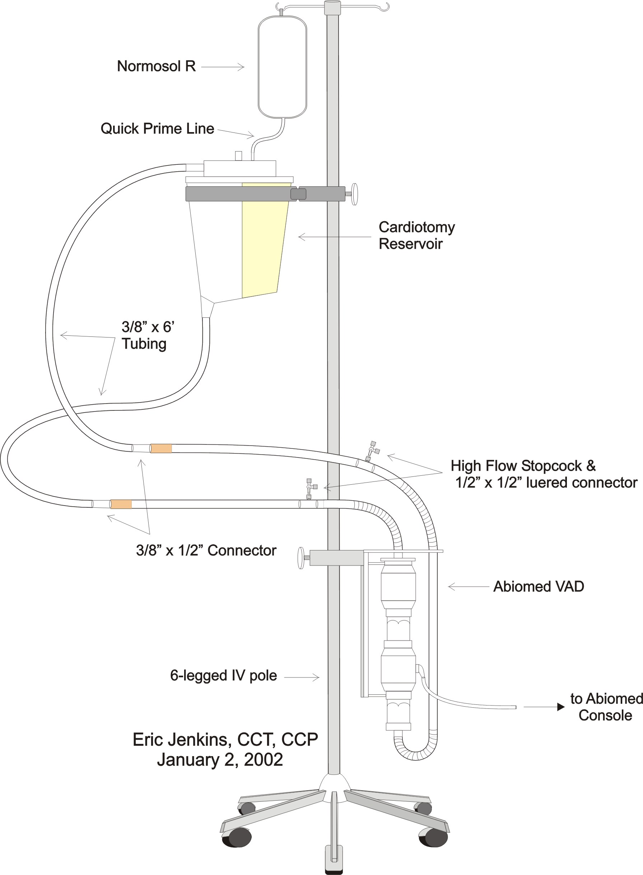

Set-Up
The gowned perfusionist will:
- For right ventricular assist only, cut the (2) ½” PVC tubing lines of the VAD unit approximately 6” above the wire re-enforcement. See “Abiomed VAD Priming Circuit” above.
- For right ventricular assist only, insert the (2) ½-½ straight connectors with luer-lock. Don not insert the (2) ½-½ straight connectors with luer-lock for left ventricular assist.
- For right ventricular assist only, attach the high flow 3 way stopcocks to the luer-locks. Make certain that the stopcocks are in the “off” position and that the stopcock is capped with a non-vented deadender.
- Attach the 6 - 8’ lengths of PVC tubing to the VAD: one to the inlet and one to the outlet.
- Hand the open end of the 3/8” PVC tubing attached to the outlet of the VAD to a perfusionist, who will then attach the 3/8” PVC tubing to a 3/8” sucker port on the cardiotomy reservoir.
- Hand the open end of the 3/8” PVC tubing attached to the inlet of the VAD to a perfusionist, who will then attach the 3/8” PVC tubing to a 3/8” outlet port on the cardiotomy reservoir.
- Clamp the cardiotomy outlet, and add 2 L Normosol to cardiotomy reservoir.
- Secure both 3/8” lines to the back table with an Alice clamp.
- The set-up perfusionist then breaks scrub.
- The scrub nurse will then hand off the Abiomed unit to the set-up perfusionist allowing no more than 1’ of tubing off the table. The scrub nurse will then secure the ½” lines to the back table with second Alice clamp.

Prime
- The set-up perfusionist will release the clamp on the cardiotomy reservoir allowing the priming fluid to enter the circuit.
- Priming should be accomplished using gravity by inverting the VAD, raising it to the level of the priming fluid and slowly lowering it to fill the VAD slowly and smoothly.
- The VAD can then be placed in its’ holder on the IV pole, the drive line attached to the console, and pumping initiated.
- If applicable, prime the high flow 3 way stopcocks using a syringe.
- The VAD should continue to recirculate for a full 5 minutes for complete de-airing.
- The VAD is now prepared.

Initiation
- When the surgeon is ready, the inlet and outlet lines can be clamped, disconnected, and handed to the operative field for connection to the VAD cannulae by the scrub nurse.
- Position the atrium of the Abiomed at the level of the patient’s atrium.
- Remove the foot pedal from the back of the console.
- The surgeon will make fluid connections between the cannulae and the Abiomed.
- Once the clamps on the inlet and outlet of the Abiomed are removed, pumping is initiated at the surgeon’s command by the perfusionist slowly depressing the foot pedal.
- Both the surgeon and perfusionist will watch for air in the lines.
- If air is observed, pumping is immediately discontinued.
- The foot pedal is returned to the back of the console and the locking handle returned to the automatic operation position.
- The cannulae are clamped and disconnected.
- The Abiomed is then connected to the prime lines and recirculated until all the air is removed.
- When the perfusionist and surgeon are satisfied that all the air is removed, then Steps 1 - 6 are repeated.
- Once the surgeon and perfusionist are satisfied with the cannulation and Abiomed function during manual operation (foot pedal), the decision is made to go to automatic operation.
- The foot pedal is returned to the back of the console, and the locking handle returned to the automatic operation position.
- Automatic operation is initiated by depressing the “on” button on the front of the console.
- When automatic pumping has been successfully initiated, the level of the Abiomed atrium may be lowered up to 10” below the patient’s atrium to maximize assist efficiency. See the Operator’s Manual for details.

Important Note
The prime lines should remain clamped and sterile on the set-up field for the following scenarios:
- Air is introduced to the VAD pump, and the system needs to be re-primed and de-aired.
- A second VAD (BIVAD) is needed requiring set-up and priming.
Please note that the return prime line must drained prior to re-priming to avoid an air lock.

Abiomed Emergency 24 hour Telephone #
- 1-800-422-8666

Recommendations for Abiomed BVS 5000 Operation during Return to the OR for Re-Exploration
- If the Abiomed BVS 5000 patient must return to the OR for bleeding re-exploration, the perfusionist should be aware that the possibility for air entrainment exists. As the surgeon moves the heart or cannulae, the last fenestration on the cannula may exit the atria or the purse string suture around the cannula may be loosened, thus, opening the system to air. The perfusionist should be prepared to prevent and/or monitor for air entrainment into the blood pump.
- When the sternum is re-opened, the perfusionist should raise the blood pump to the level of the patient’s atria. Have the patient placed into the Trendelenberg position and utilize the foot pedal to maintain flows through the system. The inflow tubing should be completely visible to the perfusionist. It should not covered by the sterile drapes or insulating sleeves.
- If air is noted in the inflow tubing, the perfusionist should stop foot pumping and “walk” the air up to the sterile field. The surgeon may now disconnect the cannula and blood pump tubing and de-air the system as described in the Physician Training Manual and the Implantation/Explantation Video. Note: There is some urgency with this maneuver as the patient may be quite dependent on the system for circulatory support and will be in circulatory arrest until flow is re-established.
- If the surgeon has difficulty disconnecting the cannula at the cannula/blood pump junction, the blood pump tubing may be crossclamped 4 - 5 inches below this junction and the line cut. Once the system is de-aired, the line can be reconnected using a ½” connector. This connection will have to be de-aired.

Bedside Replacement of the Abiomed BVS 5000

Overview
- While changing a blood pump can be carried out at the bedside, strict aseptic technique must be maintained. The set-up and procedure for priming a new blood pump is essentially the same as outlined in “Abiomed BVS 5000 Set-Up Prime and Initiation” on page 1 of Section 9. All personnel working at the bedside must have on a sterile gown, mask, and gloves during the procedure.

Sterile Field Preparation
- Obtain a rolling metal table from the OR and drape it with a sterile plastic table cover. Using sterile technique, place the items listed below on the sterile field.
- (2) 8 ft. rolls of sterile 3/8” PVC tubing
- (1) sterile blade
- (4) sterile tubing clamps (Obtain from Core A.)
- (2) sterile Alice clamps (Obtain from Core A.)
- ABIOMED VAD(s) - The device will need to be opened and handed up after the set-up perfusionist is scrubbed, gowned, and gloved.
- For right ventricular assist only, (2) ½”-½” straight connectors with luer-lock
- For right ventricular assist only, (2) Sorenson 6” Monitoring Extension (Available in the anesthesia workroom.)

IV Pole Preparation
- Obtain (1) IV pole.
- Attach Abiomed VAD holder to the IV pole.
- Attach Sorin CRF 40 Cardiotomy holder to regular IV pole at eye level.
- Place sterile Sorin CRF 40 Cardiotomy reservoir in holder.
- Remove the cardiotomy vent cap.
- Attach quick prime line to cardiotomy.

Set-Up & Priming Procedure
- If the patient is awake, the clinician should consider administration of a form of mild sedation or short acting anesthetic agent to decrease the likelihood of any discomfort or movement during the replacement procedure.
- The cannulae sites, cannulae, and blood pump tubing must be scrubbed using betadine solution.
- The patient must be draped from the neck to the feet in a sterile manner.
- The perfusionist should prepare a sterile table at the side of the bed.
- Cut the (2) ½” PVC tubing lines of the VAD unit approximately 6” above the wire re-enforcement. See “Abiomed VAD Priming Circuit” above.
- For right ventricular assist only, insert the (2) ½”-½” straight connectors with luer-lock. Do not insert the (2) ½”-½” straight connectors with luer-lock for left ventricular assist.
- If applicable, attach the Sorenson 6” Monitoring Extensions to the luer-locks. Make certain that the stopcocks are in the “off” position and that the stopcock is capped with a non-vented deadender.
- The perfusionist will open the Abiomed BVS 5000 Blood Pump, and the scrub nurse will remove the pump and pass it onto the sterile field.
- The perfusionist will open the 3/8” tubing and pass it onto the sterile field.
- The perfusionist will attach the Abiomed BVS 500 Blood Pump tubing to the 3/8” PVC tubing (one piece to the inflow tubing and one to the outflow tubing) and then pass the open ends off to the perfusionist for attachment to the cardiotomy reservoir.
- The blood pump is passed off to the perfusionist after securing approximately 12” of the circuit which contains the blood pump tubing and prime circuit junction to the sterile field using towel clamps.
- If the patient is on univentricular support, connect the drive line from the replacement pump to the unused drive port on the back of the console. If the patient is on biventricular support, a second console is required. (If a second console is required, turn the main power switch on and allow the console to complete its self-test uninterrupted before attaching the drive line.)
- The Abiomed BVS Blood Pump is then primed in the usual fashion.
- If applicable, the preferred site for connecting the new Abiomed BVS Blood Pump is at the ½”-½” straight connector with luer-lock.
- In preparation for fluid coupling, attach a 60 cc syringe filled with 0.9% NaCl to the Sorenson Extension of both the inflow and outflow lines of the new Abiomed BVS Blood Pump.

Replacement Procedure
- After the new blood pump has been primed, separate the replacement blood pump from the priming circuit by crossclamping the pump inflow and outflow and both accessory prime lines. Roll off the latex adapters before passing the pump to the surgeon. There are arrows and labels on each blood pump designating atrial and arterial sections.
- Turn off the compromised blood pump by depressing the off soft key twice. Allow a 5 sec pause before disconnecting the circuit.
- The surgeon (should be gowned, gloved, and masked) will crossclamp the Abiomed BVS cannulae and any compromised blood pump tubing. Disconnect the tubing from the cannulae.
- If applicable, connect the replacement blood pump at the ½”-½” straight connector with luer-lock on the inflow and outflow lines using the attached 60 cc syringes to make an air free fluid coupling.
- Remove all 4 tubing clamps, and initiate support using the foot pump. The surgeon or another perfusionist should have an open clamp on the atrial cannula in anticipation of any air.
- If air is noted in the cannula or inflow line, stop foot pumping clamp both sides of the connection, tap and irrigate the circuit to eliminate the air. If air has traveled into the blood pump itself, disconnect and reconnect to the priming circuit. Recirculate until all air is removed, then attempt to reinitiate support as stated above.
- Once it is ascertained that there is no air in the circuit, secure all connections with tie bands.
- If the original console was utilized, attach the replacement drive line to the appropriate drive port and depress ON soft key. (Remember to replace the foot pump and transfer lever to vertical position.)
- Document the procedure appropriately.

Return Policy
- All Abiomeds changed out due to clotting should be returned to Abiomed for their review.
Abiomed
33 Cherry Hill Drive
Danveis, MA 01923

Abiomed ECMO

Recommendations
- Abiomed ECMO is considered as a backup modality to traditional ECMO. Ensure that the ECMO department (3-9919) or the ECMO fellow (6-6267) has been contacted and is unavailable prior to committing to Abiomed ECMO.

Indication
- Abiomed ECMO will be used in the presents of Right Heart Failure with concomitant lung or ventilatory complications.

Description
- A Medtronic Trillium Affinity NT Oxygenator is inserted into the outflow of the Abiomed BVS 5000i RVAD circuit. A kit containing a pre-assembled diamond is used to incorporate the oxygenator into an unprimed circuit or a system already in use. If the kit is unavailable, it will be necessary to construct the pre-assembled diamond. The oxygenator may be obtained breaking apart an integrated unit and discarding the reservoir.

Equipment
- Heater/Cooler with Hoses
- Gas Blender with Gas Lines
- (2) DLP Pressure Display 60000
- (6) Tubing Clamps, IV Pole
- Affinity Oxygenator Holder
- Abiomed Holder
- Abiomed BVS 5000i Console
- Hemochron Jr. ACT machine with cuvettes

Disposables
- Medtronic Trillium Affinity NT Oxygenator
- Abiomed BVS 5000 Pump
- (1) L Normosol
- Oxygenator Insertion Kit
- Pre-assembled Diamond
- (1) ¼” Dead Ender
- (3) high flow Stopcock
- (2) DLP Pressure Display 60000 transducers
- (2) Stopcock Caps
- (1) Large Drip IV Set
- (1) CO2 Filter
- (1) O2 Filter with ¼” tubing stub

Figure 35: Pre-Assembled Diamond Diagram
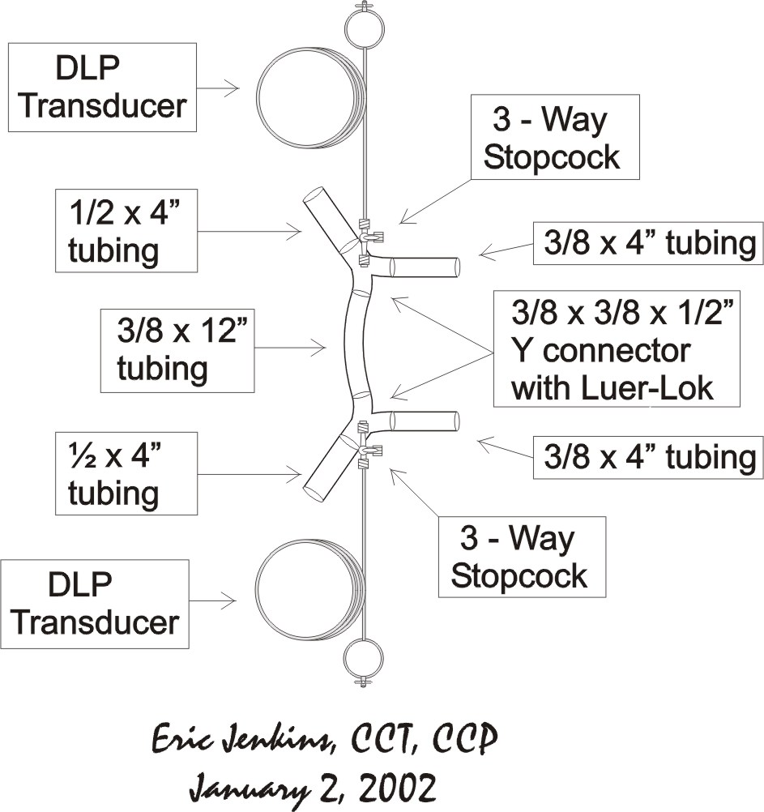

Setup

Oxygenator Insertion into Abiomed Circuit in Use
- Assemble the components of the Diamond Kit.
- Attach the pre-assembled Diamond to the In-Flow and Out-Flow of the Medtronic Oxygenator. See following diagram.
Figure 36: Oxygenator & Pre-Assembled Diamond Priming Diagram
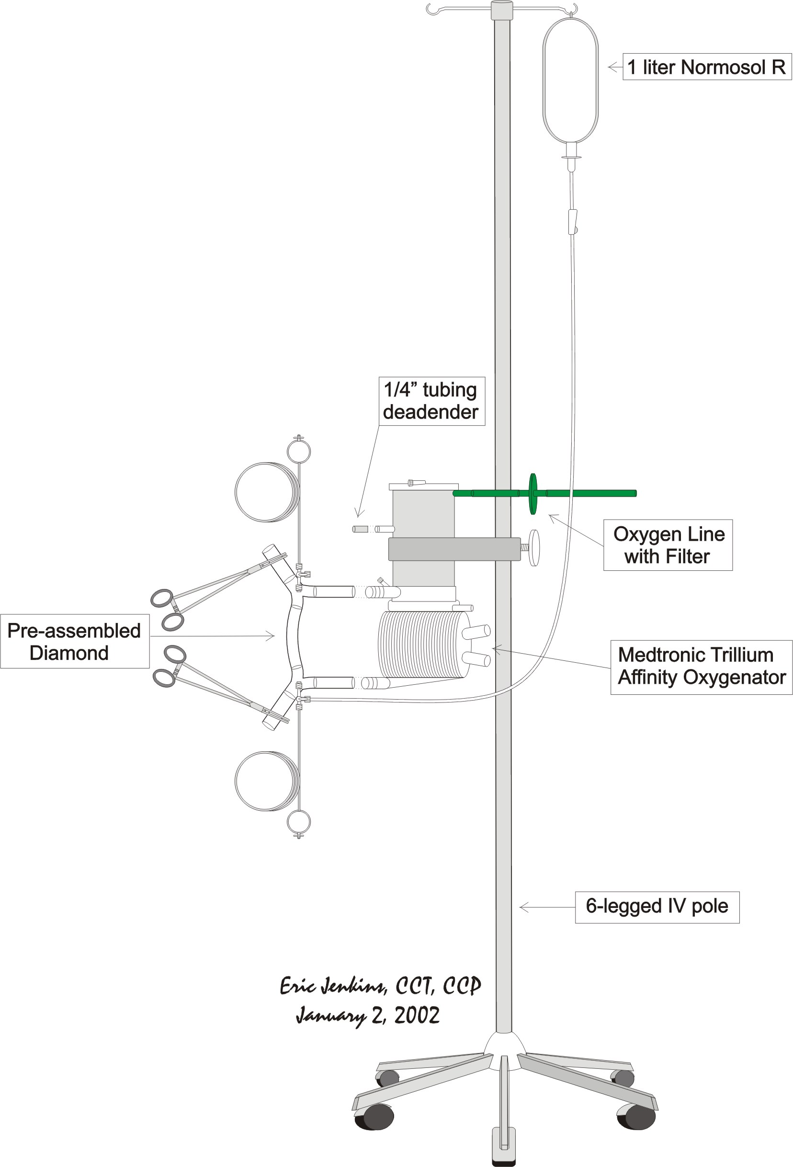
- Co₂ flush the complete assembly.
- Attach the gas line with filter to the Oxygenator.
- Clamp the open 1/2” tubing stub at the inlet Oxygenator Y.
- Connect stopcocks or 6” Monitoring Extension Sets to the Luer ports on both the Oxygenator Inlet and Outlet Y’s.
- Spike the Normosol with a large drip IV set and attach it to the stopcock or 6” Monitoring Extension Set at the Oxygenator inlet Y.
- Place clamps between the Inlet and Outlet Y’s and the Oxygenator.
- Open the priming drip and allow the bypass line to fill, then clamp the bypass line.
- Remove the recirculation port cap and the lured port cap on top the Oxygenator.
- Angle the oxygenator holder to place the recirculation port at the highest point on the Oxygenator.
- Remove the Clamp between the Inlet Y and the Oxygenator and prime the oxygenator.
- When fluid begins to exit the ¼” recirculation port on the oxygenator, attach a ¼” dead ender to the port.
- Angle the oxygenator holder to place the lured port at the highest point on the oxygenator.
- Continue filling the Oxygenator until fluid exits the lured port and replace the cap.
- Remove the clamp between the Oxygenator and the Outlet Y and fill the remainder of the diamond.
- Clamp the 1/2” tubing stub beyond the Oxygenator Out-flow Y.
- Tap the Oxygenator and purge any bubbles out the Oxygenator Out-flow port.
- Clamp the tubing between both the inlet and outlet Y’s and the Oxygenator.
- RVAD support must be temporarily interrupted during Oxygenator Insertion into the Abiomed circuit.
- Place a clamp on both sides of the ½” connector placed in the Out-flow line of the Abiomed circuit for CVVH purposes.
- Remove the ½” connector from the Abiomed line and remove the ½” tubing stub on the Inlet Y of the Oxygenator.
- Connect the Abiomed line proximal to the pump to the Oxygenator Inlet Y, using airless technique. An airless connection can be accomplished using a 60 cc syringe connected at the Y. See the diagram on the following page.
Figure 37: Oxygenator Insertion into Abiomed Circuit Diagram
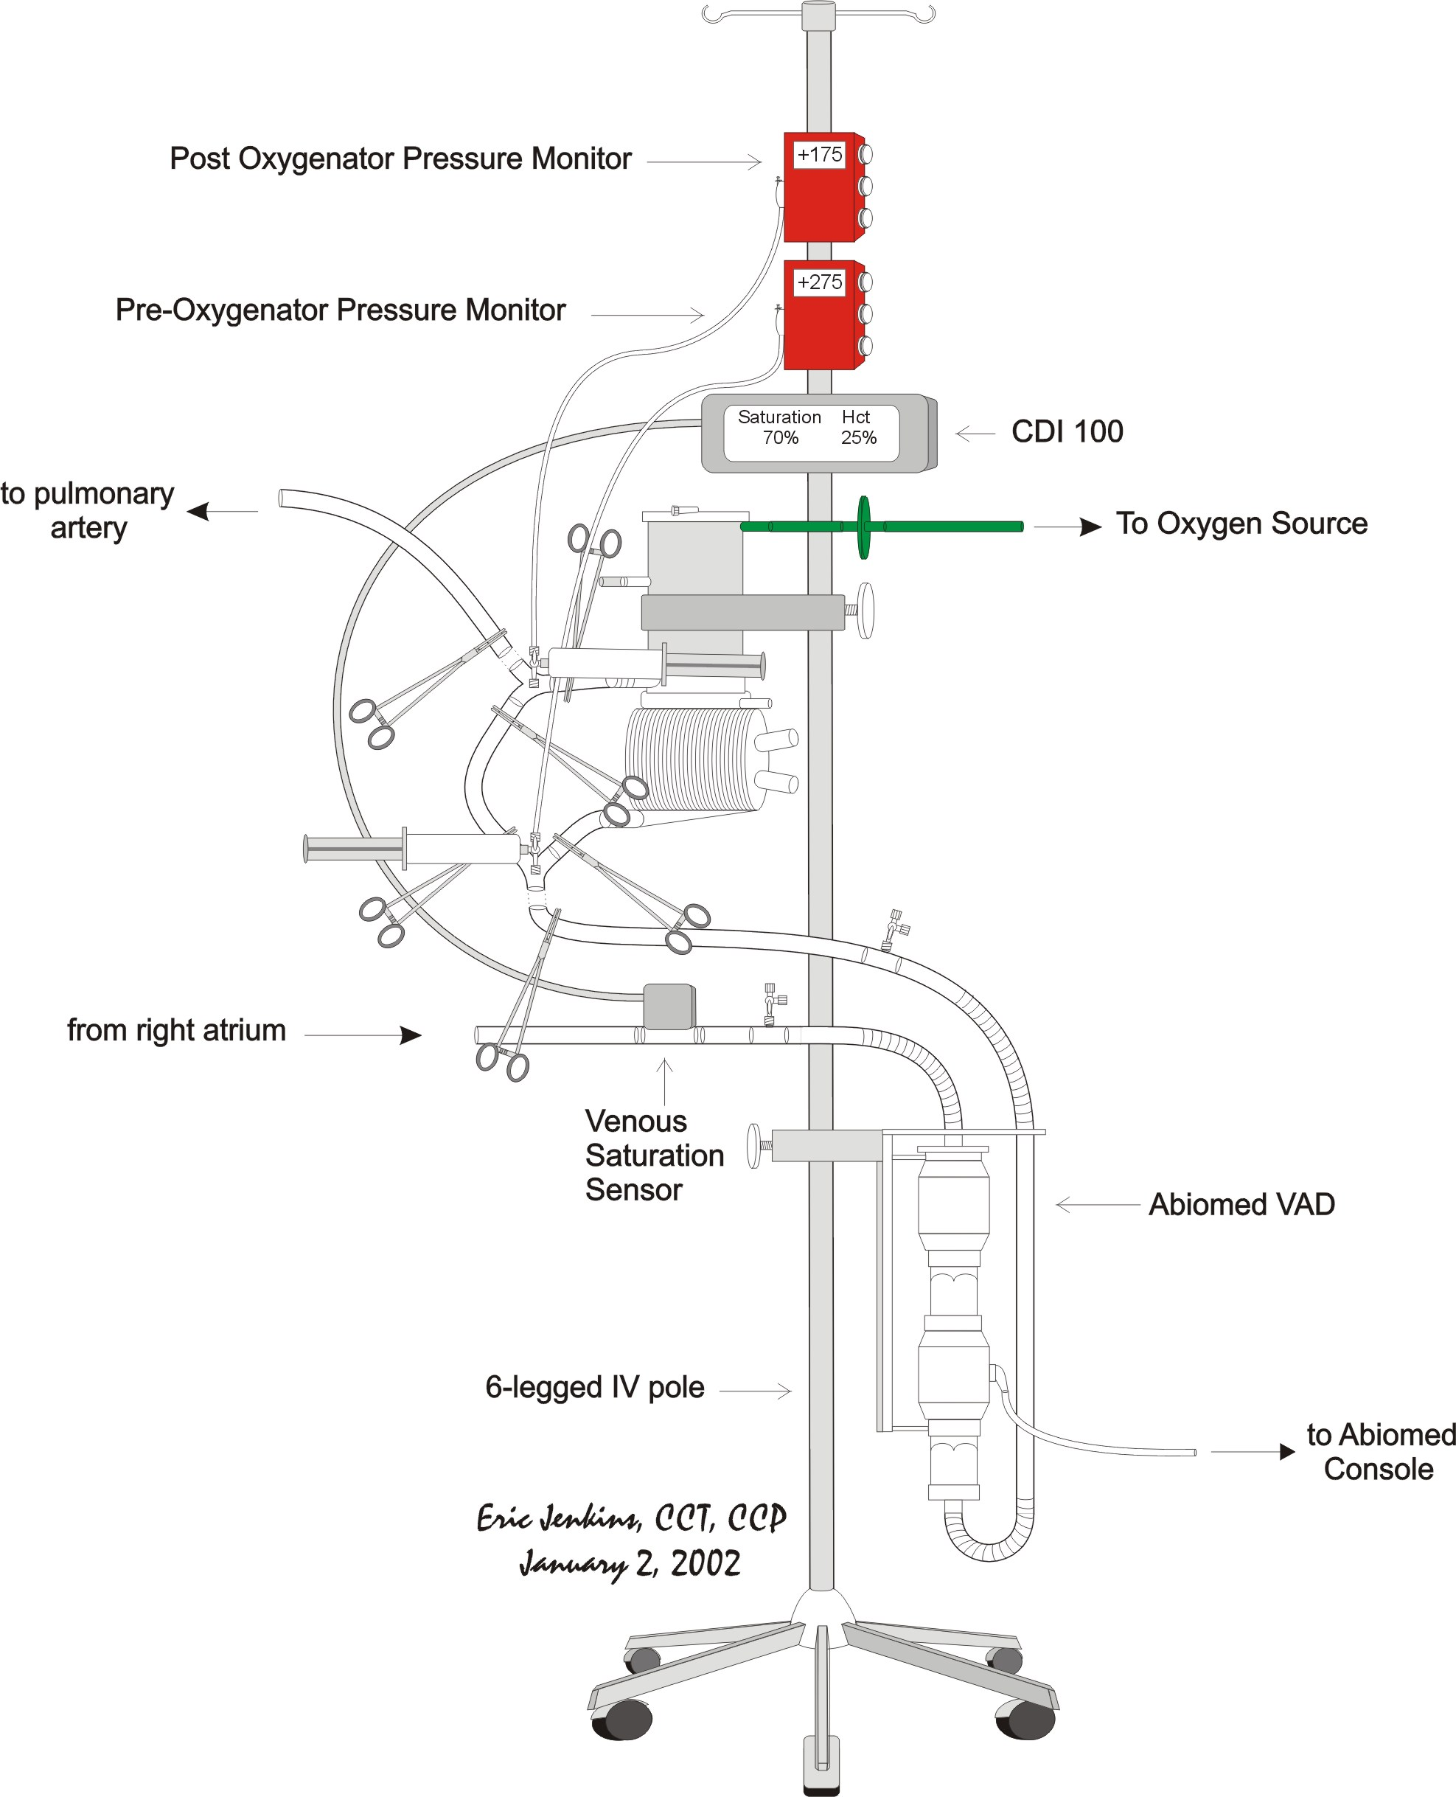
- Remove the ½” tubing stub on the Outlet Y of the Oxygenator and connect the distal end of the Abiomed line (portion connected to the patient) to the Oxygenator Outlet Y, using airless technique.
- Remove all clamps, except the clamp on the bypass line.
- Connect the Abiomed Air Drive Line to the LEFT SIDE Console Output. The Left Side Drive has the ability to generate greater drive pressures that are required to maintain flow through the Oxygenator.
- Resume Abiomed BVS 5000i support pumping.
- If a significant drop in blood pump output is observed, consider partially opening (approximately 50%) the oxygenator bypass line. This maneuver has been reported to increase output without compromising oxygenation.
- Adjust gas sweep and FiO2 as required.
- Attach the heater/cooler and adjust temperature as necessary.
- Connect and prime the DLP Pressure Domes and record baseline pressures pre and post oxygenator.
- Cap all stopcocks with airless caps.
- Check all connections.
Figure 38: Abiomed ECMO Circuit Diagram
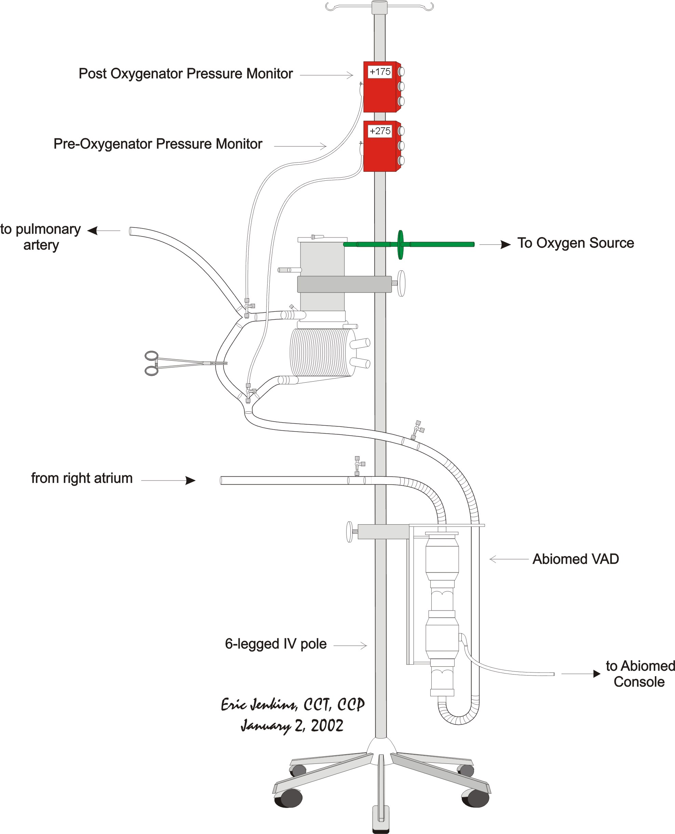
Figure 39: Abiomed ECMO Circuit with Hemoconcentrator for CVVH Diagram
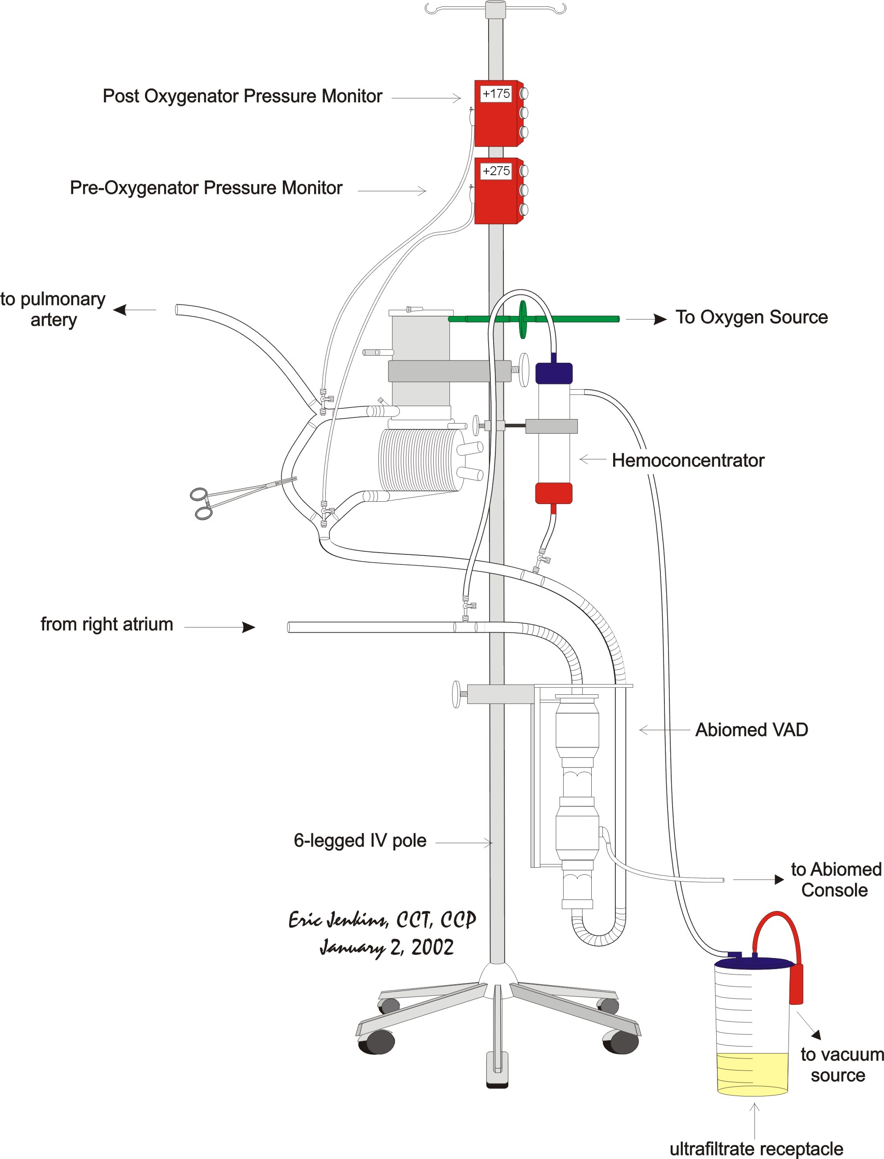

Perfusionist Role and Responsibility
- Perfusion shall be responsible for assembly, priming and initiation of Abiomed-ECMO support in the OR or ICU.
- Perfusion shall call in every 4 hours to check the status patients with an Abiomed ECMO in place. In particular, perfusion should review a recent blood gas analysis and make appropriate adjustments of the FiO₂ and gas sweep rate.
- Perfusion shall participate in all transport activity of patients supported with Abiomed-ECMO system.
- Perfusion will provide detailed report to nursing staff upon arrival in ICU.
- Perfusion shall provide 24 hour availability for consult and/or troubleshooting of the Abiomed-ECMO circuit. Monday through Friday, between the hours of 7:00 a.m. and 3:00 p.m., perfusion can be reached in the Pump room at 6-8920 or by calling the Main OR Desk at 6-8470. All other times contact the “On Call Perfusionist” through the paging system.
- Perfusion shall round twice daily on all patients supported with an Abiomed-ECMO system. Rounds will occur between the hours of 9:00-11:00 a.m. and 3:00-5:00 p.m. This responsibility can be divided between the two call perfusionists on weekends.

Abiomed Oxygenator Insertion Kit
- After completion of the procedure, it is the perfusionist responsibility to replace the “Abiomed Oxygenator Insertion Kit” and have it gas sterilized. This will also require the construction of the “Pre-Assembled Diamond” (see “Pre-Assembled Diamond Diagram).

Supplies
- 3/8” tubing
- ½” tubing
- (2) 3/8 x 3/8 x ½” Y connectors with luer lock
- (1) ¼” Dead Ender
- (2) 3 way Stopcocks
- (2) DLP Pressure Display 60000 transducers
- (2) Stopcock Caps
- (1)Large Drip IV Set
- (1) CO2 Filter
- (1) O2 Filter with ¼” tubing stub

Role and Responsibility of ICU Nursing
- Nursing will record hourly Oxygenator inlet and outlet pressures displayed on the Abiomed-ECMO circuit. Perfusion and/or the Attending Physician shall be consulted if the difference in Oxygenator inlet and outlet pressures exceeds 150 mmHg.
- Nursing shall consult perfusion on all alarm activations of the BVS 5000i console.
- Based on blood gas analysis, nursing shall make adjustments in gas sweep and FiO2 as required to maintain desired ventilation.

PaO₂ Management
- The patient’s PaO₂ can be manipulated by changes in the FiO₂.
- PaO₂ may be increased increasing the FiO₂.
- PaO₂ may be decreased by decreasing the FiO₂.

PaCO₂ Management
- Adjustments in the gas sweep flow will change the PaCO₂.
- PaCO₂ may be increased by decreasing the gas flow rate (sweep rate).
- PaCO₂ may be decreased by increasing the gas flow rate (sweep rate).
- Nursing will flash the bypass line every ten minutes or when settling is observed in the bypass line.
- Nursing will monitor and maintain the patients Activated Clotting Time at 160-180 seconds or as per physician request.
- Nursing will notify perfusion and/or the attending physician of all system malfunctions or if difficulty is encounter in its use.

CPB Management for TCI HeartMate Implantation Procedure

Overview
- The HeartMate IP and VE LVAS is a pulsatile left ventricular assist system intended for hemodynamic and circulatory support as a bridge to transplant.

Equipment Selection
- The standard extracorporeal circuit is used with the exception that a Pall LeucoGuard-6 arterial filter is inserted into the Medtronic Affinity 38 micron arterial filter bypass line. In this way, another arterial filter is available should the Pall Leuco-Guard-6 arterial filter become obstructed.
- It is recommended that the Affinity 38 micron arterial filter be primed antegrade. The Pall Leuco-Guard-6 arterial filter is then primed retrograde.
- A Bard HC70 Hemoconcentrator is also included in the set-up.
- “Vacuum Assisted Venous Drainage” is recommended for this procedure.

Cell Saver
- Set up a cardiotomy and aspiration line. Only set up a wash set if enough volume is scavenged during CPB to wash a full bowl of red blood cells.
- All washed red blood cells may be returned to the pump during CPB, but not post-CPB. The hemoconcentrator already set up for these cases will be used to handle any excess volume during CPB.
- Encourage the use of cardiotomy suckers instead of the cell saver sucker during CPB, especially during left ventricular coring.

Cardioplegia
- Unless another cardiac procedure is contemplated, do not add cardioplegia drugs to the cardioplegia circuit. Accordingly, the CP system should be primed with prime solution and recirculated.
- If cardioplegia is given, follow Dr. Pagani’s CP protocol as outlined in the adult cardioplegia protocol.

Prime Constituents & Priming Technique

Prime Technique & Initial Constituents
- After flushing with CO₂, prime and de-air the extracorporeal circuit with 2000 ml Normosol R.

Additional Constituents & Ultrafiltration
- Open the sterile wrappings of the AV loop and sucker lines. Have the scrub nurse replace the pre-bypass filter with a 3/8 x 1/2” connector and then cover the AV loop and sucker lines with a sterile sheet.
- Add the following constituents
- (4) units plasma (single donor or fresh frozen)
- Calculate the amount of leukocyte depleted packed red cells (LDPRC) necessary, if any, for CPB Hct of 30%. If PRBC’s are necessary, consult the staff surgeon prior to adding them to the extracorporeal circuit. Do not add PRBC’s without the staff surgeon’s consent. The following equation may be used to calculate the amount LDPRC:

PRBC Prime Volume for Target CPB Hct Calculation

X ml PRBC’s = (Target Hct/100) x ((65 x kg) + ml prime vol)) – (65 x kg (pt Hct / 100)
0.6

where: X ml PRBC’s = estimated amount of packed red blood cells necessary to
attain the target hematocrit on cardiopulmonary bypass
Target Hct = desired Hematocrit on cardiopulmonary bypass
prime vol = prime volume of extracorporeal circuit
kg = patient’s kilogram weight
pt Hct = patient’s hematocrit measured following monitoring lines
insertion by anesthesia

- Using the hemoconcentrator, remove enough ultrafiltrate until the venous reservoir is almost empty, approximately 100 ml.

Final Constituents
- Add the following constituents:
- 10,000 units heparin (pork mucosal)
- 50 mEq NaCO₃
- 10 g Amicar (epsilon-amino-caproic acid)
- 12.5 g Mannitol
- 200 ml Aprotinin (Trasylol)
- 1 mg vitamin K (see below)
- 1.5 g Cefuroxime (see below)

Urine Output & Furosemide (Lasix) Administration
- Always consult the surgeon regarding furosemide (Lasix) administration that deviates from established protocol.
- Inform the surgeon when the urine output is less than 100 cc / 40 min.
- In certain instances of high pulmonary resistance, Dr. Pagani has requested furosemide doses as large as 400 mg.
- If the patient is currently receiving furosemide, note the regimen and consult the surgeon regarding dosage and timing. Furosemide in the pump prime might be an option.

Vitamin K Administration
- Anesthesia should administer 1 mg vitamin K when the patient enters the OR and 1 mg vitamin K every 30 minutes thereafter until the initiation of CPB.
- It is the perfusionist’s responsibility to make sure that this dose of vitamin K is administered.
- The perfusionist should add 1 mg vitamin K to the prime of the extracorporeal circuit.

Antibiotic Regimen
- 1 g Vancomycin
- For Dr. Pagani, titrated on CPB over a 1 hour period.
- For all other surgeons, titrated on CPB.
- 1.5 g Cefuroxime
- Added to pump prime.
- Available in the key code room of the OR pharmacy.

Cannulation
- Arterial
- Ascending Aorta with 7 – 8 mm Terumo Softflow Arterial cannula
- Venous
- Bicaval cannulation

Vacuum Assisted Venous Drainage Technique

Vacuum Assisted Venous Drainage Equipment & Disposables
- Vacuum Regulator (on pump console)
- Vacuum Source (OR column)
- DLP Pressure Display 60000 monitor
- Medtronic VAVD kit

Vacuum Assisted Venous Drainage Set Up
- Refer to the diagram on the following page.
- Gather disposables.
- Open and connect the sputum bottle to oxygenator vent port using sterile technique.
- Open and connect suction tubing to sputum bottle and the ¼” Y connector attached to vacuum regulator.
- Place a stopcock on a luer port on top venous reservoir using sterile technique.
- Turn on the DLP Pressure Display 60000 monitor. Insert the DLP Pressure Display 60000 disposable transducer into monitor and then attach transducer line to the stopcock on the top of the venous reservoir. Zero the transducer at the venous reservoir.
- Remove cap on pressure relief valve on the top the venous reservoir.
- Turn on vacuum regulator and pre-set to –20 mmHg. Turn off vacuum regulator.

Vacuum Assisted Venous Drainage Diagram

Vacuum Assisted Venous Drainage Initiation
- With the vacuum assist off, initiate CPB in the usual manner.
- Increase the blood flow rate until an equilibrium between blood flow rate and the venous reservoir level is obtained.
- Turn on the vacuum regulator at the pre-set vacuum of – 20 mmHg. Assess the level of the venous reservoir for increased return, and increase the blood flow rate accordingly until adequate perfusion in terms of blood flow rate, venous hemoglobin saturation, and mean arterial pressure are obtained. It may be necessary to increase the vacuum in order to obtain the appropriate blood flow rate; however, do not allow the negative pressure in the venous reservoir to exceed a vacuum greater than – 70 mmHg. It is recommended to use the minimum vacuum assist necessary for adequate perfusion.

Vacuum Assisted Venous Drainage Management
- Negative pressure in the venous reservoir should be monitored continuously and adjusted appropriately for efficient venous return augmentation.
- Do not allow the negative pressure in the venous reservoir to exceed a vacuum greater than – 70 mmHg.
- Whenever the blood flow rate is lowered intermittently, reduce or turn off the vacuum.
- Whenever blood volume is transferred to the patient for vent insertion, for vent removal, or to aspirate air from the aorta, turn off the vacuum.

Vacuum Assisted Venous Drainage Termination
- When blood volume is transferred to the patient to initiate weaning from CPB, terminate vacuum assisted venous drainage.

MAP Management and Arginine Vasopressin Administration
- Maintain a MAP range of 80 - 100 mmHg.
- Consult Dr. Pagani regarding administration of arginine vasopressin if after a total dose of 5 - 10 mg phenylephrine, the MAP is < 60 mmHg at a blood flow rate of 2.4 l/min/m².
Source
- Arginine vasopressin in 20 units/1ml vials is available at the OR pharmacy.
Preparation
- Mix 40 units arginine vasopressin (2 vials) with 38 ml 0.9% NaCl in a 60 cc syringe. This results in a concentration of 1 unit arginine vasopressin per ml of solution.
Administration
- Arginine vasopressin is administered only with a syringe pump.
- Initiate arginine vasopressin at a rate of 5 units/hr, and then titrate for effect.
- Do not infuse arginine vasopressin at a rate > 5 units/hr.

Cooling
- Anticipate doing the implantation procedure at 37 degrees C.
- Cooling may be necessary if difficulty is encountered in the procedure or if CABG or valve repair is required.

Blood Usage
- Expect Dr. Pagani to require a hematocrit > 35% or greater coming off bypass.
- Notify the surgeon prior to administering blood products.
- All blood products should be irradiated, CMV negative, and administered through a leukocyte filter in anticipation of future transplant.
- Hemoconcentrate and/or make the necessary PRBC additions for the surgeon’s target Hct.

Water Blanket Usage
- Do not use a water blanket.

Balloon Pump
- IABP is of minimal value following HeartMate implantation and should be removed. Removal decreases the risk of bleeding and infection.

Prophylactic Treatment of Possible Protamine Reactions

Treatment Regimen

Drug | Dose
diphenhydramine (Benadryl) | 50 mg
hydrocortisone (Solu-Cortef) | 100 mg
ranitidine (Zantac) | 50 mg

- If the patient has already received a dose of steroids during the course of the case, then do not administer hydrocortisone.

Treatment Rationale
- These drugs are given to avoid a possible protamine reaction and aid in a reduction of side effects. They are to be given approximately 10 minutes before the termination of CPB. Always discuss the usage of this regime with anesthesia and the surgeon.

Termination Drug Regimen
- Expect patient loading with milrinone, and/or dobutamine, and/or isuprel.
- Expect the use of nitric oxide by anesthesia for treatment of high PA pressures and prevention of RV failure.
- Expect usage of arginine vasopressin.

Termination of CPB
- When blood volume is transferred to the patient to initiate weaning from CPB, terminate vacuum assisted venous drainage.
- Prior to CPB termination, the perfusionist should manage the patient in order to obtain the following physiological values:
- Hct > 35%
- pH > 7.5
- pCO₂ = 30 mmHg
- CaCL₂ = 1.5 mmol/l
- Upon surgeon order, the patient should be filled quickly for a CVP of 5 – 6 mmHg. Simultaneously, the CPB flow rate is decreased to 1.5 to 2.0 LPM.
- Volume is required in the left heart to eliminate the possibility of air entrainment by the HeartMate upon initiation of pumping.
- CPB flow rate and CVP will be tweaked upon orders of the surgeon in an effort to increase HeartMate output.
- Upon the surgeon’s orders, the HeartMate is started in the fixed rate mode.
- The surgeon will direct weaning the patient from CPB while simultaneously ordering increases in HeartMate pump flow.
- The perfusionist managing the HeartMate console should keep the surgeon apprised of the HeartMate’s filling capacity, as well as pump flow rate.
- Extreme caution must be exercised to prevent negative pressure on the inlet side of the HeartMate pump due to the possibility of air emboli.
- The rate and ejection time will be adjusted in coordination with decreasing CPB flows as follows:
 | Rate (bpm) | Ejection Time (sec)
1) Initiation Settings | 20 | 450
2) Intermediate Settings | 30 | 375
3) Intermediate Settings | 40 | 275
4) Intermediate Settings | 45 | 275
5) Fixed Rate per Pagani | variable | variable

Returning to CPB
- ALWAYS STOP the HeartMate prior to returning to CPB and emptying the heart. Failure to do so will result in air entrainment by the HeartMate and air embolism.

Defibrillation/Cardioversion
IP
- Always ensure that the sensor cable is disconnected from the IP LVAD console prior to defibrillation/cardioversion. Failure to do this can cause sensor malfunction and limit operation to fixed rate pumping.
VE
- Make certain the surgeon or scrub nurse disconnects the device at the percutaneous connector prior to defibrillation/cardioversion.

Transport
- We will be assisting in patient transport to the TICU to ensure proper operation and set-up of the HeartMate in the unit.
- Report should be given to the TICU staff and perfusion resource call numbers affixed to the pump.

TCI HeartMate Implantable Pneumatic (IP) Set-Up and Operation

Location
- TCI HeartMate Drive Consoles are stored in Core A.
- The Drive Console should be moved into the operating room and plugged into an outlet which will make operation possible from the patients left side.

Calibration of the LVAS
- The LVAS must be calibrated prior to priming according to the following steps:
- Turn on the console and allow sufficient time for the SELF TEST. Upon completion the front panel will display zero for RATE, and XX’s for VOLUME and FLOW and the current software revision.
- Nursing will unpack the sterile pump components and hand-off the interconnect cable.
- Connect the interconnect cable to the back of the Drive Console.
- With the Drive Console in the STOP mode, set the Fixed Rate at 20 BPM and EJECT DURATION at 450 msec.
- While nursing holds the pump parallel to the ground with the blood side up (air line on the bottom), press VENT.
- When the vent is completed, press the FIXED key and allow one or two cycles.
- Press and hold the STOP key until the red light stops flashing.
- The drive console must be left on to retain the calibration.
- Disconnect and cap the interconnect cable. Attach the console trainer and restart the console in the fixed mode.

De-airing the Blood Pump
- It is critical that residual air be removed from the pump after implantation, prior to initiating pumping.
- Disconnect the trainer and reconnect the interconnect cable and VENT the console.
- The outflow graft is cross-clamped and a loop is elevated.
- A needle vent is inserted at the highest point in the graft between the clamp and the outflow graft connection for air removal.
- Cardiopulmonary bypass pump flow is reduced allowing the left ventricle and LVAD to fill.
- Attach and SLOWLY turn the hand crank on the rear panel of the Drive Console in a clockwise direction to manually cycle the blood pump.
- Repeat hand cranking approximately every 15 seconds. Use caution not to over pressurize the blood pump and outflow graft.
- Observe LVAD filling on the front panel display. Air can be entrained into the blood pump if hand cranking is commenced prior to complete filling.
- The surgeon will manipulate the blood pump to evacuate all trapped air. TEE is used to confirm air removal.
- Continue hand cranking as above until the outflow graft cross-clamp is removed and CPB termination process initiated.
- Note: Steps 5 - 10 may be accomplished by the surgeon using the emergency handpump.

CPB Termination / LVAD Initiation
- With CPB flow reduced to approximately half flow, hand cranking is continued to perform final desiring.
- Upon the surgeon’s order remove the hand crank and begin FIXED RATE pumping at 20 bpm, with an ejection duration of 450 msec.
- Observe the front panel display for adequate filling and pump flow of approximately 1.6 LPM. Keep the surgeon informed of filling and flow conditions.
- The rate and ejection time will be adjusted in coordination with decreasing CPB flows as follows:

 | Rate (bpm) | Ejection Time (sec)
1) Initiation Settings | 20 | 450
2) Intermediate Settings | 30 | 375
3) Intermediate Settings | 40 | 275
4) Intermediate Settings | 45 | 275
5) Fixed Rate per Pagani | variable | variable

- Continue to observe the panel display for flow and filling information. Keep the surgeon informed every 3 to 4 minutes as Dr. Pagani may want to change the rate and/or ejection time.
- Expect decreased flow and filling upon chest closure.

Returning To CPB
- ALWAYS STOP the HeartMate prior to returning to CPB and emptying the left ventricle. Failure to do so will result in air entrainment by the blood pump and air embolism.

Defibrillation/Cardioversion
- Always ensure that the sensor cable is disconnected from the IP LVAD console prior to defibrillation/cardioversion. Failure to do so can result in sensor malfunction and limit LVAD operation to fixed rate pumping.

Transport
- We will be assisting in patient transport to the TICU to ensure proper operation and set-up of the HeartMate in the unit. Report should be given to the TICU staff and perfusion resource cal numbers affixed to the pump.

HeartMate Vented Electric (VE) Set-Up and Operation

Sterile Components:
- The implantable LVAD package, containing the LVAD, fittings, valves, and conduits.
- A System Controller
- Note: A backup System Controller should be readily available.
- A HeartMate Hand Pump
- A Vent Filter

Non-Sterile Components:
- The Power Base Unit (PBU) with a minimum of four fully charged batteries is set up on a pneumatic console. Both the pneumatic and vented electric consoles will remain with the patient for the duration that he/she is in the OR or ICU. The pneumatic console is to be returned to the storeroom when the patient is transferred to the 4C step-down unit.
- A PBU cable
- The System Monitor with cable for attachment to the PBU rear display connector
- Two Battery Clips
- A stroke volume limiter

Set-Up/ Initializing the System Controller
- Plug in the PBU and turn it on.
- Connect the System Monitor Cable to the PBU and turn it on also.
- Note: When microprocessor startup is complete, the “NOT RECEIVING DATA”
message will appear, indicating that the System Monitor is not yet linked to the
System Controller.
- Ensure that at least two batteries are fully charged (green light) in the PBU.
- The scrub nurse will remove the System Controller from its sterile pack.
Note: Ensure that the small power cell is placed safely aside, and the power cell receptacle in the Controller is covered to prevent fluid damage.
- The scrub nurse will pass the White and Black System Controller Cables off the sterile field.
Note: Ensure that the correct leads are passed from the field prior to contaminating the ends. The connector between the Percutaneous Line and the System Controller must remain sterile.
- Make the connections between the white and black leads from the System Controller and the Power Base Cable.
- Plug the large circular connector of the Power Base Cable into the PBU rear panel. Note: Both the PBU and System Controller will alarm. The Controller will display a “red heart” and the PBU will display “LOW BEAT RATE”, indicating that the Controller is powered but not connected to the LVAD.
- Reset these alarms with the PBU and Controller push-buttons.
- If the Monitor indicates AUTO MODE, request that the scrub nurse toggle the Fixed/Auto Switch on the Controller and observe the Monitor for the FIXED on the display.
- Set the Fixed Rate to 50 bpm with the Monitor touch screen arrow keys.
- Disconnect the PBU Cable from the Controller leads and move the PBU to a remote area of the room.

CAUTION: The leads of the controller that were extended beyond the sterile field should remain outside the sterile field.

De-aerating the Blood Pump
- After the percutaneous line has been brought through the abdominal wall, the surgeon removes the bullet and attaches the “Y” fitting.
- The Controller lead is then connected to the “Y” fitting
Note: Ensure that the power leads from the PBU are not connected to the Controller leads as the LVAD will start to run when connected.
- The surgeon then attaches the HeartMate Hand Pump by inserting the connector from the Hand Pump into the vent port on the “Y” fitting until a click is heard.
- With the cross clamp on the outflow graft and the graft vent needle in place, the surgeon depresses the vent button on the hand pump and collapses the bulb.
- He then releases the vent button and then releases the bulb. The bulb should remain slightly collapsed.
Note: The vacuum that the bulb will create ensures the diaphragm in the blood pump will be pulled to its fill position.
- After ten seconds, the vent button is pressed. When the bulb fully expands, release the vent button. The hand pump is now ready for pumping in the de-airing process.
- The surgeon will order the perfusionist to transfer volume into the patient while maintaining a flow rate of approximately 1.8 l/min/m². This procedure begins the de-aerating process by filling the LVAD with blood.
- The surgeon slowly pumps the hand pump watching the de-airing needle for exit of blood and air. Resistance to hand pumping should be observed and caution exercised not to over pressurize the LVAD.
- After all air has been removed with slow hand pumping, Fixed Rate pumping may begin.

CAUTION: All entrapped air must be removed from the LVAD blood pumping chamber and conduits in order to reduce the risk of air embolus.

Startup and Weaning from CPB
- The surgeon disconnects the Hand Pump and attaches a vent filter to the percutaneous line “Y” connector.
- The surgeon will then unclamp the outflow graft of the LVAD and order the perfusionist to transfer more blood volume to the patient while maintaining a blood flow of approximately 1.4 l/min/m². This process increases the blood flow through the LVAD.
- When the order for Fixed Rate Pumping is received, the perfusionist connects the White System Controller lead to the White PBU Cable lead.
Note: The LVAD will immediately begin pumping at a fixed rate of 50 bpm.
Note: The Yellow Wrench light and beeper of the System Controller will activate, as well as, the PBU alarm, indicating that the alarm cell is not installed in the Controller. The scrub nurse resets these advisories using the Alarm Reset keys on the Controller and PBU.
- The perfusionist then connects the Black System Controller lead to the Black PBU Cable lead.
- The scrub nurse then installs the small alarm cell when convenient.
Note: The alarm cell enables the System Controller beeper to sound a steady tone if the Controller loses power while connected to a patient.
- Orders to increase pumping rate will be given as CPB flow is further decreased to provide ample flow to the LVAD.
Note: The goal is to achieve and maintain a stroke volume of 70-80 ml with an appropriate blood flow for the patient’s size.
- Observe the Monitor for flow and stroke volume information and keep the surgeon informed so Dr. Pagani may adjust the fixed rate appropriately. The patient will not be switched to Auto Mode for 12 to 24 hours post procedure.

Recommendations for Operation Electric Cautery Usage
- Following HeartMate VE implantation, electric cautery may cause the device to cycle (beat) at an extremely rapid rate. Rapid cycling can cause pump damage, air entrainment, and poor pump output. Under these circumstances, it may be necessary to run the HeartMate VE on battery until the use of electric cautery is no longer required.

Defibrillation and Cardioversion
- CAUTION: Remove the connection between the percutaneous cable and the Controller prior to defibrillation/cardioversion. Failure to do so could cause damage to the LVAD and Controller.

Transferring Out of the Operating Room
- To transport the patient on portable batteries the PBU must be disconnected from the patient. To affect the transfer on to battery power insert two batteries in the two battery clips. Unplug the black Controller lead from the PBU lead and attach the Controller lead to the battery clip.
Note: A disconnect alarm will sound when the connection between the Controller and PBU are broken. This alarm will cease when the connection to the battery clip is made.
- Disconnect the white Controller lead from the PBU lead and connect the white Controller lead to the battery clip.
Note: A disconnect alarm will sound as above.
- When disconnecting the PBU, the ability to receive stroke volume and flow data is lost. It may be more prudent to transport the patient attached to the PBU for monitoring purposes.
Note: The PBU contains a two hour internal battery for transport.
Note: A power loss alarm will sound when the PBU is unplugged. This alarm can be silenced by using the Alarm Reset key on the PBU.

HeartMate Vented Electric (VE) Alarm & Advisory Situations

Hazardous Events
Hazardous events are those which cause the pump to slow or stop, or which cause pump filling/ejection to be reduced to a dangerous level.

Monitor Message | Controller Message | Event
LOW BEAT RATE xx MIN | Red Heart/Steady Tone | Below 35 bpm
LOW STROKE VOLUME xx MIN | Red Heart/Steady Tone | Below 25 ml
LOW FLOW xx MIN | Red Heart/Steady Tone | Below 1.5 lpm
LOW VOLTAGE xx MIN | Red Heart/Steady Tone | 5 Min or No Power

- Excluding patient hemodynamics, system malfunctions which can precipitate the alarm situations listed in the table above include the following:
- Interruption of power in or to the Controller
- An obstructed or kinked vent line.
- At least two broken power leads in the percutaneous LVAD cable.
- Damaged to the Controller or its connectors.
- Damage to the motor and/or LVAD parts.

Response to Hazardous Events
- If the LVAD is stopped, first check for a kinked vent line, then check the percutaneous lead connection to the Controller. Then check the Controller connection to the batteries or Power Base Unit cable.
- If the device still fails to operate, disconnect the Controller power connections and begin Hand Pumping. (See Hand Pumping) Do not disconnect the Controller percutaneous lead.
Note: An elapsed interval since alarm activation is displayed on the System Monitor.
- Switch to a fresh set of batteries if that was the power source in use.
- Switch to a new System Controller. (See OR Set-Up)
- Switch to Pneumatic Drive Console. (See Pneumatic Drive Console Operation)
- Call the TCI “HEARTLINE” (800) 456-1477 or (617) 932-0291.

CAUTION: In the event that the LVAD stops operating and blood is stagnant in the pump for greater than a few minutes (depending on the coagulation status of the patient), there is a risk of stroke or thromboembolism should the device be restarted.

Non Hazardous Events
- Non hazardous events are events that may reduce performance or effectiveness, eliminate or compromise protection or are a result of faulty or improper interconnection. The LVAD is still functioning.
Monitor Message | Controller Message | Event
Power Cable Disconnect | Yellow Wrench/One Beep Per Sec | One Controller Power Cable Disconnected
Low Stroke Volume Adv. | Yellow Wrench/One Beep Per Sec | Below 30 ml
Low Flow Adv. | Yellow Wrench/One Beep Per Sec | Below 2.0 lpm
Low Voltage Adv. | Yellow Wrench/One Beep Per Sec | Below 15 minute battery life
Controller Malfunction | Yellow Wrench/One Beep Per Sec | Controller Malfunction
Power Limit Adv. | Yellow Wrench/One Beep Per Sec | ?
Controller Battery Low | Yellow Wrench/One Beep Per Sec | Controller Battery Low
Controller Patient Disconnect | None/Steady Tone | Percutaneous Lead Disconnect from Controller

Response to Non-hazardous Events
- Check all Controller Connections.
- Check the vent line for obstruction or kinks.
- If on batteries, switch to PBU or vice-versa.
- Replace Controller
- Replace PBU Cable
- Replace PBU
- Call TCI “HEARTLINE” (800) 456-1477 or (617) 932-0291.

TCI HeartMate VE Trouble Shooting Decision Flow Sheet
Electrical Disconnect Outflow Valve Insufficiency
Vent Obstruction Native AV Insufficiency
Pump Motor Failure Inflow Valve Insufficiency
Component Failure

Device High Flow
Failure Condition
Atrial Fibrillation
High PVR
Hypovolemia
Inflow Conduit Obstruction
TV Insufficiency
Hand Pump Tamponade
Pneumatic Back-Up

RV
Failure Low Flow
Condition

RV Pharmacological Support

Patient & Flow Improve No Improvement

RVAD
ECMO

Viable RV Non-Viable RV

Internal LVAD Check Biventricular Support to Transplant
TEE Terminate Support

Motor Malfunction Incompetent Valve or Conduit Separation

Pneumatic Pump To Transplant To OR For Repair

HeartMate Extended Lead Vented Electric (XVE) Alarm Situations
Alarm Condition or Message | Alarm Symbol, Audio Tone | Event
LOW BEAT RATE xx MIN | Red Heart/Steady Tone | Below 35 bpm
LOW STROKE VOLUME xx MIN | Red Heart/Steady Tone | Below 25 ml
LOW FLOW xx MIN | Red Heart/Steady Tone | Below 1.5 lpm
LOW VOLTAGE xx MIN | Red Heart/Steady Tone | 5 Min or No Power
Controller Disconnected From Patient | Red Heart, Yellow Wrench , Flashing Yellow Battery/Steady Tone | System Controller disconnected from patient
Power Cable Disconnected | Yellow Wrench/Once-per-second beep | Power Base Unit Cable disconnected from System Controller
System Controller Malfunction | Yellow Wrench/Once-per-second beep | Failure of System Controller
Current Limit Advisory | Yellow Wrench/Once-per-second beep | Possible obstructed Vent Filter or kinked Percutaneous Line
Rate Control Fault | Yellow Wrench/Once-per-second beep | Contact Thoratec Corporation
Low Voltage | Red Battery/Steady Tone | <5 minutes battery power remain Default to Power Saver Mode 50 bpm
Low Voltage Advisory | Yellow Battery/Once-per-second beep | <15 minutes battery power remain
Controller Battery Module Depleted | Yellow Battery/No Tone | System Controller Battery Module power depleted
Inoperable Controller | Half Yellow Wrench/Once-per-second beep | Inoperable System Controller, Default to Basal Rate Mode 40 bpm

Response to XVE Alarm Events
- If the LVAD is stopped, first check for a kinked vent line, then check the percutaneous lead connection to the Controller. Then check the Controller connection to the batteries or Power Base Unit cable.
- If the device still fails to operate, disconnect the Controller power connections and begin Hand Pumping. (See Hand Pumping) Do not disconnect the Controller percutaneous lead.
Note: An elapsed interval since alarm activation is displayed on the System Monitor.
- Switch to a fresh set of batteries if that was the power source in use.
- Switch to a new System Controller. (See OR Set-Up)
- Switch to Pneumatic Drive Console. (See Pneumatic Drive Console Operation)
- Call the TCI “HEARTLINE” (800) 456-1477 or (617) 932-0291.

Defibrillation and Cardioversion
- CAUTION: Remove the connection between the percutaneous cable and the Controller prior to defibrillation/cardioversion. Failure to do so could cause damage to the LVAD and Controller.
- CAUTION: Before connecting or disconnecting the XVE System Controller from the XVE LVAD, remove all power sources. Failure to do so could cause damage to the LVAD and Controller.
CAUTION: In the event that the LVAD stops operating and blood is stagnant in the pump for greater than a few minutes (depending on the coagulation status of the patient), there is a risk of stroke or thromboembolism should the device be restarted.

Non Hazardous Events
- Non hazardous events are events that may reduce performance or effectiveness, eliminate or compromise protection or are a result of faulty or improper interconnection. The LVAD is still functioning.
Monitor Message | Controller Message | Event
Power Cable Disconnect | Yellow Wrench/One Beep Per Sec | One Controller Power Cable Disconnected
Low Stroke Volume Adv. | Yellow Wrench/One Beep Per Sec | Below 30 ml
Low Flow Adv. | Yellow Wrench/One Beep Per Sec | Below 2.0 lpm
Low Voltage Adv. | Yellow Wrench/One Beep Per Sec | Below 15 minute battery life
Controller Malfunction | Yellow Wrench/One Beep Per Sec | Controller Malfunction
Power Limit Adv. | Yellow Wrench/One Beep Per Sec | ?
Controller Battery Low | Yellow Wrench/One Beep Per Sec | Controller Battery Low
Controller Patient Disconnect | None/Steady Tone | Percutaneous Lead Disconnect from Controller

Response to Non-hazardous Events
- Check all Controller Connections.
- Check the vent line for obstruction or kinks.
- If on batteries, switch to PBU or vice-versa.
- Replace Controller
- Replace PBU Cable
- Replace PBU

HeartMate VE: Conversion to Pneumatic Console Operation

Overview
- The HeartMate IP drive console can be used when the HeartMate VE system must be pneumatically actuated for extended periods. A Stroke Volume Limiter (SVL) is employed to couple the console to the vent tube of the electric system.

Conversion Procedure
- Make Sure That The Controller Has Been Disconnected From Both Power Leads.
- Power on the HeartMate IP Console. Leave it in the STOP mode.
- Remove the vent filter from the end of the LVAD vent port.
- Attach the connectors on the appropriate ends of the SVL to the HeartMate IP pneumatic port and to the HeartMate VE vent tube.
- Vent the SVL by opening the clamp on its vent stub.
- Perform a vent cycle on the HeartMate console.
- Close the clamp on the SVL vent stub.
- Scroll to “Fixed Rate” and set up 60 bpm on the drive console.
- Press the Fixed Rate Button on the Console and pneumatic actuation will commence.
Note: The only operational data on the console will be the LVAD rate because the VE model has no stroke sensor interface with the console.
- Under the supervision of Dr. Pagani, increase the bpm until the patient’s hemodynamic status is optimized.
- A periodic vent of both the console and the SVL should be performed every four to eight hours. SVL venting must be performed entirely within the drive console vent cycle, or with the drive console in the “STOP” mode.
- Continue pneumatic actuation of the HeartMate VE system until electric operation can be resumed

HeartMate VE: Hand Pumping

Overview
- In the event the VE LVAD ceases to operate and restoration of power and/ or use of an alternate Controller fails to correct the situation, you must use the HeartMate Hand Pump.

Procedure
- Make Sure That The Controller Has Been Disconnected At Both Power Lead Connections.
- Disconnect the vent port filter and connect the hand pump to the vent port.
- Depress and hold down the purge valve and with thumb, collapse bulb.
- Release the valve, then release bulb. Wait 10 seconds, then depress valve and allow bulb to inflate.
- Separate and swing handles around. Swivel the bulb and orient the pump so that the bulb and the tube hang down.
- Operate the handles to fully compress the bulb; then release. Do this 60 to 90 times per minute. Allow the bulb to fully inflate each time.
- Assess the patient’s hemodynamic and gross neurological status and determine the optimal hand pumping rate.

HeartMate Patient Travel Guideline for 4C and TICU

Statement of Purpose
- To provide standard guidelines for HeartMate patients traveling off assigned unit.

Definitions
HeartMate – left ventricular assist device manufactured by Thermo CardioSystems, Inc.
Travel – patient movement off assigned unit for procedure or recreation
High Risk –potentially invasive and life threatening procedure. Patient may be in a circumstance that they will be unable to manage their own LVAD care.
Low Risk – non-invasive and not likely to cause harm. The patient will be able to manage or assist in their own LVAD care.

Policy/Guidelines/Standards
- Theses guidelines are expected to assist the heath care providers responsible for coordinating HeartMate LVAD patient’s travel off the unit.
- These guidelines are intended for the HeartMate LVAD patient’s home units (4Cand TICU).
- Coordinated travel is a expected standard of care for the HeartMate LVAD patient due to the unique aspects involved in the management of their overall care.
- Coordination of care at all points need to occur to ensure that all team members are informed of the travel plan and the patient is accompanied appropriately.

Contraindications/Precautions
- There may be exceptions to this guideline, all exceptions & rationale will be documented in the patients chart. Travel that is not mentioned in this guideline should be discussed with the LVAD nurse coordinator. If an exception occurs, the LVAD surgeon will make all final decisions in regards to patient traveling.

Preparation of the Patient
- Informing the patient and family of the travel plan.
- Ensuring adequate HeartMate travel supplies as listed in Section VII Continuing Care.

Procedure Action
When HeartMate patients travel off the 4C/TICU unit:
- Coordination of care at all points needs to occur to ensure that all team members are informed of the travel plan and the patient is accompanied appropriately.

A Registered Nurse is required to accompany the patient when:
- A procedure requires conscious sedation. A HeartMate trained perfusionist or physician may accompany patient in place of an RN if needed.
- A procedure is high risk.
- High risk is when a patient is placed in a circumstance that limits his/her ability to manage his/her own LVAD care i.e. respond to alarms, change batteries.
- High Risk also includes procedures that are invasive and potentially life threatening i.e. heart catheterizations, EP studies, and pacemaker insertions.
- Exceptions to the RN accompanying the patient include: when the department will be providing HeartMate trained personnel during the patients’ procedure. Currently, departments with trained personnel are Medical Procedure Unit and VO2 (define department) treadmill; however, this must be confirmed with either the department or LVAD nurse coordinator to ensure the HeartMate trained personnel are in attendance.

HeartMate trained personnel (RN, unit host, tech, family, OT, PT) are required to accompany the patient when:
- HeartMate competency has not been completed. The patient will need to be accompanied by a trained staff person or family/friend member for procedure or recreational purposes i.e.: x-ray, cafeteria. Competency will be documented in the patient’s chart.
- Traveling on day trips because trained OT staff accompanies the patient
- Traveling on overnight trips because the patient and family has successfully completed the HeartMate competency.

Patients who have documented HeartMate competency completion may go unattended when:
- A procedure does not require conscious sedation and is considered (low risk). Low risk is non-invasive and not likely to cause harm. The patient will be able to manage or assist in his or her own LVAD care. Examples of these procedures include: x-rays, dental clinic and Doppler studies.
- Patient travels within the hospital for recreation etc., i.e.: cafeteria, courtyard.

Continuing Care
Travel accessories – Patient always needs to travel with a handpump and spare batteries (1-2 sets). They may travel on batteries for recreation travel or low risk procedures. Power base unit is recommended for high-risk procedures or specifically when hemodynamic read outs are required for a procedure.
Transfer of care– The RN transferring care to another health care provider is responsible for giving a report. In addition, when transferring care in a unfamiliar unit, it is expected the RN will confirm the competency of the health care provider receiving the patient.
HeartMate Competency – Patient’s, family and friends competency will be recorded in the medical record.
Completion of Travel Form – At the time a patient is scheduled for a procedure or trip which requires travel from 4C/TICU, a form will be completed by the Advance Practice Team and forwarded to the 4C/TICU Charge nurse. The charge nurse will review the form and clarify the need for more information or arrangements. The charge nurse will coordinate these plans as much as possible and document his or her actions. The form will then be stored in the daily book prior to the date the travel is to occur. Any outstanding questions about arrangements should be cleared with the LVAD coordinator.

References
Benchmark data with National HeartMate centers at the 13th Annual HeartMate Investigator Users meeting.
Francis Pagani, MD
Cindy Donaldson, RN

Author(s)
Susan Wright, RN
Velicia Passaro, RN

LVAD COORDINATION OF TRAVEL

NAME PLATE

Complete the following Checklist:

Procedure Scheduled:____________________________ Procedure Date:____________________

Notification given to Charge Nurse: Name of Charge Nurse___________________ Date________

Estimated length of procedure:______________

Has the patient completed HeartMate competency training: YES NO NA

Has the family/friend completed HeartMate competency training: YES NO NA

Will the RN be required to travel with the patient: YES NO

DESCRIBE ANY ADDITIONAL ARRANGEMENTS NEEDED TO COORDINATE THE TRAVEL PLAN:

Travel Decision Tree
RN must accompany (exception is areas that have trained staff i.e.: MPU & VO2)
High risk procedure &/or requires sedation →YES →
↓
NO
↓
Is the patient HeartMate competency trained
Low risk procedure or recreation →YES →
↓
NO YES NO
↓ ↓ ↓
Pt may go unaccompanied
Pt must go accompanied by a trained healthcare worker, family or friend

Traveling on a day trip →YES →
Pt must be accompanied occupational therapist or therapeutic recreation staff
↓
NO
↓

Traveling for overnight trip →YES →
Pt must be accompanied by a trained family or friend

PA/NP/MD SIGNATURE:_____________________________________ DATE_____________________

HeartMate Travel Supplies

Procedures In-house
- Hand pump
- 1-3 set of batteries
- Travel either on batteries or with the PBU (as indicated)
- Medication if indicated

Outside the hospital
- Hand pump
- 24 hour emergency power pack
- Shoulder harness or fanny pack
- Three set of batteries
- HeartMate manual
- One air filter
- One spare controller and controller battery
- One spare battery clips
- Emergency phone numbers
- Cellular Phone
- Watch with an alarm for a reminder of battery checks
- Medication if indicated

Thoratec VAD System Set-Up and Operation

Start-Up Procedure for Operation in the Operating Room
- Plug console into AC power outlet and ensure full battery charge by observing battery condition lights on the front console.
- Open the rear console and turn on the corresponding light type switches for the compressor/vacuum pumps for the module being used. (I.e. Top, Bottom or Both)
- Ensure that the Emergency Selector Valve is set in the NORMAL position.
- Ensure that the Uninterruptable Power Supply (UPS) switch is in the on position. The switch will illuminate red in the ON positions. Note: The console should be stored with the UPS switch in the ON positions to ensure full battery charge.
- Turn ON the power switch of the control module to be used. The control module power switches are located in the middle, rear of each module. Note: Start up alarms will sound as a check of the audible alarm system but will silence automatically.
- Perform a one-point pressure transducer calibration on the console to be used. (See Pressure Transducer Calibration in the following section.)
- Set initial module settings. (See recommended settings below.)
- Connect VAD Drive Lines and Fill Switch Cable to the rear of the console. Ensure that connection corresponds to the module or modules to be used. Note: Hand Pumping may be required to de-air the blood pump.

Console Pressure Transducer Calibration
- Move the Calibration switch on the back of the control module to the ON position.
- Verify that the pressure effect/fill indicator light on the front panel is flashing.
- Press CLEAR and ENTER to silence the alarm.
- The Set Value and Eject-Fill display should read 000 +/- 1 mmHg. If not press 000 on the keyboard and Enter.
- Turn the Calibration switch OFF.
- Repeat steps 1 through 5 for the second drive module if needed.
- The pressure transducers are now calibrated. Note: Routine calibration during device operation is not required or recommended.

CAUTION: Failure to turn off the Calibration switch results in erroneous calibration values if the Set Value Rate or Systole is changed. Modules must be recalibrate.

Recommended VAD Console Settings

Initial Setting during CPB Termination LVAD or RVAD:

Mode of Operation Async (Fixed Rate)
Set Rate 40 bpm
Set % Systole 20% (1/2 Set Rate = 300 ms)
Drive (Ejection) Pressure 100 to 110 mmHg
Vacuum 0 to –4 mmHg

- As the patient’s hemodynamics improve on CPB termination and the pump is filling well at 40 bpm, the Set Rate and Drive Pressure will be adjusted upward.
- Recommended Drive pressure should be maintained at least 100 mmHg above systolic blood pressure (LVAD) and systolic pulmonary pressure (RVAD).
- LVAD and RVAD ejection duration should be 300 ms.
- CAUTION: Prior to chest closure Vacuum pressures greater than –10 to –20 mmHg can increase the possibility of air entrainment into the pump.
- CAUTION: Complete VAD ejection is required to reduce the risk of stasis and possible thrombus.
- CAUTION: Excessively long ejection time can decrease blood turbulence within the pump increasing the risk of thrombus.

Post Op Settings LVAD and RVAD
Mode of Operation Volume (Auto)
Set Rate 50 to 60 bpm
Set % Systole 25% to 30% (1/2 Set Rate = 300 ms)
Drive Pressure
LVAD 230 to 245 mmHg
RVAD 140 to 160 mmHg
Vacuum -25 to –40 mmHg

Alarm Parameters
Each control module identifies alarm conditions of Pressure, Vacuum, Low Battery, and Sync with both visual and audible warnings. The operator must determine whether the alarm conditions are related to patient hemodynamics or mechanical problems associated with VAD operation.

Pressure alarms when the drive pressure is below 100 mmHg or above 250 mmHg. Adjustment of the pressure within acceptable range will stop the alarm and the red light will disappear.

Possible reasons for Pressure alarm may include:
- Change in patients hemodynamics
- VAD rate change
- Transducer failure
- Incorrectly performed calibration
- Compressor failure
- Pneumatic leak
- Obstructed outflow cannula

Vacuum alarms when the vacuum is less than +4 mmHg or greater than –99 mmHg. Adjustment of the vacuum within acceptable range will stop the alarm and the red light will disappear.

Possible reasons for Vacuum alarm may include:
- Vacuum pump failure
- Pneumatic leak

Low Battery alarms when the module batteries have less than 30 minutes of power remaining. Module batteries supply power to the control modules only. Battery power for the compressors and vacuum pumps is supplied by the Uninterruptable Power Supply (UPS).

UPS supplies approximately 40 minutes during BiVAD support. The UPS status panel gives a continuous visual indication of battery discharge. A red battery alarm light and a continuous audible alarm indicates less than 5 minutes of UPS battery operation.

CAUTION: The console should remain plugged in with both the console power switch and the UPS switch in the on position to ensure full battery charge.
Sync alarms in the Volume (Auto) mode when the VAD rate drops to the preset default rate or a loss in the pump fill signal. An E will appear in the VAD output window when the fill signal is unreliable for flow calculation by the control module.

Possible reasons for the Sync alarm may include:
- Change in patient hemodynamics causing poor VAD filling
- Set Rate to high
- Set % Systole too high (short filling time)
- Fill cable disconnect or malfunction
- Fill switch failure
- Module failure
- Inappropriate vacuum setting
- Inflow cannula obstruction

CAUTION: Conditions can exist during Volume Mode pumping which can result in very low pump output while the control module indicates high pump flow. The operator must remain aware that the control module indications are dependent on complete pump filling and emptying.

CAUTION: Conditions can exist during Async Mode pumping which can result in very low pump output with no alarm indication.

Flash Test
To ensure that the VAD pump is completely emptying a Flash Test should be performed on a regular basis.

Shine a flashlight through the VAD pump at an angle. If the VAD pump is completely emptying the light will be transmitted clearly through the VAD pump and plainly visible on the opposite side.

CAUTION: The Flash Test must be performed in such a way as to limit inflow and outflow cannula manipulation. Excessive cannula manipulation can lead to site bleeding and infection.

Trouble Shooting
The initial response to an alarm or suspected mechanical failure the VAD operator should quickly perform the following:

- Assess the patient’s hemodynamic condition, appearance and tolerance of the alarm condition.
- Observe the VAD pump for operation, complete filling and emptying.
- Observe the Console for the alarm condition.
- For complete mechanical failure and cessation of VAD pumping, connect the hand bulb to the pneumatic driveline and begin hand pumping at a rate of 60 bpm.
- During univentricular support the second module settings should mirror those of the module used for support. In the event of mechanical failure switch the driveline and fill switch cable, turn the compressor On and press Pump On.

CAUTION: Cessation of VAD pumping for even short periods can result in pump thrombus formation.

Biventricular Support
- During biventricular (BiVAD) support the top and bottom control modules should be identified as to which ventricle each module is supporting.
- The RVAD should never operate at an output greater than the LVAD in the Async (Fixed) mode. RVAD output exceeding LVAD output could precipitate sudden onset of pulmonary edema.
- During biventricular support operating in the Volume mode it is not uncommon for RVAD and LVAD flows to differ by as much as 5%. Larger variances should be investigated for causative factors.
- During BiVAD support operating in the Volume mode the default set rate of the LVAD should remain higher than the default set rate of the RVAD. This may help to prevent the RVAD over pumping the LVAD and producing pulmonary edema.
- In the event of LVAD failure during BiVAD support the RVAD should not be allowed to continue to operate until LVAD support has resumed due to the possibility of inducing pulmonary edema.
- The Emergency Selector Valve is an alternative to manual support. The Emergency Selector Valve is red and located inside the rear console door. Use of this valve allows one module compressor to operate both VAD’s. Follow the directions posted on the valve as to its operation.

CAUTION: Drive pressures should be adjusted during Emergency Selector Valve operation to ensure complete BiVAD emptying. For example if the LVAD module fails, and the RVAD module is required to drive both VAD’s, increase drive pressure to completely eject blood from the LVAD and prevent pulmonary edema.

Anticoagulation Protocol
- In the operating room Heparin reversal should be achieved with protamine in the normal manner
- Post operatively when chest tube drainage falls to 50 ml/hr for two to three hours, with stable hematocrit and hemoglobin levels without transfusion of blood products and coagulation factors approaching normal administer heparin 10 units/kg/hr.
- After 72 hours post-op when the risk of bleeding is diminished increase the heparin dose to maintain the PTT approximately 1.5 times control.
- Once the patient is extubated and tolerating oral medication, start warfarin to maintain INR range 2.5 to 3.5.

Section 8: Special Cardiac Procedures
Eric Jenkins, CCT, CCP

Redo CABG through Left Thoracotomy with or without Left Atrial Venting and Vacuum Assisted Venous Drainage

Indication
- Patients with patent grafts on the anterior portion of the heart who require grafts to the left side of the heart.

Overview
- Patients who require a redo CABG with patent grafts on the anterior portion of the heart are placed at higher risk if they undergo a redo median sternotomy. Accordingly, for patients in need of coronary revascularization of the left side of the heart, a left thoracotomy may realize reduced operational morbidity.
- A left thoracotomy necessitates a femoral arterial and venous cannulation strategy.
- Vacuum assisted venous drainage and possibly left atrial venting (the left atrial cannula is considered a vent for database purposes) is used to ensure adequate perfusion of the patient.
- Because aortic crossclamping is not practical through a left thoracotomy, myocardial preservation strategies may include the following:
- normothermic CPB with a decompressed beating heart
- hypothermic fibrillatory arrest with or without systemic hyperkalemic cardiac arrest
- If venting of the left ventricle is not practical, transesophageal echo is used to detect ventricular distention should the heart fibrillate.

Vacuum Assisted Venous Drainage Equipment & Disposables
- Vacuum Regulator (on pump console)
- Vacuum Source (OR column)
- DLP Pressure Display 60000 monitor
- Medtronic VAVD kit

Vacuum Assisted Venous Drainage Set Up
- Refer to the diagram on the following page.
- Gather disposables.
- Open and connect the sputum bottle to oxygenator vent port using sterile technique.
- Open and connect suction tubing to sputum bottle and the ¼” Y connector attached to vacuum regulator.
- Place a stopcock on a luer port on top venous reservoir using sterile technique.
- Turn on the DLP Pressure Display 60000 monitor. Insert the DLP Pressure Display 60000 disposable transducer into monitor and then attach transducer line to the stopcock on the top of the venous reservoir. Zero the transducer at the venous reservoir.
- Remove cap on pressure relief valve on the top the venous reservoir.
- Turn on vacuum regulator and pre-set to –20 mmHg. Turn off vacuum regulator.

Vacuum Assisted Venous Drainage Diagram

Extracorporeal Circuit Prime Constituents
- 1750 ml Normosol R
- 50 mEq NaHCO₃
- 12.5 g Mannitol
- 10,000 units heparin
- 2.0 x 10⁶ KIU aprotinin (Trasylol) or 10 g epsilon-aminocaproic acid (Amicar)
- antibiotic per protocol (See Antibiotic Preference in Section 4.)

Cannulation
- femoral artery
- Edwards Life Science Fem-Flex arterial cannula (these are kept by nursing)
- metal femoral artery cannula (these are kept by nursing)
- Biomedicus arterial cannula (available from ECMO)
- DLP wire wound cannula (available from Mott)
- femoral vein
- 28 Fr. DLP 96428 Femoral Venous Cannula
- 18 - 28 Fr RMI Femoral Venous Cannulae (available from Mott Pump Room)
- Biomedicus venous cannula (available from ECMO)
- left atrium (vent)
- 24 Fr. DLP angled metal tip (Pacifico) venous cannula
- The left atrial vent is connected to the venous line by a Y connector.

Vacuum Assisted Venous Drainage Initiation
- With the vacuum assist off, initiate CPB in the usual manner.
- Increase the blood flow rate until an equilibrium between blood flow rate and the venous reservoir level is obtained.
- Turn on the vacuum regulator at the pre-set vacuum of – 20 mmHg. Assess the level of the venous reservoir for increased return, and increase the blood flow rate accordingly until adequate perfusion in terms of blood flow rate, venous hemoglobin saturation, and mean arterial pressure are obtained. It may be necessary to increase the vacuum in order to obtain the appropriate blood flow rate; however, do not allow the negative pressure in the venous reservoir to exceed a vacuum greater than – 70 mmHg. It is recommended to use the minimum vacuum assist necessary for adequate perfusion.

Vacuum Assisted Venous Drainage Management
- Negative pressure in the venous reservoir should be monitored continuously and adjusted appropriately for efficient venous return augmentation.
- Do not allow the negative pressure in the venous reservoir to exceed a vacuum greater than – 70 mmHg.
- Whenever the blood flow rate is lowered intermittently, reduce or turn off the vacuum.
- Whenever blood volume is transferred to the patient for vent insertion, for vent removal, or to aspirate air from the aorta, turn off the vacuum.

Vacuum Assisted Venous Drainage Termination
- Terminate vacuum assisted drainage whenever blood flow to the patient is temporarily lowered to facilitate the surgical procedure during CPB.
- When blood volume is transferred to the patient for vent insertion or to initiate weaning from CPB, terminate vacuum assisted venous drainage.

Perfusion Parameters
- Blood flow rate: 2.4 L/min/m²
- MAP: see MAP Management.
- vSAT: > 65%
- arterial line pressure: < 300 mmHg
- venous line pressure: > -70 mmHg

Cooling and Myocardial Preservation
- Please note that the following is not applicable if the normothermic CPB with decompressed beating heart technique is used.
- hypothermic fibrillatory arrest
- Cool the patient as rapidly as possible maintaining an 8 - 12ºC between the perfusate and bladder temperatures to induce ventricular fibrillation.
- Once the patient fibrillates, maintain a 25ºC perfusate temperature until otherwise requested.
- systemic hyperkalemic cardiac arrest
- The surgeon may request that the heart be arrested by the injection of 80 - 120 mEq KCl into the arterial line just proximal to the arterial filter because the aortic root and coronary ostia are inaccessible from this surgical exposure.

Rewarming and Pharmacological Administration
- Please note that the following is not applicable if the normothermic CPB with decompressed beating heart technique is used.
- Rewarming is initiated at the surgeon’s request maintaining an 8 - 12ºC between the perfusate and water bath temperatures until the bladder temperature reaches at least 37ºC.
- When it appears that the patient might spontaneously convert from ventricular fibrillation to sinus rhythm or when the patient is going to be defibrillated, administer the following drug regimen.

200 mg lidocaine (Xylocaine)
12.5 g mannitol
10 mg furosemide (Lasix)
3 g MgSO₄

CPB Termination
- The following conditions must be met before the patient is weaned from CPB.
- Vacuum assisted venous drainage terminated.
- 37 - 38ºC bladder temperature
- left atrial vent clamped and/or removed
- ventilator on and functioning
- stable cardiac rhythm
- CPB is then terminated in the usual manner.

Redo Mitral Valve Repair/Replacement through a Right Thoracotomy with Vacuum Assisted Venous Drainage and Mild Hypothermia

Indication
- Patients who meet the following conditions:
- s/p median sternotomy
- no aortic insufficiency
- require one or more of the following procedures:
- mitral valve repair
- mitral valve replacement
- require coronary revascularization solely on the right side of the heart

Overview
- Patients who undergo a redo median sternotomy have higher rate of operational morbidity. Accordingly, for patients who have had a previous sternotomy, a right thoracotomy may realize reduced operational morbidity.
- A right thoracotomy necessitates an ascending aorta arterial and bicaval venous cannulation strategy.
- Vacuum assisted venous drainage is used to ensure adequate perfusion of the patient.
- Because aortic crossclamping is not practical through a right thoracotomy, the usual myocardial preservation strategy is mild hypothermia without systemic hyperkalemic cardiac arrest

Vacuum Assisted Venous Drainage Equipment & Disposables
- Vacuum Regulator (on pump console)
- Vacuum Source (OR column)
- DLP Pressure Display 60000 monitor
- Medtronic VAVD kit

Vacuum Assisted Venous Drainage Set Up
- Refer to the diagram below.
- Gather disposables.
- Open and connect the sputum bottle to oxygenator vent port using sterile technique.
- Open and connect suction tubing to sputum bottle and the ¼” Y connector attached to vacuum regulator.
- Place a stopcock on a luer port on top venous reservoir using sterile technique.
- Turn on the DLP Pressure Display 60000 monitor. Insert the DLP Pressure Display 60000 disposable transducer into monitor and then attach transducer line to the stopcock on the top of the venous reservoir. Zero the transducer at the venous reservoir.
- Remove cap on pressure relief valve on the top the venous reservoir.
- Turn on vacuum regulator and pre-set to –20 mmHg. Turn off vacuum regulator.

Vacuum Assisted Venous Drainage Diagram

Extracorporeal Circuit Prime Constituents
- 1750 ml Normosol R
- 50 mEq NaHCO₃
- 12.5 g Mannitol
- 10,000 units heparin
- 2.0 x 10⁶ KIU aprotinin (Trasylol) or 10 g epsilon-aminocaproic acid (Amicar)
- antibiotic per protocol (See Antibiotic Preference in Section 4.)

Cannulation
- ascending aorta
- DLP wire wound arterial cannula (Deeb)
- Terumo Soft Flow arterial cannula (Bolling)
- SVC
- 24 Fr. DLP angled metal tip (Pacifico) venous cannula
- IVC
- 32 Fr. USCI Lighthouse Tip venous cannula

Vacuum Assisted Venous Drainage Initiation
- With the vacuum assist off, initiate CPB in the usual manner.
- Increase the blood flow rate until an equilibrium between blood flow rate and the venous reservoir level is obtained.
- Turn on the vacuum regulator at the pre-set vacuum of – 20 mmHg. Assess the level of the venous reservoir for increased return, and increase the blood flow rate accordingly until adequate perfusion in terms of blood flow rate, venous hemoglobin saturation, and mean arterial pressure are obtained. It may be necessary to increase the vacuum in order to obtain the appropriate blood flow rate; however, do not allow the negative pressure in the venous reservoir to exceed a vacuum greater than – 70 mmHg. It is recommended to use the minimum vacuum assist necessary for adequate perfusion.

Vacuum Assisted Venous Drainage Termination
- Terminate vacuum assisted drainage whenever blood flow to the patient is temporarily lowered to facilitate the surgical procedure during CPB.
- When blood volume is transferred to the patient for vent insertion or to initiate weaning from CPB, terminate vacuum assisted venous drainage.

Perfusion Parameters
- Blood flow rate: 2.4 L/min/m²
- MAP: see MAP Management Section 4.
- vSAT: > 65%
- arterial line pressure: < 300 mmHg
- venous line pressure: > -70 mmHg

Vacuum Assisted Venous Drainage Management
- Negative pressure in the venous reservoir should be monitored continuously and adjusted appropriately for efficient venous return augmentation.
- Do not allow the negative pressure in the venous reservoir to exceed a vacuum greater than – 70 mmHg.
- Whenever the blood flow rate is lowered intermittently, reduce or turn off the vacuum.
- Whenever blood volume is transferred to the patient for vent insertion, for vent removal, or to aspirate air from the aorta, turn off the vacuum.

Cooling and Myocardial Preservation
- Mild hypothermic
- Cool the patient to 32ºC by making the perfusate 32ºC.
- systemic hyperkalemic cardiac arrest
- The surgeon may request that the heart be arrested by the injection of 80 - 120 mEq KCl into the arterial line just proximal to the arterial filter because the aortic root and coronary ostia are inaccessible from this surgical exposure.

Rewarming and Pharmacological Administration
- Rewarming is initiated at the surgeon’s request maintaining an 8 - 12ºC between the perfusate and water bath temperatures until the bladder temperature reaches at least 37ºC.
- When it appears that the patient might spontaneously convert from ventricular fibrillation to sinus rhythm or when the patient is going to be de-fibrillated, administer the following drug regimen.

200 mg lidocaine (Xylocaine)
12.5 g mannitol
10 mg furosemide (Lasix)
3 g MgSO₄

CPB Termination
- The following conditions must be met before the patient is weaned from CPB.
- Vacuum assisted venous drainage terminated.
- 37ºC bladder temperature
- left atrial vent clamped and/or removed
- ventilator on and functioning
- stable cardiac rhythm
- CPB is then terminated in the usual manner.

CPB with DHCA and Lancaster Cooling Jacket for Pulmonary Thromboendarterectomy

Purpose
- Preserve the brain and heart using deep hypothermia during circulatory arrest.
- Provide bloodless surgical field.

Indication
- Cases requiring short intermittent periods of circulatory arrest, ex. pulmonary thromboendarterectomy.

Extra Hardware Components
- independent Sarns roller pump
- small rolling stand or table for roller pump
- IV pole
- ice bucket holder
- hemoconcentrator holder

Extracorporeal Circuit Components
- bicaval cannulation with USCI lighthouse tip venous cannulae
- surgeon's preference arterial cannula
- Medtronic Affinity 38 micron arterial filter
- Medtronic Affinity Membrane Oxygenator
- Minntech HPH 1000
- Custom Adult Tubing Pack
- Biomedicus BP-80
- Medtronic Myotherm Cardioplegia System
- Lancaster Cooling Jacket

Cell Saver
- A cell saver will be set up and used on all pulmonary thromboendarterectomy procedures unless specified otherwise by the attending surgeon.

Prime Constituents
- 1750 ml Normosol R
- 30 mg/kg methylprednisolone (Solu-Medrol)
- 50 g Albumin
- 50 mEq NaHCO₃
- 12.5 g mannitol
- 10,000 units heparin
- antibiotic per protocol (See Section 4.)

Monitoring
- Temperature
- nasopharyngeal
- bladder temperature
- A portable tympanic temperature probe is available in Recovery if necessary.
- perfusate temperature
- water bath temperature
- radial artery pressure
- central venous pressure
- extracorporeal arterial line pressure

Pre-CPB Blood Collection
- Anesthesia may collect 1-2 units of blood provided the resultant estimated patient-machine Hct is not < 20%.

Anticoagulation
- Heparin dose: 300 units/kg
- An ACT > 480 seconds is to be maintained.

Cooling
- Cooling is not initiated until a left ventricular vent is in place.
- When cooling is initiated, administer the drug regimen:
- infusion: 250 mcg/kg/min phenytoin (Dilantin) to a maximum dose of 1 g
- Cool to a bladder temperature of 18ºC maintaining an 8-10ºC gradient between the bladder and perfusate temperatures.
- When cooling is initiated, have anesthesia apply ice bags to the patient's head.
- The Hct during cooling and circulatory arrest should be approximately 20 - 25%.
- The duration of cooling should take 45 - 60 minutes to insure that the patient is uniformly cooled.

Cardioplegia
- Cardioplegia is delivered antegrade per protocol. See Section 3.
- The Lancaster Cooling Jacket is placed around the heart after cold cardioplegic induction.

Lancaster Cooling Jacket Description
- The Lancaster Cooling Jacket is a device that provides topical hypothermia for the myocardium. The jacket consists of 2 sheets of bonded polyurethane that channel cold solution through all sections of the jacket. A closure strap allows the jacket to surround both ventricles but still allows access to the atria and aorta. The inlet and outlet lines from the jacket lead to the heat exchanger coil and pump, which are located outside the operative field. The silicone pump boot is 3/8”.

Figure 40: Lancaster Cooling Jacket Components
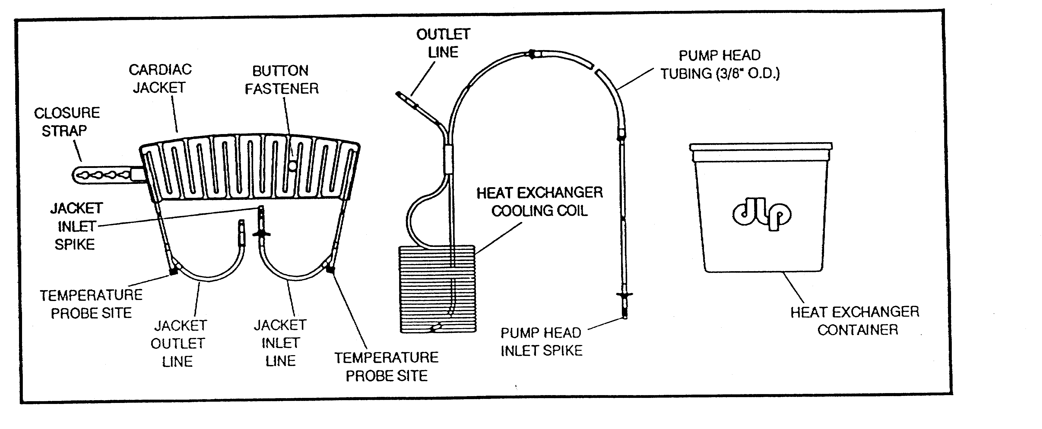

Precautions
- If the product leaks at any point in the system, do not use.
- Avoid overfilling during priming. Overfilling the jacket may reduce the product’s flexibility. Excess solution may be drained from the jacket in order to optimize flexibility.
- Do not exceed a flow rate of 300 ml/min. Do not restrict the flow through the tubing or the jacket. Excessive pressure within the system may damage the jacket and/or force connections apart.
- To avoid fracturing cold tubing, it is recommended that all tubing connections and significant tubing manipulations be completed prior to immersing the cooling coil in ice water.
- Do not separate heat exchanger tubing coils under any conditions.

Priming and Assembly Directions
- Use the diagram on the following page as a reference to these directions.
- Inspect the jacket package and product for damage and expiration date. If undamaged and unexpired, open the jacket package and transfer the jacket and connection lines onto the sterile field using aseptic technique.
- Inspect the tubing/coil set package and product for damage. If undamaged, open the package and remove the product.
- Mount a bucket holder on an IV pole.
- Position the ice bucket near the roller pump and at approximately the same level as the roller head.
- Set the 3/8” silicone pump boot into the roller head.
- Join the inlet spike from the jacket to the outlet line of the cooling coil. Place the coil in the bucket with the outlet line on top.
- Remove the vent cap from the outlet line.
- Inject 5 ml of sterile methylene blue (obtainable from the OR pharmacy) into a 1 liter bag of sterile normal saline. Spike the 1 liter bag of sterile normal saline with the pump head inlet spike and allow the solution to drain into the jacket.
- Have the scrub nurse hold the jacket vertically, e.g. with the closure strap on top. Begin to slowly pump the solution in through the bottom of the jacket. Have the scrub nurse agitate the jacket so air can escape from the jacket channels.
- After filling the jacket and lines, stop the pump. Priming requires approximately 300 ml. Avoid overfilling
- Aseptically join the pump head inlet spike to the jacket outlet spike.
Figure 41: Lancaster Cooling Jacket Circuit Diagram
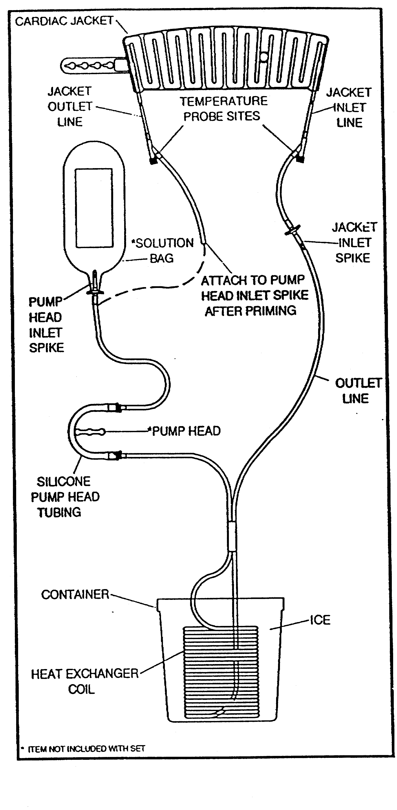
- Before the cooling coil is packed in ice, start the pump and stabilize the flow at approximately 120 ml/min. Check the coil, jacket, tubing, and all connections for leaks. If any leaks are observed, do not use the set. If the jacket appears overfilled, open one of the luer ports to allow fluid to escape. The jacket is effective without being distended.
- Fill the bucket with ice and top off with water.

Operation Directions
- The Lancaster Cooling Jacket is placed around the heart after cold cardioplegic induction.
- Position the jacket around the heart with the flat (non-channeled) side against the heart. The inlet/outlet should be directed towards the apex of the heart.
- Secure the jacket around the heart by slipping the closure strap over the button fastener and locking the strap in place. While adjusting the jacket be sure that the inlet and outlet tubing form a loop at the apex of the heart to minimize the possibility of kinking within the pericardium.
- Begin circulation of the cooling solution, adjusting the flow rate on the advice of the surgeon. The effectiveness of the jacket will vary depending on the solution temperature and flow rate. The recommended flow rate is 120 ml/min.
- To maintain the temperature of the recirculating solution, remove excess water from the bucket and replace it with ice.

Pre-DHCA with RCP Pharmacology
- Administer the drugs listed below ~5 minutes prior to the initiation of DHCA.
- 1 g thiopental
- 25 g mannitol
- 5,000-10,000 units heparin

DHCA Initiation
- When the patient has been sufficiently cooled, the patient is placed in Trendelenburg.
- On the surgeon's command, the blood flow rate (Q_{b}) is lowered and then CPB is stopped by the perfusionist clamping the arterial line.
- The patient is allowed to exsanguinate, and then the venous line occluded.

Intermittent DHCA
- Multiple periods of DHCA of approximately 20 minute duration are used during this procedure.
- Inform the surgeon of the fact that 20 minutes have elapsed since the initiation of each period of DHCA.
- After CPB is re-established, inform the surgeon when the vSAT > 90%.
- The next period of DHCA will not be initiated unless the vSAT >90% or the CPB period has been at least 10 minutes.

Rewarming
- Rewarm maintaining an 8-10ºC gradient between the venous blood and the water bath temperatures.
- Hemoconcentrate and make the necessary PRBC additions for a Hct of 25%.

Post-Aortic Crossclamp Pharmacology
- Immediately upon or just prior to the release of the aortic crossclamp administer the drugs listed below.
- 10 mg furosemide
- 200 mg lidocaine
- 25 g mannitol
- 3 g MgSO₄
- 500 mg methylprednisolone (Solu-Medrol)

CPB Termination
- The following conditions must be met before the patient is weaned from CPB.
- Vacuum assisted venous drainage terminated.
- 37 - 38ºC bladder temperature
- left atrial vent clamped and/or removed
- ventilator on and functioning
- stable cardiac rhythm
- CPB is then terminated in the usual manner.

Section 9: Non-Cardiac CPB Procedures
Eric Jenkins, CCT. CCP

Fem-Fem CPB with DHCA and Active Venous Drainage for Repair of Giant Intra-Cerebral Aneurysms

Overview
- Repair of intra-cerebral aneurysms frequently requires deep hypothermic circulatory arrest (DHCA) to minimize potential neurological morbidity.
- For patients without aortic valve insufficiency, a closed chest CPB technique, utilizing femoral-femoral cannulation, is employed to avoid a median sternotomy. (Patients with aortic valve insufficiency require a conventional open chest CPB technique with active left ventricular venting.)
- Vacuum assisted venous enhances venous return thereby assuring adequate blood flow and oxygen delivery.
- Transesophageal echo is used to detect ventricular distension while the heart is fibrillating.

Hardware
- Sarns 8000 pump console
- Sarns Heater/Cooler
- Medtronic Affinity NT Holder
- Hemoconcentrator holder
- Medtronic Affinity 38 micron arterial line filter holder

Disposables
- Main Adult Tubing Pack
- Medtronic Affinity NT Oxygenator with Integrated CVR
- Medtronic Vacuum Assisted Venous Drainage Conversion Kit (See Below.)
- 1/2" CDI H/S Cuvette
- Minntech HPH 1000 hemoconcentrator
- Edwards Life Science femoral arterial cannula or surgeon’s preference
- 28 Fr. DLP femoral vein cannula
- DLP Pressure Display Set (optional)

Cell Saver Technique

Primary Sternotomy

Deeb
- No cell saver is set up.

Bolling, Pagani, Prager, Patel
- Consult the surgeon regarding cell saver technique. If the surgeon requests a cell saver, use the following guidelines.
- Set up a cardiotomy and aspiration line. Only set-up a wash set if enough volume is scavenged during CPB to wash a full bowl of red blood cells.
- All washed red blood cells may be returned to the pump during CPB, but not post-CPB. The hemoconcentrator already set up for these cases will be used to handle any excess volume during CPB.

Redo Sternotomy

Deeb
- No cell saver is set up.

Bolling, Pagani, Prager, Patel
- Consult the surgeon regarding cell saver technique. If the surgeon requests a cell saver, follow the following guidelines.
- Set up a cardiotomy and aspiration line. Only set-up a wash set if enough volume is scavenged during CPB to wash a full bowl of red blood cells.
- All washed red blood cells may be returned to the pump during CPB, but not post-CPB. The hemoconcentrator already set up for these cases will be used to handle any excess volume during CPB.

Vacuum Assisted Venous Drainage Equipment & Disposables
- Vacuum Regulator (on pump console)
- Vacuum Source (OR column)
- DLP Pressure Display 60000 monitor
- Medtronic VAVD kit

Vacuum Assisted Venous Drainage Set Up
- Refer to the diagram below.
- Gather disposables.
- Open and connect the sputum bottle to oxygenator vent port using sterile technique.
- Open and connect suction tubing to sputum bottle and the ¼” Y connector attached to vacuum regulator.
- Place a stopcock on a luer port on top venous reservoir using sterile technique.
- Turn on the DLP Pressure Display 60000 monitor. Insert the DLP Pressure Display 60000 disposable transducer into monitor and then attach transducer line to the stopcock on the top of the venous reservoir. Zero the transducer at the venous reservoir.
- Remove cap on pressure relief valve on the top the venous reservoir.
- Turn on vacuum regulator and pre-set to –20 mmHg. Turn off vacuum regulator.

Vacuum Assisted Venous Drainage Diagram

Extracorporeal Circuit Prime Constituents
- 1750 ml Normosol R
- 50 g Albumin
- 50 mEq NaHCO₃
- 12.5 g Mannitol
- 10,000 units heparin
- antibiotic per protocol (See Antibiotic Preference in Section 4.)
- Please note that neither aprotinin nor Amicar are administered unless specifically requested by the attending surgeon.

Pre-CPB Autologous Whole Blood Collection
- 1 -2 units of the patient’s own whole blood are to be collected prior to heparinization. This is done as long as the resultant hematocrit falls within a calculated 18 - 22% resultant hematocrit on CPB. The perfusionist should spin a patient Hct following pre-CPB autologous whole blood collection and then calculate an estimated patient-machine Hct. If the resultant Hct is less than 25%, consult the attending surgeon regarding adding PRBC’s to the pump prime or at the initiation of CPB.

Estimated CPB Hct Calculation

Estimated CPB Hct = (65 x kg x (pt Hct / 100) x 100
(65 x kg) + ml prime)

where: Estimated CPB Hct = estimated Hematocrit on cardiopulmonary bypass
ml prime = prime volume of extracorporeal circuit
kg = patient’s kilogram weight
pt Hct = patient’s hematocrit measured following autologous
whole blood collection by anesthesia

Collection Procedure

Disposables
- (1 -2) 600 cc transfer packs
- (1)500 cc CPD bottle
- (1-2) 60 cc syringes
- (1-2) 3-way stopcocks

Procedure
- Attach a 3-way stopcock to a transfer pack.
- Draw 63 cc CPD into a 60 cc syringe and inject it into the transfer pack. Hand the CPD transfer pack(s) to the anesthesiologist.
- Blood collection should be timed to be completed just prior to heparinization. The collection time for each unit is ~15 minutes.
- Anesthesia personnel must monitor the patient blood pressures and EKG during blood collection and transfuse the patient with crystalloid and colloid solutions appropriately. Blood collection should be terminated if the patient becomes unstable.

Storage and Expiration
- When stored at 37ºC, autologous whole blood expires 8 hours from the start of collection.
- When the collected autologous whole blood approaches expiration before the termination of CPB, it may be stored at 1 - 6 ºC or transfused into the extracorporeal circuit. If the collected autologous whole blood is stored at 1 - 6 ºC within 8 hours of the start of collection, it will expire 24 hours from the start if collection.
  - (American Association of Blood Banks Standards for Perioperative Autologous Blood Collection and Administration, 1st Edition)

Transfusion Technique
- Collected autologous whole blood is transfused after protamine administration is completed.
- Do not transfuse collected autologous whole blood with the Belmont HMS2000 Rapid Infusion System.

Monitoring
- Temperature
- bladder
- nasopharyngeal
- arterial perfusate
- venous perfusate
- brain
- Pressure
- radial artery
- pulmonary artery
- central venous
- arterial line
- Transesophageal Echocardiograph (TEE)
- Electroencephalograph (EEG)
- Electrocardiograph (EKG)

Anticoagulation
- Heparin dose: 300 -400 units/kg
- Maintain an ACT > 480 s

Cannulation
- femoral artery
- Edwards Life Science femoral arterial cannula (Deeb)
- metal femoral artery cannula (these are kept by nursing)
- DLP wire reinforced arterial cannula
- femoral vein
- 28 Fr. DLP 96428 Femoral Venous Cannula
- 18 - 28 Fr. RMI Femoral Venous Cannula (available from Mott)

Vacuum Assisted Venous Drainage Initiation
- With the vacuum assist off, initiate CPB in the usual manner.
- Increase the blood flow rate until an equilibrium between blood flow rate and the venous reservoir level is obtained.
- Turn on the vacuum regulator at the pre-set vacuum of – 20 mmHg. Assess the level of the venous reservoir for increased return, and increase the blood flow rate accordingly until adequate perfusion in terms of blood flow rate, venous hemoglobin saturation, and mean arterial pressure are obtained. It may be necessary to increase the vacuum in order to obtain the appropriate blood flow rate; however, do not allow the negative pressure in the venous reservoir to exceed a vacuum greater than – 70 mmHg. It is recommended to use the minimum vacuum assist necessary for adequate perfusion.

Vacuum Assisted Venous Drainage Termination
- Terminate vacuum assisted drainage whenever blood flow to the patient is temporarily lowered to facilitate the surgical procedure during CPB.
- When blood volume is transferred to the patient for vent insertion or to initiate weaning from CPB, terminate vacuum assisted venous drainage.

Perfusion Parameters
- Blood flow rate: 2.4 L/min/m²
- MAP: see MAP Management Section 4.
- vSAT: > 65%
- arterial line pressure: < 300 mmHg
- venous line pressure: > -70 mmHg

Vacuum Assisted Venous Drainage Management
- Negative pressure in the venous reservoir should be monitored continuously and adjusted appropriately for efficient venous return augmentation.
- Do not allow the negative pressure in the venous reservoir to exceed a vacuum greater than – 70 mmHg.
- Whenever the blood flow rate is lowered intermittently, reduce or turn off the vacuum.
- Whenever blood volume is transferred to the patient for vent insertion, for vent removal, or to aspirate air from the aorta, turn off the vacuum.

TEE
- Cardiac function and filling will be monitored continuously by TEE.
- Absence of ventricular distention is confirmed by comparing the left ventricular cross-sectional area to the pre-CPB end diastolic volume.
- Ventricular distention can, in most instances, be resolved by increasing the vacuum.
- If increasing the vacuum does not resolve the distention, then active left ventricular venting, which requires a median sternotomy, should be considered.

Cooling
- Cool to a bladder temperature of 16 - 18ºC maintaining an 8 - 12ºC between the bladder and perfusate temperatures.
- Have anesthesia apply ice bags to the patient’s head.
- The Hct during cooling should be approximately 20%.

Myocardial Preservation Technique
- Cardioplegia cannot be delivered in the usual manner because the aortic root and coronary ostia are inaccessible from this surgical exposure.
hypothermic fibrillatory arrest
- Cool the patient as rapidly as possible maintaining an 8 - 12ºC between the perfusate and bladder temperatures to induce ventricular fibrillation.
systemic hyperkalemic cardiac arrest
- The surgeon may request that the heart be arrested by the injection of 80 - 120 mEq KCl in 20 mEq increments into the arterial line just proximal to the arterial filter because the aortic root and coronary ostia are inaccessible from this surgical exposure.

Pre-DHCA Pharmacological Administration
- Administer the drugs listed below 5 minutes prior to the initiation of HCA.
- 25 g mannitol
- 5000 - 10,000 units heparin
- 1 g thiopental
- 1 g methylprednisolone (Solu-Medrol)

DHCA
- CPB is discontinued in the usual manner making sure that vacuum assisted venous drainage is terminated, the arterial line is clamped, and the purge line closed.
- Blood is drained into the venous reservoir to shrink the cerebral vessels and aneurysm as well as provide the surgeon with a bloodless field.
- The venous line should be clamped once all the blood is drained.
- The perfusate in the extracorporeal circuit should be recirculated.
- The surgeon may require intermittent transfusion to test the aneurysm repair.

Post-DHCA Pharmacological Administration
- Upon resumption of CPB, administer the following drugs.
- 12.5 g mannitol
- 10 mg furosemide (Lasix)
- 3 g MgSO₄
- When it appears that the patient might spontaneously convert from ventricular fibrillation to sinus rhythm or when the patient is going to be de-fibrillated, administer 200 mg lidocaine (Xylocaine).

Rewarming
- Initiate rewarming once the surgeon determines that the aneurysm repair is hemostatic.
- During rewarming, maintain an 8 - 12ºC between the perfusate and water bath temperatures until the bladder temperature reaches at least 37ºC. Avoid perfusate temperatures > 38.9ºC.
- Hemoconcentrate and make the necessary PRBC additions for a HCT of at least 25%.

CPB Termination
- The following conditions must be met before the patient is weaned from CPB.
- Vacuum assisted venous drainage terminated.
- 37 - 38ºC bladder temperature
- left atrial vent clamped and/or removed
- ventilator on and functioning
- stable cardiac rhythm
- CPB is then terminated in the usual manner.

Resection of Intravascular Renal Carcinoma Requiring Deep Hypothermic Circulatory Arrest (DHCA)

Considerations
- This procedure is still evolving with respect to perfusion technique. Due to the varying nature of these tumors, the attending thoracic surgeon may require the case perfusionist to depart from this protocol. Accordingly, the case perfusionist must consult with the attending thoracic surgeon prior to circuit set-up whenever possible. Possible variations include:
- incorporation of vacuum assisted venous drainage
- an alternative cannulation strategy

Purpose
- Facilitate the resection of an intravascular renal carcinoma.
- Provide oxygen to the brain during deep hypothermic circulatory arrest.

Indication
- Resection of an intravascular renal carcinoma involving the inferior vena cava and possibly the right atrium that requires DHCA and/or RCP.

Monitoring
- Temperature
  - bladder
  - nasopharyngeal
  - arterial perfusate
- Pressure
  - radial artery
  - pulmonary artery
  - central venous
  - arterial line
- Transesophageal Echocardiograph (TEE)
- Electrocardiograph (EKG)

- Options
- Venous blood temperature may be measured to facilitate monitoring of the perfusate temperature gradient during rewarming.
- A portable tympanic temperature probe is available in Recovery if an alternate method of cerebral temperature monitoring is necessary.

Pre-CPB Autologous Whole Blood Collection
- 1 -2 units of the patient’s own whole blood are to be collected prior to heparinization. This is done as long as the resultant hematocrit falls within a calculated 18 - 22% resultant hematocrit on CPB. The perfusionist should spin a patient Hct following pre-CPB autologous whole blood collection and then calculate an estimated patient-machine Hct. If the resultant Hct is less than 25%, consult the attending surgeon regarding adding PRBC’s to the pump prime or at the initiation of CPB.

Estimated CPB Hct Calculation

Estimated CPB Hct = (65 x kg x (pt Hct / 100) x 100
(65 x kg) + ml prime)

where: Estimated CPB Hct = estimated Hematocrit on cardiopulmonary bypass
ml prime = prime volume of extracorporeal circuit
kg = patient’s kilogram weight
pt Hct = patient’s hematocrit measured following autologous
whole blood collection by anesthesia

Collection Procedure

Disposables
- (1 -2) 600 cc transfer packs
- (1)500 cc CPD bottle
- (1-2) 60 cc syringes
- (1-2) 3-way stopcocks

Procedure
- Attach a 3-way stopcock to a transfer pack.
- Draw 63 cc CPD into a 60 cc syringe and inject it into the transfer pack. Hand the CPD transfer pack(s) to the anesthesiologist.
- Blood collection should be timed to be completed just prior to heparinization. The collection time for each unit is ~15 minutes.
- Anesthesia personnel must monitor the patient blood pressures and EKG during blood collection and transfuse the patient with crystalloid and colloid solutions appropriately. Blood collection should be terminated if the patient becomes unstable.

Storage and Expiration
- When stored at 37ºC, autologous whole blood expires 8 hours from the start of collection.
- When the collected autologous whole blood approaches expiration before the termination of CPB, it may be stored at 1 - 6 ºC or transfused into the extracorporeal circuit. If the collected autologous whole blood is stored at 1 - 6 ºC within 8 hours of the start of collection, it will expire 24 hours from the start if collection.
(American Association of Blood Banks Standards for Perioperative Autologous Blood Collection and Administration, 1st Edition)

Transfusion Technique
- Collected autologous whole blood is transfused after protamine administration is completed.
- Do not transfuse collected autologous whole blood with the Belmont HMS2000 Rapid Infusion System.

Extracorporeal Circuit Components
- (2) 6’ x 3/8” PVC tubing
- 3/8” Y connector
- 3/8” x 3/8” x ½” Y connector
- 3/8" straight connectors (number depends on specific cannulae utilized)
- 24 Fr DLP venous cannula or surgeon's preference
- 31 Fr DLP venous cannula (Do not open unless requested.)
- surgeon’s preference femoral venous cannula (most likely a 23 - 28 Fr. USCI lighthouse tip venous cannula)
- surgeon's preference arterial cannula
- Medtronic Affinity Membrane Oxygenator
- Minntech HPH 1000 hemoconcentrator
- Custom Adult Tubing Pack with Medtronic Affinity 38 micron arterial line filter and Medtronic Myotherm cardioplegia system

Prime Constituents
- 1750 ml Normosol R
- 50 g albumin
- 50 mEq NaHCO₃
- 12.5 g mannitol
- 10,000 units heparin
- 1 g ceftazidime Ceptaz)
- 1g vancomycin (titrated during CPB)
- Please note that neither aprotinin nor Amicar are administered unless specifically requested by the attending surgeon.

Vacuum Assisted Venous Drainage Equipment & Disposables
- Vacuum Regulator (on pump console)
- Vacuum Source (OR column)
- DLP Pressure Display 60000 monitor
- Medtronic VAVD kit

Vacuum Assisted Venous Drainage Set Up
- Refer to the diagram on the following page.
- Gather disposables.
- Open and connect the sputum bottle to oxygenator vent port using sterile technique.
- Open and connect suction tubing to sputum bottle and the ¼” Y connector attached to vacuum regulator.
- Place a stopcock on a luer port on top venous reservoir using sterile technique.
- Turn on the DLP Pressure Display 60000 monitor. Insert the DLP Pressure Display 60000 disposable transducer into monitor and then attach transducer line to the stopcock on the top of the venous reservoir. Zero the transducer at the venous reservoir.
- Remove cap on pressure relief valve on the top the venous reservoir.
- Turn on vacuum regulator and pre-set to –20 mmHg. Turn off vacuum regulator.

Vacuum Assisted Venous Drainage Diagram

Cell Saver

Cell Saver Technique

Primary Sternotomy

Deeb
- No cell saver is set up.

Bolling, Pagani, Prager, Patel
- Consult the surgeon regarding cell saver technique. If the surgeon requests a cell saver, use the following guidelines.
- Set up a cardiotomy and aspiration line. Only set-up a wash set if enough volume is scavenged during CPB to wash a full bowl of red blood cells.
- All washed red blood cells may be returned to the pump during CPB, but not post-CPB. The hemoconcentrator already set up for these cases will be used to handle any excess volume during CPB.

Redo Sternotomy

Deeb
- No cell saver is set up.

Bolling, Pagani, Prager, Patel
- Consult the surgeon regarding cell saver technique. If the surgeon requests a cell saver, follow the following guidelines.
- Set up a cardiotomy and aspiration line. Only set-up a wash set if enough volume is scavenged during CPB to wash a full bowl of red blood cells.
- All washed red blood cells may be returned to the pump during CPB, but not post-CPB. The hemoconcentrator already set up for these cases will be used to handle any excess volume during CPB.

Circuit Preparation
- The arterial and venous Y set-ups are attached and primed after the A-V loop is divided.

Anticoagulation
- An ACT > 480 seconds is to be maintained.

CPB & Vacuum Assisted Venous Drainage Initiation
- With the vacuum assist off, initiate CPB in the usual manner.
- Increase the blood flow rate until an equilibrium between blood flow rate and the venous reservoir level is obtained.
- Turn on the vacuum regulator at the pre-set vacuum of – 20 mmHg. Assess the level of the venous reservoir for increased return, and increase the blood flow rate accordingly until adequate perfusion in terms of blood flow rate, venous hemoglobin saturation, and mean arterial pressure are obtained. It may be necessary to increase the vacuum in order to obtain the appropriate blood flow rate; however, do not allow the negative pressure in the venous reservoir to exceed a vacuum greater than – 70 mmHg. It is recommended to use the minimum vacuum assist necessary for adequate perfusion.

Vacuum Assisted Venous Drainage Termination
- Terminate vacuum assisted drainage whenever blood flow to the patient is temporarily lowered to facilitate the surgical procedure during CPB.
- When blood volume is transferred to the patient for vent insertion or to initiate weaning from CPB, terminate vacuum assisted venous drainage.

Perfusion Parameters
- Blood flow rate: 2.4 L/min/m²
- MAP: see MAP Management Section 4.
- vSAT: > 65%
- arterial line pressure: < 300 mmHg
- venous line pressure: > -70 mmHg

Vacuum Assisted Venous Drainage Management
- Negative pressure in the venous reservoir should be monitored continuously and adjusted appropriately for efficient venous return augmentation.
- Do not allow the negative pressure in the venous reservoir to exceed a vacuum greater than – 70 mmHg.
- Whenever the blood flow rate is lowered intermittently, reduce or turn off the vacuum.
- Whenever blood volume is transferred to the patient for vent insertion, for vent removal, or to aspirate air from the aorta, turn off the vacuum.

Cooling
- Cool to a bladder temperature of 18 - 20ºC maintaining an 8-12ºC gradient between the bladder and perfusate temperatures. Have anesthesia apply ice bags to the patient's head. The Hct during cooling should be approximately 20 - 25%.

Cardioplegia
- Cardioplegia is delivered at the surgeon's discretion; however, maintenance cardioplegia doses of 250-500 ml are usually delivered at 20 minute intervals. It is the perfusionist's responsibility to inform the surgeon that 20 minutes have elapsed since the delivery of cardioplegia.

Pre-DHCA Pharmacology
- Administer the drugs listed below ~5 minutes prior to the initiation of DHCA.
- 1 g methylprednisolone (Solu-Medrol)
- 1 g thiopental
- 25 g mannitol
- 5,000-10,000 units heparin

DHCA
- When the patient has been sufficiently cooled, the patient is placed in Trendelenburg.
- On the surgeon's command, the blood flow rate (Q_{b}) is lowered and then CPB is stopped by the perfusionist clamping the arterial line.
- The patient is allowed to exsanguinate. Then the venous line may is occluded.

Fluid Volume Replacement
- Avoid making large volume additions without ascertaining the cause of blood loss.
- Should large crystalloid volume additions be necessary, consult the staff surgeon and anesthesiologist concerning the administration of additional albumin.

Rewarming
- Rewarming is initiated once the surgeon determines that the aneurysm repair is hemostatic.
- During rewarming, maintain an 8 - 12ºC between the perfusate and water bath temperatures until the bladder temperature reaches at least 37ºC. Avoid perfusate temperatures > 38.9ºC.
- Hemoconcentrate and make the necessary PRBC additions for a HCT of at least 25%.

Continuous Zero Balanced Ultrafiltration (Z-BUF)
- The technique is used by Dr. Deeb only. Consult all other surgeons before applying this technique.
- Begin continuous Z-BUF immediately after the reestablishment of CPB and continue to the termination of CPB.
- Produce a minimum of 5 liters of effluent using the appropriate replacement fluid as suggested below.

0.9% NaCl Solution
- Use 0.9% NaCl solution as a perfusate volume replacement when the serum potassium and/or glucose are elevated.
- Be sure to correct the serum calcium prior to CPB termination.
- Buffer each liter of 0.9% NaCl with 24 mEq NaHCO₃ unless the patient has metabolic alkalosis.

Normosol R Solution
- Use Normosol R solution as a perfusate volume replacement when the serum potassium and/or glucose are not elevated.
- Be sure to correct the serum calcium prior to CPB termination.
- Buffer each liter of Normosol R solution with 24 mEq NaHCO₃ unless the patient has metabolic alkalosis.

Post-Aortic Crossclamp Pharmacology
- Immediately upon or just prior to the release of the aortic crossclamp administer the drugs listed below.
- 12.5 g mannitol
- 10 mg furosemide
- 200 mg lidocaine
- 3 g MgSO₄

CPB Termination
- The following conditions must be met before the patient is weaned from CPB.
- Vacuum assisted venous drainage terminated.
- 37 - 38ºC bladder temperature
- left atrial vent clamped and/or removed
- ventilator on and functioning
- stable cardiac rhythm
- CPB is then terminated in the usual manner.

Section 10: Perfusion Management of Pathologies Affecting CPB Technique
Eric Jenkins, CCT, CCP; Rocco Polito, CCP; Wei Lau, MD; and Francis Pagani, PhD, MD

Perfusion Management of Cold Agglutinins

Pathology
- Cold agglutinins are serum antibodies activated by a decrease in blood temperature. Once activated, cold agglutinins produce erythrocyte agglutination or hemolysis (hemolysis is secondary to complement activation). The temperature below which cold agglutinins become activated is called “thermal amplitude.” In most instances, thermal amplitude occurs below ambient temperature. Generally, rewarming to normal body temperature or above the thermal amplitude reverses cold agglutinins activity. Failure to reverse cold agglutinins activity can produce generalized ischemia resulting in possible multi-organ damage secondary to gangrene.
Gravlee, Davis, Utley, eds. Cardiopulmonary Bypass: Principles and Practice. Baltimore: Williams & Wilkins; 1993. pp. 742-3.

Clinical Significance
- Depending on a patient’s individual thermal amplitude, cold agglutinins activation can occur during hypothermic cardiopulmonary bypass and/or cold sanguineous cardioplegia delivery. Perfusion management of cold agglutinins, while somewhat dependent on the timing of diagnosis, encompasses the maintenance of perfusate temperature above a patient’s thermal amplitude and of safe and effective myocardial preservation.

Diagnosis

Pre- Operative Diagnosis
- If cold agglutinins are diagnosed by the blood bank during cross match and antibody screening, then a patient’s thermal amplitude is usually determined. Accordingly, perfusion management consists of maintaining the perfusate temperature above the patient’s thermal amplitude, as well as the delivery of warm sanguineous cardioplegia followed by warm crystalloid and then cold crystalloid cardioplegia. Maintenance of myocardial preservation is accomplished with cold crystalloid cardioplegia. Frequently, warm sanguineous reperfusion cardioplegia is delivered just prior to aortic crossclamp release.
- The perfusionist may also diagnose cold agglutinins, if inelegantly, by placing a 3 cc syringe of the patient’s blood (obtained from the anesthesiologist) in a cup of ice and looking for evidence of agglutination after ~5 minutes. This method does not determine thermal amplitude, and precise perfusion management should be planned in consultation with the staff surgeon and anesthesiologist.

Intra-Operative Diagnosis
- In some instances, cold agglutinins remain undiagnosed until either the perfusionist observes agglutination in the cardioplegia reservoir or the surgeon observes intravascular agglutination. Once the diagnosis is determined, then the patient should be rewarmed, and the cardioplegia circuit replaced. In these circumstances, the perfusionist should consult the surgeon as to whether he wants to wash out and warm the heart with warm sanguineous cardioplegia or warm crystalloid cardioplegia. In either case, the heart is cooled and preserved with cold crystalloid cardioplegia.

Perfusate Temperature Management
- The degree of hypothermia should be determined by the staff surgeon, staff anesthesiologist, and perfusionist in consultation prior to the initiation of CPB. The degree of hypothermia should be based on the patient’s thermal amplitude if it is known. Otherwise, the safest course is to keep the patient normothermic during CPB.

Cardioplegia Composition and Pre CPB Set-Up
- Myocardial preservation is induced with warm sanguineous induction cardioplegia, followed by warm crystalloid maintenance cardioplegia and then cold crystalloid cardioplegia.
- Myocardial preservation is maintained with cold crystalloid cardioplegia.

Additional Equipment & Supplies
- (2) quick prime lines
- (2) perfusion adapters
- (1) high flow 3-way stopcock
- Warm induction technique also requires (2) Blanketrols, one set at 39ºC and the other at 4ºC. The cardioplegia heat exchanger is initially connected to the 39ºC Blanketrol.

Disposable Set-Up and Prime Technique
- When myocardial preservation is induced with warm sanguineous induction cardioplegia, followed by warm crystalloid maintenance cardioplegia and then cold crystalloid cardioplegia, the integration of 2 reservoir bags into the cardioplegia circuit minimizes the mixing of blood cardioplegia with crystalloid cardioplegia.
- Attach perfusion adapter to quick prime line.
- Attach high flow 3-way stopcock to the luer port on ¼” Y connector of the cardioplegia circuit.
- Prime the cardioplegia circuit in the usual manner, and then prime the quick prime line assembly.
- Connect a (1) liter bag of Normosol R to quick prime line assembly and transfer ~950 ml to the regular cardioplegia bag.
- Place tubing clamps on both the inlet and outlet of the regular cardioplegia reservoir.
- Turn the quick prime line assembly off to the cardioplegia circuit. The almost empty (1) liter bag of Normosol R attached to quick prime line assembly will be referred to as an auxiliary cardioplegia reservoir.
- Add the warm sanguineous induction cardioplegia constituents listed in the table below to the auxiliary cardioplegia reservoir. Remove any air from the auxiliary cardioplegia reservoir using a syringe.

Warm Sanguineous Induction Cardioplegia Constituents
Constituents | Amount
Prime Solution | 50 ml
KCl (2 mEq/ml) | 24 mEq
THAM (0.3 mEq/ml) | 50 ml
CPD | 12 ml
50% Dextrose (0.5 g/ml) | 10 ml
0.46 M Aspartate/Glutamate | 50 ml
2% Lidocaine (20 mg/ml) | 5 ml (Dr. Pagani only)

- Add the warm crystalloid cardioplegia constituents listed in the table below to the regular cardioplegia reservoir filled with Normosol R.

Warm Crystalloid Cardioplegia Constituents
Constituents | Amount
KCl (2 mEq/ml) | 4 ml
8.4% NaHCO₃ (1 mEq/ml) | 24 ml
THAM (0.3 mEq/ml) | 50 ml
50% Dextrose (0.5 g/ml) | 10 ml
2% Lidocaine (20 mg/ml) | 5 ml (Dr. Pagani only)

- Add the cold crystalloid cardioplegia constituents listed in the table below to each of however many 1 liter bags of Normosol R are required for the case. A minimum of 2 bags should be prepared for cooling the heart after delivery of warm crystalloid cardioplegia. Remove any excess air from the bags with a syringe.

Cold Crystalloid Cardioplegia Constituents
Constituents | Amount
KCl (2 mEq/ml) | 4 ml
8 .4% NaHCO₃ (1 mEq/ml) | 24 ml
THAM (0.3 mEq/ml) | 50 ml
50% Dextrose (0.5 g/ml) | 10 ml (Add only if the patient’s glucose < 200 mg/dl.)

- Attach perfusion adapter to the second quick prime line
- Place a tubing clamp on the quick prime line, and spike a bag of the prepared cold crystalloid cardioplegia. Invert the bag, open the tubing clamp, prime the quick prime line, and then close the tubing clamp. Set aside for later.

Induction Cardioplegia Preparation & Delivery Technique

Warm Sanguineous Induction Cardioplegia
- When CPB has been safely established and a left ventricular vent has been inserted (if applicable), transfer ~950 ml perfusate to the auxiliary cardioplegia reservoir.
- When the aorta is crossclamped, warm sanguineous induction cardioplegia is delivered antegrade at rate of 250-350 ml/min and a line pressure of 200-250 mmHg until the heart arrests. Usually ~500 ml is delivered if retrograde cardioplegia delivery is planned. Otherwise, all cardioplegia is delivered antegrade.
- If applicable, warm induction is then delivered retrograde at a rate of ~200 ml/min for a coronary sinus pressure of 28 - 40 mmHg until a total of 1 liter is administered.
- When the warm sanguineous induction cardioplegia has been delivered, turn the high flow 3-way stopcock off to the cardioplegia circuit.

Warm Crystalloid Cardioplegia
- Immediately following warm sanguineous induction cardioplegia delivery, remove the tubing clamp from the outlet of the regular cardioplegia reservoir.
- Begin delivery of warm crystalloid cardioplegia retrograde at a rate of ~250 ml/min.
- Remove the auxiliary cardioplegia reservoir and the attached quick prime line from the high flow 3-way stopcock. Connect the bag of the prepared cold crystalloid maintenance cardioplegia spiked with the quick prime line to the high flow 3-way stopcock. Take to remove any air. Remove the tubing clamp on the quick prime line.

Cold Crystalloid Cardioplegia
- After administration of 500 – 750 ml of warm crystalloid cardioplegia, switch the water lines from the warm Blanketrol to the cold Blanketrol. Be sure to inform the surgeon when you are changing from warm to cold.
- From this point, cold crystalloid cardioplegia is then delivered antegrade and/or retrograde until the myocardium is cooled to the surgeon’s satisfaction.
- When the regular cardioplegia reservoir is almost empty, open the high flow 3-way stopcock to the auxiliary cardioplegia bag (1 liter bag of Normosol R with cold crystalloid maintenance cardioplegia constituents added). Replace the auxiliary cardioplegia bag as needed until the myocardium is cooled to the surgeon’s satisfaction.

Cold Crystalloid Maintenance Cardioplegia Preparation & Delivery Technique

Description
- The purpose of cold crystalloid maintenance cardioplegia is to ensure myocardial preservation during extended aortic crossclamp periods. Maintenance cardioplegia achieves this by keeping the myocardial temperature <15ºC; washing out metabolites; and delivering oxygen, energy substrate, and buffer. Accordingly, the perfusionist should alert the surgeon should the myocardial temperature exceed 15ºC. The surgeon should also be informed when 20 minutes have passed since the last dose of cardioplegia was delivered. If cardioplegia is not immediately delivered, the surgeon will usually inform the perfusionist when to remind him thereafter.

Cold Crystalloid Maintenance Cardioplegia
- Cold crystalloid maintenance cardioplegia is delivered antegrade and/or retrograde at a rate of ~250 ml/min and a line pressure of 200-250 mmHg. The dose as well as method and frequency of delivery will vary from surgeon to surgeon on a case by case basis. It is the perfusionist’s responsibility to consult the staff surgeon accordingly.

Warm Reperfusion (Hot Shot)
- It is the perfusionist’s responsibility to consult the staff surgeon regarding warm reperfusion delivery on case by case basis.

Description
- Warm reperfusion is given just prior to the removal of the aortic cross clamp. This option is available to all surgeons and facilitates the recovery of a compromised myocardium by providing Kreb's Cycle substrates (aspartate & glutamate), glycolysis substrate (dextrose), intracellular buffer (THAM), and a calcium chelating agent (CPD).

Set-Up & Delivery Technique
- Clamp both the inlet and outlet of the regular cardioplegia bag. This preserves a blood free cardioplegia reservoir should it become necessary to crossclamp the heart a second time.
- Spike an empty 1 liter bag with the quick prime line.
- Add constituents listed in the table below to the empty 1 liter bag. This formulation produces ~600 ml of warm reperfusion cardioplegia solution.

Warm Reperfusion Constituents
Constituents | Amount
KCl | Sufficient KCl is added to produce a 600ml of maintenance cardioplegia with a K⁺ concentration of 12 mEq/L. The amount of KCl is calculated by subtracting the current serum K⁺ concentration from12 and multiplying by 0.6.
THAM (0.3 mEq/ml) | 45 ml
CPD | 12 ml
Dextrose | Add 5 g dextrose if the current serum glucose is < 300 g/dl.
0.46 M Aspartate/Glutamate | 40 ml
Perfusate | ~500 ml

- The warm reperfusion cardioplegia solution is mixed in the cardioplegia reservoir bag and warmed to 37ºC by recirculation

Dose
- The usual warm perfusion dose is 600 ml. The warm CP temperature is achieved by switching the cardioplegia heat exchanger hoses from the cold Blanketrol to the warm Blanketrol.

Technique
- Generally, the "Hot Shot" is delivered retrograde at 150 - 200 ml/min at a temperature of 32 - 37ºC.
- The “Hot Shot” is usually followed by a minute of warm perfusate.

Perfusion and Anticoagulation Management of the Heparin Induced Thrombocytopenia/Heparin Associated Thrombocytopenia (HIT/HAT) Patient with Bivalirudin (Angiomax)

Overview
- Heparin induced thrombocytopenia can be a life threatening complication of long-term heparin therapy. An alternative to heparin must be used in these patients in order to perform cardiopulmonary bypass safely. Bivalirudin is one such alternative anticoagulation therapy.
- Bivalirudin is a direct thrombin inhibitor that has no neutralizing agent. Despite its reported fast renal elimination, quick hemostasis following cardiopulmonary bypass should not be expected.
- Maintain a venous reservoir level below the filter sock whenever possible to avoid providing a matrix for thrombus formation.
- Do not use pericardial suckers until CPB has been safely initiated.

Anticoagulation Management

Pre-CPB

Loading
- Bivalirudin bolus to prime: 50 mg bivalirudin (Angiomax)
- Loading dose to patient: 2.25 mg/kg IV bivalirudin (Angiomax) to patient
- Start constant infusion at 1.25 mg/kg/hr bivalirudin (Angiomax)
- Wait 5 minutes before checking ACT.
- Do not initiate CPB until ACT is > 550 seconds and a minimum of 20 mins has elapsed from the time that the initial loading dose was administered.
- If initial ACT is < 550 seconds, re-bolus patient with 1.125 mg/kg bivalirudin (Angiomax).
- Repeat ACT after 5 minutes. Repeat step #6 as necessary following consultation with the staff surgeon and staff anesthesiologist.

During CPB
- Just prior to CPB initiation, transfer the bivalirudin (Angiomax) bivalirudin constant infusion to the heart and lung machine. The bivalirudin (Angiomax) constant infusion is inserted into the venous blood temp probe site.
- Measure an ACT a minimum of every 10 – 15 mins using Hemochron Jr. II.
- If the ACT falls below 480 seconds, re-bolus with 0.25 mg/kg and increase constant infusion rate by 0.5 mg/kg/hr.
- If the ACT is over 600 seconds, lower constant infusion rate by 0.5 mg/kg/hr.

Preparation for CPB Termination
- Discontinue bivalirudin (Angiomax) infusion 30 minutes prior to CPB termination. Consult the staff surgeon and staff anesthesiologist regarding the exact timing of infusion termination.
- Discontinue pericardial sucker usage 15 – 30 mins prior to CPB following consultation with the staff surgeon.
- Ultrafiltrate to lower bivalirudin (Angiomax) concentration. Consult staff surgeon and anesthesia regarding target ACT for CPB termination.

Post-CPB
- Vigorous diuresis.

Extracorporeal Circuit Components
- Do not use Carmeda or Trillium coated components.
- Medtronic Affinity membrane oxygenator with integrated cardiotomy/venous reservoir
- Uncoated Medtronic Affinity membrane oxygenator with integrated cardiotomy/venous reservoir is stored on the wire racks in the Core A storage area.
- (1) Medtronic Affinity arterial filter (38 micron)
- Main Adult tubing pack
- Medtronic Myotherm cardioplegia system
- Minntech HPH 1000TS hemoconcentrator
- (1) high flow stopcock

Circuit Modification
- Insert a Medtronic Affinity arterial filter (38 micron) into the ALF bypass line.
- After priming both filters, isolate the ALF inserted into the ALF bypass line with tubing clamps. If the ALF exposed to the perfusate becomes obstructed during CPB, remove the tubing clamps isolating the spare ALF and then isolate the obstructed ALF.
Figure 42: Extra-Corporeal Circuit for HIT / HAT Patient Diagram
Cell Saver
- No cell saver is used.

Prime Constituents
- 1750 ml Normosol R
- 50 mEq NaHCO₃
- 12.5 g mannitol (Do not administer in presence of severe renal impairment unless authorized by the attending surgeon.)
- 50 mg bivalirudin (Angiomax)
- antibiotic (See Section 6.)

Note: Consult surgeon regarding Amicar and/or aprotinin administration.
- 2.0 x 10⁶ KIU aprotinin (Trasylol) (Do not administer unless test dose is negative.)
- 10 g Amicar

Cooling
- Patient is cooled according to the surgeon’s directions on a per case basis.

Cardioplegia
- See Section 5.

Post Aortic Crossclamp Pharmacology
- Per surgeon preference. See Section 6.

Post Aortic Crossclamp CPB Management
- Be prepared to terminate CPB anytime after aortic crossclamp release should thrombosis cause oxygenator and/or extracorporeal circuit failure.
- Initiate zero-balanced ultrafiltration (Z-BUF) to remove bivalirudin (5 – 10 liters). Monitor ACT’s constantly. If the ACT falls below 400 seconds, terminate Z-BUF and consult the surgeon and anesthesiologist.

Perfusion Management of Sickle Cell Anemia Patient

Pathophysiology
- Sickle cell hemoglobinopathy is a single gene recessive abnormality that may be present in a heterozygous form, sickle cell trait, or in a homozygous recessive form, sickle cell disease. Recessive gene expression results in the substitution of a percentage of normal hemoglobin A with abnormal hemoglobin S.
- The hemoglobin of patients with sickle cell trait (heterozygous) is usually 20 - 45% hemoglobin S. These patients have few clinical problems. Sickle cell crises result only from severe provocation.
- The hemoglobin of patients with sickle cell disease (homozygous) is usually 80 - 98% hemoglobin S. Clinically, sickle cell disease manifests as a sickle cell crisis where the hemoglobin S within erythrocytes dimerizes. This dimerization causes the cell to become sickle shaped. The distortion of erythrocytes increases their fragility resulting in a severe hemolytic anemia. The aggregation of sickled red cells increases blood viscosity resulting in vaso-occlusive phenomena. The sickled cells also disrupt the capillary endothelium resulting in the release of collagen into the capillary bed. Collagen activates the intrinsic pathway of the coagulation cascade which in turn promotes platelet activation and aggregation on damaged endothelial surfaces resulting in further vaso-occlusive phenomena.
- A variety of conditions can induce a sickle cell crisis.
- hypoxic (Hb O₂ saturation < 85%)
- acidosis
- low flow states
- hypovolemia
- hypotension
- dehydration
- hypothermia
- infection
- increased concentration of 2.3-diphosphoglyceric acid

Management Strategy Overview
- Reduce the level of hemoglobin to approximately 5% prior to the operation.
- partial exchange transfusion during preoperative period
- complete exchange transfusion just prior to CPB initiation
- Minimize sickling by avoiding predisposing conditions.

Extracorporeal Circuit Components
- Medtronic Affinity Membrane Oxygenator with CVR
- Adult Tubing Pack
- Medtronic Myotherm Cardioplegia System
- Medtronic Affinity Arterial Line Filter (38 micron)
- Cobe Brat Cardiotomy Reservoir
- ½” x 6’ PVC tubing
- 3/8” x 6’ PVC tubing
- (1) 6’ x ¼” PVC tubing
- (1) ½” Y connector
- (1) ¼” connector with luer lock adapter
- (1) ¼” perfusion adapters
- (2 - 3) 3 liter suction canisters

Circuit Modification
- Use the diagram on the following page as guide to complete the modifications listed below.
- A 6” length of the venous line is cut. Insert a ½” Y connector and attach the 6” length of ½” tubing. The modified venous line is attached to the CDI cuvette and then attached to the venous port of the oxygenator in the usual manner.
- Cut a 2’ length of ½” tubing and attach it to the free arm of the ½” Y connector. Clamp and cap the free arm of the venous line.
Figure 43: Exsanguination Circuit Diagram
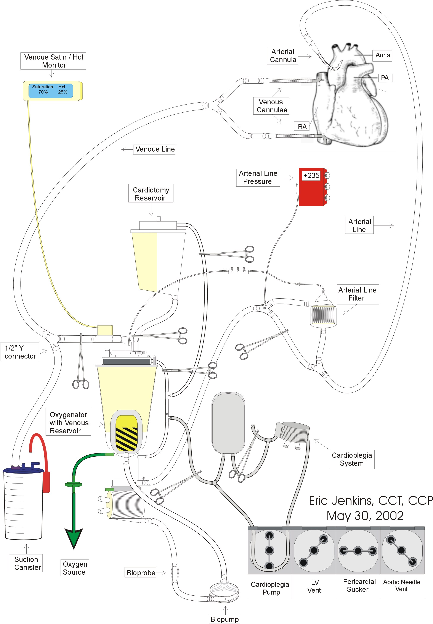
Extracorporeal Circuit Prime Technique
- After flushing with CO₂, prime and de-air the extracorporeal circuit with 1750 ml Normosol R at 40ºC.
- Hand the lines up to the field. Have the scrub nurse replace the pre-bypass filter with a 3/8 x 1/2” connector.
- Purge 500 ml crystalloid prime solution and add the following constituents:
- 50 g Mannitol
- 150 mEq NaHCO₃
- 30,000 units Heparin
- 1.0 - 2.0 x 10⁶ KIU Aprotinin
- 5 units PRBC
- 5 units FFP
- 1.5 mg Fentanyl
- 500 mg CaCl₂
- 10 mg Pancuronium
- 5 mg Midazolam
- Recirculate the prime at 38ºC.
- Take a sample of the prime for hematocrit, blood gas, and electrolyte analysis. Correct to normal values if necessary. The Hct should be approximately 24 - 30 %.

CPB Initiation and Compete Exchange Transfusion Technique
- The patient is heparinized with at least 300 units/kg for a resultant ACT of > 480 seconds.
- The patient is then cannulated.
- Both arms of the venous line are clamped distal to the ½” Y connector

- The free arm of the venous line is placed in a 3 liter suction canister A second 3 liter suction canister should be within easy reach.
- On the surgeon’s command, the perfusionist removes the clamp on the free arm of the venous line allowing the patient to exsanguinate the equivalent of their calculated blood volume (0.65 x kilogram weight, ~ 4 liters).
- The patient is then rapidly transfused from the extracorporeal circuit to maintain adequate blood pressures. Simultaneously, an additional 2 liters is allowed to drain into the suction canisters.
- When the complete exchange transfusion is complete, the free arm of the venous line is clamped and capped.
- Full CPB is then initiated in the usual manner.

Perfusion Parameters Management
- The following perfusion parameters are to be followed in order to avoid conditions that could induce sickle cell crisis;
- Blood Flow Rate: > 3.0 l/min
- vSAT: > 85%
- pH: > 7.4
- PaCO₂: < 35 mmHg
- PaO₂: > 300 mmHg
- Hct: > 24%
- HCO₃⁻: > 24 mEq
- BE: > 0.0

Cardioplegia Composition and Technique
- Myocardial preservation is induced and maintained with crystalloid cardioplegia.
- Cardioplegia delivery technique is per protocol. See Section 4.

Cold Induction Cardioplegia Solution Composition
- 1000 ml Normosol R
- 12 ml KCl (2 mEq/ml)
- 24 ml NaHCO₃ (2 mEq/ml)
- 10 ml 50% dextrose
- 50 ml THAM (0.3 mEq/ml)

Cold Maintenance Cardioplegia Solution Composition
- 1000 ml Normosol R
- 6 ml KCl (2 mEq/ml)
- 24 ml NaHCO₃ (2 mEq/ml)
- 10 ml 50% dextrose
- 50 ml THAM (0.3 mEq/ml)

Section 11: Emergency Procedures
Kevin Griffith, CCP; Russell Butler, CCP; and Eric Jenkins, CCT, CCP

- Please note that these emergency procedures are general guidelines that may or may not apply in exact detail to clinical emergent situations. No perfusionist is liable for not following these procedures exactly during clinical emergent situations. Rather, these procedures are intended to help prepare the perfusionist to resolve clinical emergent situations in a timely manner.

Failed Oxygenator Change Out

Purpose
- To replace a failed or damaged oxygenator prior, during or after cardiopulmonary bypass.
- Since cardiopulmonary bypass must be terminated during oxygenator change out, the patient can be at high risk of hypoxic injury.
- While the process as outlined below is not the only method for changing a failed oxygenator, the perfusionist should use his/her discretion as to the most appropriate procedure based on patient and surgical circumstances.
- This procedure should be reviewed periodically and practiced during simulations to ensure familiarization with the procedure and minimize patient risk.

Requisites
- Two perfusionists are required to perform this procedure to minimize the time off cardiopulmonary bypass and to preserve sterility of the cardiopulmonary bypass circuit. The assisting perfusionist should act under the direction of the primary perfusionist.
- If poor oxygenator performance is suspect, perform patient oxygen consumption calculation. The patient’s oxygen consumption may have exceeded the oxygen delivery capacity of the oxygenator.
- Oxygen Consumption (ml/min) = {(Arterial Saturation (decimal) – Venous Saturation (decimal)) x 1.34 x Hgb (gm/dl) x Blood Flow Rate (ml/min)} / 100

Normal VO₂ Ranges Stratified by Age
Adult: 3 – 5 ml/kg/min of oxygen
(Gravlee, et al, Cardiopulmonary Bypass: Principles and Practice, Baltimore, 1993, 659.)
- If patient oxygen consumption is high, verify that the patient is adequately anesthetized and paralyzed. Rule out malignant hyperthermia.
- If poor oxygenator performance remains suspect, consult the attending CV surgeon and anesthesiologists prior to initiation of oxygenator change out procedure.

Supplies
- Oxygenator
- (6) Tubing clamps
- A blanket to absorb spilled blood

Procedure

Prepare the Patient
- If the patient is capable of normal cardiac function, fill the patient and terminate cardiopulmonary bypass in the normal manner.
- If the patient is incapable of normal cardiac function, consider cooling the patient for a short period of circulator arrest.
- Open CPR can be performed to provide circulation during arrest period.
- Consider packing the head in ice and the use of systemic topical hypothermia.

Prepare the Oxygenator To Be Added
- Open and inspect a new oxygenator for defects.
- Separate the new oxygenator from the venous reservoir.

Prepare the Oxygenator To Be Removed
- Turn off heater-cooler, disconnect from oxygenator and move out of way.
- Remove the arterial temperature probe and gas scavenging line.
- Detach the failed oxygenator from the venous reservoir and let it hang loose.
- Spread a blanket under the failed oxygenator to absorb spilled blood, which may occure during the change out procedure.

Oxygenator Change Out
- Terminate cardiopulmonary bypass in the appropriate manner. Clamp the arterial line distal to the arterial line filter. Clamp the venous line and close the arterial filter purge line.
- Start a timer to record the circulatory arrest period.
- Move the oxygen line to the new oxygenator.
- Raise the failed oxygenator above the blood level in the venous reservoir and open the recirculation line.
- Clamp the tubing near the blood in port of the failed oxygenator and pry off the tubing.
- Have the assistant attach the clamped tubing to the blood in port of the new oxygenator while allowing sufficient time for the blood to drain from the failed oxygenator into the venous reservoir.
- Pry the recirculation line from the failed oxygenator and move it to the new oxygenator.
- Pry the arterial line tubing from the blood out port of the failed oxygenator and reattach it to the blood out port of the new oxygenator.
- Remove the clamp on the blood in tubing and begin filling the new oxygenator.
- Ensure that the recirculation line is unclamped and recirculate until all air is removed from the new oxygenator. Tilt the oxygenator to remove the air trapped in the arterial line at the blood out port of the oxygenator.
- Open the arterial filter purge line, and remove the clamp at the blood out port. Any residual air in the arterial line trapped at the blood out port will be purged through the arterial line filter.
- When all air is removed, stop the pump, clamp the recirculation line, close the arterial line filter purge, and resume cardiopulmonary bypass in the usual manner.
- Stop the circulatory arrest timer and record time.
- Reattach the heater-cooler, arterial temperature probe and gas scavenging line.

Risk Management
- Sequester the failed oxygenator for further investigative testing according to the “Failed Medical Device” OR policy.
- Completely document the incident according to OR policy.

Open Venous Reservoir Change Out

Purpose
- To replace a failed or damaged cardiotomy reservoir prior, during or after cardiopulmonary bypass. Since cardiopulmonary bypass must be terminated during venous reservoir change out, the patient can be at high risk of hypoxic injury. This procedure should be reviewed periodically and practiced during simulations to ensure familiarization and minimize patient risk.

Requisites
- Consult the attending CV surgeon prior to initiation of cardiotomy reservoir change out.

Supplies
- Cardiotomy Reservoir
- (6) Tubing Clamps
- (2) 3/8” tubing connectors
- (1) 6” stub of 3/8” tubing
- Sterile scissor

Procedure
- If poor venous reservoir function is due to high volumes of sucker and vent return, consider adding a sucker cardiotomy. The additional blood handling properties of a sucker cardiotomy may eliminate the need to terminate cardiopulmonary bypass for venous reservoir change out.
- Attempt to repair small cracks or leaks in the reservoir with bone wax.

Prepare the New Veinous Reservoir
- Connect the tubing stub with a tubing connector attached, to the new venous reservoir outlet and clamp it.

Prepare the Patient
- If the patient is capable of normal cardiac function, fill the patient and terminate cardiopulmonary bypass in the normal manner.
- If the patient is incapable of normal cardiac function, consider cooling the patient for a short period of circulator arrest.
- Open CPR can be performed to provide circulation during arrest period.
- Consider packing the head in ice and the use of systemic topical hypothermia.

Venous Reservoir Change Out
- Terminate cardiopulmonary bypass in the appropriate. Clamp the arterial and venous lines and close the arterial filter purge line.
- Stop the vent and sucker pumps.
- Start a timer to record the circulatory arrest period.
- Have an assistant hold the new venous reservoir close to facilitate moving lines to the new reservoir.
- Remove the recirculation line from the defective venous reservoir and attach it to the recirculation port of the new venous reservoir.
- Unclamp the recirculation line and pump the remaining blood from the defective venous reservoir into the new venous reservoir. Clamp the recirculation line when the blood volume in the defective venous reservoir is exhausted.
- Double clamp the tubing near the outlet of the defective venous reservoir and sterilely cut the tubing.
- Attach the cut end of the tubing to the tubing connector at the outlet of the new venous reservoir.
- Remove the clamp from the outlet of the new venous reservoir and walk any residual air in the tubing back to the reservoir.
- Transfer the venous line to the new venous reservoir and reestablish cardiopulmonary bypass.
- Stop the circulatory arrest timer and record time.
- Detach the defective venous reservoir from the oxygenator and place it out of the way.
- Attach the new venous reservoir to the oxygenator by aligning and twisting it into position. Caution must be exercised to ensure that no air is permitted to exit the outflow of the venous reservoir during this manipulation.
- Transfer the vent, sucker and arterial filter purge lines to the new venous reservoir and turn the pumps on.

Risk management
- Sequester the failed reservoir for further investigative testing according to the “Failed Medical Device” OR policy.
- Completely document the incident according to OR policy.

Pump Boot or Centrifugal Pump Head Change Out

Purpose
- To replace a failed or damaged arterial roller pump boot or centrifugal pump head. Since cardiopulmonary bypass must be terminated during pump boot or centrifugal pump head change out, the patient can be at high risk of hypoxic injury. This procedure should be reviewed periodically and practiced during simulations to ensure familiarization and minimize patient risk.

Requisites
- Consult the attending CT surgeon and anesthesiologists prior to roller pump boot or centrifugal pump change out.

Supplies
- Sterile pump boot or centrifugal pump head
- (4)Tubing clamps
- (2) 3/8” x ½” tubing connectors

Procedure

Prepare the Patient
- If the patient is capable of normal cardiac function, fill the patient and terminate cardiopulmonary bypass in the normal manor.
- If the patient is incapable of normal cardiac function, consider cooling the patient for a short period of circulator arrest.
- Open CPR can be performed to provide circulation during arrest period.
- Consider packing the head in ice and the use of systemic topical hypothermia.

Centrifugal Pump Head Change Out
- Terminate cardiopulmonary bypass in the appropriate manner for a centrifugal arterial pump. Clamp the arterial and venous lines and close the arterial filter purge line.
- Start a timer to record the circulatory arrest period.
- Double clamp the tubing very close to the outlet connector of the failed centrifugal arterial pump. Using sterile technique cut the tubing between the clamps at the outlet of the centrifugal arterial pump.
- Remove the failed centrifugal arterial pump from the pump console and raise it above the blood level in the cardiotomy reservoir.
- Remove the clamp at the outlet of the failed centrifugal arterial pump and allow the blood to drain back into the venous/cardiotomy reservoir.
- Clamp the tubing very close the inlet of the centrifugal arterial pump.
- Using sterile technique cut the tubing between the clamp and the centrifugal arterial pump inlet connector.
- Attach the tubing from the venous/cardiotomy reservoir to the inlet of the new centrifugal arterial pump.
- Holding the new centrifugal arterial pump above the blood level in the reservoir, unclamp the pump head inlet tubing. Slowly lower the new centrifugal arterial pump allowing it to fill.
- When the new centrifugal arterial pump is full, attach the pump outlet tubing, remove the clamp and place the centrifugal arterial pump in the pump console.
- Open the oxygenator recirculation line and start the centrifugal arterial pump, purging any residual air through the recirculation line.
- Clamp the recirculation line and reestablish cardiopulmonary bypass in the usual manor.
- Stop the circulatory arrest timer and record time.

Roller Pump Boot Change Out
- Terminate cardiopulmonary bypass; clamp the arterial and veinous lines and close the arterial filter purge line.
- Start a timer to record the circulatory arrest period.
- Remove the failed pump boot from the pump console.
- Double clamp the inlet and outlet sides of the failed roller pump boot.
- Using sterile technique cut the tubing between the clamps at the inlet and outlet of the failed roller pump boot.
- Attach an appropriate size tubing connector to the pump boot inlet tubing and attach a new roller pump boot.
- Holding the new roller pump boot above the blood level in the venous/ cardiotomy reservoir, unclamp the inlet tubing. Slowly lower the new pump boot allowing it to fill.
- Attach the new pump boot to the tubing connected to the oxygenator blood inlet port using an appropriate size tubing connector and remove the remaining clamp.
- Open the oxygenator recirculation line and load the pump boot into the pump console by rotating the roller pump in the forward direction.
- Start the pump console and purge any residual air through the recirculation line.
- Stop the pump, clamp the recirculation line and reestablish cardiopulmonary bypass in the usual manor.
- Stop the circulatory arrest timer and record time.

Cardioplegia Delivery System Change Out

Purpose
- Failure of the cardioplegia delivery system can result in inadequate myocardial preservation. Inability to delivery cardioplegia due to system contamination, leakage, precipitate formation, heat exchanger leak, or bubble screen blockage may necessitate cardioplegia delivery system change out.

Requisites
- Consult the attending CT surgeon prior to cardioplegia system change out.
- Precipitate formation due to undiagnosed cold agglutinins will require priming of the new cardioplegia system with crystalloid solution to prevent the formation of precipitate in the new system.

Supplies
- A sterile cardioplegia delivery system
- Cardioplegia additives as required
- (3) Tubing clamps

Procedure

Recirculating Cardioplegia System Change Out, With Blood Prime
- Clamp the oxygenator recirculation line between the oxygenator and the cardioplegia blood line attachment point.
- Unclamp the oxygenator recirculation line between its venous/cardiotomy reservoir attachment and the cardioplegia blood line.
- Unclamp the cardioplegia blood line and allow all uncontaminated/agglutinated blood being held in the cardioplegia mixing bag to drained back into the venous/cardiotomy reservoir via the oxygenator recirculation line.
- Reclamp the recirculation line between the venous/cardiotomy reservoir and the cardioplegia blood line.
- Disconnect the cardioplegia blood line from the oxygenator recirculation line.
- Remove the failed cardioplegia system and set aside.
- Attach the cardioplegia blood line of a new cardioplegia system to the oxygenator recirculation line and install the new cardioplegia delivery system in the usual manor.
- Unclamp the oxygenator recirculation line between the oxygenator and the cardioplegia blood line and prime the cardioplegia system in the usual manner. Use caution not to empty the venous reservoir while diverting volume into the cardioplegia system.
- Attach the temperature probe and heater cooler lines and adjust the water temperature as required.
- Mix the appropriate cardioplegia solution additives. (Consult: Cold Agglutinins Management.)
- Pass a sterile cardioplegia delivery line to the sterile field and prime when appropriate.

Risk management
- Sequester the malfunctioning or damaged cardioplegia system for further investigative testing according to the “Failed Medical Device” OR policy.
- Completely document the incident according to OR policy.

Pump Module Failure

Purpose
- To serve as a guide in the event of a failure of an arterial pump module. Arterial pump module failure can result in cessation of arterial blood flow exposing the patient to a high risk of hypoxic injury. This procedure should be reviewed periodically and practiced during simulations to ensure familiarization with the procedure and minimize patient risk.

Requisites
- Notify the attending CT surgeon and anesthesiologists of the arterial pump module failure.
- Ensure that the arterial pump battery system is fully charged prior to initiation of cardiopulmonary bypass.

Procedure

Centrifugal Console Failure
- Upon centrifugal pump module failure clamp the arterial and venous lines to prevent retrograde flow and patient exsanguination.
- Reduce the RPM setting to 1800, to prevent tubing rupture should the pump restart.
- Ensure that false indication from the level or air detectors are not the source of pump shut down.
- Make sure the Master Power switch is still turned on.
- Ensure that the three console circuit breakers are in the ON position.
- On the back of the console check that the AC power cord and the battery plug are firmly connected to the proper receptacles.
- Ensure that the pump base power cord is plugged in and that the pump base power switch is tuned on.
- Switch the pump base power cord to another AC power outlet.
- Switch to a backup console, if immediately available.
- Begin hand cranking if a backup console is not immediately available.
- Switch to a roller pump module if no backup console is available. (Consult procedure for arterial pump change out.)

Note: Many variables affect the length of time a centrifugal console battery will operate. The three main factors are console RPM, blood flow rate, the age and charge status of the battery. Under operating conditions of 2800 RPM, 4 LPM flow, the battery will function for approximately 1 hour.

Roller Pump Module Failure (Sarns 8000)
- Upon roller pump module failure clamp the venous line to prevent patient exsanguination
- Reduce the RPM setting to prevent tubing rupture should the pump module restart.
- Ensure that a false indication from the safety monitors is not the source of pump shut down.
- Check the module message display for pump failure indication. Examples of message displays are: Overspeed, Pump Jam, Belt Slip, etc. Consult Sarns 8000 Operators Manual for additional message displays and operator responses.
- Ensure that the pump base power cord is plugged in and that the plump base power switch is turned on.
- Switch the pump base power cord to another AC power outlet.
- Ensure that the pump console is connected to both the 24v and AC cables from the base. Consult the Sarns 8000 Operators Manual.
- Switch to a backup module, if immediately available, or switch the pump boot to an adjacent pump module if tubing length is adequate.
- Hand crank the console if a backup module is not immediately available.

Note: The Sarns 8000 Battery Module is capable of short-term power supply for two pump consoles and the Safety Monitor System. When operating on the Battery Module a set of power supply indicator lights should be monitored as a gage of battery life remaining. A green light indicates that the battery supply is changed. Yellow indicates that the battery power is dropping and Red indicates a discharged battery. The battery supply indicators are a relative indication of the operating time available based on the amount of equipment operating. When both the yellow and red lights are illuminated only a few minutes of battery power remain.

Risk management
- Sequester the malfunctioning or damaged pump console for further investigative testing.
- Completely document the incident according to OR policy.

Water Heater/Cooler Failure

Purpose
- To serve as a guide in the event of a failure of a heater/cooler supplying water to the oxygenator or cardioplegia heat exchangers.

Requisites
- Notify the attending CT surgeon and anesthesiologists of the heater/cooler failure.
- Have a back up device available prior to initiating cardiopulmonary bypass.

Procedure
- Check the heater/cooler for the ability to deliver water flow at appropriate temperatures prior to cardiopulmonary bypass.
- Check water lines for kinks or obstructions.
- If the heater/cooler is determined to be defective switch to a back up device.
- It is possible to devise an alternative water source from a near by sink. Caution should be exercised in monitoring the water temperature.

Risk Management
- Sequester the malfunctioning or damaged heater/cooler for further investigative testing.
- Completely document the incident according to OR policy.

Management of Massive Gas Embolism

Purpose
- Eliminate and minimize the detrimental effects of a massive air embolus delivered during cardiopulmonary bypass.

Requisites
- Notify the attending CV surgeon and anesthesiologist immediately when gas embolism is suspect. If air is found in the arterial cannula consider executing this protocol immediately.

Procedure
- Stop the arterial pump and clamp both the arterial and venous lines.

Temporary Hypothermic Retrograde Cerebral Perfusion
- Place the patient in steep Trendelenburg position.
- Remove the arterial cannula and de-bubble the arterial line by pumping fluid through the circuit.
- Institute hypothermic retrograde cerebral perfusion by connecting the arterial line to a cannula placed in the SVC. Blood and air exiting the arterial cannulation site is returned to the pump through the pump sucker lines.
- Maintain retrograde cerebral blood flow temperature at 20º C at flow rates of 1-2 lpm for 1-2 minutes or until no air is observed exiting the arterial cannulation site. Carotid compression is performed intermittently to allow retrograde purging of air from the vertebral arteries.

Resume Antegrade Cardiopulmonary Bypass
- Recannulate the aorta and resume antegrade cardiopulmonary bypass maintaining hypothermia at 20º C for 40-45 minutes. Lowering the patients body temperature increases gas solubility, which helps reabsorb bubbles and decreased metabolic demands may limit ischemic damage prior to bubble reabsorption.
- Induce hypertension with vasoconstrictor drugs. Increased hydrostatic pressure helps shrink bubble size.
- Maintain high blood flow rates. High blood flow helps push bubbles out of the vasculature and perfuse ischemic tissue.
- Maintain the pCO₂ below 30 mmHg to reduce cerebral edema.
- Set the FiO₂ at 100% to maximize blood alveolar gradient for elimination of nitrogen.
- Warm the patient slowly. Exceeding temperature gradients of 8ºC between the blood and tissues can bring gas back out of solution.

Barbiturate Coma and Steroid Administration
- Barbiturate coma should be considered if the myocardium will be able to tolerate the significant negative inotropy. Thiopental 10 mg/kg loading dose and 1-3 mg/kg/hr infusion.
- Methylprednisolone 30 mg/kg may be administered.

Weaning from cardiopulmonary bypass
- Terminate cardiopulmonary bypass with the systolic blood pressure greater than 100 mmHg and low filling pressures.
- Continue ventilating the patient with 100% oxygen for at least 6 hours.
- Hyperbaric chamber therapy can accelerate resorption of residual bubbles.

Risk Management
- Completely document the incident according to OR policy

Re-establishment of Bypass Following Initial Termination

Purpose
- Cardiopulmonary bypass may need to be re-established due to hemorrhage, hypotension, cardiac arrhythmias or cardiac arrest. The need to return to cardiopulmonary bypass will be urgent and needs to be performed in a systematic manner.

Requisites
- Following termination of cardiopulmonary bypass delay contaminating the circuit until reasonably certain that the patient is stable
- Blood should be available for the treatment of low hematocrit normally associated with reinitiation of cardiopulmonary bypass.
- Ensure adequate patient heparinization prior to reinitiating cardiopulmonary bypass.
- Additional crystalloid solutions should be available to ensure adequate pump volume for reinitiation of cardiopulmonary bypass.

Procedure
- Reheparinize the patient if the heparin has been neutralized or sufficient anticoagulation is questionable.

AV Loop Sterile and Bubble Free
- If the lines are still sterile and bubble free, recirculate the prime.
- Heparinize the circuit during recirculation.
- Recannulate the patient and initiate cardiopulmonary bypass in the normal fashion.

AV Loop Drained But Still Sterile
- The lines must be reconnected at the sterile field using a ³/₈”x ½” connector, so that prime can be added and recirculated until the lines are free of bubbles.
- Heparinize the circuit during recirculation.
- Consider the use of blood to elevate the patient’s hematocrit.
- If the arterial filter has been drained, it should be bypassed rather than attempt to refill and debubble it.
- Initiate cardiopulmonary bypass in the normal fashion.
- Reconnect the water lines and monitoring equipment as time permits.

AV Loop Contaminated
- Set up a new circuit and prime with the usual components.
- Initiate cardiopulmonary bypass in the normal fashion.
- Connect the water lines and monitoring equipment as time permits.

Appendix A: Reference

Essentials and Guidelines for Perfusion Practice of the American Society of Extra-Corporeal Circulation

Essential I: An accurate perfusion record must be maintained according to an established protocol.

Practice Guidelines

- The perfusion record should include the following patient information:
- Hospital ID
- Age
- Gender
- Height
- Weight
- Body Surface Area (BSA)
- Allergies
- Blood Type
- Pre-op Laboratory Data
- Diagnosis/History
- Additional procedure information should include:
- Date
- Procedure
- Perfusionist(s)
- Surgeon(s)
- Anesthesia Personnel
- Comments/Events
- The following disposable lot numbers should be recorded:
- Oxygenator
- Cardiotomy Reservoir
- Tubing Pack/Arterial Filter
- Cardioplegia set
- Ultrafiltration set
- Cell washing set
- Centrifugal pumphead and flow probe
- The following patient parameters should be documented at a frequency determined by institutional perfusion protocol:
- Blood flow rates
- Arterial blood pressure
- Central venous/Pulmonary artery pressure
- Arterial/Venous blood gases
- Venous oxygen saturation
- Potassium concentration
- Ionized calcium concentration
- Sodium concentration
- Activated Clotting Times (ACT) and/or Heparin/Protamine assay results
- At least one of the following patient temperatures which may include:
- Bladder
- Esophageal
- Rectal
- Nasopharygeal
- Tympanic
- Additional Temperature may include:
- Venous blood
- Arterial blood
- Cardioplegic solution
- Myocardium
- Water bath(s)
- Oxygenator gases including flow rate and concentration
- Input fluid volumes:
- Prime
- Blood products
- Asanguineous fluids
- Cardioplegic solution
- Autologous components
- Output fluid volumes including:
- Urine output
- Ultrafiltrate
- Urine output
- Ultrafiltrate
- Medications and/or inhalational anesthetic agents administered via extracorporeal circuit
- The perfusion record should be signed by the primary perfusionist and retained as part of the patient’s medical record. Additional copies of the perfusion record may be retained in the perfusion department and/or patient database.
- Patient parameters that are monitored/measured during the conduct of cardiopulmonary bypass should be documented.
Essential II: The perfusionist shall employ a checklist(s) according to an established protocol.

Practice Guidelines
- The perfusion checklist(s) according to an established protocol.
- Checklist(s) should be retained.

Essential III: Extracorporeal circulation shall be conducted by a knowledgeable and competent perfusionist.

Practice Guidelines
- Extracorporeal circulation should be conducted by a certified or board eligible perfusionist. Certification by the American Board of Cardiovascular Perfusion or its equivalent meets this requirement.
- A perfusionist should conduct cardiopulmonary bypass with perfusion assistance available.
- For emergency situations, a perfusionist should be available within 30 minutes of the hospital.
- D. Perfusion department/services should maintain a policy and procedures manual which includes:
- Routine and emergency procedures
- Departmental policies
- Continuing education policies
- Catastrophic perfusion event management
- Policy and procedures should be reviewed and revised on a periodic basis.

Essential IV: The perfusionist shall monitor the anticoagulation status of the patient according to an established protocol.

Practice Guidelines
- Monitoring of the anticoagulation status of the patient intraoperatively should include the testing of activated clotting time (ACT). Other monitoring tests may include:
- Platelet count
- Heparin/Protamine assay
- Prothrombin Time (PT)
- Partial Thromboplastin Time (PTT)
- Thromboelastogram
- Patient specific initial heparin dose should be determined by one of the following methods:
- Weight
- Dose Response Curve, automated or manual
- Blood Volume
- Body Surface Area
- Additional doses of heparin during cardiopulmonary bypass should be determined by using an ACT and/or Heparin/Protamine assay.
- The perfusionist may determine the protamine dose.

Essential V: Appropriate gas exchange shall be maintained during extracorporeal circulation according to an established protocol.

Practice Guidelines
- A. Appropriate oxygenator gas flow rate and concentration should be determined by using blood gas analysis which may include monitoring devices. Further determinations may be guided by oxygenator directions for use and perfusion parameters such as blood flow rate and temperature.
- Blood gas analysis should be performed and recorded a minimum of every 30 minutes. Blood gas analysis may be performed at reasonable intervals as clinical conditions dictate.

Essential VI: The perfusionist shall maintain an appropriate blood flow rate during extracorporeal circulation according to an established protocol.

Practice Guidelines
- Calculated blood flow rate should be determined prior to cardiopulmonary bypass using the patient’s body surface area (BSA).
- Appropriate blood flow rate should be determined by evaluation of a combination of:
- Venous oxygen saturation
- Body surface area
- Arterial blood pressure
- Temperature
- Additional parameters that may guide blood flow rate include:
- Base excess
- Oxygen consumption
- Venous pO₂
- Arterial pO₂
- Circuit volume
- Physician request
- Body weight
- Anesthesia level
- Arterial oxygen saturation
Essential VII: The perfusionist shall maintain an appropriate blood pressure during extracorporeal circulation according to an established protocol.

Practice Guidelines
- Arterial blood pressure should be monitored and recorded.
- Maintenance of arterial blood pressure may be influenced by factors other than the conduct of cardiopulmonary bypass.

Essential VIII: During extracorporeal circulation, the perfusionist must maintain a safe operational volume in the extracorporeal circuit according to an established protocol.

Practice Guidelines
- The perfusionist should pre-determine a safe operational level for each perfusion circuit used.
- A method of safe level detection should be employed. Appropriate blood volume should be maintained to allow for sufficient reaction time in the event of a decrease or loss of circulating volume.

Essential IX: Appropriate safety devices shall be employed.

Practice Guidelines
- The following devices should be employed during cardiopulmonary bypass:
- Arterial line filter with a one-way valved purge line
- Bubble detector
- Level sensor
- Anesthetic gas scavenge line
- Additional safety devices or techniques may include:
- One-way valve in the intracardiac vent/sump line
- Bubble trap
- A method of preventing retrograde flow when using a centrifugal pump
- Ventilating gas oxygen analyzer
Essential X: Appropriate monitoring devices shall be employed.

Practice Guidelines
- The should include the following patient/circuit devices.
- Blood flow indicator
- Gas flow meter
- Physiologic monitor(s)
- Hematologic monitor(s)
- Temperature monitors
- Timers
- These may also include:
- Blood gas analyzer
- Oxygen saturation monitor(s)
- Chemistry monitor(s)

Essential XI: The perfusionist shall make a reasonable effort at cost containment.

Practice Guidelines
The perfusionist should actively participate in cost containment processes as they relate to the delivery of patient care. These activities may include a conscious effort at balancing user preference with patient care issues and cost containment in the selection of perfusion supplies and capital equipment. The perfusionist should be involved in quality management.

Essential XII: The perfusionist must assure that properly maintained equipment is used in the conduct of extracorporeal circulation.

Practice Guidelines
- The perfusionist should check for the function of all pumps prior to each case. Roller pump occlusions should be verified and adjusted as necessary prior to each case. Blood flow sensor(s) should be checked for proper installation and calibration.
- Preventive maintenance on perfusion equipment should be performed on a regularly scheduled basis. The interval of such maintenance may be determined any or all of the following:
- Manufacturer recommendations
- External accrediting agency guidelines
- Institutional requirements

Appendix B: Perfusion Documentation

UMMC Policy: Medical Records and Confidentiality

Legend
- This document is part of a series of publications collectively comprising a medicolegal primer that addresses legal topics concerning the health care provider. This document does not constitute legal advice, but rather provides an overview of the subject matter pertaining to a specified area of health law. For legal assistance, please contact the University of Michigan Health System Legal Office (HSLO) at 764-2178.

Introduction
- A health care facility is required to keep and maintain a record for each patient which includes full and complete documentation of tests and examinations performed, observations made, treatments provided, and in the case of a hospital, the purpose for hospitalization. All employees must respect the confidentiality of patient clinical records and must not divulge or disclose the contents of the records in any manner which identifies a patient, except on court order. [MCLA 333.20175(4)]

Purpose of Medical Records
- Hospitals are required by law to maintain records for each patient that accurately record all tests, observations, examinations, treatments and diagnoses provided during the hospital stay, as well as the purpose of the hospitalization. MCLA 333.20175. Patients have a right to view their own record, but appropriate hospital personnel should remain with the patient while viewing the records to provide any needed explanations as well as to protect the integrity of the record.
- Well kept records can be crucial both in prevention of incidents leading to potential lawsuits and in defense of the medical care given to a patient in the context of litigation.

Accurate Documentation
Accurate and complete patient records are necessary to provide effective, consistent medical care to patients. Patient records should include a reasonably complete discussion of all diagnostic and therapeutic events in the care and treatment of a patient. They should reflect the continuity and thoroughness of the care rendered by the physician and other medical personnel.
- A health care provider or other person, knowing that the information is inaccurate or misleading, cannot intentionally, willfully, or recklessly place, or direct another to place, in a patient's medical record or chart misleading or inaccurate information regarding the diagnosis, treatment, or cause of a patient's condition. Violation of this law is criminally punishable. MCLA 750.492a

Content of Medical Record
- Entries in the medical record should:
- be clear and legible;
- reflect professional medical assessments;
- address patient health care needs;
- document patient responses, including any non-compliance;
- document instructions given to patient;

- Entries in the chart should not:
- address system or facility problems;
- make references to legal advice (i.e. do not write "incident report" or "attorney" in the chart, or send a "cc: Risk Management" in the discharge summary.)
- reflect accusations against other professionals;
- create unrealistic expectations about possible outcomes;

- It should be remembered that patients have access to their own records and physicians should avoid any inappropriate opinions or speculations in the record.

Destruction or Alteration of Documents
- A health care provider or other person cannot intentionally or willfully alter or destroy, or direct another to alter or destroy, a patient's medical record or chart for the purpose of concealing responsibility for a patient's injury, sickness, or death. Violation of this law is criminally punishable. MCLA 750.492a
- Destruction of a patient's original medical record or chart may occur if all the information contained therein is otherwise retained by means of photography, mechanical or electronic recording, chemical reproduction, or other equivalent techniques which accurately reproduce all the information contained in the original. MCLA 750.492a

Supplementation or Correction of Documents
- Supplementation of information or correction of an error in a patient's medical record or chart may be done in a manner which reasonably discloses that the supplementation or correction was performed and which does not conceal or alter prior entries. Therefore, a single ink line should be drawn through the entry, dated and signed, and the corrected information entered above the error. White out or other methods of concealing an error cannot be used for correcting medical records. [MCLA 750.492a]

Confidentiality
- Patient information and records must be kept confidential. Health care professionals may need to discuss various needs of their patients with others in order to properly care for them, but only when there is a need to know for the purpose of treating the patient. Care should be taken to preserve the confidential trust placed by the patient in the health care professionals. Information in the chart should be treated as highly personal and accorded great respect by all involved in the patient's care.
- Parts of medical records can be made available for various legitimate purposes if it is done in a way that prevents identification of the patient.
- However, access to medical information is also sought for secondary, nonmedical purposes. Disclosure of information may occur without a patient's consent through improper means by secondary users or careless discussions of confidential information by health care professionals outside the treatment context. Obviously, these secondary disclosures of medical information are of great concern to patients, since disclosure may result in loss of employment, denial of insurance or credit, or, at the least, severe embarrassment. In order to avoid potential liability, it is important that the health care professional be mindful of his or her obligation of confidentiality to patients and avoids situations where disclosure of medical information may be a breach of confidentiality.

Release of Information
- Information from medical records can be released if:
- The patient signs a release form.
- A court orders release to the court.
- Note: court order from a judge is required, not just a subpoena signed by an attorney.
- Blinded information can be released pursuant to a valid request. The identity of the patient must not be traceable.
- Release can be legally required by statute.
i.e. contagious diseases, child abuse reporting obligations, duty to warn third parties of potential dangers. See M.C.L.A. 333.20201(2)(b).

Conclusions
- Every time a person consults with a medical professional, is admitted to a health care institution, or receives a medical test, the health care professional obtains personal information about the patient and an entry is made in the patient's medical record. It is generally recognized that there is a property right in the information which belongs to the patient, and a property right in the medical record which belongs to the institution or practitioner that creates the document. Great care must be taken in handling these documents to avoid altering or destroying them. Additionally, caution must be exercised in the disclosure of patient information obtained by the health care professional or contained in the patient's medical record to avoid a breach of the duty of confidentiality.

Cardiopulmonary Bypass Record & Guidelines for Charting
Kevin Griffith, CCP, Russell Butler, CCP, and Eric Jenkins, CCT, CCP

- Make an imprint of the patient’s registration card (red card) on the upper right corner of the Cardiopulmonary Bypass Record Page #1.

Demographic Section
- Refer to CPB Record Page #1 on the following page.
Date: Operation Date, Month, Day, Year
Mott: Check if procedure occurred at Mott Children’s Hospital.
Main: Check if procedure occurred at University of Michigan Main Hospital.
Room #: Record the Operating Room number.
Scheduled: Check if the operation was a scheduled procedure.
Emergent: Check if the operation was an emergency procedure.
Procedure: Description of procedure
Surgeon: Name of attending surgeon
Anesthesiologist: Name of attending anesthesiologist
Perfusionist #1: Name of clinical perfusionist in charge of the case
Perfusionist #2: Name of back-up perfusionist for the case

Patient Information Section
- Refer to CPB Record Page #1 on the following page.
Age: Enter the patient’s numeric age, and circle the corresponding increment.
(Y= Years, M = Months, D = Days).
Blood Type: Circle appropriate blood type and Rh factor.
Antibody: Check the negative box if no blood antibodies are documented. Check the positive box if the presence of blood antibodies are documented.
Type: Record the name(s) of the blood antibodies.
Procedure: Record the procedure(s) performed.
HPI: History Of Present Illness: Record any pertinent information pertaining
to the patients recent medical condition.
PSH: Past Surgical History: Record any pertinent past surgical interventions
the patient has had.
Allergies: Record all allergies the patient possesses to medication. If the patient has no allergies, check the NKDA box.
Meds: Record all pertinent medications. If the patient has recently been on
a heparin drip, check the Heparin gtt. box as a reminder to order Single Donor Plasma as required.

CPB Record Page #1
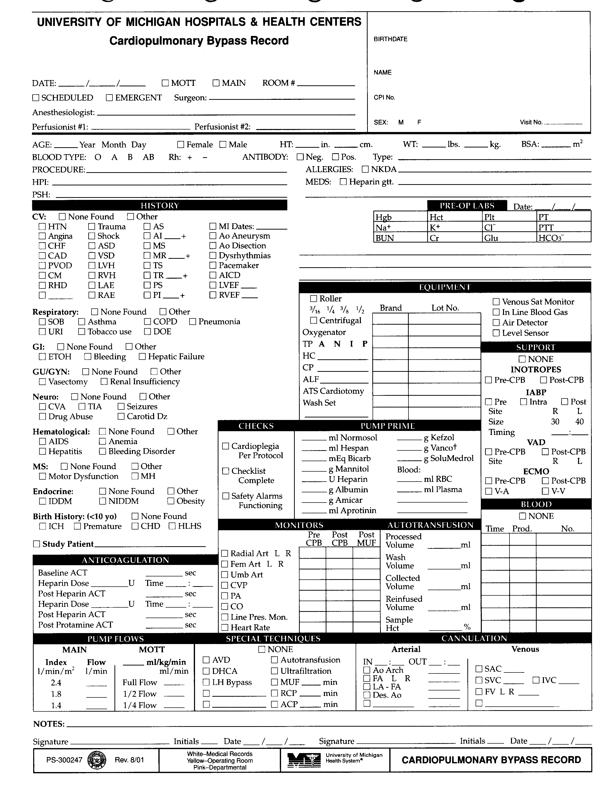

History Section
- Refer to CPB Record Page #1 on the preceding page.

CV: Cardiovascular System: Check all applicable elements of the patients cardiovascular history and record additional findings in the space to the right. Abbreviations follow:
None Found = No pertinent cardiovascular system history
HTN = Hypertension
Angina = Angina Pectoris
CHF = Congestive Heart Failure
CAD = Coronary Artery Disease
PVOD = Peripheral Vascular Obstructive Disease
CM = Cardiomyopathy
RHD = Rheumatic Heart Disease
Trauma = Recent Trauma precipitating this hospitalization
Shock = Cardiovascular Shock episode precipitating this hospitalization
ASD = Atrial Septal Defect
VSD = Ventricular Septal Defect
LVH = Left Ventricular Hypertrophy
RVH = Right Ventricular Hypertrophy
LAE = Left Atrial Enlargement
RAE = Right Atrial Enlargement
AS = Aortic Valve Stenosis
AI = Aortic Valve Insufficiency recorded as 1, 2, 3,or 4 +
MS = Mitral Valve Stenosis
MR = Mitral Valve Regurgitation recorded as 1, 2, 3, or 4 +
TR = Tricuspid Valve Regurgitation recorded as 1, 2, 3, or 4 +
PS = Pulmonary Valve Stenosis
PI = Pulmonary Insufficiency recorded as 1, 2, 3, or 4 +
MI Dates = Myocardial Infarction and dates of each
Ao Aneurysm = Aortic Aneurysm
Ao Dissection = Aortic Dissection
Dysrhythmias = Cardiac Dysrhythmias
Pacemaker = Cardiac Pacemaker
AICD = Automatic Implantable Cardiac Defibrillator
LVEF = Left Ventricular Ejection Fraction written as percent
RVEF = Right Ventricular Ejection Fraction written as percent
Other = Condition related to present illness not listed

Respiratory: Respiratory System: Check all applicable elements of the patients respiratory system history and record additional findings in the space to the right. Abbreviations follow:
None Found = No pertinent respiratory system history
SOB = Short Of Breath
Asthma = Asthma
COPD = Chronic Obstructive Pulmonary Disease
Pneumonia = Past episodes of pneumonia
URI = Upper Respiratory Infection multiple episodes
Tobacco Use = Current or significant past tobacco abuse
DOE = Dyspnea On Exertion
Other = Condition not listed

GI: Gastrointestinal System: Check all applicable elements of the patients gastrointestinal history and record additional findings in the space to the right. Abbreviations follow:
None Found = No pertinent gastrointestinal system history
ETOH = History of Alcohol Abuse
Bleeding = History of Gastrointestinal bleeding of any type
Hepatic Failure = History of Hepatic Failure or Insufficiency
Other = Condition not listed

GU/GYN: Genital Urinary / Gynecological: Check all applicable elements of the patients genital urinary or gynecological system history and record additional findings in the space to the right. Abbreviations follow:
None Found = No pertinent genital urinary or gynecological history
Vasectomy = History of Vasectomy
Renal Insufficiency = History of renal insufficiency or renal impairment of
any type
Other = Condition not listed

Neuro: Neurological System: Check all applicable elements of the patients neurological system history and record additional findings in the space to the right. Abbreviations follow:
None Found = No pertinent neurological system history
CVA = Cardiovascular Accident or Stroke
TIA = Transient Ischemic Attack
Seizures = Seizures or Epilepsy
Drug Abuse = History or Current Drug Abuse of any type
Carotid DZ = Carotid Obstructive Disease recorded as percent on right or
left side
Other = Condition not listed
Hematological: Hematological System: Check all applicable elements of the patients hematological system history and record additional elements in the space to the right. Abbreviations follow:
None Found = No pertinent hematological history
AIDS = Acquired Immune Deficiency Syndrome
Anemia = Chronic Anemia
Hepatitis = Hepatitis any type
Bleeding Disorder = Bleeding Disorder any type
Other = Condition not listed

MS: Musculoskeletal System: Check all applicable elements of the patients musculoskeletal system history and record additional findings in the space to the right. Abbreviations follow:
None Found = No pertinent musculoskeletal system history
Motor Dysfunction = Skeletal Muscle Motor Dysfunction of any type
MH = Malignant Hyperthermia
Other = Condition not listed

Endocrine: Endocrine System: Check all applicable elements of the patients endocrine system history and record additional findings in the space to the right. Abbreviations follow:
None Found = No pertinent endocrine system history
IDDM = Insulin Dependent Diabetes Mellitus
NIDDM = Non-insulin Dependent Diabetes Mellitus
Obesity = Grossly Exceeding Ideal Body Weight
Other = Condition not listed

Birth History: Birth History of patients less than 10 year of age: Check all applicable elements of the birth history and record additional findings in the space to the right. Abbreviations follow:
None Found = No pertinent birth history
ICH = Intracranial Hemorrhage
Premature = Premature Birth of any duration
CHD = Congenital Heart Defect of any type
Other = Condition not listed

Study Patient: Check the box if the patient is enrolled in a study involving any perfusion participation. Record the name of the study on the line provided.

Pre-Op Lab Section
Refer to CPB Record Page #1 above.
Record pre-operative laboratory results in this section.
Date: Date of the preoperative laboratory results recorded.
HB: Hemoglobin gm/dl
Hct: Hematocrit %
Plat: Platelets x 1000 /mm³
PT: Prothrombin Time sec.
PTT: Partial Thromboplastin Time sec.
Na+: Sodium mmol/l
K+: Potassium mmol/l
Cl-: Chloride mmol/l
BUN: Blood Urea Nitrogen mg/dl
Creatinine: Creatinine mg/dl
GLU: Glucose mg/dl
HCO3: Bicarbonate mmol/l

Equipment Section
- Refer to CPB Record Page #1 above.
- Record the elements of the Cardiopulmonary Bypass Circuit as well as the brand and Lot Numbers of appropriate equipment.
Pump: Arterial Pump
- Check either Roller = Roller Pump or Centrif = Centrifugal Pump.
- If Roller Pump used, circle either 3/16 = 3/16”, ¼ = ¼”, 3/8 = 3/8”, or ½”, to denote the size arterial boot used.
- Record the brand and Lot Number of the centrifugal pump disposable in the space provided only if the pump is supplied separately from the tubing pack (example: left heart bypass requires that BP-80 lot number be recorded).
Oxygenator: Cardiopulmonary Bypass Oxygenator:
- Record the brand and the peal off bar code number from the wrapper of the oxygenator.
TP: Tubing Pack
- Circle either A = Adult, N = Neonatal, I = Infant, or P = Pediatric to denote type of tubing pack used.
- Record the brand and Lot Number in the space provided. All components contained within the pack can be traced from the tubing pack lot number. Individual lot numbers of components need not be recorded.
HC: Hemoconcentrator:
- Record the type of hemoconcentrator used, the brand, and Lot Number in the spaces provided.
CP: Cardioplegia System:
- Record the brand and Lot Number of the cardioplegia system in the space provided. If the CP system is a component of the tubing pack no Lot Number is required.
ALF: Arterial Line Filter
- Record brand and Lot number.
Wash Set: Autotransfusion Wash Set
- Record brand and Lot number.
ATS Cardiotomy: Autotransfusion Cardiotomy Reservoir
- Record brand and Lot number.
Venous Sat Monitor: Venous Line Hemoglobin Oxygen Saturation Monitor
- Check the box if a venous line saturation monitor is used.
In Line Blood Gas: Arterial In Line Blood Gas Monitor
- Check the box if an arterial in line blood gas monitor is used.
Air Detector: Arterial Line Air Detector
- Check the box if an arterial line air detector is used.
Level Sensor: Venous Reservoir Level Sensor
- Check the box if a venous reservoir level sensor is used.

Checks Section
- Refer to CPB Record Page #1 above.
Cardioplegia Per Protocol
- Check this box if the cardioplegia was mixed according to the attending cardiac surgeon’s current cardioplegia protocol.
Checklist Complete
- Check this box if a pre-cardiopulmonary bypass check list was completed.
Safety Alarms Functioning
- Check this box if the safety alarms were set prior to or just after the initiation of cardiopulmonary bypass.

Pump Prime Section
- Refer to CPB Record Page #1 above.
Normosol R: Record the number of milliliters in the space provided.
Hespan: Record the number of milliliters in the space provided.
Bicarb (NaHCO₃): Record the number of mEq in the space provided.
Mannitol: Record the number of grams in the space provided.
Heparin: Record the number of units in the space provided.
Albumin: Record the number of grams in the space provided.
Amicar (epsilon-amino-caproic acid): Record the number of grams in the space provided.
Aprotinin (Trasylol): Record the number of milliliters in the space provided.
Kefzol (cefazolin, Ancef): Record the number of grams in the space provided.
Vanco (vancomycin): Record the number of grams in the space provided.
Solu-Medrol (methylprednisolone): Record the number of grams in the space provided.
Blood:
RBC
- Record the number of milliliters in the space provided.
Plasma
- Record the number of milliliters in the space provided.

Support Section
- Refer to CPB Record Page #1 above.
- Check the NONE box if the patient does not require any of the following methods of cardiovascular support.
Inotropes
Pre-CPB
- Check the box if patient is on inotropic support before the initiation of CPB.
Post-CPB
- Check the box if patient is on inotropic support following the termination of CPB.
IABP: Intra-aortic Balloon Pump
- Check the appropriate box which designates the time of balloon pump insertion.
- Pre = Pre-operative
- Intra = Intra-operative, if IABP is required to separate from CPB.
- Post = Post-operative, if patient has separated from CPB and then is placed on IABP.
Site: Site of Balloon Catheter Insertion
- Circle the letter designating the site of balloon pump insertion.
- R = Right Femoral Artery
- L = Left Femoral Artery
Size: Size of Balloon Catheter Inserted
- Check the appropriate box which designates the size of balloon pump catheter.
- 30 = 30 cc Balloon
- 40 = 40 cc Balloon
Timing: Timing of Intra-aortic Balloon Pump
- Record the number of IABP inflations to cardiac cycles in the spaces provided.
VAD: Ventricular Assist Device
- Check the appropriate box which designates the time of ventricular assist device placement.
- Pre-CPB = Prior to Cardiopulmonary Bypass
- Post-CPB = After or to separate from Cardiopulmonary Bypass.
Site: Ventricle Supported by Assist Device
- Circle the letter designating the site of VAD insertion.
- R = Right Ventricle
- L = Left Ventricle
ECMO: Extra-Corporeal Membrane Oxygenation
- Check the appropriate box which designates the time of initiation to ECMO.
- Pre-CPB = Before Cardiopulmonary Bypass
- Post-CPB = After Cardiopulmonary Bypass.
Check the appropriate box which designates the type of ECMO preformed.
- V-A = Veno-Arterial ECMO
- V-V = Veno-Venous ECMO

Anticoagulation Section
- Refer to CPB Record Page #1 above.
Base ACT: Patient baseline activated clotting time test, recorded in seconds
Post Heparin ACT: Patient activated clotting time following heparinization, recorded in seconds
Post Protamine ACT: Patient activated clotting time following protamine administration, recorded in seconds
Heparin Dose: The initial amount of heparin administered in units, second space provided for additional doses
Time: The time of heparin administration, recorded in military time, second space provided for additional doses
X-Clamp RX: The time of cross clamp removal drug administration, recorded in military time (see Page 3 for regimen)
Protamine RX: The time of protamine reaction pretreatment, recorded in military time (see Page 3 for regimen)

Monitors Section
- Refer to CPB Record Page #1 above.
- Record the monitoring devices attached to the patient and their values Pre and Post Cardiopulmonary Bypass as well as Post MUF when applicable.

Radial Art L R: Radial Arterial Pressure (mmHg)
- Circle either R = Right Radial Artery or L = Left Radial Artery
Fem Art L R: Femoral Arterial Pressure (mmHg)
- Circle either R = Right Femoral Artery or L = Left Femoral Artery
Umb Art: Umbilical Arterial Pressure (mmHg)
CVP: Central Venous Pressure (mmHg)
PA: Pulmonary Artery Pressure (mmHg)
CO: Cardiac Output (lpm)
Art Pres Mon: Arterial Line Pressure Monitor (mmHg)
- Not required post-MUF
Heart Rate: Heart Rate (bpm)

Autotransfusion Section
- Refer to CPB Record Page #1 above.
Processed Vol.: Record in mls the total volume of fluid scavenged by the autotransfusion machine the OR procedure.
Wash Volume: Record in mls the total volume of 0.9% NaCl used to wash red blood cells the OR procedure.
Reinfused Volume: Record in mls the total volume of washed red blood cells collected during the OR procedure.
Reinfused Volume: Record in mls the total volume of washed red blood cells collected during the OR procedure.
Sample Hct: Record the hematocrit of a sample taken from the product of a full washed bowl.

Blood Section
- Refer to CPB Record Page #1 on the page 2-2.
Usage
- If no blood products were used by perfusion check the NONE box.
Time
- Record the completion time of blood product administration by perfusion.
Type
- Record the type of blood product administered by perfusion
- PRBC= Packed Red Blood Cells
- SDP= Single Donor Plasma
- FFP= Fresh Frozen Plasma
- WB= Whole Blood
Donor Type
- A prefix of A or D accompanying the above abbreviations designates the following
- A= Auto Unit
- D= Directed Donor.
No.: Unit Number
- Record the blood product identification number.
- Refer to CPB Record Page #1 above.

Pump Flows Section
- Refer to CPB Record Page #1 above.
- Record the target pump flows for the appropriate hospital.
Main: Main Hospital
Index
Record target pump flows, in liters per minute, for cardiac indexes of 2.4, 1.8 and 1.4
Mott
ml/kg
Record the ml/Kg target for Mott cases as well as values for Full, ½, and ¼ flows.

Special Techniques Section
- Refer to CPB Record Page #1 above.
- Check all boxes corresponding to special techniques employed during the cardiopulmonary bypass period.
AVD: Augmented Venous Drainage, either kinetic or vacuum assist
DHCA: Deep Hypothermic Circulatory Arrest
RCP: Retrograde Cerebral Perfusion
Autotransfusion: Cell Saver
- Requires the completion of an Autotransfusion Record.
Ultrafiltration: Hemoconcentration, Ultrafiltration
MUF: Modified Ultrafiltration
- Record the length of MUF period in minutes
LH Bypass: Left Heart Bypass

Cannulation Section
Refer to CPB Record Page #1 above.
- Check all the cannulation site boxes used (see list below). Note the size and manufacturer of the every cannula used in the blanks provided
Arterial:
IN: Arterial Cannulation Time (Military Time)
OUT: Arterial Decannulation Time (Military Time)
Ao Arch: Aortic Arch
FA: Femoral Artery
- Circle either L = Left or R = Right
LA – FA: Left Atrium and Femoral Artery
Des. Ao: Descending Aorta
Venous:
SAC: Single Atrial Cannula
SVC: Superior Vena Cava
FV: Femoral Vein: Circle either L = Left or R = Right
IVC: Inferior Vena Cava

Miscellaneous Section
Notes: Record notes as required.
1st Signature: Signature of primary perfusionist
1st Initials: Initials of primary perfusionist
1st Date: Date of signature
2nd Signature: Signature of perfusionist completing the case
2nd Initials: Initials of perfusionist completing the case
2nd Date: Date of signature

Pump Section
- Refer to CPB Record Page #2 on page 2-13.
Time: Record military time in 10-minute intervals.
LINE Pres: Arterial Line Pressure recorded in mmHg
RPM: Arterial Pump Revolutions recorded times 100 rpm
FLOW: Arterial Pump Flow recorded in liters per minute
ART Pres: Patient Arterial Pressure recorded in mmHg
PA/CVP
- At Main Hospital record the patient’s pulmonary artery pressure, if unavailable record CVP.
- At Mott Hospital record the CVP pressure in mmHg.
TEMP P: Perfusate temperature recorded in degrees C
TEMP N/E
- Circle either N= Nasopharyngeal or E= Esophageal.
- Record the temperature in degrees C.
TEMP B/R
- Circle either B= Bladder or R= Rectal.
- Record the temperature in degrees C.
V. SAT: Venous Line Hemoglobin Saturation recorded as percent.
HCT: Venous Line Hematocrit reading recorded as percent.
AVD Pres: Augmented Venous Drainage Negative Pressure recorded in negative mmHg.
AF PURGE: Arterial Line Filter Air Purge
O= Open
X= Closed
NOTES: Marker for perfusion notes

Gas Section
- Refer to CPB Record Page #2 on the following page.
GAS FLOW: Oxygenator gas sweep in liter per minute
FiO2: Percent oxygen delivered as percent
FORANE: Forane gas delivered as percent

CPB Record Page #2
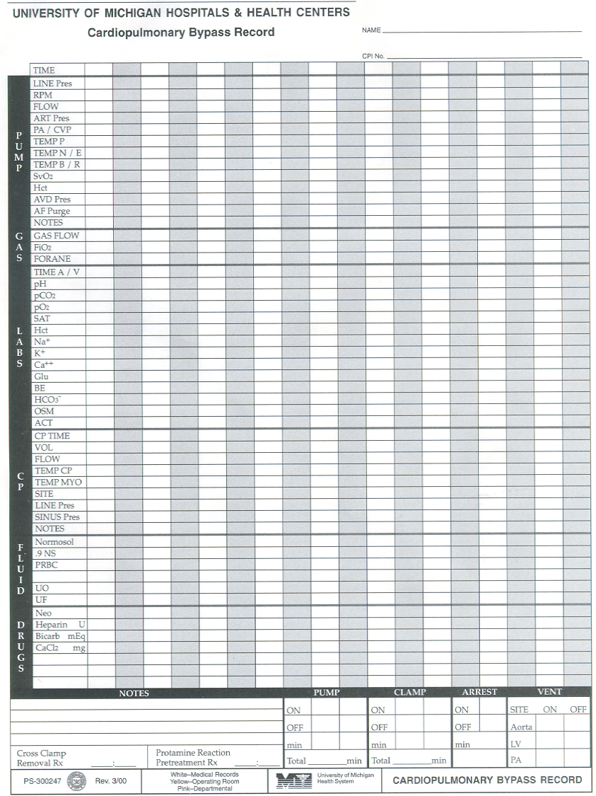

Labs Section
- Refer to CPB Record Page #2 on the preceding page.
TIME A/V/C
- Record the time of laboratory sample in military time.
- Sample type identification
- A = Arterial
- V = Venous
- C = CDI

CP (Cardioplegia) Section
- Refer to CPB Record Page #2 on the preceding page.
CP TIME: Time of cardioplegia dose recorded in military time
VOL: Volume of cardioplegia dose recorded in milliliters
FLOW: Flow rate of cardioplegia during delivery recorded in milliliters per minute
TEMP CP: Temperature of the cardioplegia during delivery recorded in ºC.
TEMP MYO: Myocardial temperature recorded in degrees C.
SITE: Route of cardioplegia delivery.
A = Antegrade R = Retrograde
S = Saphenous Vein Graft O = Coronary Ostia
LINE Pres: Cardioplegia delivery line pressure recorded in mmHg.
SINUS Pres: Coronary sinus cardioplegia delivery pressure recorded in mmHg
NOTES: Marker for cardioplegia delivery note

Fluid Section
- Refer to CPB Record Page #2 on the preceding page.
Normosol: Quantity of Normosol administered during the bypass period, recorded in milliliters
9 NS: Quantity of normal saline administered during the bypass period, recorded in milliliters
PRBC: Packed red blood cells administered during the bypass period, recorded in milliliters
UO: Patient urine output during the bypass period, recorded in milliliters
UF: Ultrafiltrate produced during the bypass period, recorded in milliliters

Drug Section
- Refer to CPB Record Page #2 on the preceding page.
Neo: The amount of Phenylephrine administered over the 10-minute charting period, recorded in micrograms
Heparin: The amount of Heparin administered, recorded in units
Bicarb: The amount of Sodium Bicarbonate administered, recorded in milliequivalents
CaCl2: The amount of Calcium Chloride administered, recorded in milligrams

Pump Section
Refer to CPB Record Page #2 above.
ON – OFF
- Record the time of initiation and termination of cardiopulmonary bypass using military time notation.
- Additional space is provided for multiple bypass periods.
Min: Elapsed time of bypass period, recorded in minutes
TOTAL: Total of all elapsed bypass periods, recorded in minutes

Clamp Section
- Refer to CPB Record Page #2 above.
ON – OFF: The time of application and removal of the aortic cross clamp using military time notation.
Min: Duration of aortic cross clamp period, recorded in minutes. Additional space is provided for multiple cross clamp periods.
TOTAL: Total of all elapsed cross clamp periods, recorded in minutes

Arrest Section
Refer to CPB Record Page #2 above.
ON – OFF: The time of initiation and termination of circulatory arrest using military time notation.
Min: Elapsed time of circulatory arrest period recorded in minutes

Vent Section
- Refer to CPB Record Page #2 above.
SITE
- Record the method used for venting the heart.
Aorta = Aortic Needle Vent
LV = Left Ventricular Vent
PA = Pulmonary Artery Vent
IN – OUT: The time of vent placement and removal recorded in military time

CPB Record Page #3
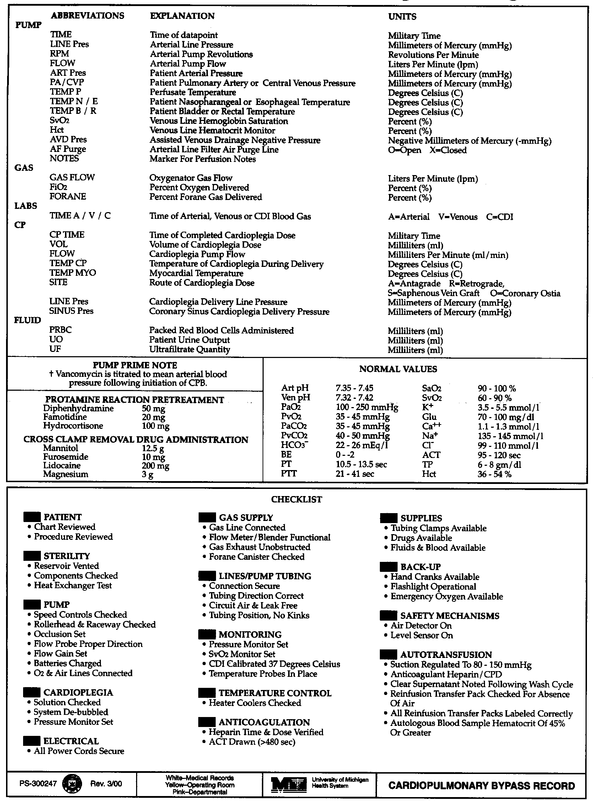

Abbreviations
- Refer to CPB Record Page #3 on the preceding page.
- Explanation of abbreviations utilized on Page 2 of the Cardiopulmonary Bypass Record

Normal Values
- Refer to CPB Record Page # on the preceding page.
- Review of normal blood gas and electrolyte values.

Protamine Reaction Pretreatment
- Refer to CPB Record Page #3 on the preceding page.
- Review of Protamine reaction pretreatment drug regimen.

Cross Clamp Removal Drug Administration
- Refer to CPB Record Page #3 on the preceding page.
- Review of cross clamp removal drug regimen.

Normal Values
- Refer to CPB Record Page #3 on the preceding page.
- Review of normal values for blood gases, electrolytes, and blood work.

Pre-Bypass Checklist
- Refer to CPB Record Page #3 on the preceding page.
- Pre-bypass checklist for the convenience of the perfusionist. Completion of a Pre-Bypass checklist is a mandatory perfusion responsibility. By checking the Pre-Bypass Checklist Complete box on Page #1, the perfusionist is verifying that an appropriate pre-bypass checklist was completed. A copy of this checklist should not accompany the patient’s records.

Orthotopic Liver Transplant Veno-Venous Bypass Record & Guidelines for Charting
- Make an imprint of the patient’s registration card (red card) on the upper right corner of the Orthotopic Liver Transplant Veno-Venous Bypass Record.

Demographic Section
- Refer to OHT Veno-Venous Bypass Record on the following page.
DATE: Operation Date, Month, Day, Year
SURGEON: Name of attending surgeon
ANESTHESIOLOGIST: Name of attending anesthesiologist

Patient Information Section
- Refer to OHT Veno-Venous Bypass Record on the following page.
Diagnosis / Risk Factors
- Record any pertinent information pertaining to the patients recent medical condition.
- Record any pertinent past surgical interventions the patient has had.
Meds: Record all pertinent medications.
Allergies: Record all allergies the patient possesses to medication. If the patient has no, allergies check the NKDA box.

Pre-Op Lab Section
- Refer to OHT Veno-Venous Bypass Record on the following page.
- Record pre-operative laboratory results in this section.

Date: Date of the preoperative laboratory results recorded.
HB: Hemoglobin gm/dl
Hct: Hematocrit %
Plat: Platelets x 1000 /mm³
PT: Prothrombin Time sec.
PTT: Partial Thromboplastin Time sec.
Na+: Sodium mmol/l
K+: Potassium mmol/l
Cl-: Chloride mmol/l
BUN: Blood Urea Nitrogen mg/dl
Creatinine: Creatinine mg/dl
GLU: Glucose mg/dl
HCO3: Bicarbonate mmol/l

OLT Veno-Venous Bypass Record
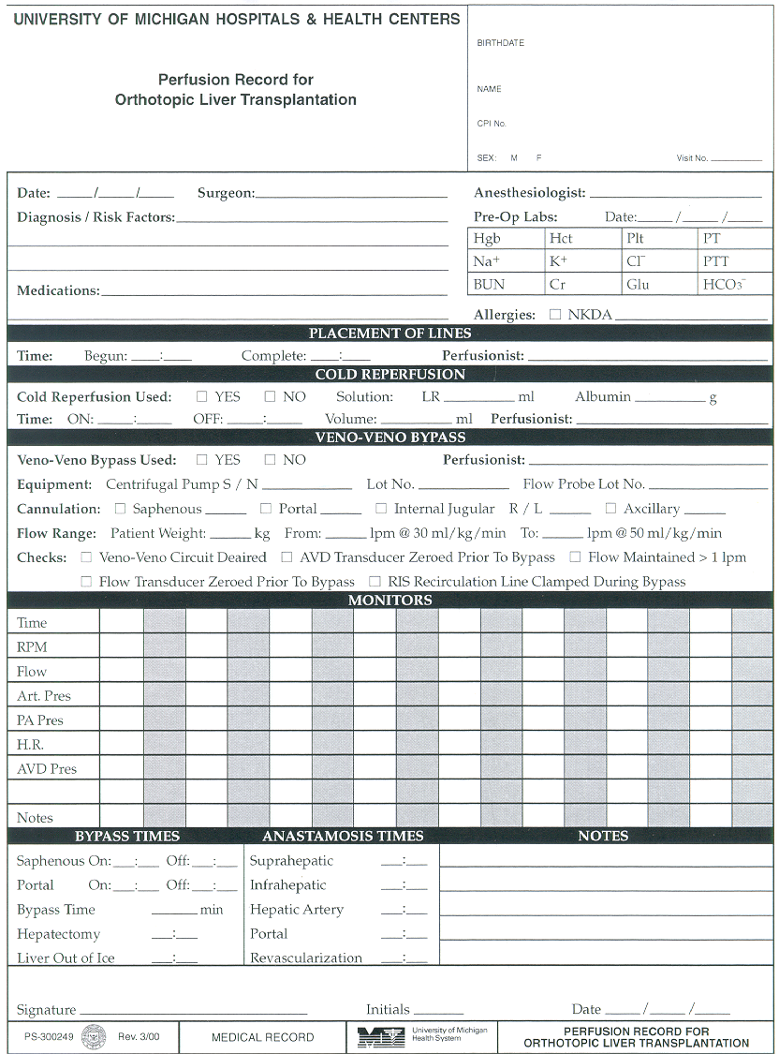

Placement of Lines Section
- Refer to OHT Veno-Venous Bypass Record on the preceeding page.
Begun: ____:____
- Record the time when the placement of lines is initiated using military time notation.
Complete: ____:____
- Record the time when the placement of lines is completed using military time notation.
Perfusionist: Enter name of clinical perfusionist present for placement of lines.

Reperfusion Solution Section
- Refer to OHT Veno-Venous Bypass Record on the preceding page.
- Check either the Yes or No box depending whether or not reperfusion solution is delivered.
Reperfusion Solution Composition
L&R ________ml
- Enter the volume of lactated Ringer’s solution used to make the reperfusion solution (usually 1000 ml).
Albumin _______g
- Enter the amount of albumin used to make the reperfusion solution (usually 37.5 g).
Cold Reperfusion
On:____:____
- Record the time when the cold reperfusion is initiated using military time notation.
Off:____:____
- Record the time when the cold reperfusion is completed using military time notation.
Vol. ____ml
- Enter the volume of reperfusion solution delivered.
Perfusionist: Enter name of clinical perfusionist administering cold reperfusion.

Veno-Venous Bypass Section
- Refer to OHT Veno-Venous Bypass Record on page 2-19.
- Check either the Yes or No box depending whether or not veno-venous bypass is utilized.
Perfusionist: Enter the name of the perfusionist conducting veno-venous bypass.
Equipment
Centrifugal Pump
S / N: Record the serial number of the centrifugal pump used.
Lot No.: Record the Lot number of the centrifugal pump used.
Flow Probe
Lot No.: Record the Lot number of the flow probe used.
Cannulation
- Check all the cannulation site boxes used (see list below). Note the size and manufacturer of every cannula used in the blanks provided
Saphenous: Saphenous Vein
Portal: Portal Vein
Internal Jugular: Internal Jugular Vein
- Circle either L = Left or R = Right
Axillary: Axillary Vein
Flows
Patient Weight: Enter patient’s current kilogram weight.
_____l/min @ 30 ml/kg/min: Calculate and enter the flow rate.
_____l/min @ 50 ml/kg/min: Calculate and enter the flow rate.
Checks
- Check the corresponding boxes after completing each of the following tasks:
Veno-Venous circuit de-aired
AVD transducer zeroed prior to bypass
Flow maintained > l / min
Flow transducer zeroed prior to veno-venous bypass
R.I.S. recirculation line clamped during veno-venous bypass

Monitors Section
- Refer to OHT Veno-Venous Bypass Record.
Time
- Record military time in 10-minute intervals.
RPM
- Centrifugal pump revolutions recorded in revolutions per minute.
Flow
- Arterial pump flow recorded in liters per minute.
ART Pres
- Patient arterial pressure recorded in mmHg.
PA
- Patient pulmonary artery pressure recorded in mmHg.
H.R.
- Patient heart rate in beats per minute.
AVD Pres
- Active Venous Drainage pressure recorded in mmHg.
NOTES: Marker for perfusion notes

Veno-Venous Bypass Times Section
- Refer to OHT Veno-Venous Bypass Record on page 2-19.
Saph. On:____:____ Off:____:____
- Record the time when the saphenous vein to right internal jugular or axillary vein is initiated. Use military time notation.
- Record the time when the saphenous vein to right internal jugular or axillary vein is terminated. Use military time notation.
Portal On:____:____ Off:____:____
- Record the time when the portal vein to right internal jugular or axillary vein is initiated. Use military time notation.
- Record the time when the portal vein to right internal jugular or axillary vein is terminated Use military time notation.
Hepatectomy: ____:____
- Record the time when the hepatectomy is completed. Use military time notation.
Liver out of ice: ____:____
- Record the time when the donor liver is removed from ice. Use military time notation.

Anastomosis Times Section
- Refer to OHT Veno-Venous Bypass Record on page 2-19.
Suprahepatic: ____:____
- Record the time when the suprahepatic anastomosis is completed. Use military time notation.
Infrahepatic: ____:____
- Record the time when the infrahepatic anastomosis is completed. Use military time notation.
Hepatic Artery: ____:____
- Record the time when the hepatic artery anastomosis is completed. Use military time notation.
Portal: ____:____
- Record the time when the portal vein anastomosis is completed. Use military time notation.
Revascularization: ____:____
- Record the time when the hepatectomy is completed. Use military time notation.

Miscellaneous Section
- Refer to OHT Veno-Venous Bypass Record on page 2-19.
Notes: Space for perfusion notes.
Signature: Space primary perfusionist’s signature.
Initials: Space for initials of perfusionist completing the case.
Date: Space for date of signature.

Appendix C: Equipment Specifications

PVC Tubing Flow & Volume Specifications

PVC Tubing Flow & Volume Specifications Table
Size | Volume | Arterial Boot Stroke Volume | Maximum Recommended Arterial Flow | Maximum Recommended Venous Flow Range
3/32” | 1.80 ml/ft | 2.5 ml/revolution | not applicable | not applicable
1/8” | 2.50 ml/ft | 3.5 ml/revolution | 250 ml/min | not applicable
3/16” | 5.00 ml/ft | 7.0 ml/revolution | 800 ml/min | 400 - 500 ml/min
1/4” | 9.65 ml/ft | 13.0 ml/revolution | 1300 ml/min | 1278 –1566 ml/min
3/8” | 21.71 ml/ft | 27.0 ml/revolution | 3000 ml/min | 2898 – 4000 ml/min
1/2” | 38.61 ml/ft | 45.0 ml/revolution | 7000 ml/min | 4000 – 7000 ml/min

Oxygenator Specifications

Medtronic Affinity NT 541
Recommended Blood Flow Range: > 4.0 < 7.0 l/min
Oxygenator Static Prime Volume 270 ml
Membrane Material Polypropylene
Membrane Type Microporous Hollow Fibers
Blood Film outside
Membrane Surface Area 2.5 m²
Minimum Operating Reservoir Volume 200 ml
Maximum Reservoir Volume 4000 ml
Maximum Cardiotomy Flow Rate 6.0 l/min
Venous Inlet Filter 200 mcn screen
Final Reservoir Screen 150 mcn screen
Cardiotomy Filter 30 mcn depth

Arterial Line Filter Specifications

Affinity 351

Maximum Recommended Blood Flow Rate 7 liters/min
Screen Size 38 micron
Prime Volume 212 ml
Size Adult

Pall LeucoGuard 6
Maximum Recommended Blood Flow Rate 6.0 liters/min
Screen Size 40 micron
Prime Volume 220 ml
Size Adult

Pall LeucoGuard LGB
Maximum Recommended Blood Flow Rate 6.0 liters/min
Screen Size 40 micron
Prime Volume 205 ml
Size Adult

Hemoconcentrator Specifications

Hemoconcentrator Transmembrane Pressure Calculation

TMP = ((P_{A} + P_{V}) / 2) + P_{N}

TMP = Transmembrane Pressure (mmHg)
P_{A} = Arterial (inlet pressure (mmHg)
P_{V} = Venous (outlet) Pressure (mmHg)
P_{N} = Absolute value of any applied suction on the
ultrafiltration outlet (mmHg)

Minntech HPH 1000TS
Membrane Material Polysulfone
Membrane Type Microporous Hollow Fibers
Membrane area 1.06 m²
Pressure Drop 85 mmHg
Maximum Transmembrane Pressure 500 mmHg
Priming Volume 70 ml
Molecular Weight Cut-Off 65,000 Daltons

Minntech HPH 1000TS Filtration Rate Graph

Recommended Circuit Configurations of Minntech HPH 1000TS

